Literal comprehension
Stage 3

Overview

Purpose
This literacy teaching strategy supports teaching and learning for Stage 3 students across all key learning areas. It targets specific literacy skills and suggests a learning sequence to build skill development. Teachers can select individual tasks, or a sequence, and embed into their teaching and learning program according to their students’ needs. While exemplar texts are provided throughout this resource, it is recommended that teachers select texts which are relevant to their students and curriculum.

Learning intention
Students will learn to use a range of texts to locate and interpret directly stated information, including multimodal and digital texts. Students will learn to use skimming and scanning strategies to identify key words.

Syllabus outcomes
The following teaching and learning strategy will assist in covering elements of the following outcomes:
- EN3-RECOM-01: fluently reads and comprehends texts for wide purposes, analysing text structures and language, and by monitoring comprehension
NSW English K-10 Syllabus (2022)

Success criteria
The following Year 5 NAPLAN item descriptors may guide teachers to co-construct success criteria for student learning.

- interprets directly stated information in a blog post
- interprets directly stated information in a narrative
- interprets directly stated information in a persuasive text
- locates directly stated information in a text
- locates directly stated information on a sign
- interprets directly stated information in an information text
- interprets directly stated information on a website
- locates directly stated information in a comment on a website

National Literacy Learning Progression guide

Understanding Texts (UnT8-UnT10)
Key: C=comprehension P=process V=vocabulary

UnT8
- monitors reading for meaning using grammatical and contextual knowledge (see Fluency) (P)
- uses knowledge of the features and convention of the type of text to build meaning (e.g. recognises that the beginning of a persuasive text may introduce the topic and the line of argument) (P)
- skims and scans texts for key words to track the development of ideas (P)
- identifies how technical and discipline-specific words develop meaning in texts (V)

UnT9
- summarises the text identifying key details only (C)
- draws inferences, synthesising clues and evidence across a text (C)
- selects reading/viewing strategies appropriate to reading purpose (e.g. scans text for evidence) (P)
- uses a range of context and grammatical cues to understand unfamiliar words (V)

UnT10
- integrates automatically a range of processes such as predicting, confirming predictions, monitoring, and connecting relevant elements of the text to build meaning (P)
National Literacy Learning Progression

Evidence base
- Centre for Education Statistics and Evaluation (2017). Effective reading instruction in the early years of school, literature review.
- Konza, D. (2014). Teaching Reading: Why the “Fab Five” should be the “Big Six”. Australian Journal of Teacher Education, 39(12)
- Oakhill, J., Cain, K. & Elbro, C. (2015). Understanding and teaching reading comprehension: A handbook. Routledge.
- Quigley, A. (2020). Closing the reading gap. Routledge.
- Scarborough, H.S. (2001). Connecting early language and literacy to later reading (dis)abilities: Evidence, theory and practice. In S. Neuman & D. Dickson (Eds.), Handbook for research in early literacy (pp. 97-110). New York, NY: Guilford Press.
Alignment to system priorities and/or needs: Five priorities for Literacy and Numeracy, Our Plan for NSW NSW Public Education, School Excellence Policy (nsw.gov.au).
Alignment to School Excellence Framework: Learning domain: Curriculum, Teaching domain: Effective classroom practice and Professional standards
Consulted with: Strategic Delivery, Teaching Quality and Impact
Author: Literacy and Numeracy
Reviewed by: Literacy and Numeracy, Teaching Quality and Impact
Created/last updated: January 2024
Anticipated resource review date: January 2025
Feedback: Complete the online form to provide any feedback

Copyright
Section 113P Notice
Texts, Artistic Works and Broadcast Notice
Some of this material has been copied and communicated to you in accordance with the statutory licence in section 113P of the Copyright Act. Any further reproduction or communication of this material by you may be the subject of copyright protection under the Act. Do not remove this notice.

Teaching strategies
Tasks | Appendices
Building background knowledge to identify information | Appendix 1 - ‘It’s Right Here!’ Anchor chart  Appendix 2 - ‘Food Miles: How well-travelled is your food?’  Appendix 3 - Student-led analysis: where, when, who, what, how?
Literal comprehension in action | Appendix 4 - ‘The Hobbit’ teacher annotations and student copy
Hunting for e-facts | Appendix 5 - ‘Hunting for e-facts’
Cloze | Appendix 6 - Cloze passage ‘Echoes’
Understanding unfamiliar words in a text | Appendix 7 - ‘The honey bee mystery’ text
Connecting directly stated information | Appendix 8 - ‘Adventure by moonlight’  Appendix 9 - Locating directly-stated information

Background information

Literal comprehension
Literal comprehension is often referred to as the ‘on the page’ comprehension; it is what the reader can see and hear from the page. Surface level comprehension is the simplest form of comprehension and requires students to locate directly stated information. Finding the main idea, summarising, key facts and understanding vocabulary are key building blocks of literal comprehension.
Questioning before, during and after reading a text is the key component of building comprehension skills (Singer, 1978). Literal comprehension questions are the “how, what, who, when, where” types of questions in their most basic form. The answer is clearly evident, for example, who did Little Red Riding Hood visit? Where did her grandmother live? What was in Little Red Riding Hood’s basket? Readers will use decoding skills, as well as syntax and semantic skills to recognise and remember directly stated information.

Reading
To process written words, to derive and/or construct meaning. It is the product of word reading and language comprehension.

Skimming
Skimming happens when the reader is unfamiliar with a text and skims to find out the type of text or to get the general idea. Some strategies to use include:
- read the first and last paragraphs
- look for general information
- use headlines, page layout, graphs and charts, pictures and highlighted text
Scanning
When the reader knows something about what the text is about but wants to find out more, they scan to find specific information and key words. Strategies to use include:
- look over the text quickly to locate words and sentences that link to what you need to find out
- use contents pages, first and last sentences in paragraphs, subheadings, captions, bold key words and hyperlinks
Reference: English K-10 Syllabus © NSW Education Standards Authority (NESA) for and on behalf of the Crown in right of the State of New South Wales, 2012 and 2022.

Where to next?
- Compare and contrast
- Main idea
- Inference

Overview of teaching strategies

Purpose
These literacy teaching strategies support teaching and learning from Stage 2 to Stage 5. They are linked to NAPLAN task descriptors, syllabus outcomes and literacy and numeracy learning progressions.
These teaching strategies target specific literacy and numeracy skills and suggest a learning sequence to build skill development. Teachers can select individual tasks or a sequence to suit their students.

Access points
The resources can be accessed from:
- NAPLAN App in Scout using the teaching strategy links from NAPLAN items
- NSW Department of Education literacy and numeracy website.

What works best
Explicit teaching practices involve teachers clearly explaining to students why they are learning something, how it connects to what they already know, what they are expected to do, how to do it and what it looks like when they have succeeded. Students are given opportunities and time to check their understanding, ask questions and receive clear, effective feedback.
This resource reflects the latest evidence base and can be used by teachers as they plan for explicit teaching.
Teachers can use classroom observations and other assessment information to make decisions about when and how they use this resource as they design teaching and learning sequences to meet the learning needs of their students.
Further support with What works best is available.

Differentiation
When using these resources in the classroom, it is important for teachers to consider the needs of all students, including Aboriginal and EAL/D learners.
EAL/D learners will require explicit English language support and scaffolding, informed by the EAL/D enhanced teaching and learning cycle and the student’s phase on the EAL/D Learning Progression. Teachers can access information about supporting EAL/D learners and literacy and numeracy support specific to EAL/D learners.
Learning adjustments enable students with disability and additional learning and support needs to access syllabus outcomes and content on the same basis as their peers. Teachers can use a range of adjustments to ensure a personalised approach to student learning.
Assessing and identifying high potential and gifted learners will help teachers decide which students may benefit from extension and additional challenge. Effective strategies and contributors to achievement for high potential and gifted learners helps teachers to identify and target areas for growth and improvement. A differentiation adjustment tool can be found on the High potential and gifted education website.

Using tasks across learning areas
This resource may be used across learning areas where it supports teaching and learning aligned with syllabus outcomes.
Literacy and numeracy are embedded throughout all syllabus documents as general capabilities. As the English and mathematics learning areas have a particular role in developing literacy and numeracy, NSW English and Mathematics syllabus outcomes aligned to literacy and numeracy skills have been identified.

Text selection
Example texts are used throughout this resource. Teachers can adjust activities to use texts which are linked to their unit of learning.
Further support with text selection can be found within the National Literacy Learning Progression Text Complexity appendix.
The NESA website has additional information on text requirements within the NSW English syllabus.

Teaching strategies

Building background knowledge to identify information
- Explain literal comprehension to the class. ‘The answers to literal comprehension questions are on the page – they are the easiest form of comprehension question that require skimming and scanning for information, but increase with challenge, depending on text complexity.’ Display the anchor chart and discuss how ‘who, when, where, what, how and which’ are used to ask literal comprehension questions. (Refer to Appendix 1 - ‘It’s Right Here!’ Anchor chart.)
- Brainstorm: Read the heading of the text: ‘Food Miles: How well-travelled is your food?’ (Appendix 2 - ‘Food Miles: How well-travelled is your food?’) to the class and discusses possible content, purpose and audience using clues from the heading and sub-heading. Students predict and record words they would expect to read in the text.
Additional task: Read a section of the text aloud and have students play bingo with their words suggested during word prediction.
- KWL: Students complete a KWL chart about where they think food comes from. Students are given the text: ‘Food Miles: How well-travelled is your food?’ to read and analyse:

Text analysis guide
What to look for | How to identify
Subject-specific language | Highlight with one colour
Unknown terms | Highlight with one colour
Repeated words | Circle
Topic sentences | Underline
Key messages or ideas | Highlight with one colour
- Students use a text relevant to a current unit or learning, or an appropriate text from Appendix 3 - Student-led analysis: where, when, who, what, how?, and design a suite of literal questions on the text. Students swap with a partner to answer the questions and check understanding.

Literal comprehension in action
- Think-Pair-Share: Teacher asks students what they know about J.R.R Tolkien’s ‘The Hobbit’. Students predict vocabulary they would expect to find in the text. Teacher reads aloud ‘The Hobbit’ text excerpt (refer to Appendix 4 - ‘The Hobbit’ teacher annotations and student copy).
- Concept Mapping: Display and jointly construct a concept map of information gathered around key questions: who, where, what, when, how?
- Students are given the student copy from Appendix 4 to read, then look at the questions and colour code answers with the questions.

Hunting for e-facts
- Discuss that students may enter a career, including communications or politics, where part of their job will be to ensure that information is sourced from reputable agencies and that we may also need to cross-reference to verify information. Ask students to look at the fact or myth (refer to Appendix 5 - ‘Hunting for e-facts’), predict vocabulary, then ‘go fact busting’ by searching for accurate information across a range of sources.
To increase abstraction, teacher discusses the challenges associated with searching for facts using online resources. For example, credibility of websites, how to find reliable sources. Refer to Stage 3 ‘Evaluating sources’ resource for further support.

Cloze
- Have students brainstorm vocabulary in response to the word ‘echoes’. Keep displayed throughout the learning, adding vocabulary to the word bank as needed.
- Students read ‘What makes an echo’ cloze passage (Appendix 6 - Cloze passage ‘Echoes’). Students determine a suitable vocabulary choice within the text. Come together as a class and review the actual answers from the teacher copy. Discuss options and add alternate words that maintain meaning.
- Students design their own cloze passages to share with a partner, focusing on important vocabulary omissions that will allow the reader to maintain meaning, for example, omitting words such as ‘interesting’ or ‘event’ rather than ‘the’ or ‘and’.
Differentiation: students suggest two synonyms for their partner to choose from with an obvious choice and one that does not maintain meaning.

Understanding unfamiliar words in a text
- Explain to students that they will be learning how to understand unfamiliar words when locating explicit information. Discuss with students that when reading about unfamiliar topics or new texts it is common to come across unfamiliar words. Skilled readers will use clues in the text to help find the meaning of these words.
- Brainstorm the terms ‘technical’, ‘terminology’ and ‘scientific’. Discuss when students might come across these terms. Ask students if they have come across any examples of these? Where? How do they know it is scientific terminology? Display responses.
- Display the heading ‘The honeybee mystery’ (Appendix 7 - ‘The honey bee mystery’ text). Ask the class if they know what a magazine article is and what information it might include.
- Students use clues to make predictions on what they think this text is about. Prompt students to predict vocabulary including scientific or technical terms. For example, beehive, wax, pollen, theory, life cycle.
- Highlight to students that authors use clues to tell us that a word is scientific or a technical term. They do this by using text features such as brackets, italics, bolded words or using initialism or acronyms. Model locating scientific and technical terminology using skimming and scanning strategies. Highlight responses.
- Display the stem question ‘What is happening to the honeybees? Explain to students that they will be looking for this information in the text. Highlight information. Teacher to use think aloud process the demonstrate how to locate explicit information containing unfamiliar words.

Suggested ‘think aloud’:
“I am going to scan the text to find the answer to the question ‘what’. I will use my highlighter to find any unfamiliar words when I see words that tell me what is happening to the bees. I can see from the title that this text is about bees. I need to read carefully to see if there is more information on bees to answer the question: what is happening to the bees? I can see the use of initialism of the letters CCD. I will highlight the words Colony Collapse Disorder in pink. I don’t understand what this means, so I will keep it in my head. I am going to keep looking at the text so I can work out what this scientific term means. I am going to look around the text to see if whether there are any other words that will help me understand what CCD means. I am going to look at both the sentence before and after the initialism to see if there any words that will help me. I can see the words ‘disappearance’ and ‘worrying’ in the previous sentence. I will read this sentence again to make sure that CCD means is the scientific term for the bees disappearing. I can see that the answer to what is happening to the bees must be that they are disappearing.”
- In pairs, students use the above strategy to locate and understand unfamiliar words directly stated in the text ‘The honeybee mystery’ (Appendix 7 - ‘The honey bee mystery’ text).

Connecting directly stated information
- Explain to students that they will be learning how to connect directly-stated information to answer the stem questions; who, where, what, why, when and how.
- Discuss with students that sometimes they can locate more than one piece of information using skimming and scanning. When this happens, they will need to use other parts of the text to find the answer to the question they are looking for. Students may need to use this information and make an interpretation and inference.
- Display a text linked to current unit of learning, or use Appendix 8 - ‘Adventure by moonlight’. Ask students to predict what this imaginative text is about. Including possible vocabulary. Ask students to support their ideas with evidence.
- Read the text ‘Adventure by moonlight’. Display the heading stem ‘where’. Tell students they will be looking to find the answer to this question by locating two different pieces of information.
Model connecting directly-stated information using the following:
Question | Information stated in the text | Information stated in the text | What I have understood
Where?  Where is this set? | But being the city kids they accepted his authority unquestioningly. | The country became more open and they could see the narrow sheep trail. | The children from the city are visiting the country.
- Explain to students that both the words ‘city’ and ‘country’ appear in the text. Both these words are directly-stated; however, students need to read both sentences to find the correct answer to the question: Where is this set? In the country.
- Students are given a copy of Appendix 9 - Locating directly-stated information. In pairs, students complete the answer to the question- who? Come together as a class and check answers, asking students to justify their responses and complete the task.

Appendix 1

Anchor Chart

It’s Right Here!
Who…?
Who is the main character? Who blew down the house?
Where…?
Where is the story set? Where can you find the park?
When…?
When did he go to the concert? On what day did the event occur?
What...?
What did she say to her friend? What did they take on their trip?
How did…? How far…?
How did they fix the sunglasses? How far did they run?
Which…?
Which character chose the cheese sandwich? Which puppy did they adopt?

Appendix 2
Joint text analysis
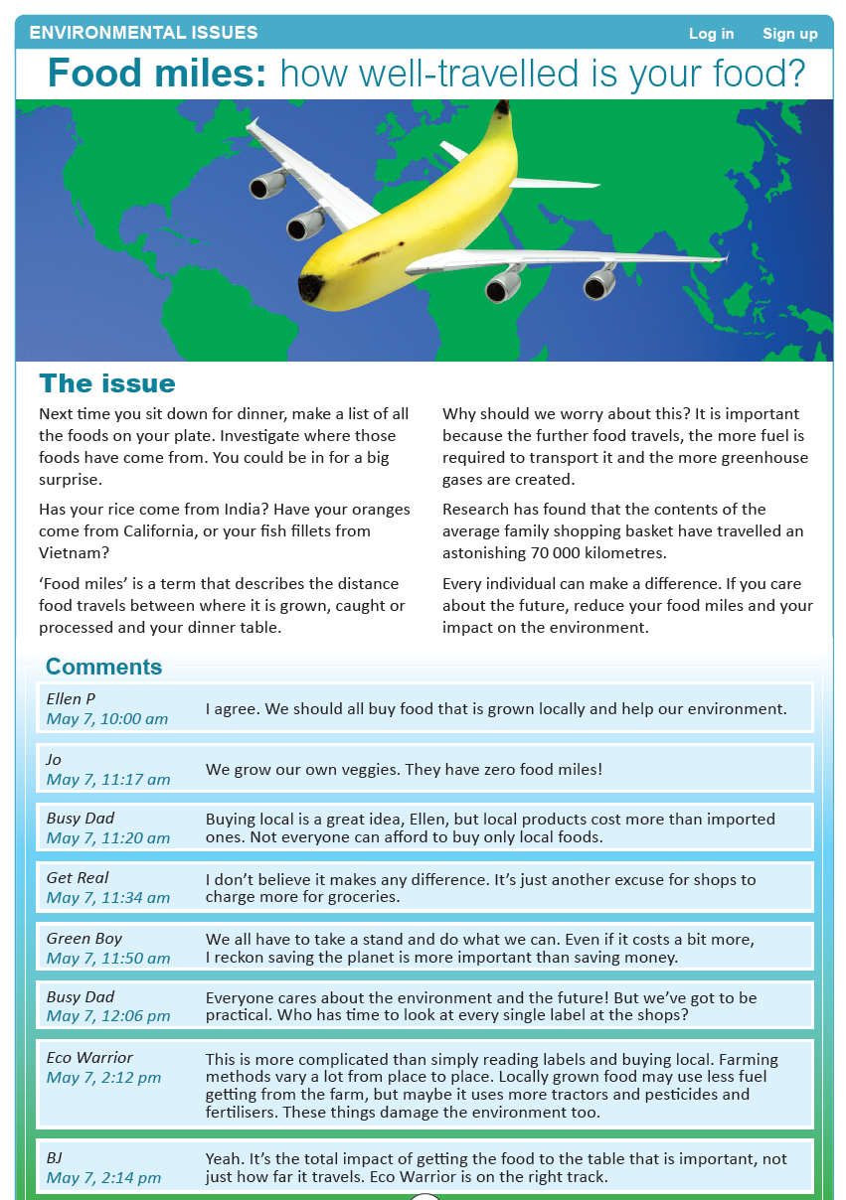
Where?
What?
Which?
How?
What?
Year 5 NAPLAN Reading Magazine, 2014 ACARA

Joint text analysis - accessible version
Environmental Issues
Food miles: how well-travelled is your food?
The issue
Next time you sit down for dinner, make a list of all the foods on your plate. Investigate where those foods have come from. You could be in for a big surprise.
Has your rice come from India? Have your oranges come from California, or your fish fillets from Vietnam?
‘Food miles’ is a term that describes the distance food travels between where it is grown, caught or processed and your dinner table.
Why should we worry about this? It is important because the further food travels, the more fuel is required to transport it and the more greenhouse gases are created.
Research has found that the contents of the average family shopping basket have travelled an astonishing 70 000 kilometres.
Every individual can make a difference. If you care about the future, reduce your food miles and your impact on the environment.
Ellen P May 7, 10:00 am I agree. We should all buy food that is grown locally and help our environment.
Jo May 7, 11:17 am We grow our own veggies. They have zero food miles!
Busy Dad May 7, 11:20 am Buying local is a great idea, Ellen, but local products cost more than imported ones. Not everyone can afford to buy only local foods.
Get Real May 7, 11:34 am I don’t believe it makes any difference. It’s just another excuse for shops to charge more for groceries.
Green Boy May 7, 11:50 am We all have to take a stand and do what we can. Even if it costs a bit more, I reckon saving the planet is more important than saving money.
Busy Dad May 7, 12:06 pm Everyone cares about the environment and the future! But we’ve got to be practical. Who has time to look at every single label at the shops?
Eco Warrior May 7, 2:12 pm This is more complicated than simply reading labels and buying local. Farming methods vary a lot from place to place. Locally grown food may use less fuel getting from the farm, but maybe it uses more tractors and pesticides and fertilisers. These things damage the environment too.
BJ May 7, 2:14 pm Yeah. It’s the total impact of getting the food to the table that is important, not just how far it travels. Eco Warrior is on the right track.
Year 5 NAPLAN Reading Magazine, 2014 ACARA

Appendix 3
Student-led analysis: where, when, who, what, how?
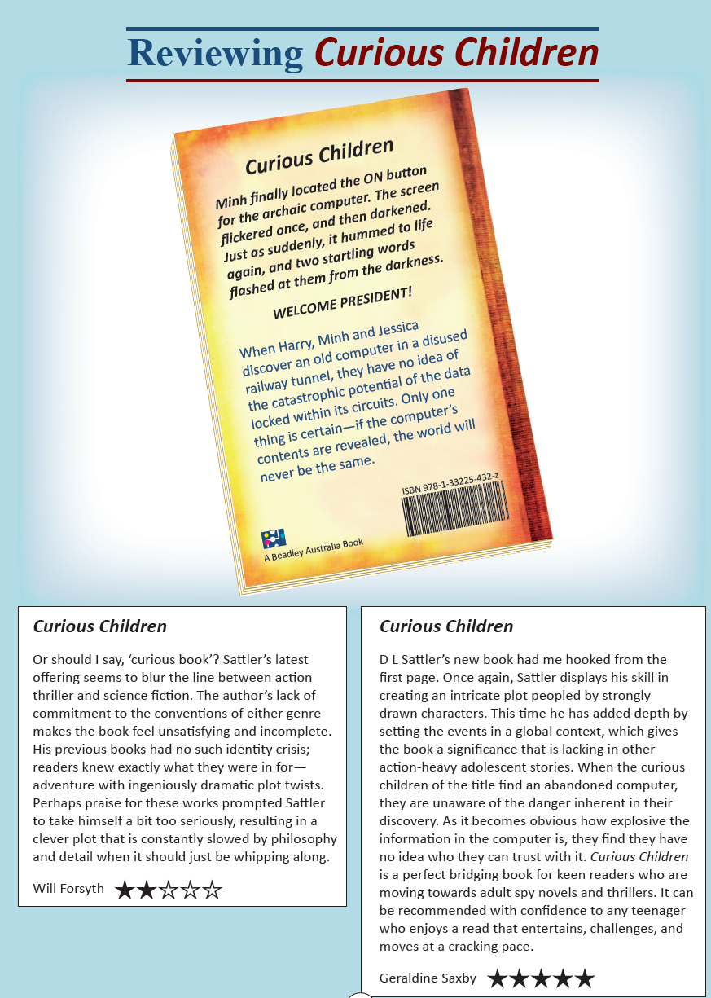
What?
Who?
Where?
When?
Your turn
Year 5 NAPLAN Reading Magazine, 2016 ACARA

Student-led analysis: where, when, who, what, how? Accessible version

Reviewing Curious Children
Minh finally located the ON button for the archaic computer. The screen flickered once, and then darkened. Just as suddenly, it hummed to life again, and two startling words flashed at them from the darkness.
WELCOME PRESIDENT!
When Harry, Minh and Jessica discover an old computer in a disused railway tunnel, they have no idea of the catastrophic potential of the data locked within its circuits. Only one thing is certain—if the computer’s contents are revealed, the world will never be the same.
Curious Children Or should I say, ‘curious book’? Sattler’s latest offering seems to blur the line between action thriller and science fiction. The author’s lack of commitment to the conventions of either genre makes the book feel unsatisfying and incomplete. His previous books had no such identity crisis; readers knew exactly what they were in for— adventure with ingeniously dramatic plot twists. Perhaps praise for these works prompted Sattler to take himself a bit too seriously, resulting in a clever plot that is constantly slowed by philosophy and detail when it should just be whipping along.
Will Forsyth. 2 stars.
Curious Children D L Sattler’s new book had me hooked from the first page. Once again, Sattler displays his skill in creating an intricate plot peopled by strongly drawn characters. This time he has added depth by setting the events in a global context, which gives the book a significance that is lacking in other action-heavy adolescent stories. When the curious children of the title find an abandoned computer, they are unaware of the danger inherent in their discovery. As it becomes obvious how explosive the information in the computer is, they find they have no idea who they can trust with it. Curious Children is a perfect bridging book for keen readers who are moving towards adult spy novels and thrillers. It can be recommended with confidence to any teenager who enjoys a read that entertains, challenges, and moves at a cracking pace.
Geraldine Saxby. 5 stars.
Year 5 NAPLAN Reading Magazine, 2016 ACARA
Who?

What?

Where?

When?

Your turn

Student-led analysis: where, when, who, what, how?
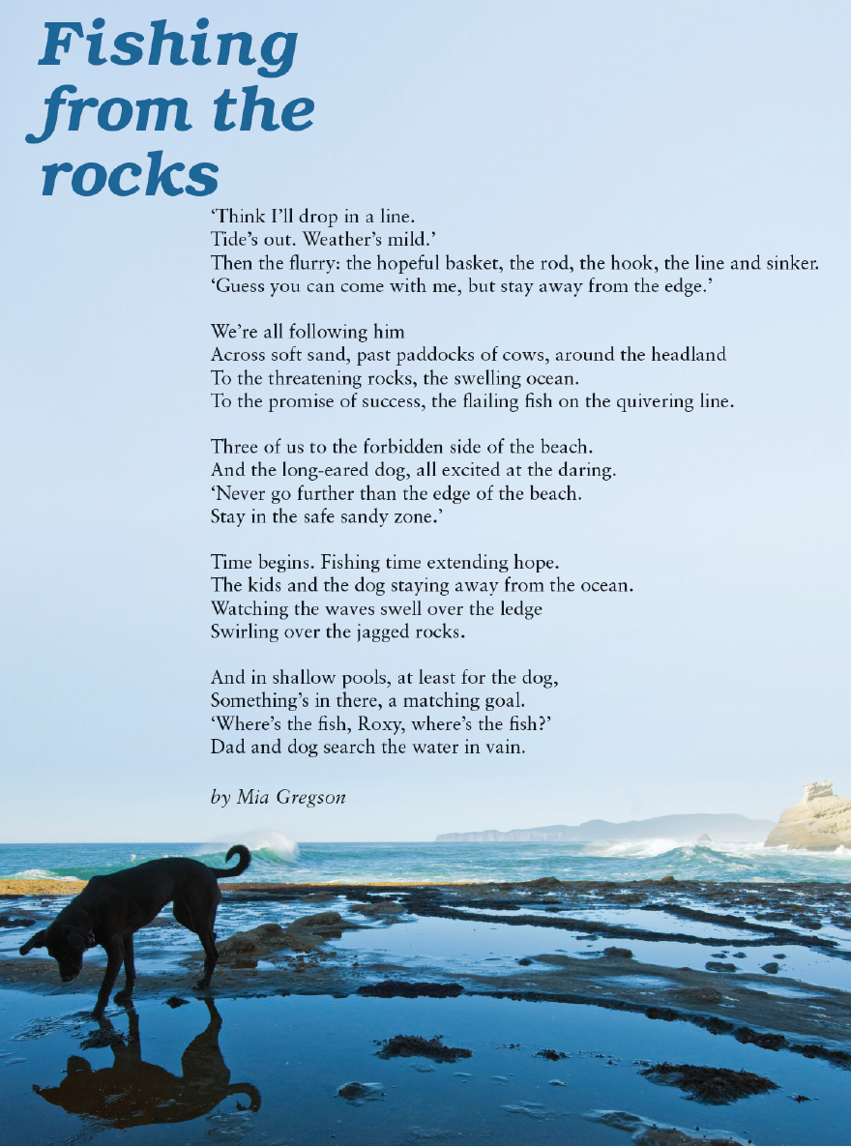
Year 5 NAPLAN Reading Magazine, 2013 ACARA
What?

Where?

When?

Your turn

Student-led analysis: where, when, who, what, how? Accessible version

Fishing from the rocks
‘Think I’ll drop in a line.
Tide’s out. Weather’s mild.’
Then the flurry: the hopeful basket, the rod, the hook, the line and sinker.
‘Guess you can come with me, but stay away from the edge.’
We’re all following him
Across soft sand, past paddocks of cows, around the headland
To the threatening rocks, the swelling ocean.
To the promise of success, the flailing fish on the quivering line.
Three of us to the forbidden side of the beach.
And the long-eared dog, all excited at the daring.
‘Never go further than the edge of the beach.
Stay in the safe sandy zone.’
Time begins. Fishing time extending hope.
The kids and the dog staying away from the ocean.
Watching the waves swell over the ledge
Swirling over the jagged rocks.
And in shallow pools, at least for the dog,
Something’s in there, a matching goal.
‘Where’s the fish Roxy, where’s the fish?’
Dad and dog search the water in vain.
by Mia Gregson.
Year 5 NAPLAN Reading Magazine, 2013 ACARA

What?

Where?

When?

Your turn

Student-led analysis: where, when, who, what, how?

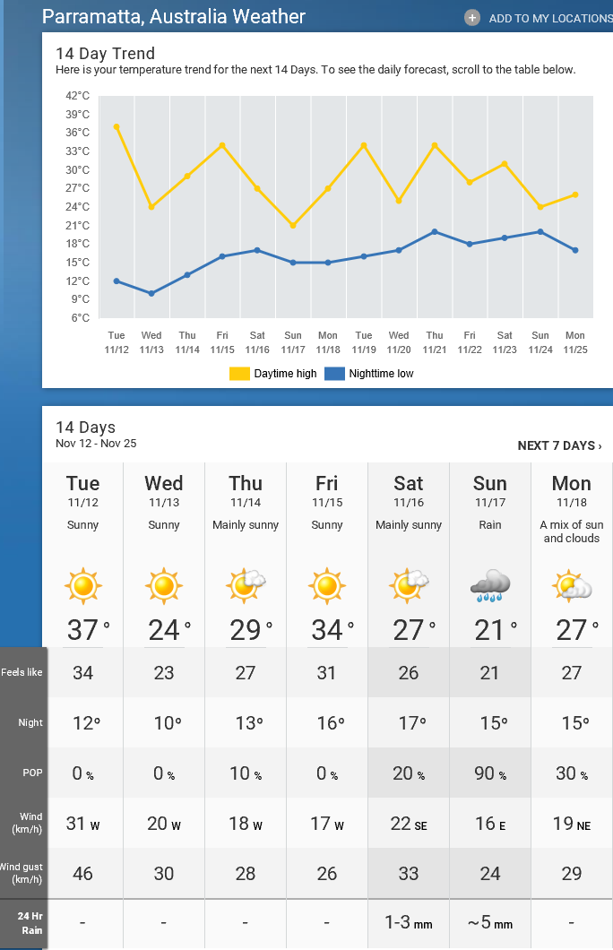Source:
Copied under the statutory licence in s 113P of the Copyright Act. Weather network. Date accessed: 11/12/20. Section 113P Warning Notice
What?
Where?
When?

Your turn!

Appendix 4

Teacher copy: Annotated copy

Bilbo Baggins's Hobbit Hole
The Hobbit by JRR Tolkien, first published 1937, Allen & Unwin, Page 15-16
Text | Questions
In a hole in the ground there lived a hobbit. Not a nasty, dirty, wet hole, filled with the ends of worms and an oozy smell, nor yet a dry, bare sandy hole with nothing in it to sit down on or eat: it was a hobbit-hole, and that means comfort. | Who lived in the hole?  What kind of hole did the hobbit live in?
It had a perfectly round door like a porthole, painted green with a shiny yellow brass knob in the exact middle. The door opened on to a tube-shaped hall like a tunnel: a very comfortable tunnel without smoke, with panelled walls, and floors tiled and carpeted, provided with polished chairs and lots and lots of pegs for hats [and coat]—the hobbit was fond of visitors. | What did the round door look like?  Where were the hats and coats kept?
The tunnel wound on and on, going fairly but not quite straight into the side of the hill—The Hill, as all the people for many miles around called it—and many little round doors opened out of it, first on one side and then on another. No going upstairs for the hobbit: bedrooms, bathrooms, cellars, pantries (lots of these), wardrobes (he had whole rooms devoted to clothes), kitchens, dining-rooms, all were on the same floor, and indeed on the same passage. | Where did doors open?  What are some of the features of hobbit holes?
The best rooms were all on the left-hand side (going in) for these were the only ones to have windows—deep-set round windows looking over his garden and meadows beyond, sloping down to the river. | Where were the best rooms and why were they the best?
This hobbit was a very well-to-do hobbit, and his name was Baggins. The Baggins had lived in the neighbourhood of The Hill for time out of mind. | What was the hobbit’s name?
Copied under the statutory licence in s 113P of the Copyright Act. JRR Tolkien, The Hobbit 1937, Allen & Unwin. Section 113P Warning Notice

Student copy: Colour code the answers to the questions in the text

Bilbo Baggins's Hobbit Hole
The Hobbit by JRR Tolkien, first published 1937, Allen & Unwin (page 15-16)
Text | Questions
In a hole in the ground there lived a hobbit. Not a nasty, dirty, wet hole, filled with the ends of worms and an oozy smell, nor yet a dry, bare sandy hole with nothing in it to sit down on or eat: it was a hobbit-hole, and that means comfort. | Who lived in the hole?  What kind of hole did the hobbit live in?
It had a perfectly round door like a porthole, painted green with a shiny yellow brass knob in the exact middle. The door opened on to a tube-shaped hall like a tunnel: a very comfortable tunnel without smoke, with panelled walls, and floors tiled and carpeted, provided with polished chairs and lots and lots of pegs for hats and coats—the hobbit was fond of visitors. | What did the round door look like?  Where were the hats and coats kept?
The tunnel wound on and on, going fairly but not quite straight into the side of the hill—The Hill, as all the people for many miles around called it—and many little round doors opened out of it, first on one side and then on another. No going upstairs for the hobbit: bedrooms, bathrooms, cellars, pantries (lots of these), wardrobes (he had whole rooms devoted to clothes), kitchens, dining-rooms, all were on the same floor, and indeed on the same passage. | Where did doors open?  What are some of the features of hobbit holes?
The best rooms were all on the left-hand side (going in) for these were the only ones to have windows—deep-set round windows looking over his garden and meadows beyond, sloping down to the river. | Where were the best rooms and why were they the best?
This hobbit was a very well-to-do hobbit, and his name was Baggins. The Baggins had lived in the neighbourhood of The Hill for time out of mind. | What was the hobbit’s name?
Copied under the statutory licence in s 113P of the Copyright Act. JRR Tolkien, The Hobbit 1937, Allen & Unwin. Section 113P Warning Notice

Appendix 5

Student copy: Hunting for e-facts
Is it a fact or myth? | Predict key words | Websites researched | Answer
There are approximately 4000 koalas living in their natural habitat.
The Berlin wall came down in 1989.
Armistice day falls on September 12 each year.
John Howard was the 32nd Prime Minister of Australia.
Aboriginal art culture spreads back 60000 to 80 000 years.
The average person spends six months of their lives waiting for red lights to turn green.
Challenge zone: make your own!

Appendix 6

Student copy: Cloze passage

Curious Kids: What makes an echo?

By Noel Hanna. (Copied under the statutory licence in s 113P of the Copyright Act. Noel Hanna, Curious Kids: What makes an echo?, The Conversation, March 20, 2019. Section 113P Warning Notice)

What is a sound?
What we call “sound” is really just the air in our ears ______________________ back and forth.
The air can move fast or slow. We can ______________________ air moving back and forth between 20 and 20,000 times per second. That’s really, really ______________________ ! (For the grownups reading right now, human hearing is from about 20 - 20,000 Hertz, which means repetitions per second).
But did you know that there are faster and slower air movements that can be heard by other animals, but not people?

Where does sound come from?
If we hear the air moving in our ears, where did that moving air come from?
A sound can come from anything that ______________________ or moves back and forth.
It could start with the moving string of a ______________________ or the vocal folds in your voice box that move when you speak or sing.
Once the air starts to move, it travels in all ______________________ until it finds something to stop it.

Bounce back!
When sound travelling in air (we call this a sound wave) hits a hard flat ______________________ , like a tiled bathroom wall, most of it ______________________ back. Maybe this is why people like to sing in the shower.
But to get a really good ______________________ , that sounds the same as the original sound, we need a very big bathroom, or another very big, hard-walled place – like a valley or a canyon!
For a sound to bounce back and make an echo, there has to be a lot of space between the sound source and the thing (wall or mountain) that it hits and bounces ______________________ .
Why? Because it takes ______________________ for the sound to come back as an echo. If there’s no big space, it won’t sound like an echo because the sound that comes back will get mixed up with the original sound.
Noticing changes in the sound can still be useful. Some animals like bats and dolphins, and even some children, can use this to tell where they are. This is called “echolocation”.
So if you don’t have a very large bathroom, you may want to try a bushwalk in a valley, or perhaps an underground carpark to find your ______________________ .

Teacher copy: Cloze passage

Curious Kids: What makes an echo?
By Noel Hanna (UNSW Global, UNSW) at The conversation, December 2019
That’s a tricky question. The simplest way to answer is to say that an echo is a sound that later comes back to where it came from. Before we get into what makes an echo, we need to have a think about sound.

What is a sound?
What we call “sound” is really just the air in our ears moving back and forth.
The air can move fast or slow. We can hear air moving back and forth between 20 and 20,000 times per second. That’s really, really fast! (For the grownups reading right now, human hearing is from about 20 - 20,000 Hertz, which means repetitions per second).
But did you know that there are faster and slower air movements that can be heard by other animals, but not people?

Where does sound come from?
If we hear the air moving in our ears, where did that moving air come from?
A sound can come from anything that vibrates or moves back and forth.
It could start with the moving string of a guitar or the vocal folds in your voice box that move when you speak or sing.
Once the air starts to move, it travels in all directions until it finds something to stop it.

Bounce back!
When sound travelling in air (we call this a sound wave) hits a hard flat surface, like a tiled bathroom wall, most of it bounces back. Maybe this is why people like to sing in the shower.
But to get a really good echo, that sounds the same as the original sound, we need a very big bathroom, or another very big, hard-walled place – like a valley or a canyon!
For a sound to bounce back and make an echo, there has to be a lot of space between the sound source and the thing (wall or mountain) that it hits and bounces back.
Why? Because it takes time for the sound to come back as an echo. If there’s no big space, it won’t sound like an echo because the sound that comes back will get mixed up with the original sound.
Noticing changes in the sound can still be useful. Some animals like bats and dolphins, and even some children, can use this to tell where they are. This is called “echolocation”.
So if you don’t have a very large bathroom, you may want to try a bushwalk in a valley, or perhaps an underground carpark to find your echoes.

Copied under the statutory licence in s 113P of the Copyright Act. Noel Hanna, Curious Kids: What makes an echo?, The Conversation, March 20, 2019. Section 113P Warning Notice

Appendix 7

The honey bee mystery
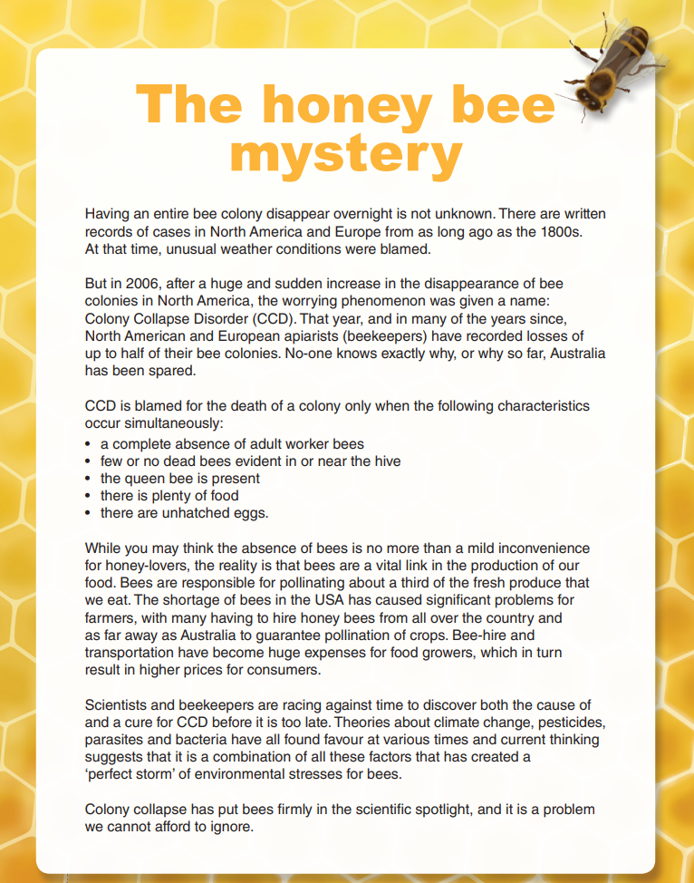
Year 5 NAPLAN Reading magazine 2015 ACARA

The honey bee mystery accessible version
Having an entire bee colony disappear overnight is not unknown. There are written records of cases in North America and Europe from as long ago as the 1800s. At that time, unusual weather conditions were blamed.
But in 2006, after a huge and sudden increase in the disappearance of bee colonies in North America, the worrying phenomenon was given a name: Colony Collapse Disorder (CCD). That year, and in many of the years since, North American and European apiarists (beekeepers) have recorded losses of up to half of their bee colonies. No-one knows exactly why, or why so far, Australia has been spared.
CCD is blamed for the death of a colony only when the following characteristics occur simultaneously:
- a complete absence of adult worker bees
- few or no dead bees evident in or near the hive
- the queen bee is present
- there is plenty of food
- there are unhatched eggs
While you may think the absence of bees is no more than a mild inconvenience for honey-lovers, the reality is that bees are a vital link in the production of our food. Bees are responsible for pollinating about a third of the fresh produce that we eat. The shortage of bees in the USA has caused significant problems for farmers, with many having to hire honey bees from all over the country and as far away as Australia to guarantee pollination of crops. Bee-hire and transportation have become huge expenses for food growers, which in turn result in higher prices for consumers.
Scientists and beekeepers are racing against time to discover both the cause of and a cure for CCD before it is too late. Theories about climate change, pesticides, parasites and bacteria have all found favour at various times and current thinking suggests that it is a combination of all these factors that has created a ‘perfect storm’ of environmental stresses for bees.
Colony collapse has put bees firmly in the scientific spotlight, and it is a problem we cannot afford to ignore.
Year 5 NAPLAN Reading Magazine, 2015 ACARA

Appendix 8

Adventure by moonlight
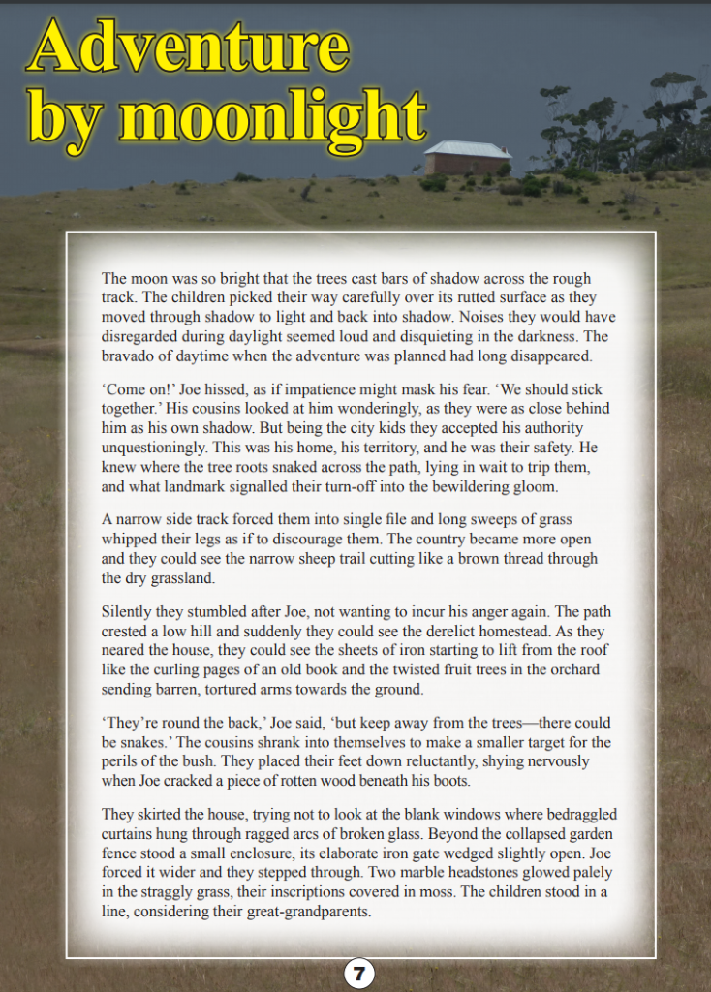
Year 5 NAPLAN Reading Magazine 2014 ACARA

Adventure by moonlight – accessible version
The moon was so bright that the trees cast bars of shadow across the rough track. The children picked their way carefully over its rutted surface as they moved through shadow to light and back into shadow. Noises they would have disregarded during daylight seemed loud and disquieting in the darkness. The bravado of daytime when the adventure was planned had long disappeared.
‘Come on!’ Joe hissed, as if impatience might mask his fear. ‘We should stick together.’ His cousins looked at him wonderingly, as they were as close behind him as his own shadow. But being the city kids they accepted his authority unquestioningly. This was his home, his territory, and he was their safety. He knew where the tree roots snaked across the path, lying in wait to trip them, and what landmark signalled their turn-off into the bewildering gloom.
A narrow side track forced them into single file and long sweeps of grass whipped their legs as if to discourage them. The country became more open and they could see the narrow sheep trail cutting like a brown thread through the dry grassland.
Silently they stumbled after Joe, not wanting to incur his anger again. The path crested a low hill and suddenly they could see the derelict homestead. As they neared the house, they could see the sheets of iron starting to lift from the roof like the curling pages of an old book and the twisted fruit trees in the orchard sending barren, tortured arms towards the ground.
‘They’re round the back,’ Joe said, ‘but keep away from the trees—there could be snakes.’ The cousins shrank into themselves to make a smaller target for the perils of the bush. They placed their feet down reluctantly, shying nervously when Joe cracked a piece of rotten wood beneath his boots.
They skirted the house, trying not to look at the blank windows where bedraggled curtains hung through ragged arcs of broken glass. Beyond the collapsed garden fence stood a small enclosure, its elaborate iron gate wedged slightly open. Joe forced it wider and they stepped through. Two marble headstones glowed palely in the straggly grass, their inscriptions covered in moss. The children stood in a line, considering their great-grandparents.
Year 5 NAPLAN Reading Magazine 2014 ACARA

Appendix 9

Locating directly stated information
Student-led analysis: Who, where, when, and how?
Questions | Information located in the text | Information located in the text | What have I learnt?
Who
Who is the story about?
Where  Where is this set? | But being the city kids they accepted his authority unquestioningly. | The country became more open and they could see the narrow sheep trail. | The children from the city are visiting the country.
When
When is this happening?
How
How are the children feeling?
Year 5 NAPLAN Reading Magazine 2014 ACARA

Locating directly stated information- Worked example
Student-led analysis: Who, where, when and how?
Questions | Information located in the text | Information located in the text | What have I learnt?
Who  Who is the text about? | Joe hissed | His cousins looked at him wonderingly | This text is about Joe and his cousins.
Where  Where is this set? | But being the city kids they accepted his authority unquestioningly. | The country became more open and they could see the narrow sheep trail. | The children from the city are visiting the country.
When  When is this happening? | The moon was so bright that the trees… | Noises they would have disregarded during daylight seemed loud and disquieting in the darkness. | This story is set at night.
How  How are the children feeling? | He was their safety. | They placed their feet down reluctantly, shying nervously | The children feel unsafe and nervous.
Year 5 NAPLAN Reading Magazine 2014 ACARA

