Inference
Stage 3

Overview

Purpose
This literacy teaching strategy supports teaching and learning for Stage 3 students across all key learning areas. It targets specific literacy skills and suggests a learning sequence to build skill development. Teachers can select individual tasks, or a sequence, and embed into their teaching and learning program according to their students’ needs. While exemplar texts are provided throughout this resource, it is recommended that teachers select texts which are relevant to their students and curriculum.

Learning intention
Students will learn to use background information and clues in the text to make inferences.

Syllabus outcomes
The following teaching and learning strategy will assist in covering elements of the following outcomes:
- EN3-RECOM-01: fluently reads and comprehends texts for wide purposes, analysing text structures and language, and by monitoring comprehension.
- EN3-UARL-01: analyses representations of ideas in literature through narrative, character, imagery, symbol and connotation, and adapts these representations when creating texts.
- EN3-UARL-02: analyses representations of ideas in literature through genre and theme that reflect perspective and context, argument and authority, and adapts these representations when creating texts.
NSW English K-10 Syllabus (2022)

Success criteria
The following Year 5 NAPLAN item descriptors may guide teachers to co-construct success criteria for student learning.

- infers the purpose of a statement in a persuasive text
- infers characters’ actions in a narrative
- infers the reason for a character’s actions from vocabulary
- infers a key idea in an imaginative text
- infers a key idea in a narrative
- interprets a reference in an information text
- interprets information in a narrative
- interprets the meaning of a description in a poem
- interprets the meaning of a phrase in a narrative
- interprets the meaning of a phrase in an information text
- interprets the meaning of a prefix in a narrative
- interprets the meaning of a sentence from descriptive language in a poem
- interprets the meaning of a sentence in context in an information text.

National Literacy Learning Progression guide

Understanding Texts (UnT8-UnT10)
Key: C=comprehension P=process V=vocabulary

UnT8
- reads and views some moderately complex texts (see Text complexity) (C)
- draws inferences and verifies using text evidence (C)

UnT9
- draws inferences, synthesising clues and evidence across a text (C)
- identifies different interpretations of the text citing evidence from a text (C)
- uses processes such as predicting, confirming prediction, monitoring and connecting relevant elements of the text to build or repair meaning (P)
- selects reading/viewing strategies appropriate to reading purpose (e.g. scans text for evidence) (P)
- identifies language used to create tone or atmosphere (V)
- interprets complex figurative language (e.g. euphemisms, hyperbole) (V)

UnT10
- interprets abstract concepts integrating complex ideas (C)
- draws inferences using evidence from the text and discounting possible inferences that are not supported by the text (C)
- demonstrates an understanding of nuances and subtleties in words of similar meaning (e.g. frustrated, discouraged, baffled) (V)
National Literacy Learning Progression

Evidence base
- Centre for Education Statistics and Evaluation (2017). Effective reading instruction in the early years of school, literature review.
- Konza, D. (2014). Teaching Reading: Why the “Fab Five” should be the “Big Six”. Australian Journal of Teacher Education, 39(12).
- Oakhill, J., Cain, K. & Elbro, C. (2015). Understanding and teaching reading comprehension: A handbook. Routledge.
- Quigley, A. (2020). Closing the reading gap. Routledge.
- Scarborough, H.S. (2001). Connecting early language and literacy to later reading (dis)abilities: Evidence, theory and practice. In S. Neuman & D. Dickson (Eds.), Handbook for research in early literacy (pp. 97-110). New York, NY: Guilford Press
Alignment to system priorities and/or needs: Five priorities for Literacy and Numeracy, Our Plan for NSW Public Education , School Excellence Policy (nsw.gov.au).
Alignment to School Excellence Framework: Learning domain: Curriculum, Teaching domain: Effective classroom practice and Professional standards
Consulted with: Strategic Delivery, Teaching Quality and Impact
Author: Literacy and Numeracy
Reviewed by: Literacy and Numeracy, Teaching Quality and Impact
Created/last updated: January 2024
Anticipated resource review date: January 2025
Feedback: Complete the online form to provide any feedback

Copyright
Section 113P Notice
Texts, Artistic Works and Broadcast Notice
Some of this material has been copied and communicated to you in accordance with the statutory licence in section 113P of the Copyright Act. Any further reproduction or communication of this material by you may be the subject of copyright protection under the Act. Do not remove this notice.

Teaching strategies
Task | Appendices
What is inference?
Using pictures to infer | Appendix 1 - Modelled image clues  Appendix 2 - Image analysis student scaffold and images
Inferring from text | Appendix 3 - Inference match and sort
Show Don’t Tell | Appendix 4 - ‘Library magician’  Appendix 5 - Inferring character traits ‘Show Don’t Tell’  Appendix 6 - Inferring key ideas ‘Show Don’t Tell’
Actions and motivations | Appendix 7 - ‘The mission’  Appendix 8 - Character actions and motivations table
Inference in poetry | Appendix 9 - Michael Leunig poem  Appendix 10 - Poetry

Background information
Inference is a conclusion reached on the basis of evidence and reasoning.
The development of inferential understanding of texts requires explicit teaching. Modelling the ‘think aloud’ strategy whilst working with texts enables the students to ‘hear’ the thinking process an accomplished reader undertakes when reading or viewing material. Students require multiple opportunities to work with diverse texts to be able to develop and apply inferential understanding and generalise the skill to other learning experiences.
Making inferences enables the students to:
- provide explanations for ideas that are presented in the text that are not explicitly stated
- offer details or reasons for events that have occurred throughout the text
- recognise the author's point of view or bias
- interpret the language choices (technical and figurative) and how they shape the meaning of the text
- consider and evaluate content that is presented as visuals within the text (where applicable)
- offer conclusions from facts presented in the text
- connect content and meaning of the text to prior knowledge and/or similar texts
- support inferences with evidence from the text.
Reference: English K-10 Syllabus © NSW Education Standards Authority (NESA) for and on behalf of the Crown in right of the State of New South Wales, 2012 and 2022.

Where to next?
- Understanding character
- Literal comprehension
- Understanding perspective

Overview of teaching strategies

Purpose
These literacy teaching strategies support teaching and learning from Stage 2 to Stage 5. They are linked to NAPLAN task descriptors, syllabus outcomes and literacy and numeracy learning progressions.
These teaching strategies target specific literacy and numeracy skills and suggest a learning sequence to build skill development. Teachers can select individual tasks or a sequence to suit their students.

Access points
The resources can be accessed from:
- NAPLAN App in Scout using the teaching strategy links from NAPLAN items
- NSW Department of Education literacy and numeracy website.
What works best
Explicit teaching practices involve teachers clearly explaining to students why they are learning something, how it connects to what they already know, what they are expected to do, how to do it and what it looks like when they have succeeded. Students are given opportunities and time to check their understanding, ask questions and receive clear, effective feedback.
This resource reflects the latest evidence base and can be used by teachers as they plan for explicit teaching.
Teachers can use classroom observations and other assessment information to make decisions about when and how they use this resource as they design teaching and learning sequences to meet the learning needs of their students.
Further support with What works best is available.
Differentiation
When using these resources in the classroom, it is important for teachers to consider the needs of all students, including Aboriginal and EAL/D learners.
EAL/D learners will require explicit English language support and scaffolding, informed by the EAL/D enhanced teaching and learning cycle and the student’s phase on the EAL/D Learning Progression. Teachers can access information about supporting EAL/D learners and literacy and numeracy support specific to EAL/D learners.
Learning adjustments enable students with disability and additional learning and support needs to access syllabus outcomes and content on the same basis as their peers. Teachers can use a range of adjustments to ensure a personalised approach to student learning.
Assessing and identifying high potential and gifted learners will help teachers decide which students may benefit from extension and additional challenge. Effective strategies and contributors to achievement for high potential and gifted learners helps teachers to identify and target areas for growth and improvement. A differentiation adjustment tool can be found on the High potential and gifted education website.

Using tasks across learning areas
This resource may be used across learning areas where it supports teaching and learning aligned with syllabus outcomes.
Literacy and numeracy are embedded throughout all syllabus documents as general capabilities. As the English and mathematics learning areas have a particular role in developing literacy and numeracy, NSW English and Mathematics syllabus outcomes aligned to literacy and numeracy skills have been identified.

Text selection
Example texts are used throughout this resource. Teachers can adjust activities to use texts which are linked to their unit of learning.
Further support with text selection can be found within the National Literacy Learning Progression Text Complexity appendix.
The NESA website has additional information on text requirements within the NSW English syllabus.

Teaching strategies

What is inference?
- Discuss inference: inference is the process of drawing conclusions using evidence in texts. We use clues and background knowledge to make an inference.
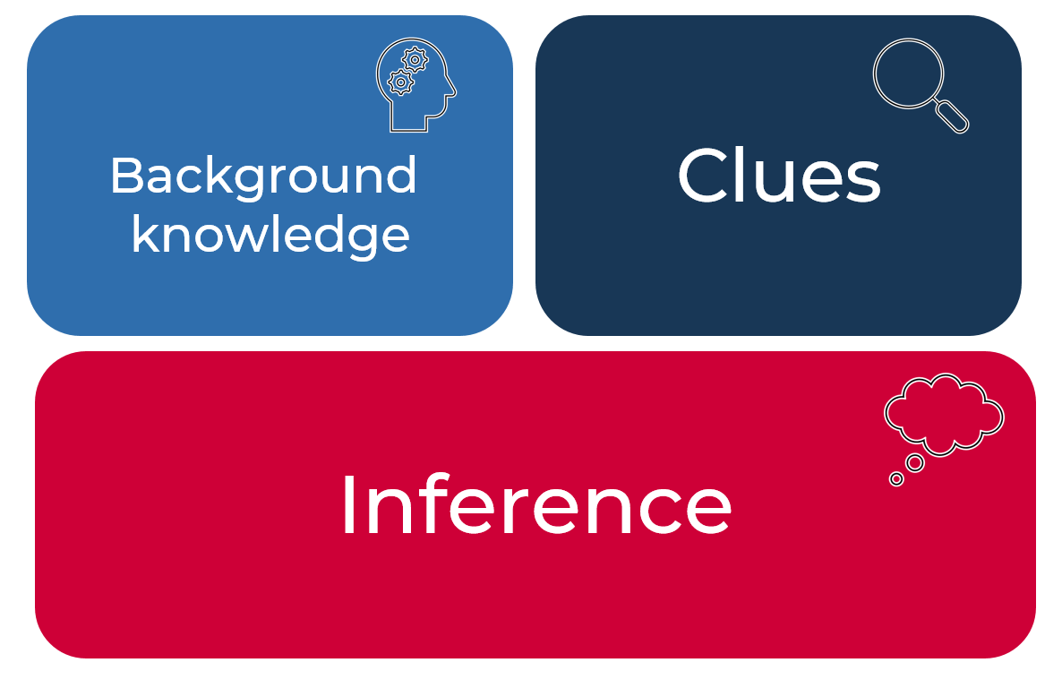
- Discuss how we infer every day. You might have heard people say: “Jenny has eaten three sandwiches and two pieces of fruit already!” We can infer that Jenny is hungry. Another example might be that Michelle was rubbing her eyes and yawning – we can infer that Michelle was tired. Have students think of more examples and have a peer infer using their everyday occurrences.
- Review background knowledge: Brainstorm elements that make up background knowledge, ideas include vocabulary, travel destinations, places visited, interests and hobbies, subject-knowledge, relationships and family experiences and so on. Students create a mind map showing elements that make up their background knowledge.
- Review clues: clues can be found in both images and texts. Both will be explored in the following tasks.
- Newsflash!: Students use the newsflash strategy to synthesise their understanding of inference.
Headline
Visual representation | Key points

Using pictures to infer
- Discuss what clues we can gather from an image, for example, objects, positioning of objects and characters, facial expressions, setting, lines and vectors, character, character physical features, colours, and modality of image.
- Explore an image linked to current unit of learning or use unsplash.com or an image from Appendix 1 - Modelled image clues. Have students notice the clues in the image and make connections with personal experiences. Create a brainstorm of any questions the students have on this image.
- Model identifying clues and what inferences we can make. In Appendix 1 - Modelled image clues, the clues such as magnifying glass, yellowing map, pictures and an open book, together with our background knowledge of knowing that things turn yellow when old, allow us to infer that the person is exploring or spying on something and this happened some time ago.
- Students apply the same process of exploring images and finding clues within this. Students detail the clues they found, as well as the background knowledge they called upon, to make an inference with the images. (Refer to Appendix 2 - Image analysis student scaffold and images.)
To increase higher order thinking, students locate and display a series of images on the same subject/topic which infer different meanings, for example, this could be connected to a relevant news story on protests or climate change. Students conduct a gallery walk, explaining how they used background knowledge and clues to make inferences for each image.

Inferring from text
- Review inference: inference is the process of drawing conclusions using evidence in texts. We use clues and background knowledge to make an inference.
- “He slammed the door behind him, making a huge racket! “
- The evidence in the text includes: ‘slammed’ and ‘huge racket’ as well as an exclamation mark.
- We can infer that the person is angry.
Discuss that when we infer, we are making a conclusion based on something that might not be explicitly stated. This may be referred to as ‘reading between the lines’.
- Review student understanding of what evidence in the text might be: character details such as clothing/facial expressions, direct speech, setting such as time of day/weather, punctuation, tone, language devices and visual imagery.
- Students work in small groups to complete the Appendix 3 - Inference match and sort by connecting evidence, background knowledge and text clues with an inference. Students engage in discussion as to what other inferences could be drawn. (Students could use the labelled option to offer additional support.)
Additional task: Students are given a range of texts from which to create their own ‘match and sort’ inference activity for another pair to complete.
- Encourage students to validate their inferences as they read – talking note when their ideas are confirmed or whether there is a twist in the story and their inference was debunked. Students share and justify their responses with the class.
- Discuss how authors use inference in their writing by ‘showing not telling’ and using foreshadowing. It is important for a reader to not find answers to all their questions and they need to ‘read between the lines’. As students continue to read, students can add examples of where they made inferences.

Show don’t tell
- Explain that authors give characters ‘traits’; these traits can be about how they look (physical descriptors) or how they act and feel (personality descriptors). We use traits to add interest to a story and for the reader to connect with the reader, as well as to make inferences about what is happening and what might happen next.
- Students brainstorm favourite characters from stories they have read, stating at least one trait that describes each character. List these traits on the board. Students then classify each as either a physical descriptor or a personality descriptor.
- Think aloud: Introduce the text ‘Library Magician’ (Appendix 4 - ‘Library magician’) or adapt this activity to any text relevant to a current unit of learning. Use the think aloud strategy to explain how writers ‘Show, don’t tell.’
‘Good writers don’t ‘tell us’ all the information about characters, they ‘show us’. When I read the excerpt: ‘The children’s librarian, Mr Frank, has been leading story time ever since my mum was a little girl!’ I can make some inferences about the character. We can describe the librarian, Mr Frank, as an old man. We can infer this from the information that he has been the librarian since the narrator’s mum was a girl (and is now an adult). The author has also used an exclamation mark to emphasise just how long he has been the librarian.
- Read the remainder of the text aloud. Using Appendix 5 - Inferring character traits ‘Show Don’t Tell’, ask students to infer additional character traits for the character of Mr Frank, reminding them that these can be a physical or personality descriptor. For example, Mr Frank is friendly, Mr Frank is old fashioned, Mr Frank knows how to engage children in reading.
- Think-Pair-Share: Teacher explains that often a key idea in an imaginative response is also inferred, rather than ‘told’. Using Appendix 6 - Inferring key ideas ‘Show Don’t Tell’ to record information, class brainstorms the key ideas in the text ‘Library magician’. (Key ideas include reading is exciting, libraries don’t have to be quiet, libraries are exciting places, and reading opens up new worlds.) Teacher uses the think aloud strategy to model ‘key idea 1- libraries don’t have to be quiet.’ In pairs, students highlight sections of the text which infer further key ideas (use a different colour for each idea). Students record their evidence in the table and share findings with the class. Each pair reflects on the findings of their peers and considers the reasons behind any differing conclusions.

Actions and motivations
- Brainstorm: Introduce Appendix 7 - ‘The mission’. Ask students to predict what the story might be about using clues in the title, the image in the text and their background knowledge of the word ‘mission’. What types of characters might they expect to see? Record and discuss student responses. Students may be prompted to explain their observations by asking, ‘What makes you think that?’
- Read text aloud to students, noting the characters mentioned. After reading the text, introduce the idea of inferring information about characters in narratives. This can include the reasons for their behaviours and actions. Using the think aloud strategy, work through an example from the text, inferring information about actions and motivations for one of the characters. Use Appendix 8 - Character actions and motivations table to record answers.
‘As we read we ask ourselves what the character did. Why did they do this? How do I know? What does this action suggest about the character and their motivations? Let’s look at an example from the text:
I knew there had been a mistake. Although Bella had assured me that the house was empty, a dog bark, followed swiftly by unwelcome lights glimpsed between twitching curtains, suggested otherwise. I signalled to indicate it was time to abandon the operation.
I ask myself. ‘What did the character/narrator do?’ He signalled to the other characters to abandon the operation. ‘Why did he/she do it?’ There was someone in the house and that was unexpected. ‘How do I know?’ Bella had said the house would be empty but a dog barked, lights came on and curtains moved.’
- Review student understanding of what evidence in the text might be: the details, quotes, punctuation, information and visuals found within the text. In the example demonstrated the why or motivation for the character’s action was inferred based on clues in the text. The clues become part of our supporting evidence.
- Students use Appendix 8 - Character actions and motivations table to complete further analysis of character actions and behaviours. To increase complexity, students share and justify their ideas with the class. Teacher uses ‘What if...?’ questioning to stimulate thinking.

Inference in poetry
- Y chart: Students read a poem: ‘The Crowdless Man’ by Michael Leunig (Appendix 9 - Michael Leunig poem), ‘Talons of Power by Jody Cook (Appendix 10 - Poetry ) or poetry linking to a current unit of learning, such as Oodgeroo Noonuccal and other Aboriginal and Torres Strait Islander poets. Students display information in a Y chart: What I see/feel, what I wonder and what I think. In pairs, students then review the selected poetry using the T-Chart strategy. As a class, discuss students’ initial responses to the poem(s), prompting them to consider how their personal experiences and background knowledge may have led to different interpretations.
- Review language devices/figurative language used to create meaning in poetry. For example: metaphor, simile, symbolism, contrast/juxtaposition, irony, hyperbole, repetition, sound devices. Discuss how poets often say ‘more with less’, using powerful language devices to support inference making. Choose an excerpt from the poem and uses the think aloud strategy to demonstrate how language features can support inference making. For example:
‘In ‘The Crowdless Man’, the first four lines make me think that this man might be lonely.
See him wandering alone,
The crowdless man,
He has no group,
He has no tribe…
I ask myself: He is ‘alone’, but is he lonely? and does ‘crowdless’ (an interesting way of saying he isn’t part of a crowd or group of people) mean that I can infer that he feels isolated? And, if he is, it is a bad thing? Sometimes I quite like being on my own! I will have to read on. The repetition of ‘he has no’ suggests he is missing something in his life, there is a tone of loss or emptiness here. I could also infer that he has no friends, a ‘group’, and maybe not even family, a ‘tribe’. I think that not being part of something, or connected to others, would make someone quite lonely, I will have to read on to see if my assumptions are correct.’
- Jigsaw task: As a class, students are each given a section of the poem. Using their background knowledge and context clues, students make inferences to determine the main message or theme of the poem. Reconvene as a class and discuss each section, students justifying how they came to their conclusions using evidence from the text. (This may include identifying and explaining how language devices have been used to support inference making.) Using this information the class discusses the overall message of the poem, and how students may have reached different interpretations based on their own context.

Appendix 1

Modelled image clues
Photo by Daniel Sankowski on Unsplash.com

Appendix 2

Image analysis
Photo by Christina @wocintechchat.com on Unsplash.com

Image analysis
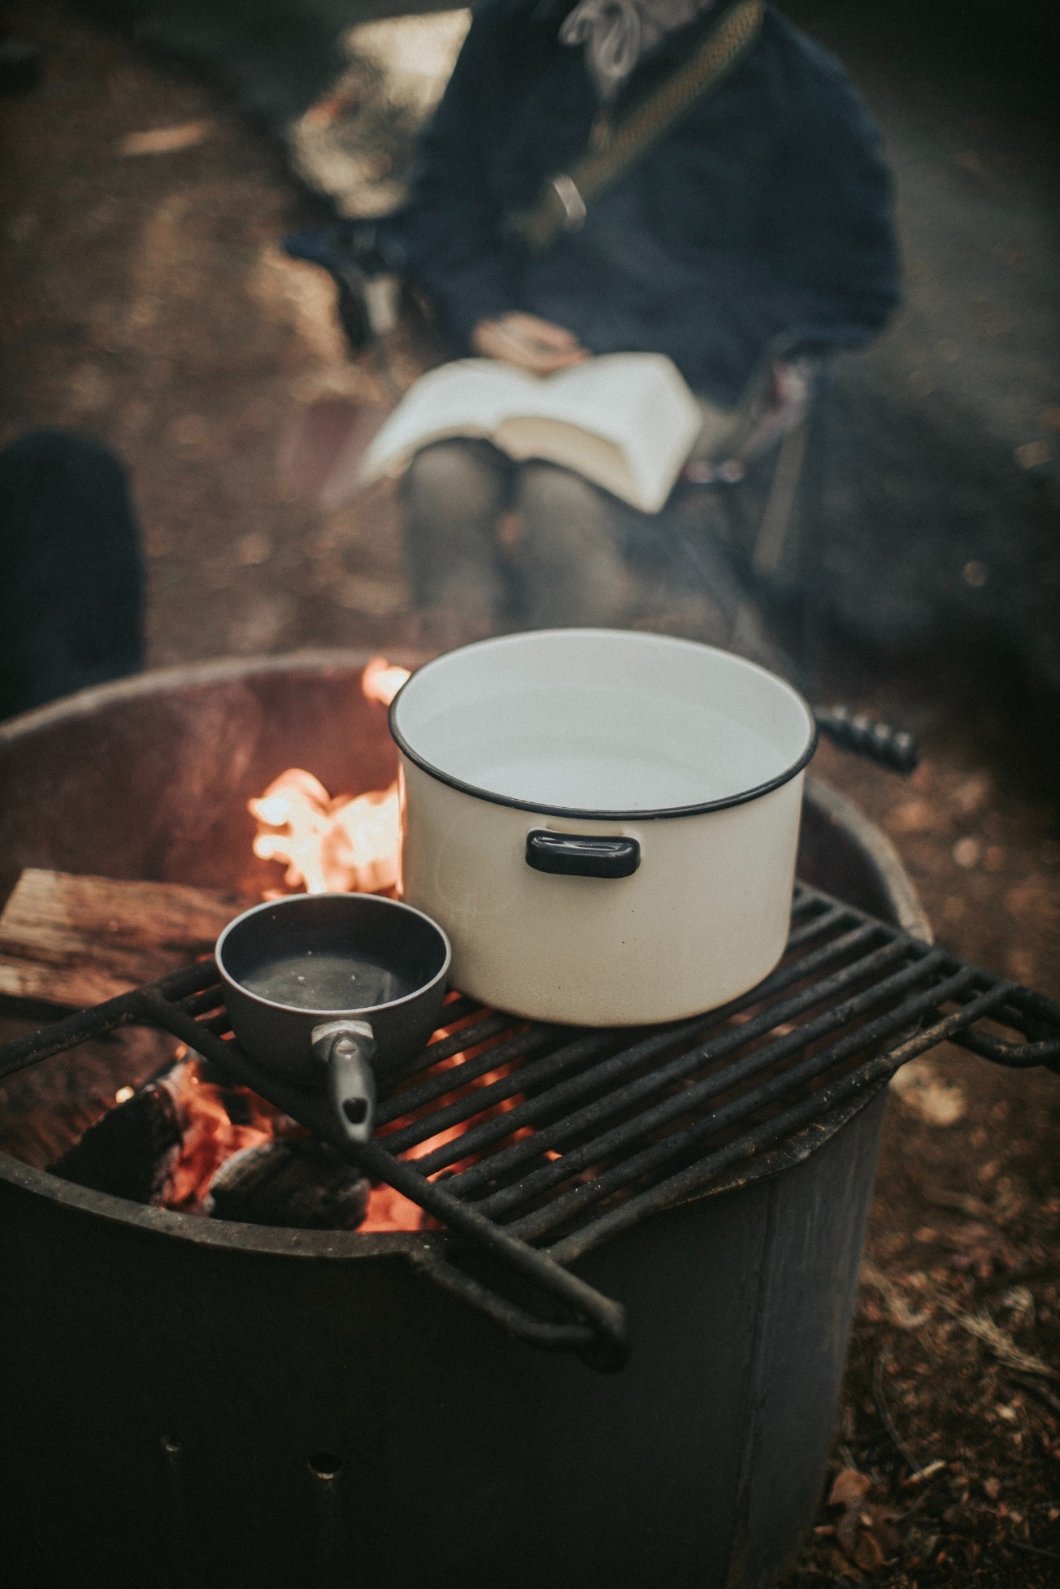
Photo by Jed Villejo on Unsplash.com

Image analysis
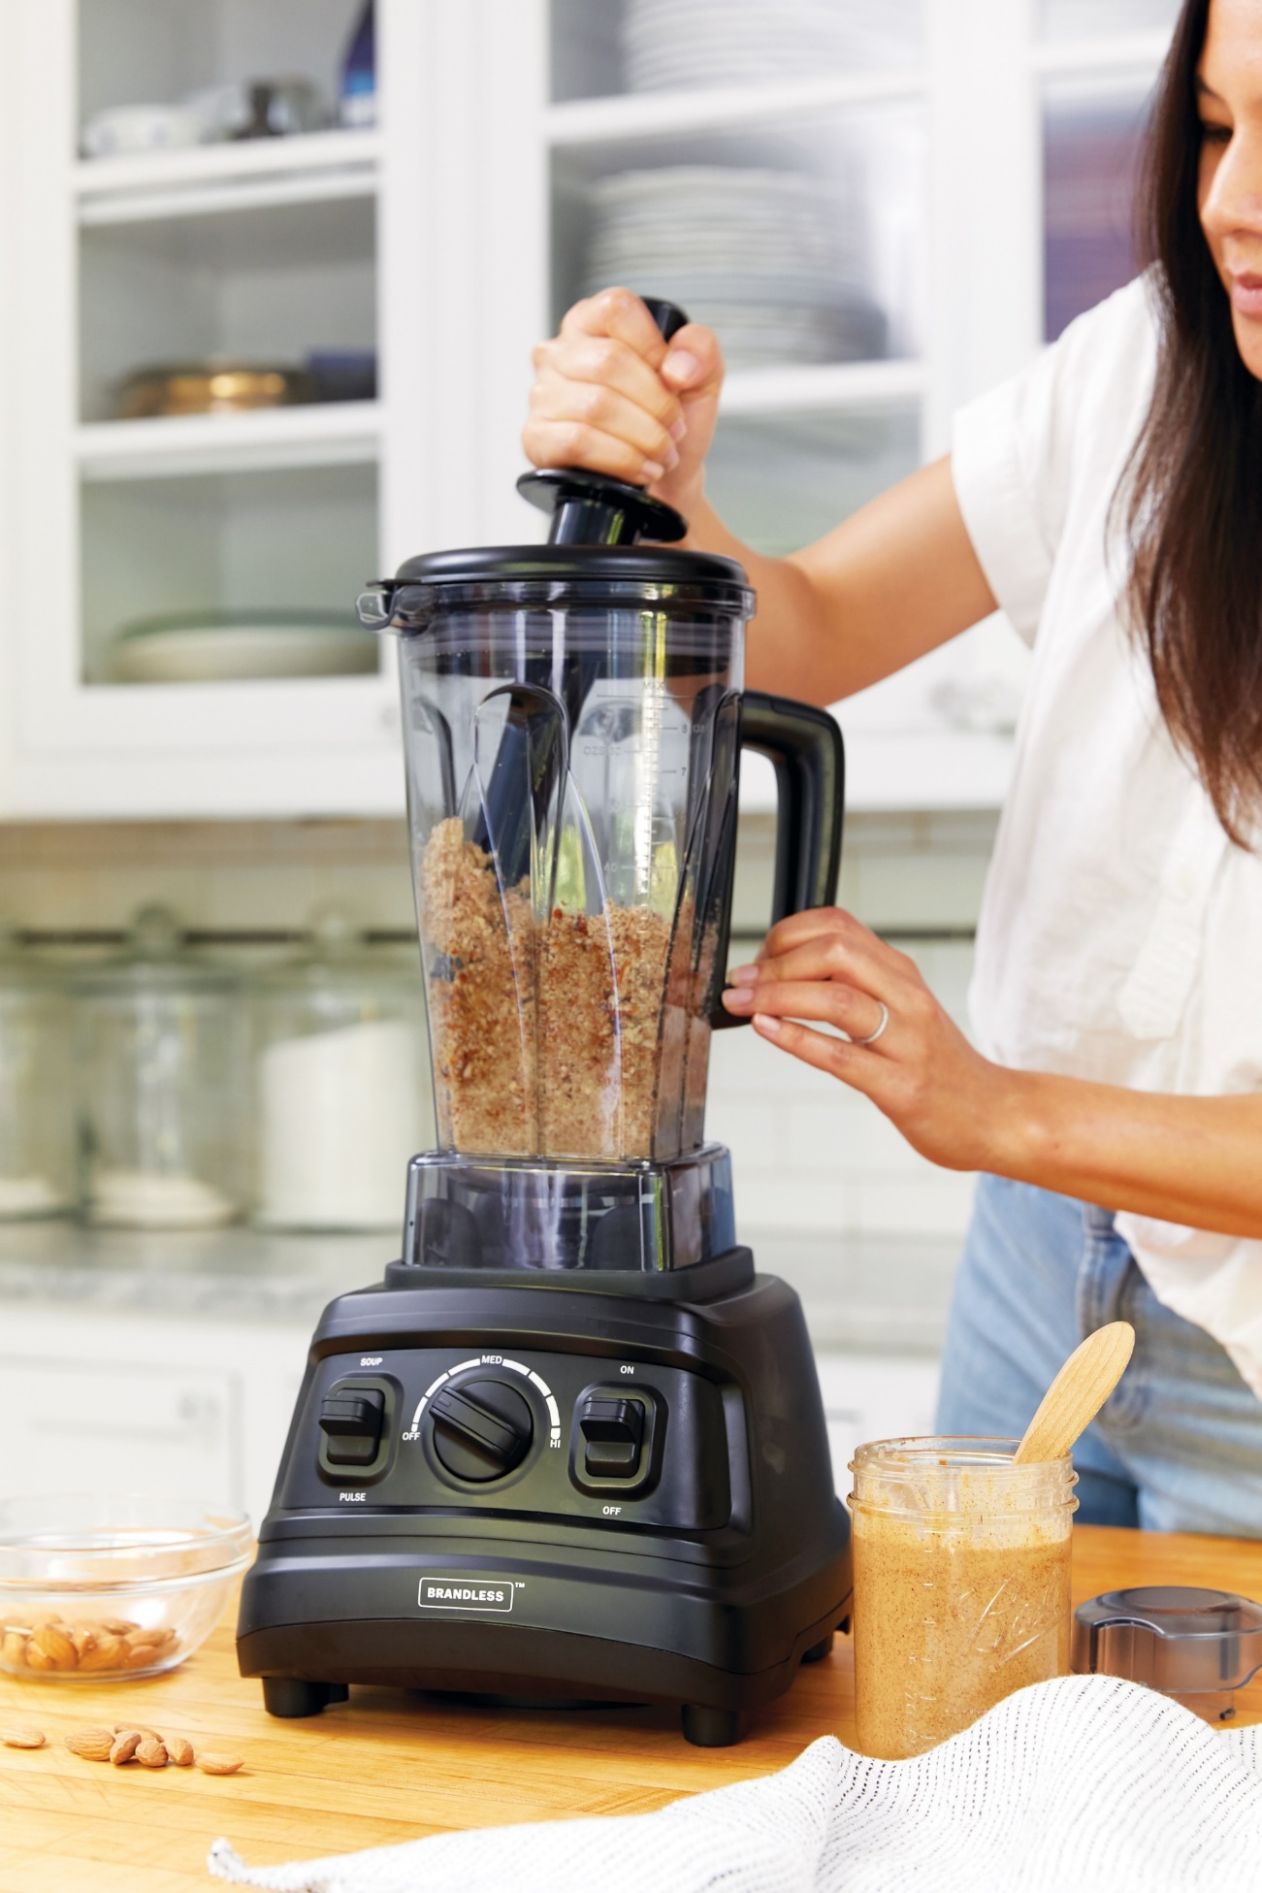
Photo by Brandless on Unsplash.com

Image analysis
Photo by Dan Meyers on Unsplash.com

Image analysis
Photo by Les routes sans fin(s) on Unsplash.com

Image analysis scaffold
 | Evidence | Background knowledge | Inference
Image 1
Image 2
Image 3
Image 4
Image 5

Appendix 3

Inference match and sort – students cut up and categorise, then sort
Evidence from text | Background knowledge | What we can infer
The mug was stained a deep black. | - Tea stains mugs black over time | - It was well-loved  - It was old and used
The girl held her handbag close to her, gripping it tightly. | - Typically, girls keep items in handbags  - People protect their valuables | - There was danger  - There was something worthy of protection inside
Animals rushed into the darkness at the first tremble. | - Animals run when frightened | - It was night  - There was danger coming  - Earthquake or volcano
Beneath the bathroom sink there were two cans of shaving cream and a rusty razor. | - Men typically use shaving cream  - When metal items are old, they rust when wet. | - A man lived here  - The man is growing a beard
The house was a mess- there were nappies and dummies on every surface. | - Babies wear nappies  - Babies use dummies | - There is a baby in the house  - There is chaos
The dentures were yellowing in the glass by the bedside table. | - Dentures are false teeth  - People wear dentures when their teeth fall out  - Things yellow with age | - An older person lives here  - The teeth are quite old and used
The boat was unsteady on the water, an ant in the blue. | - When water is rough, this moves the boat  - Ants are small | - The water was rough  - The boat was unsafe  - The boat was small
It seemed never-ending; every surface was covered in books. | - Libraries are full of books  - Books are read by people | - We are in a library  - The people liked to read  - Well educated

Inference match and sort – labelled cards for scaffold support
Evidence from text | Background knowledge | What we can infer
Evidence:  The mug was stained a deep black. | Background knowledge:  - Typically, girls keep items in handbags  - People protect their valuables | Inference:  - There is a baby in the house  - There is chaos
Evidence:  The girl held her handbag close to her, gripping it tightly. | Background knowledge:  - Animals run when frightened | Inference:  - A man lived here  - The man is growing a beard
Evidence:  Animals rushed into the darkness at the first tremble. | Background knowledge:  - Tea stains mugs black over time | Inference:  - An older person lives here  - The teeth are quite old and used
Evidence:  Beneath the bathroom sink there were two cans of shaving cream and a rusty razor. | Background knowledge:  - When water is rough, this moves the boat  - Ants are small | Inference:  - It was night  - There was danger coming  - Earthquake or volcano
Evidence:  The house was a mess- there were nappies and dummies on every surface. | Background knowledge:  - Libraries are full of books  - Books are read by people | Inference:  - We are in a library  - The people liked to read  - Well-educated
Evidence:  The dentures were yellowing in the glass by the bedside table. | Background knowledge:  - Babies wear nappies  - Babies use dummies | Inference:  - There was danger  - There was something worthy of protection inside
Evidence:  The boat was unsteady on the water; an ant in the blue. | Background knowledge:  - Men typically use shaving cream  - When metal items are old, they rust when wet. | Inference:  - The water was rough  - The boat was unsafe  - The boat was small
Evidence:  It seemed never-ending; every surface was covered in books. | Background knowledge:  - Dentures are false teeth  - People wear dentures when their teeth fall out  - Things yellow with age | Inference:  - It was well-loved  - It was old and used

Appendix 4

Library magician
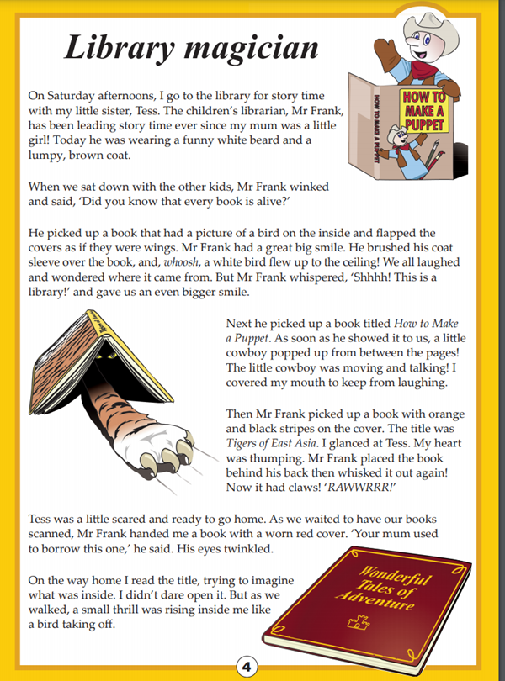
Year 5 NAPLAN Reading Magazine, 2016 ACARA

Library magician - Accessible version
On Saturday afternoons, I go to the library for story time with my little sister, Tess. The children’s librarian, Mr Frank, has been leading story time ever since my mum was a little girl! Today he was wearing a funny white beard and a lumpy, brown coat.
When we sat down with the other kids, Mr Frank winked and said, ‘Did you know that every book is alive?’
He picked up a book that had a picture of a bird on the inside and flapped the covers as if they were wings. Mr Frank had a great big smile. He brushed his coat sleeve over the book, and, whoosh, a white bird flew up to the ceiling! We all laughed and wondered where it came from. But Mr Frank whispered, ‘Shhhh! This is a library!’ and gave us an even bigger smile.
Next he picked up a book titled How to Make a Puppet. As soon as he showed it to us, a little cowboy popped up from between the pages! The little cowboy was moving and talking! I covered my mouth to keep from laughing. Then Mr Frank picked up a book with orange and black stripes on the cover. The title was Tigers of East Asia. I glanced at Tess. My heart was thumping. Mr Frank placed the book behind his back then whisked it out again! Now it had claws! ‘RAWWRRR!’
Tess was a little scared and ready to go home. As we waited to have our books scanned, Mr Frank handed me a book with a worn red cover. ‘Your mum used to borrow this one,’ he said. His eyes twinkled.
On the way home I read the title, trying to imagine what was inside. I didn’t dare open it. But as we walked, a small thrill was rising inside me like a bird taking off.
Year 5 NAPLAN Reading Magazine, 2016 ACARA

Appendix 5

Inferring character traits - ‘Show don’t tell’.
Character name | Inferred character traits | Evidence from the text

Appendix 6

Inferring key ideas – ‘Show don’t tell’.
Key idea | Evidence from the text | Inference explained
Libraries do not have to be quiet | We all laughed and wondered where it came from. But Mr Frank whispered, ‘Shhhh! This is a library!’ and gave us an even bigger smile | Mr Frank smiles after he whispers ‘Shhhh! This is a library!’ This smile indicates Mr Frank is joking, he doesn’t think that they should be quiet and that laughing is OK. If he thought they should be quiet he would have frowned.

Appendix 7

The mission
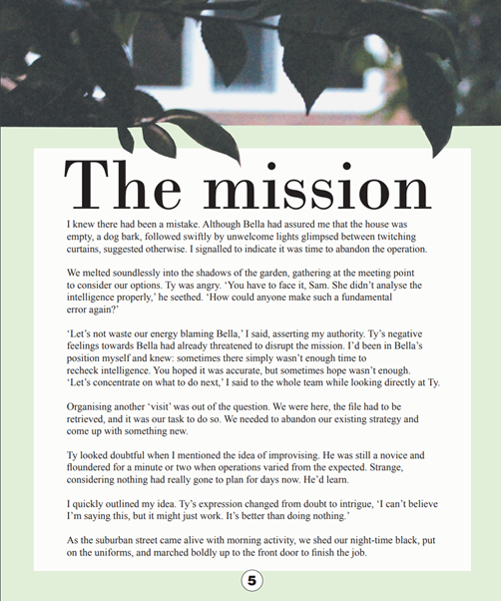
Year 5 NAPLAN Reading Magazine, 2015 ACARA

The mission - Accessible version

The mission
I knew there had been a mistake. Although Bella had assured me that the house was empty, a dog bark, followed swiftly by unwelcome lights glimpsed between twitching curtains, suggested otherwise. I signalled to indicate it was time to abandon the operation.
We melted soundlessly into the shadows of the garden, gathering at the meeting point to consider our options. Ty was angry. ‘You have to face it, Sam. She didn’t analyse the intelligence properly,’ he seethed. ‘How could anyone make such a fundamental error again?’
‘Let’s not waste our energy blaming Bella,’ I said, asserting my authority. Ty’s negative feelings towards Bella had already threatened to disrupt the mission. I’d been in Bella’s position myself and knew: sometimes there simply wasn’t enough time to recheck intelligence. You hoped it was accurate, but sometimes hope wasn’t enough. ‘Let’s concentrate on what to do next,’ I said to the whole team while looking directly at Ty.
Organising another ‘visit’ was out of the question. We were here, the file had to be retrieved, and it was our task to do so. We needed to abandon our existing strategy and come up with something new.
Ty looked doubtful when I mentioned the idea of improvising. He was still a novice and floundered for a minute or two when operations varied from the expected. Strange, considering nothing had really gone to plan for days now. He’d learn.
I quickly outlined my idea. Ty’s expression changed from doubt to intrigue, ‘I can’t believe I’m saying this, but it might just work. It’s better than doing nothing.’
As the suburban street came alive with morning activity, we shed our night-time black, put on the uniforms, and marched boldly up to the front door to finish the job.
Year 5 NAPLAN Reading Magazine, 2015 ACARA

Appendix 8

Character actions and motivations
Who?  Character name | What?  Action or behaviour | Why?  Motivation | How do I know?  Supporting evidence

Appendix 9

Michael Leunig poem

The Crowdless Man
See him wandering alone,
The crowdless man,
He has no group,
He has no tribe,
He carries his identity in his pocket.
His pocket has a hole in it,
His story has a hole in it,
His tragedy is not a tune you can hum.
His suffering and sacrifice,
They have no handles;
His persecution has no logo,
No shrine, no yardstick.
His joy has no credentials,
His observations have no fixed address;
There are no awards whatsoever.
His gaze and yearning are way outside the loop,
His pilgrimage has lots of holes in it.
See him wandering alone.
Beaming to himself.
By Michael Leunig
Text reproduced courtesy of Michael Leunig. Accessed from ‘Leunig’ website (2022.)

Appendix 10

Poetry
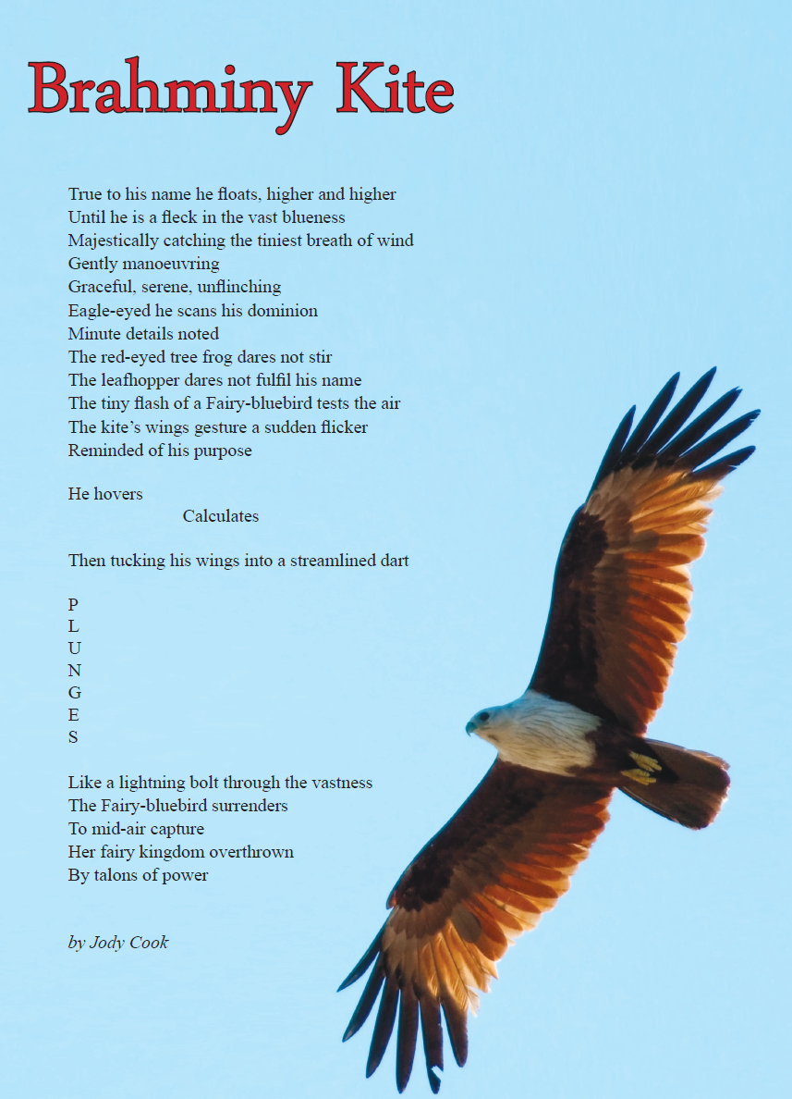

Year 5 NAPLAN Reading Magazine, 2014 ACARA

Poetry – accessible version

Brahminy Kite
True to his name he floats, higher and higher
Until he is a fleck in the vast blueness
Majestically catching the tiniest breath of wind
Gently manoeuvring
Graceful, serene, unflinching
Eagle-eyed he scans his dominion
Minute details noted
The red-eyed tree frog dares not stir
The leafhopper dares not fulfil his name
The tiny flash of a Fairy-bluebird tests the air
The kite’s wings gesture a sudden flicker
Reminded of his purpose
He hovers
Calculates
Then tucking his wings into a streamlined dart
P
L
U
N
G
E
S
Like a lightning bolt through the vastness
The Fairy-bluebird surrenders
To mid-air capture
Her fairy kingdom overthrown
By talons of power
by Jody Cook
Year 5 NAPLAN Reading Magazine, 2014 ACARA

