Fact and opinion
Stage 3

Overview

Purpose
This literacy teaching strategy supports teaching and learning for Stage 3 students across all key learning areas. It targets specific literacy skills and suggests a learning sequence to build skill development. Teachers can select individual tasks, or a sequence, and embed into their teaching and learning program according to their students’ needs. While exemplar texts are provided throughout this resource, it is recommended that teachers select texts which are relevant to their students and curriculum.

Learning intention
Students will learn the difference between fact and opinion and to how to identify these in texts.

Syllabus outcomes
The following teaching and learning strategy will assist in covering elements of the following outcomes:
- EN3-RECOM-01; fluently reads and comprehends texts for wide purposes, analysing text structures and language, and by monitoring comprehension
- EN3-UARL-01: analyses representations of ideas in literature through narrative, character, imagery, symbol and connotation, and adapts these representations when creating texts
NSW English K-10 Syllabus (2022)

Success criteria
The following Year 5 NAPLAN item descriptors may guide teachers to co-construct success criteria for student learning:
- evaluates the accuracy of statements using information from an information text
- evaluates the presence of information in an imaginative text
- evaluates potential modifications in an information text
- evaluates the presence of information in an information text
- identifies an opinion in a persuasive text

National Literacy Learning Progression guide

Understanding Texts (UnT8-UnT10)
Key: C=comprehension P=process V=vocabulary

UnT8
- evaluates the accuracy within and across texts on the same topic (C)
- explains how authors use evidence and supporting detail to build and verify ideas (C)
- identifies and explains techniques used to present perspective (e.g. emotive or descriptive language, order in which ideas are presented) (P)
- identifies language features used to present opinions or points of view (P)
- skims and scans texts for key words to track the development of ideas (P)

UnT9
- builds meaning by actively linking ideas from a number of texts or a range of digital sources (C)
- distils information from a number of texts according to task and purpose (e.g. uses graphic organisers) (C)
- selects reading/viewing strategies appropriate to reading purpose (e.g. scans text for evidence) (P)

UnT10
- analyses how text features are used to support or conflate the point of view in the text (e.g. the strategic use of images such as a cartoon in an editorial) (C)
- evaluates the reasoning and evidence in a persuasive text (C)
National Literacy Learning Progression

Evidence base
- Centre for Education Statistics and Evaluation (2017). Effective reading instruction in the early years of school, literature review.
- Konza, D. (2014). Teaching Reading: Why the “Fab Five” should be the “Big Six”. Australian Journal of Teacher Education, 39(12).
- Oakhill, J., Cain, K. & Elbro, C. (2015). Understanding and teaching reading comprehension: A handbook. Routledge.
- Quigley, A. (2020). Closing the reading gap. Routledge.
- Scarborough, H.S. (2001). Connecting early language and literacy to later reading (dis)abilities: Evidence, theory and practice. In S. Neuman & D. Dickson (Eds.), Handbook for research in early literacy (pp. 97-110). New York, NY: Guilford Press.

Alignment to system priorities and/or needs: Five priorities for Literacy and Numeracy, Our Plan for NSW Public Education, School Excellence Policy (nsw.gov.au).
Alignment to School Excellence Framework: Learning domain: Curriculum, Teaching domain: Effective classroom practice and Professional standards
Consulted with: Strategic Delivery, Teaching Quality and Impact
Author: Literacy and Numeracy
Reviewed by: Literacy and Numeracy, Teaching Quality and Impact
Created/last updated: January 2024
Anticipated resource review date: January 2025
Feedback: Complete the online form to provide any feedback

Copyright
Section 113P Notice
Texts, Artistic Works and Broadcast Notice
Some of this material has been copied and communicated to you in accordance with the statutory licence in section 113P of the Copyright Act. Any further reproduction or communication of this material by you may be the subject of copyright protection under the Act. Do not remove this notice.

Teaching strategies
Task | Appendices
Determining difference between fact or opinion | Appendix 1 - ‘I have, who has?’ game
Determining fact and opinion in texts | Appendix 2 - Information text
Expert panel

Background information

Fact and opinion
Facts can be based on an observation and can be validated through testing whereas opinion is an assumption or belief.
Introduce terms of ‘subjective’ and ‘objective’ and how these connect with fact and opinion; encourage students to use this vocabulary where appropriate.
Objective language is language that is fact-based, measurable and observable, verifiable and unbiased. It does not include a speaker or writer’s point of view, interpretation or judgement.
Subjective language includes words used to communicate based on opinion, feelings or personal biases.

Evaluative language
Positive or negative language that judges the worth of something. It includes language to express feelings and opinions, to make judgements about aspects of people such as their behaviour, and to assess the quality of objects such as literary works. It includes evaluative words. The language used by a speaker or writer to give a text a particular perspective (for example judgemental, emotional, critical) in order to influence how the audience will respond to the content of the text.
Reference: English K-10 Syllabus © NSW Education Standards Authority (NESA) for and on behalf of the Crown in right of the State of New South Wales, 2012 and 2022.

Where to next?
- Compare and contrast
- Literal comprehension
- Understanding perspective

Overview of teaching strategies

Purpose
These literacy teaching strategies support teaching and learning from Stage 2 to Stage 5. They are linked to NAPLAN task descriptors, syllabus outcomes and literacy and numeracy learning progressions.
These teaching strategies target specific literacy and numeracy skills and suggest a learning sequence to build skill development. Teachers can select individual tasks or a sequence to suit their students.

Access points
The resources can be accessed from:
- NAPLAN App in Scout using the teaching strategy links from NAPLAN items
- NSW Department of Education literacy and numeracy website.

What works best
Explicit teaching practices involve teachers clearly explaining to students why they are learning something, how it connects to what they already know, what they are expected to do, how to do it and what it looks like when they have succeeded. Students are given opportunities and time to check their understanding, ask questions and receive clear, effective feedback.
This resource reflects the latest evidence base and can be used by teachers as they plan for explicit teaching.
Teachers can use classroom observations and other assessment information to make decisions about when and how they use this resource as they design teaching and learning sequences to meet the learning needs of their students.
Further support with What works best is available.

Differentiation
When using these resources in the classroom, it is important for teachers to consider the needs of all students, including Aboriginal and EAL/D learners.
EAL/D learners will require explicit English language support and scaffolding, informed by the EAL/D enhanced teaching and learning cycle and the student’s phase on the EAL/D Learning Progression. Teachers can access information about supporting EAL/D learners and literacy and numeracy support specific to EAL/D learners.
Learning adjustments enable students with disability and additional learning and support needs to access syllabus outcomes and content on the same basis as their peers. Teachers can use a range of adjustments to ensure a personalised approach to student learning.
Assessing and identifying high potential and gifted learners will help teachers decide which students may benefit from extension and additional challenge. Effective strategies and contributors to achievement for high potential and gifted learners helps teachers to identify and target areas for growth and improvement. A differentiation adjustment tool can be found on the High potential and gifted education website.

Using tasks across learning areas
This resource may be used across learning areas where it supports teaching and learning aligned with syllabus outcomes.
Literacy and numeracy are embedded throughout all syllabus documents as general capabilities. As the English and mathematics learning areas have a particular role in developing literacy and numeracy, NSW English and Mathematics syllabus outcomes aligned to literacy and numeracy skills have been identified.

Text selection
Example texts are used throughout this resource. Teachers can adjust activities to use texts which are linked to their unit of learning.
Further support with text selection can be found within the National Literacy Learning Progression Text Complexity appendix.
The NESA website has additional information on text requirements within the NSW English syllabus.

Teaching strategies

Determining difference between fact or opinion
- Share a range of facts and opinions about a current unit of learning or student area of interest. Students indicate whether they are fact or opinion, justifying their reasoning.
Models a think aloud:
“I think that running when the weather is cooler is more enjoyable for athletes…” is an opinion because I can see vocabulary to indicate it is coming from one person’s perspective “I think”. I can also see the word ‘enjoyable’ – this can mean different things to different people and isn’t able to be measured for all ‘athletes’, so it is an opinion. In contrast, the statement “There are less runners in the cooler months than hotter months” can be measured. I can research and cross check this statement with a range of sources to determine its validity. There are also no emotional words in this statement which might indicate a belief or assumption.
- Venn diagram: Teacher leads a discussion on the differences between fact and opinion. Students add ideas into a Venn diagram to determine similarities and differences. Using this information, the class designs a set of criteria to determine a fact or opinion. For example, an opinion could be indicated by use of first person, emotive language, low modality, and may be one-sided or omit key details/evidence.
- Students play ‘I have, who has?’ game (refer to Appendix 1 - ‘I have, who has?’ game).
Differentiation: the cards labelled with an asterisk have both a fact and opinion on the same topic and will offer an additional challenge.
Key topic words could also be omitted and replaced with synonyms to provide opportunities for problem solving strategies.
- Additional task: Students create their own ‘I have, who has’ game using the blank guide from Appendix 1 - ‘I have, who has?’ game and play with the class or a small group. (There are enough cards for 30 students.)

Determining fact and opinion in texts
- Walk and talk: Students are provided with a topic that they have already explored and are familiar with such as natural disasters. Students walk around the room and the teacher calls out ‘fact’ or ‘opinion’. Students share with the person nearest them a fact or opinion then start to walk again when the teacher calls out ‘walk’. Alternate between fact and opinion talk.
- Students discuss and review the purpose of informative texts; to provide information on a particular topic using facts. Where can we find facts? Discuss how informative texts differ from imaginative texts. Students identify the purpose of a range of texts presented by the teacher, for example, letter, blog, meteorological report, letter to editor, narrative, and categorise the texts into ‘mainly opinion’ and ‘mainly fact’. Discuss how some types of text may have both fact and opinion.

- Introduce the topic of an information text linked to a current unit of learning or use Appendix 2 - Information text. Students predict vocabulary expected in the text based on the topic and brainstorm student background knowledge. Students read and highlight subject-specific language to add to the class vocabulary bank.
- Students highlight 5-8 key facts from their text. Discuss: ‘What language clues indicate it is factual?” (Facts can be based on observation and can be validated through testing whereas opinion is an assumption or belief.) Students interview a peer by sharing their fact and asking and recording their peer’s opinion. Students repeat the process for opinions, using a different colour to highlight.
To increase abstraction, students turn ‘facts into opinions’. Students research 2-3 of the opinions in their text and try to find evidence which supports them. Using this ‘evidence’ rewrite the opinion as a fact. Students could also make facts appear to be opinions by removing key evidence, using first person and emotive language.
- Provide students with a persuasive text linked to the same topic explored in activity 3 and 4. Discuss the purpose of a persuasive text with the class and explain that sometimes the facts and opinions may be harder to identify in these texts as the authors are trying to sway their audience to their way of thinking. Students repeat activity 4, identifying key facts and opinions. Class discussion: ‘What language clues indicate facts and what language clues indicate opinions? Are visual features used to support opinions and facts in the text? Does the author try to disguise their opinions as facts in order to persuade their audience?
To increase complexity, in pairs students discuss how evidence and reasoning may be used differently in a persuasive text compared to an informative text. Students collate their ideas using a graphic organiser and present their findings to the class, justifying their response with evidence from the texts.

Expert panel
- Groups of students read a text linked to a current unit of learning and become ‘experts’. They form an expert panel and answer questions from other members of the class.
- Students nominate who wants to be on the expert panel; these students read the text and consult each other to summarise, find the main idea and supporting details ready to respond to questions.
- The remaining students read the same text and devise questions to elicit fact and opinion statements from the expert panel. Ask the other students to read the same text and compose questions to ask the experts.
- Students ask their questions; the experts must respond and justify their answers from within the text.
- Have students work in pairs to write statements about the text, either facts or opinions. Have partners exchange their work and categorise the statements as fact or opinion.
Statement | Fact | Opinion

Appendix 1

I have, who has? Fact or opinion game
Facts | Opinions
I am the starter!  Who has a fact about koalas? | Koalas are an arboreal herbivorous marsupial that live in Australia.  Who has an opinion about tourism?
Tourism has ruined our town! No longer can I walk down my street without being bombarded by buses, photos and ‘I love Australia’ t-shirts!  Who has a fact about the Aboriginal people of Dubbo? | The traditional owners of the lands surrounding Dubbo are the Wiradjuri people.  Who has an opinion about lemon myrtle?
Lemon Myrtle is a surprising addition to my cake; it gives a fresh vibrancy which I haven’t experienced before!  Who has a fact about lemon myrtle? | Lemon myrtle is a native plant naturally occurring in the wetter coastal areas of northern New South Wales (NSW) and southern Queensland.  Who has an opinion about quokkas?
Thanks to social media, the Quokkas on Rottnest Island don’t seem to be getting a break – I hope they are being protected from tourists.  Who has a fact about Batemans Bay? | Batemans Bay is a coastal town located in the South Coast region of New South Wales. It is situated where the Clyde River meets the South Pacific Ocean.  Who has an opinion about Batemans Bay?
Fresh seafood, surf and sun! What more could you want from one of Australia’s coastal gems?  Who has a fact about eucalyptus trees? | Australian eucalyptus trees are easily recognised by their unique fragrance when leaves release their oil. There are over 600 species found in Australia.  Who has an opinion about the great white shark?
I am too nervous to swim with great white sharks – even when I know that I am safe in a cage in the water.  Who has a fact about the brush-tailed possum? | The brush-tailed possum is the most common species of possum found in Australia; they thrive in both urban and natural environments.  Who has an opinion on farming and water?
As a farmer, we must ensure we protect the heart of Australia.  Who has a fact about Aboriginal artefacts? | We have found a range of sacred Aboriginal sites including rock art and paintings, shell middens and fish traps.  Who has an opinion on water conservation?
I believe we must act now to improve efforts to protect Australia’s precious water supply.  Who has a fact about Port Macquarie? | Port Macquarie is located on the mid-north coast of Australia, approximately 400km north of Sydney.  Who has an opinion on vegemite?
Vegemite is my absolute favourite food; it is incredibly delicious and satisfies my craving for salt.  Who has a fact about Binnaway? | Binnaway is situated in north-west NSW in the Castlereagh region near Coonabarabran. It had a population of 425 people in 2016.  Who has an opinion on the Sydney Opera House?
It needs an upgrade! Time to let our state capital’s most recognisable monument shine even brighter.  Who has a positive opinion on surfing? | Surfing is an Australian way of life  Who has a different opinion on surfing?
I have never surfed in the ocean before, but I enjoy wakeboarding in the local weir.  Who has a fact about Warragamba Dam? | The current water level of Warragamba dam, as of 5th December, 2019, indicate it is at 46.1% capacity.  Who has an opinion about lamingtons?
Lamingtons drive me crazy! That incessant desiccated coconut is always falling into my lap.  Who has a fact about wattle? | Wattle has long been touted as Australia’s national emblem.  Who has an opinion on cattle farming?
It has been particularly hard for us lately. Cattle farming has been hugely affected by the drought; we are doing it tough but hanging in there to support each other. We just need some rain!  Who has a fact about Australia’s coat of arms? | The kangaroo and emu are two animals represented on the Australian coat of arms.  Who has an opinion on rainforests?
I think that by protecting our rainforests, we will allow our native flora and fauna to thrive.  Who has a fact about banksia? | Banksia has 173 different species and all but one grow in Australia.  Who has an opinion about the Warrumbungles?
It is sad that we can no longer climb Split Rock in the Warrumbungles, but it was a bit of a safety risk so I understand the decision.  Who has a fact on the Bungle Bungles | The Bungle Bungles are a natural sandstone formation found in the Purnululu National Park in the Kimberley region of Western Australia.  I am the end!

I have, who has? Blank guide
Facts | Opinions
I am the starter!  Who has a fact about _____________? | Who has an opinion about _________?
Who has a fact about _____________? | Who has an opinion about _________?
Who has a fact about _____________? | Who has an opinion about _________?
Who has a fact about _____________? | Who has an opinion about _________?
Who has a fact about _____________? | Who has an opinion about _________?
Who has a fact about _____________? | Who has an opinion about _________?

Appendix 2

Information text
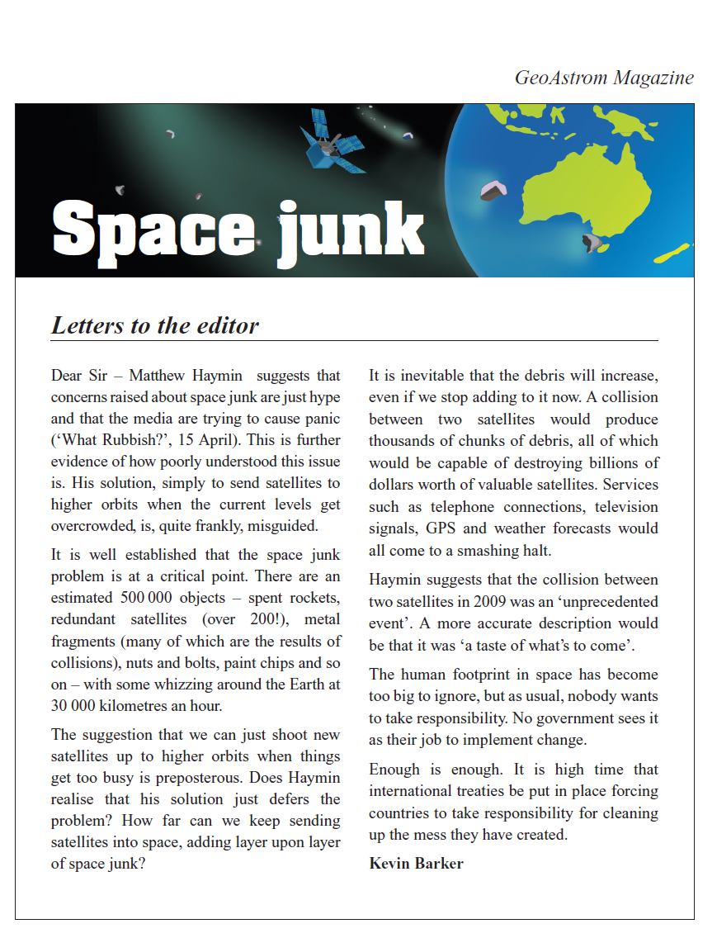
Year 5 NAPLAN Reading Magazine, 2012 ACARA

Information text - accessible version
Space junk - GeoAstrom magazine
Letters to the editor
Dear Sir – Matthew Haymin suggests that concerns raised about space junk are just hype and that the media are trying to cause panic (‘What Rubbish?’, 15 April). This is further evidence of how poorly understood this issue is. His solution, simply to send satellites to higher orbits when the current levels get overcrowded, is, quite frankly, misguided.
It is well established that the space junk problem is at a critical point. There are an estimated 500 000 objects – spent rockets, redundant satellites (over 200!), metal fragments (many of which are the results of collisions), nuts and bolts, paint chips and so on – with some whizzing around the Earth at 30 000 kilometres an hour.
The suggestion that we can just shoot new satellites up to higher orbits when things get too busy is preposterous. Does Haymin realise that his solution just defers the problem? How far can we keep sending satellites into space, adding layer upon layer of space junk?
It is inevitable that the debris will increase, even if we stop adding to it now. A collision between two satellites would produce thousands of chunks of debris, all of which would be capable of destroying billions of dollars worth of valuable satellites. Services such as telephone connections, television signals, GPS and weather forecasts would all come to a smashing halt.
Haymin suggests that the collision between two satellites in 2009 was an ‘unprecedented event’. A more accurate description would be that it was ‘a taste of what’s to come’.
The human footprint in space has become too big to ignore, but as usual, nobody wants to take responsibility. No government sees it as their job to implement change.
Enough is enough. It is high time that international treaties be put in place forcing countries to take responsibility for cleaning up the mess they have created.
Kevin Barker
Year 5 NAPLAN Reading Magazine, 2012 ACARA
Appendix 2

Information text

Curious and Curiouser: Burping cows, Bending spoons, beer goggles and other scintillating scientific stories
Dr Karl Kruszelnicki, Macmillan, 2010

Photosynthesis
The big difference between ‘plants’ and ‘fungi’ is that plants can do ‘photosynthesis’, but fungi cannot.
It was way back in 1771 when the English chemist Joseph Priestly did the first experiments with photosynthesis. This was even before oxygen had been discovered. Priestly burned a candle inside a closed jar. Sure enough, once the oxygen inside the jar had been consumed, the flame went out. He then inserted a sprig of mint into the narrow mouth of the jar. After a few days, the sprig of mint had made enough oxygen to again support a flame.
Photosynthesis is the process where a plant captures the energy of sunlight. It uses this energy to turn water and carbon dioxide into carbohydrates (simple sugars) and oxygen.
Speaking of ‘carbon’, all life on our planet is based on the element carbon. This element is present in practically every chemical in our body. (But not in water, which is made only from the elements ‘hydrogen’ and ‘oxygen’.)
More than 2.7 billion years ago, there was no photosynthesis. The cyanobacteria were able to grab carbon dioxide from the air around them and split it into carbon and oxygen. They kept the carbon for themselves to incorporate in their body. The oxygen was released into the atmosphere. Plants evolved from the early cyanobacteria. And this is how we got oxygen.
But fungi are different from plants, even though they grow in the same soil. They can’t do photosynthesis. So the only way they can get carbon is by ‘eating’ some organic chemicals in the soil and breaking them down. These organic chemicals can come from rotting wood and leaves, animal droppings and compost.

