Understanding character
Stage 3

Overview

Purpose
This literacy teaching strategy supports teaching and learning for Stage 3 students across all key learning areas. It targets specific literacy skills and suggests a learning sequence to build skill development. Teachers can select individual tasks, or a sequence, and embed into their teaching and learning program according to their students’ needs. While exemplar texts are provided throughout this resource, it is recommended that teachers select texts which are relevant to their students and curriculum.

Learning intention
Students will learn to identify and understand how character feelings, points of view and motivation is developed in texts.

Syllabus outcomes
The following teaching and learning strategies will assist in covering elements of the following outcomes:
- EN3-RECOM-01 fluently reads and comprehends texts for wide purposes, analysing text structures and language, and by monitoring comprehension
- EN3-UARL-01 analyses representations of ideas in literature through narrative, character, imagery, symbol and connotation, and adapts these representations when creating texts
NSW English K-10 Syllabus (2022)
Visit the Leading curriculum K-12 website for more information on the syllabus implementation timeline.

Success criteria
The following Year 5 NAPLAN item descriptors may guide teachers to co-construct success criteria for student learning.
- compares each character's perspective in a text
- identifies a character's motivations in a narrative
- identifies a character's perspective in a narrative
- identifies a character's role in an information text
- identifies how a character is portrayed in a narrative
- identifies how a character is portrayed in an imaginative text
- interprets a character's feelings in a narrative
- interprets a character's motivations in a narrative
- interprets a character's motivations in a text
- identify a character trait from a narrative
- identifies how a character is portrayed in a text
- infers the reason for a character’s actions in a narrative
- infers the reason for a character’s actions in a narrative extract
- infers the reason for a character’s actions from vocabulary in a narrative
- compares each character's perspective in a text
- identifies a character's motivations in a narrative
- identifies a character's perspective in a narrative
- identifies a character's role in an information text
- identifies how a character is portrayed in a narrative
- identifies how a character is portrayed in an imaginative text
- interprets a character's feelings in a narrative
- interprets a character's motivations in a narrative
- interprets a character's motivations in a text

National Literacy Learning Progression guide

Understanding Texts (Un8-Un10)
Key: C=comprehension P=process V=vocabulary

UnT8
- reads and views some moderately complex texts (see Text Complexity) (C)
- draws inferences and verifies using text evidence (C)
- identifies and explains techniques used to present perspective (e.g. emotive or descriptive language, order in which ideas are presented) (P)

UnT9
- draws inferences, synthesising clues and evidence across a text (C)
- identifies different interpretations of the text citing evidence from a text (C)

UnT10
- draws inferences using evidence from the text and discounting possible inferences that are not supported by the text (C)
- analyses the techniques authors use to position readers (C)
National Literacy Learning Progression

Evidence base
- Centre for Education Statistics and Evaluation (2017). Effective reading instruction in the early years of school, literature review.
- Konza, D. (2014). Teaching Reading: Why the “Fab Five” should be the “Big Six”. Australian Journal of Teacher Education, 39(12).
- Oakhill, J., Cain, K. & Elbro, C. (2015). Understanding and teaching reading comprehension: A handbook. Routledge.
- Quigley, A. (2020). Closing the reading gap. Routledge.
- Scarborough, H.S. (2001). Connecting early language and literacy to later reading (dis)abilities: Evidence, theory and practice. In S. Neuman & D. Dickson (Eds.), Handbook for research in early literacy (pp. 97-110). New York, NY: Guilford Press.
Alignment to system priorities and/or needs: Five priorities for Literacy and Numeracy, Our Plan for Public Education, School Excellence Policy (nsw.gov.au).
Alignment to School Excellence Framework: Learning domain: Curriculum, Teaching domain: Effective classroom practice and Professional standards
Consulted with: Strategic Delivery, Teaching Quality and Impact
Author: Literacy and Numeracy
Reviewed by: Literacy and Numeracy, Teaching Quality and Impact
Created/last updated: January 2024
Anticipated resource review date: January 2025
Feedback: Complete the online form to provide any feedback

Copyright
Section 113P Notice
Texts, Artistic Works and Broadcast Notice
Some of this material has been copied and communicated to you in accordance with the statutory licence in section 113P of the Copyright Act. Any further reproduction or communication of this material by you may be the subject of copyright protection under the Act. Do not remove this notice.

Teaching strategies
Task | Appendices
Trait bank | Appendix 1 - ‘Trait Bank’
Bull’s eye | Appendix 1 - ‘Trait Bank’
Matching actions and traits | Appendix 2 - ‘Identifying character traits and actions’
DIAL into a character | Appendix 3 - ‘DIAL’ into a Character’
Inferring a character's emotions in a narrative | Appendix 4 - ‘Feelings, Actions, Motivations’  Appendix 5 - ‘Concept Map’  Appendix 6 - ‘Blueback excerpt’  Appendix 7 - ‘Feelings flowchart’

Background information
The following information from the English Textual Concepts website can further support understanding of point of view and perspective.
Further information on English textual concepts can be found on the curriculum textual concepts web page.

Character
Character is traditionally viewed as a description of a fictional person. As a construct, it is made up of verbal or visual statements about what that fictional person does, says and thinks and what other fictional characters and the author of the text say about him or her. The reader, listener or viewer fleshes out these statements to imagine a person-like character, sufficiently individualised and coherent to establish the sense of an identity. In this way, representation of a ‘real’ person invites personal identification and judgements about the character’s morality and value to their society. This kind of analysis can contribute to shaping one’s own sense of a moral and ethical self and so becoming a way of enculturation.
Characters may also be created and/ or read as representations of ideas, of groups of people or of types that serve a function in a narrative genreQuestions of characterisation then focus on the ways a character is constructed both by the responder and the composer and its function in the text.
Character is an important concept in narrative as a driver of the action, a function in the plot, a way of engaging or positioning a reader or as a way of representing its thematic concerns. The way character is read is an indication of particular approaches to texts, be it through personal engagement or critical response.

Where to next?
- Text structure
- Understanding perspective
- Text features

Overview of teaching strategies

Purpose
These literacy teaching strategies support teaching and learning from Stage 2 to Stage 5. They are linked to NAPLAN task descriptors, syllabus outcomes and literacy and numeracy learning progressions.
These teaching strategies target specific literacy and numeracy skills and suggest a learning sequence to build skill development. Teachers can select individual tasks or a sequence to suit their students.

Access points
The resources can be accessed from:
- NAPLAN App in Scout using the teaching strategy links from NAPLAN items
- NSW Department of Education literacy and numeracy website.

What works best
Explicit teaching practices involve teachers clearly explaining to students why they are learning something, how it connects to what they already know, what they are expected to do, how to do it and what it looks like when they have succeeded. Students are given opportunities and time to check their understanding, ask questions and receive clear, effective feedback.
This resource reflects the latest evidence base and can be used by teachers as they plan for explicit teaching.
Teachers can use classroom observations and assessment information to make decisions about when and how they use this resource as they design teaching and learning sequences to meet the learning needs of their students.
Further support with What works best is available.

Differentiation
When using these resources in the classroom, it is important for teachers to consider the needs of all students, including Aboriginal and EAL/D learners.
EAL/D learners will require explicit English language support and scaffolding, informed by the EAL/D enhanced teaching and learning cycle and the student’s phase on the EAL/D Learning Progression. Teachers can access information about supporting EAL/D learners and literacy and numeracy support specific to EAL/D learners.
Learning adjustments enable students with disability and additional learning and support needs to access syllabus outcomes and content on the same basis as their peers. Teachers can use a range of adjustments to ensure a personalised approach to student learning.
Assessing and identifying high potential and gifted learners will help teachers decide which students may benefit from extension and additional challenge. Effective strategies and contributors to achievement for high potential and gifted learners helps teachers to identify and target areas for growth and improvement. A differentiation adjustment tool can be found on the High potential and gifted education website.

Using tasks across learning areas
This resource may be used across learning areas where it supports teaching and learning aligned with syllabus outcomes.
Literacy and numeracy are embedded throughout all syllabus documents as general capabilities. As the English and mathematics learning areas have a particular role in developing literacy and numeracy, NSW English and Mathematics syllabus outcomes aligned to literacy and numeracy skills have been identified.

Text selection
Example texts are used throughout this resource. Teachers can adjust activities to use texts which are linked to their unit of learning.
Further support with text selection can be found within the National Literacy Learning Progression Text Complexity appendix.
The NESA website has additional information on text requirements within the NSW English syllabus.

Teaching strategies

Trait bank
- Character hot seat: A volunteer student sits on a chair in the middle of the audience. Students draw out a trait from the ‘Trait Bank’ (Appendix 1 - ‘Trait Bank’). Volunteer acts out what that might look like. Teacher guides students to create a phrase or sentence to explain the action in words. For example, for the trait ‘curious’, the student might look under a chair, through a bag or around a corner. When the students have guessed the trait as being curious, the class might represent the action with words: “He could not contain himself, he needed to peek and inquire into every hiding space he could find!”
- Think-Pair-Share: Students work in pairs to categorise trait banks into visible or physical traits and emotional or behaviour traits. Working in pairs, student A draws and acts out a card from a bank of traits. Student B guesses the trait. Students then work together to compose a sentence that describes the trait of the character.

Bull’s eye
- Teacher selects a quality text with strong easily recognisable characters. Discuss: What is the main message of the text? What clues did the author use to make you think this?
- Bull’s eye: Using a ‘bull’s-eye’ target, teacher models completing the target using information as it unravels in the text (refer to Appendix 1 - ‘Trait Bank’). Target – Character’s name Next layer – Physical features (e.g. dragging feet) Next outer layer – Emotional (depressed and anxious).
- Students create their own bull’s eye and complete using information about another character from the same text. To increase creative and critical thinking, students could use the language from their Bull’s eye to create a word web which represents their character.
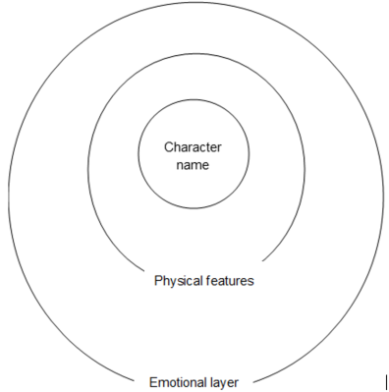

Matching actions and traits
- Using a text relevant to a current unit of leraning, or refer to the text below, teacher reads aloud and annotates an exemplar text, noting character traits and actions. For the following text teachers may note how the author builds the character of Clar through both the overt physical descriptions as well as personality traits.
In the dimly lit room, Clara stood, her attire a chaotic ensemble of mismatched patterns and colors. Her disheveled hair cascaded down her shoulders, wild strands refusing to be tamed. Clara had a mysterious aura, a desire to stay hidden beneath layers of uniqueness. Her gaze, behind big glasses, hinted at a world of thoughts and dreams she kept guarded. In the bustling crowd, Clara moved like a ghost, known only to those who observed her closely. She possesed a hidden brilliance, waiting to be discovered by those willing to look beyond the surface.
Physical description | Personality trait
…her attire a chaotic ensemble of mismatched patterns and colors. | Clara had a mysterious aura, a desire to stay hidden beneath layers of uniqueness
Her disheveled hair cascaded down her shoulders, wild strands refusing to be tamed.
Her gaze, behind big glasses | Her gaze…hinted at a world of thoughts and dreams she kept guarded.
Clara moved like a ghost, known only to those who observed her closely | She possesed a hidden brilliance…
- Discuss how sets of words can relate to one another. Use a coloured highlighter to track the words the author has used to build a visual image of the character:
In the dimly lit room, Clara stood, her attire a chaotic ensemble of mismatched patterns and colors. Her disheveled hair cascaded down her shoulders, wild strands refusing to be tamed. Clara had a mysterious aura, a desire to stay hidden beneath layers of uniqueness. Her gaze, behind big glasses, hinted at a world of thoughts and dreams she kept guarded. In the bustling crowd, Clara moved like a ghost, known only to those who observed her closely. She possesed a hidden brilliance, waiting to be discovered by those willing to look beyond the surface.
- Using the phrases that are highlighted, suggest an adjective that could describe the character’s trait and the matching phrase that lead us to infer the trait:

Character trait – suggested adjectives | Evidence of the action
unique  creative | her attire a chaotic ensemble of mismatched patterns and colors
messy  untamed | Her disheveled hair cascaded down her shoulders, wild strands refusing to be tamed.
unassuming  stealthy | Clara moved like a ghost, known only to those who observed her closely
- Think-Pair-Share. Students read the paragraphs and sections from Appendix 2 - ‘Identifying character traits and actions’ and circle the words that build a visual image of the new character. Students organise their ideas into four quadrants:
Clothing | Gesture/posture
Physical traits | Any revealing behaviours
As a group, students share their ideas with the class, justifying their choices.

DIAL into a character
- Select a familiar quality text linked to a current unit of learning. Using the DIAL model (refer to Appendix 3 - ‘DIAL’ into a Character’), guide student thinking and understanding that builds a picture of the traits and actions of a character.
D  Description | What descriptive words did the author choose to tell us about the character?
I  Illustration | What do the illustrations tell us?  Illustrate what you think the character looks like.
A  Actions | What does this character do?
L  Language | What does this character say? How do they speak? What words do they use?
Adapted from © State of New South Wales through the NSW Department of Education and Training, 2011

Inferring a character's emotions in a narrative
- Explain to students that there are many ways a writer can show us what a character is like or what they are feeling. For example, if the character was angry:
- they could yell (what they say)
- they could be described as having a red face or a stern expression (how they look)
- they could slam the door (what they do)
- other characters may say things like, ‘Fred looks so angry he could burst’ (other opinions)
- Our perceptions of each character are shaped by our previous experiences and by other books we have read (background knowledge) and our knowledge of what words mean. When we read we can use clues from the text and our background knowledge to draw conclusions and infer character feelings from their actions (For more information refer to Reading Stage 3 – inference). Characters can have different feelings and may change quickly depending on the suspense the author is attempting to create. Teachers could support students understanding by providing an example from a text that the class has recently read or a well-known character.
- To increase higher order thinking, teacher provides students with two characters examples and students compare and contrast their feelings, actions and motivations. (Refer to Appendix 4 - ‘Feelings, Actions, Motivations’.)
- Students complete a Think-Pair-Share to build a word wall of vocabulary that describe feelings. As students share their words with the class, the teacher records responses in a ‘concept map’, organising words in logical groups focusing on synonyms (refer to Appendix 5 - ‘Concept Map’).
- Explain to students that you are going to read an extract from the novel ‘Blueback’ by Tim Winton (refer to Appendix 6 - ‘Blueback excerpt’). Provide context for the excerpt. In the text we meet the main character, Abel, and his Mother, Dora. They are out on a fishing boat diving for abalone when Abel dives into the water, where he meets a large old grouper, a kind or species of fish.
- Teacher models a ‘think aloud’ strategy to determine how Abel was feeling throughout the text and uses supporting information from the text to draw conclusions. Teacher records the inferred feelings on a ‘storyboard’ or a flowchart, to visually display to students how they can identify changes in a character using evidence from the text, vocabulary of feelings and background knowledge (refer to Appendix 7 - ‘Feelings Flowchart’).
- After the ‘think aloud’, the teacher asks student to generate two words (not in a phrase) that reflect how Abel was feeling throughout the text. Teacher encourages students to think why they chose those words, using evidence from the text to justify selections with a partner.
- Teacher and students review the initial concept map and add any additional vocabulary that was not initially recorded.

Appendix 1

Trait bank - student trait cards
Students use these cards to create actions and behaviours with inferred traits.
interested | curious
determined | hard-working
unkempt | courageous
efficient | affectionate
hateful | eloquent
supportive | haughty
sorry | suspicious
inventive | jealous
embarrassed | particular
animated | illogical
intrigued | happy
disheartened | intelligent
dishevelled | energetic
stressed | humble
sad | annoyed
distressed | upset

Trait bank – Images to support learners
Students use these cards to match actions and behaviours with inferred traits. Print the two pages on separate colours.
Curious  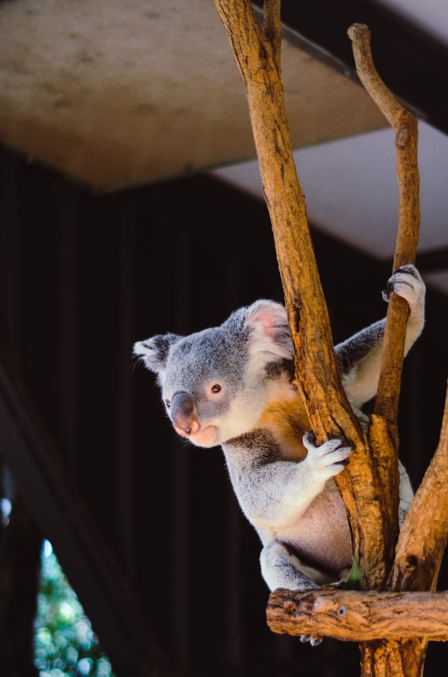  Photo:Vita Vilcina, Unsplash.com | dreamer  Photo: Tachina Lee, Unsplash.com
upset  Photo: Christian Erfurt, Unsplash.com | doubtful  Photo:In collaboration with Ave Calvar, Unsplash.com
carefree  Photo: Johannes Plenio. Unsplash.com | quick  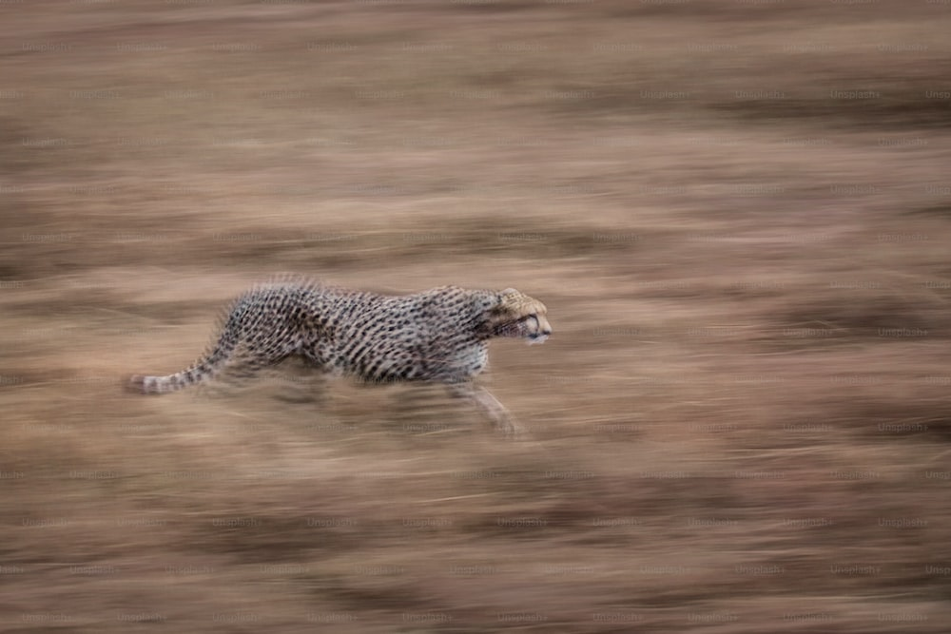  Photo:In collaboration with Getty Images, Unsplash.com
brave  Photo:Sammie Chaffin, Unsplash.com | neat  Photo: tu tu, Unsplash.com
cheerful  Photo:Nick Page, Unsplash.com | sorry  Photo: Matthew Henry, Unsplash.com

Appendix 2

Identifying character traits and actions
Juliet uses her fingers as a comb in the morning and her socks are always at odd heights to each other. Her face is quite beautiful, but she hides this with thick-rimmed, nerdy glasses that serve as a mask. Her mumbly voice is barely audible, even in complete silence and her hair hangs across her face like a flouncy stage curtain, hiding talent behind it. Juliet is the girl you will always find shying away from the spotlight and sitting in the back of the class, gazing nonchalantly at the world beyond.
© State of New South Wales (Department of Education), NEALS, 2011.
Use evidence from the text to find details about:
Clothing | Gesture/posture
Face/hair/eyes | Any revealing behaviours
Eventually Miss Walsh stood up to go and Sally noticed her neatly darned gloves, the frayed hem of her coat, and the brightly polished old boots, now badly in need of resoling. It had been more than money she’d lost – it had been the chance of living in modest comfort and without worry after a lifetime of helping others. Sally looked at her and saw how, despite her age and anxiety, the old lady’s posture was firm and straight and dignified, and found herself standing more straightly too. They shook hands...Miss Walsh smiled. ‘I’ll send on all the documents I’ve got,’ she said. I’m most grateful to you Miss Lockhart.’
(Phillip Pullman, the Shadow in the North, Scholastic 1999)
Use evidence from the text to find details about:
Clothing | Gesture/posture
Face/hair/eyes | Any revealing behaviours

Identifying character traits and actions
‘Beyond the Deepwoods’ by Paul Stewart, Illustrated by Chris Riddell. David Fickling Books, 2004
The Snatchwood Cabin
Twig sat on the floor between his mother’s knees, and curled his toes in the thick fleece of the tilder rug. It was cold and draughty in the cabin. Twig leaned forwards and opened the door of the stove.
‘I want to tell you the story of how you got your name,’ his mother said.
‘But I know that story, Mother-Mine,’ Twig protested.
Spelda sighed. Twig felt her warm breath on the back of his neck, and smelled the pickled tripweed she had eaten for lunch. He wrinkled his nose. Like so much of the food which the woodtrolls relished, Twig found tripweed disgusting, particularly pickled. It was slimy and smelled of rotten eggs.
‘This time it will be a little different,’ he heard his mother saying. ‘This time I will finish the tale.’
Twig frowned. ‘I thought I’d already heard the ending.’
Spelda tousled her son’s thick black hair. He’s grown so fast, she thought, and wiped a tear from the end of her rubbery button-nose. ‘A tale can have many endings,’ she said sadly, and watched the purple light from the fire gleaming on Twig’s high cheekbones and sharp chin. ‘From the moment you were born,’ she began, as she always began, ‘you were different . . .’
Twig nodded. It had been painful, so painful, being different when he was growing up. Yet it amused him now to think of his parents’ surprise when he had appeared: dark, green-eyed, smooth-skinned, and already with unusually long legs for a woodtroll. He stared into the fire.
The lufwood was burning very well. Purple flames blazed all round the stubby logs as they bumped and tumbled around inside the stove.
The woodtrolls had many types of wood to choose from and each had its own special properties. Scentwood, for instance, burned with a fragrance that sent those who breathed it drifting into a dream-filled sleep, while wood from the silvery-turquoise lullabee tree sang as the flames lapped at its bark — strange mournful songs, they were, and not at all to everyone’s taste. And then there was the bloodoak, complete with its parasitic sidekick, a barbed creeper known as tarry vine.
Obtaining bloodoak wood was hazardous. Any woodtroll who did not know his woodlore was liable to end up satisfying the tree’s love of flesh — for the bloodoak and the tarry vine were two of the greatest dangers in the dark and perilous Deepwoods.
Certainly the wood of the bloodoak gave off a lot of heat, and it neither smelled nor sang, but the way it wailed and screamed as it burned put off all but a few. No, among the woodtrolls, lufwood was by far the most popular. It burned well and they found its purple glow restful.
Twig yawned as Spelda continued her story. Her voice was high-pitched but guttural; it seemed to gurgle in the back of her throat.
‘At four months you were already walking upright,’ she was saying, and Twig heard the pride in his mother’s words. Most woodtroll children remained down on their knuckles until they were at least eighteen months old.
‘But . . .’ Twig whispered softly. Drawn back inside the story despite himself, he was already anticipating the next part. It was time for the ‘but’. Every time it arrived Twig would shudder and hold his breath.
‘But,’ she said, ‘although you were so ahead of the others physically, you would not speak. Three years old you were, and not a single word!’ She shifted round in her chair. ‘And I don’t have to tell you how serious that can be!’
Once again his mother sighed. Once again Twig screwed up his face in disgust. Something Taghair had once said came back to him: ‘Your nose knows where you belong.’ Twig had taken it to mean that he would always recognize the unique smell of his own home. But what if he was wrong? What if the wise old oakelf had been saying — in his usual roundabout way — that because his nose didn’t like what it smelled, this was not his home?
Twig swallowed guiltily. This was something he had wished so often as he’d lain in his bunk after yet another day of being teased and taunted and bullied.
Through the window, the sun was sinking lower in the dappled sky. The zigzag silhouettes of the Deepwood pines were glinting like frozen bolts of lightning. Twig knew there would be snow before his father returned that night.
Vocabulary Task:
- Highlight any vocabulary that is unfamiliar.
- Using sentences surrounding the word, consider what this word might mean.
- Use a dictionary to define the word and use with a partner
Character trait and evidence from text table
Character traits | Evidence from text
Copied under the statutory licence in s 113P of the Copyright Act. Paul Stewart ‘Beyond the Deepwoods’ Illustrated by Chris Riddell. David Fickling Books, 2004. Section 113P Warning Notice

Identifying character traits and actions
Mr Twit
The other thing you should know about Mr Twit is that he has a horrible, hairy, bristly, dirty, smelly beard that he never washes. Ever. "Even on Sundays," we're told. As a result, that beard is full of all sorts of disgusting leftovers from Mr Twit's meals: cornflakes, tinned sardines, stilton cheese.
Roald Dahl tells us, "Because of all this, Mr Twit never really went hungry. By sticking out his tongue and curling it sideways to explore the hairy jungle around his mouth, he was always able to find a tasty morsel here and there to nibble on."
We know. YUCK.
The Twits by Roald Dahl, Penguin Random House, 2007
Use evidence from the text to find details about:
Clothing | Gesture/posture
Face/hair/eyes | Any revealing behaviours

Appendix 3

DIAL into a character

Student scaffold
D  Description | What descriptive words did the author choose to tell us about the character?
I  Illustration | What do the illustrations tell us?  Illustrate what you think the character looks like.
A  Actions | What does this character do?
L  Language | What does this character say? How do they speak? What words do they use?

Appendix 4

Student scaffold: feelings, actions, motivations
Character | Feelings  What are they feeling?  Use evidence from the text. | Actions  What did they do?  Use evidence from the text. | Motivation  Why are they feeling this way?  Use evidence from the text.
Character 1

Character 2
How do the two differ?
Character | Feelings  What are they feeling?  Use evidence from the text. | Actions  What did they do?  Use evidence from the text. | Motivation  Why are they feeling this way?  Use evidence from the text.
Character 1

Character 2
How do the two differ?

Appendix 5

Concept Map
An example of a completed concept map to scaffold teachers understanding of the task.
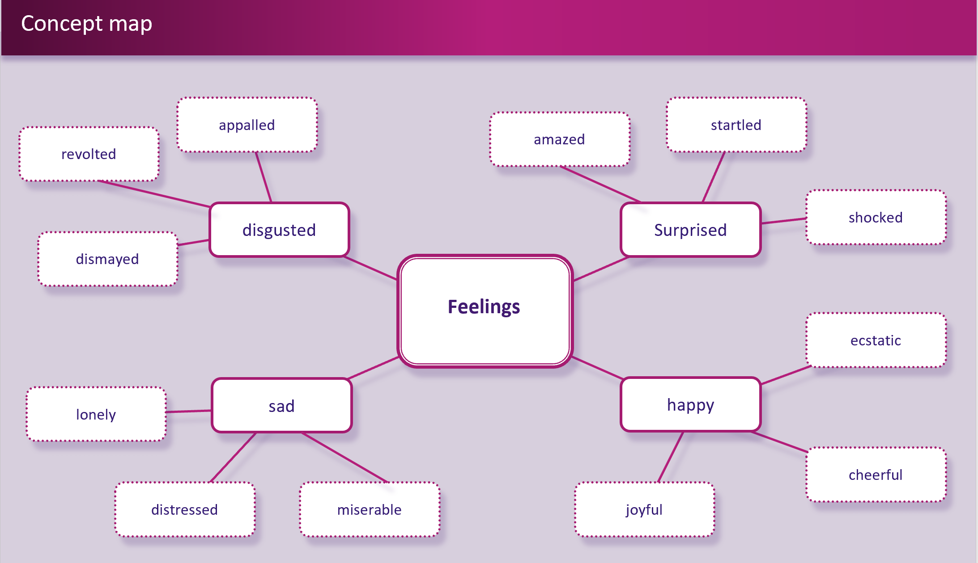
Graphic organiser templates availble through the NSW Department of Education’s Digital Learning Selector.

Appendix 6

Blueback excerpt – page 1
Winton, Tim. Blueback (2008) Penguin
On the deepest dive, at his limit, Abel was almost at the end of his breath when he felt a rush in the water behind him. It felt like something big, like his mother passing. But at the corner of his eye he saw a blue shadow that blocked out the sun. He whirled around to see a huge mouth and an eye the size of a golf ball coming at him. The mouth opened. He saw massive pegs of teeth as it came on in a terrible rush. Abel screamed in his snorkel and pushed hard off the bottom but the big blue shadow suddenly had him by the hand. The abalone he was holding came tearing out of his fingers. Abel thought he was about to die. He felt pain shoot up his arm. A vast flat tail blurred across his body. And then it was gone.
Abel shot to the surface and burst into the fresh air with a shriek. He wheeled around, looking for danger, waiting for another rush from the lurking shadow. His whole body quaked and trembled. He looked at his hand; a tiny thread of blood curled into the water. It was only a scratch.
His mother came slowly upward with her bag full. She gave him the thumbs up.
`Get in the boat!' he shouted when she surfaced. 'There's something down there!'
She grabbed him by the arm and squeezed. 'It's okay, love.'
`Mum, it nearly got me!' `Close call, eh?' she said with a smile.
‘Look, it took skin off my fingers!'
`Look down now.'
`Let's get to the boat. Please!'
`Just look down,' said his mother.

Blueback excerpt – page 2
Reluctantly he stuck the snorkel back in his mouth and put his head under. Near the bottom, in the mist left from their abalone gathering, a huge blue shadow twitched and quivered. There it was, not a shark, but the biggest fish he had ever seen. It was gigantic. It had fins like ping-pong paddles. Its tail was a blue-green rudder. It looked as big as a horse.
`Come down,' said his mother. 'Let's look at him.'
`I - I thought it was a shark.' 'He sure took you by surprise,' she said, laughing.
'That's a blue groper. Biggest I've ever seen.'
Abel and his mother slid down into the deep again and saw the fish hovering then turning, eyeing them cautiously as they came. It twitched a little and edged along in front of them to keep its distance. The big gills fanned. All its armoured scales rippled in lines of green and black blending into the dizziest blue. The groper moved without the slightest effort. It was magnificent; the most beautiful thing Abel had ever seen.
After a few moments his mother eased forward with an abalone in one outstretched hand. The groper watched her. It turned away for a moment, afraid, and then came round in a circle. Abel couldn't hold his breath much longer but he didn't want to miss anything so he hung there above his mother and the fish with his lungs nearly bursting.
The groper arched back. The mosaic of its scales shone in the morning sun. His mother got close enough to touch the fish with the meat of the abalone. The fish trembled in the water and then froze for a moment as though getting ready to flee. She ran the shell meat along its fat bottom lip and let go. The fish powered forward, chomped the abalone and hurtled off into a dark, deep hole.

Appendix 7

Feelings flowchart
An example of a completed storyboard to scaffold teachers understanding of the task.
Excerpts from Tim Winton’s Blueback (1997) Macmillan.
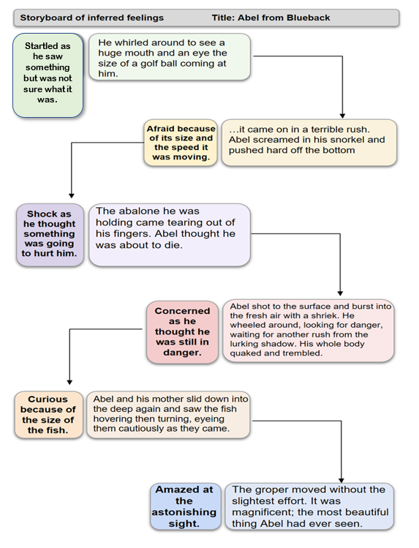

Appendix 7

Feelings flowchart – accessible version
An example of a completed storyboard to scaffold teachers understanding of the task.
Excerpts from Tim Winton’s Blueback (1997) Macmillan.

Storyboard of inferred feelings: Abel from Blueback
1. Startled - as he saw something but wasn’t sure what it was.
‘He whirled around to see a huge mouth and an eye the size of a golf ball coming at him.’
- Afraid – because of its size and the speed it was moving.
‘…it came on in a terrible rush. Able screamed in his snorkel and pushed hard off the bottom.’
- Shock – as he thought something was going to hurt him.
‘The abalone he was holding came tearing out of his fingers. Abel thought he was going to die.’
- Terrified - as he still thought he was in danger.
‘Abel shot to the surface and burst into the fresh air with a shriek. He wheeled around, looking for danger, waiting for another rush from the lurking shadow. His whole body quaked and trembled.’
- Curious – because of the size of the fish.
‘Able and his mother slid down into the deep again and saw the fish hovering then turning, eyeing them cautiously as they came.’
- Amazed – at the astonishing sight.
‘The groper moved without the slightest effort. It was magnificent; the most beautiful thing Abel had ever seen.’

