Understanding perspective
Stage 3

Overview

Purpose
This literacy teaching strategy supports teaching and learning for Stage 3 students across all key learning areas. It targets specific literacy skills and suggests a learning sequence to build skill development. Teachers can select individual tasks, or a sequence, and embed into their teaching and learning program according to their students’ needs. While exemplar texts are provided throughout this resource, it is recommended that teachers select texts which are relevant to their students and curriculum.

Learning intention
Students will learn to identify and understand author perspective in texts. Students will learn to find evidence in the text to understand author perspective.

Syllabus outcome
The following teaching and learning strategies will assist in covering elements of the following outcomes:
- EN3-RECOM-01: fluently reads and comprehends texts for wide purposes, analysing text structures and language, and by monitoring comprehension
- EN3-UARL-02: analyses representations of ideas in literature through genre and theme that reflect perspective and context, argument and authority, and adapts these representations when creating texts
NSW English K-10 Syllabus (2022)

Success criteria
The following Year 5 NAPLAN item descriptors may guide teachers to co-construct success criteria for student learning.
- analyses the author's perspective in an imaginative text
- compares each author's perspective in a multi-text
- identifies the purpose of a convention on a website
- identifies the tone in a persuasive text
- interprets the author's perspective in a comment on a blog post

National Literacy Learning Progression guide

Understanding Texts (UnT8-UnT10)
Key: C=comprehension P=process V=vocabulary

UnT8
- identifies and explains techniques used to present perspective (e.g. emotive or descriptive language, order in which ideas are presented) (C)
- explains how authors use evidence and supporting detail to build and verify ideas (C)
- identifies language features used to present opinions or points of view (P)

UnT9
- identifies different interpretations of the text citing evidence from a text (C)
- analyses the use of language appropriate to different types of texts (e.g. compare the use of pun in imaginative and persuasive texts) (C)
- uses processes such as predicting, confirming predictions, monitoring, and connecting relevant elements of the text to build or repair meaning (P)
- identifies language used to create tone or atmosphere (V)
UnT10
- analyses the author’s perspectives in complex or some highly complex texts (C)
National Literacy Learning Progression

Evidence base
- Oakhill, J., Cain, K. & Elbro, C. (2015). Understanding and teaching reading comprehension: A handbook. Routledge.
- Quigley, A. (2020). Closing the reading gap. Routledge.
- Scarborough, H.S. (2001). Connecting early language and literacy to later reading (dis)abilities: Evidence, theory and practice. In S. Neuman & D. Dickson (Eds.), Handbook for research in early literacy (pp. 97-110). New York, NY: Guilford Press.
Alignment to system priorities and/or needs: Five priorities for Literacy and Numeracy, Our Plan for NSW Public Education, School Excellence Policy (nsw.gov.au).
Alignment to School Excellence Framework: Learning domain: Curriculum, Teaching domain: Effective classroom practice and Professional standards
Consulted with: Strategic Delivery, Teaching Quality and Impact
Author: Literacy and Numeracy
Reviewed by: Literacy and Numeracy, Teaching Quality and Impact
Created/last updated: January 2024
Anticipated resource review date: January 2025
Feedback: Complete the online form to provide any feedback

Copyright
Section 113P Notice
Texts, Artistic Works and Broadcast Notice
Some of this material has been copied and communicated to you in accordance with the statutory licence in section 113P of the Copyright Act. Any further reproduction or communication of this material by you may be the subject of copyright protection under the Act. Do not remove this notice.

Teaching strategies
Task | Appendices
What is perspective?
What is your perspective?
Author perspective | Appendix 1 – Interview with an author
Author purpose
Tone | Appendix 2 - Identifying tone memory
Mood
Bias
Identifying author perspective | Appendix 3 - Identify author perspective in images Appendix 4 - Author perspective match and sort  Appendix 5 - Graphic organiser for identifying author perspective  Appendix 6 - Identifying author perspective in texts
Finding perspectives

Background information

Perspective
Perspective is a lens through which the author perceives the world and creates a text, or the lens through which the reader or viewer perceives the world and understands a text. Readers may also temporarily adopt the perspectives of others as a way of understanding texts.
Perspective provides a dynamic basis for the relationship between composer, text and responder.
A video to support developing an understanding of perspective can be found on the NSW Department of Education English curriculum website.

Tone
The voice adopted by a particular speaker to indicate emotion, feeling or attitude to subject matter.
The author's attitude towards the subject and audience, for example playful, serious, ironic, formal and so on.

Bias
In argument or discussion, to favour one side or viewpoint by ignoring or excluding conflicting information; a prejudice against something.
Reference: English K-10 Syllabus © NSW Education Standards Authority (NESA) for and on behalf of the Crown in right of the State of New South Wales, 2012 and 2022.

Where to next?
- Audience and purpose
- Text structure
- Text features

Overview of teaching strategies

Purpose
These literacy teaching strategies support teaching and learning from Stage 2 to Stage 5. They are linked to NAPLAN task descriptors, syllabus outcomes and literacy and numeracy learning progressions.
These teaching strategies target specific literacy and numeracy skills and suggest a learning sequence to build skill development. Teachers can select individual tasks or a sequence to suit their students.

Access points
The resources can be accessed from:
- NAPLAN App in Scout using the teaching strategy links from NAPLAN items
- NSW Department of Education literacy and numeracy website.
What works best
Explicit teaching practices involve teachers clearly explaining to students why they are learning something, how it connects to what they already know, what they are expected to do, how to do it and what it looks like when they have succeeded. Students are given opportunities and time to check their understanding, ask questions and receive clear, effective feedback.
This resource reflects the latest evidence base and can be used by teachers as they plan for explicit teaching.
Teachers can use classroom observations and other assessment information to make decisions about when and how they use this resource as they design teaching and learning sequences to meet the learning needs of their students.
Further support with What works best is available.
Differentiation
When using these resources in the classroom, it is important for teachers to consider the needs of all students, including Aboriginal and EAL/D learners.
EAL/D learners will require explicit English language support and scaffolding, informed by the EAL/D enhanced teaching and learning cycle and the student’s phase on the EAL/D Learning Progression. Teachers can access information about supporting EAL/D learners and literacy and numeracy support specific to EAL/D learners.
Learning adjustments enable students with disability and additional learning and support needs to access syllabus outcomes and content on the same basis as their peers. Teachers can use a range of adjustments to ensure a personalised approach to student learning.
Assessing and identifying high potential and gifted learners will help teachers decide which students may benefit from extension and additional challenge. Effective strategies and contributors to achievement for high potential and gifted learners helps teachers to identify and target areas for growth and improvement. A differentiation adjustment tool can be found on the High potential and gifted education website.

Using tasks across learning areas
This resource may be used across learning areas where it supports teaching and learning aligned with syllabus outcomes.
Literacy and numeracy are embedded throughout all syllabus documents as general capabilities. As the English and mathematics learning areas have a particular role in developing literacy and numeracy, NSW English and Mathematics syllabus outcomes aligned to literacy and numeracy skills have been identified.

Text selection
Example texts are used throughout this resource. Teachers can adjust activities to use texts which are linked to their unit of learning.
Further support with text selection can be found within the National Literacy Learning Progression Text Complexity appendix.
The NESA website has additional information on text requirements within the NSW English syllabus.

Teaching strategies

What is perspective?
- Source or make a range of eyeglasses, magnifying glass or a telescope with different ‘lenses’ to see the world through, for example, the eyeglasses might show the attitudes, values and beliefs of someone who loves pets, a person who has grown up in the country, a person who plays a musical instrument or someone who enjoys protecting the environment. The eyeglasses, magnifying glasses or telescopes can have decorations or images of the ‘lens’ on them so students know how they might be viewing the world.
- A student stands behind a screen or curtain with their eyeglasses on and answers some questions by the teacher and class as they try to guess what lens or perspective the reader brings to the text. Questions might include: How are you feeling today? What has been troubling you recently? Have you read anything interesting in the newspaper? What would you like to be when you are older? To further support students, teacher might prompt students with questions or provide question starters to help scaffold ideas.
- Students guess the perspective and take turns behind the screen.
- Hot seat: Teacher chooses an issue explored in a text linked to a current unit of learning. After reading, teacher assigns ‘characters’ to students who may each have a different perspective on the topic. Students brainstorm different perspectives ‘characters’ might have based on their context. Students complete the hot seat activity, responding to ‘What if...?’ and ‘What makes you say this...?’ questions.
To increase challenge, students reflect on their own perspective on the issue prior to this task and how it may have shifted after the hot seat activity.
- Watch the video on the NSW Department of Education English curriculum website to then create a class definition of perspective. Perspective shapes what you see in a text and the way you see it. Alternatively, this can be completed at the beginning of this sequence.

What is your perspective?
- What are your own values, beliefs and personal experiences? Students might answer this in response to a topic such as ‘school’, ‘healthy eating’ and ‘holidays’. Teachers might need to brainstorm values, such as compassion, honesty, friendship, to guide discussion and to support students further.
- Discuss how we all have our own values, beliefs and personal experiences and that these form our perspective – we always approach things with these as a ‘lens’ that we see through.
- Teacher shows their own perspective with the class. For example, the teacher might enjoy reading, has travelled to different places around the world, and was raised in the city, living there their whole life.
- A mind map can be constructed to show what makes up someone’s perspective.
- Students spend time determining what perspectives they bring to a text. This can be done by interviewing a partner or working independently to reflect on life experiences, likes and dislikes, beliefs.
- Additional task: Can perspectives change? Discuss.

Author perspective
- Discuss how authors, just like the reader, have their own perspectives, beliefs, values and attitudes, towards things they are writing about.
- Discuss why it might be important for a reader to be able to identify the perspective of an author?
- Discuss what clues might exist in a text to show an author’s perspective? We can try to determine an author’s perspective with questions such as:
- What is the author’s purpose for writing?
- What is the author’s opinion or attitude about the subject?
- What is the author’s purpose for expressing this opinion or attitude?
- Discuss and define ‘perspective’ with the class: a way of regarding situations, facts and texts. Discuss how authors all have a perspective and a reason for writing a text; it might be to teach an idea, persuade someone to try something new or that something is important.
- Using a collection of texts linked to a current unit of learning, students work in teams to read the text and discuss why they think the text was written and what the author’s perspective on the topic might be. Encourage students to use accountable talk to support the conversation i.e. “I agree with … but I can also see that…”, “Building on this idea, I would like to add…” and “I can see the text says …this makes me think…”
- Interview with an author: Students use their own work sample of a text they have composed and conduct panel interviews with a small group of three (a persuasive text may work better in this scenario as a clear perspective is evident). Each student takes turns sharing their text with the panel. The panel then takes time to create and ask questions about what was shared in order to understand why the text was created and to ascertain the author’s perspective.
- Using Appendix 1 – Interview with an author teacher models highlighting evidence in the text which might indicate perspective, discuss how we look for clues such as opinion vocabulary (believe, wonderful, frightening) and modal verbs (should, must, should not). Students then find other examples in their own copy of the text and share with the class.

Author purpose
- Judging a book by its cover: Use book club magazines and have students cut out texts and arrange them according to whether they think they are persuasive, informative or imaginative. Students can add reasons for their decisions.
Persuasive | Imaginative | Informative
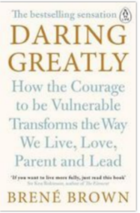  Copied under s 113P of the Copyright Act, [Brene Brown, Daring Greatly: How the Courage to Be Vulnerable Transforms the Way We Live, Love, Parent, and Lead, Penguin Life, February 1 2016, 9780241257401. | 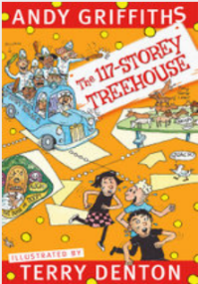  Copied under s 113P of the Copyright Act, Terry Denton, The 117-Storey Treehouse, Pan Macmillan, July 23 2019, 1760559148. | 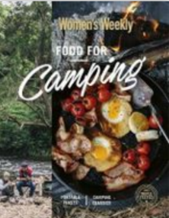  Copied under s 113P of the Copyright Act, The Australian Women’s Weekly, Food for Camping, AWW Cookbooks, July 30 2018,1925694682.
Alternative Task: Students can use book websites to find examples of each type of text or interview the school librarian to find some examples.

Tone
- Don’t take that tone with me! Teacher walks into the classroom and says this phrase in an angry tone. Ask students how they thought you were feeling when you said this. Repeat entering the classroom and saying the same phrase in different ways, for example, pleading, nervous, fearful, happy, sarcastic. Discuss that it is not always what is said, but how it is said. Discuss how authors get this tone across with words alone.
- Brainstorm a list of words that describe an emotion/tone, for example, annoyed, happy, unconcerned, sad, bitter, joyful, direct. Categorise the words into three groups:
- Positive tone words – happy, joyful
- Neutral tone words – unconcerned, direct
- Negative tone words – sad, bitter
- Students fold a piece of paper into quarters. Write one tone word in each quadrant. Students work with a partner. One person suggests a situation where there is a problem and the other partner responds with a solution in a tone from one of the quadrants. Swap and then rotate partners.
- Discuss tone and what clues might be found in a text to indicate the tone of an author. Tone is the voice adopted by a particular speaker to indicate emotion, feeling or attitude towards a subject matter. In the context of author perspective, tone is the author's attitude towards the subject and audience, for example playful, serious, ironic, formal. (NSW English K-10 Syllabus Glossary, 2012). Teacher reads a range of excerpts from texts and leads a discussion into what tone the author is presenting.
- Students complete ‘Identifying tone memory (Appendix 2 - Identifying tone memory). Students are given a set of the cards and arrange them face down. Students then turn over two cards and see if they match, return if not and keep pairs if they match.
- Students are given a whole text to read linked to current unit of learning to explore. Students work in teams to discuss and identify the tone of each section within the text. This task can be done with any text linked with a current unit of learning. Students track how the tone changes throughout the text and visually represent the changes. Students discuss how this impacts author perspective, for example, the beginning of an article might state facts and statistics and be quite formal yet end with an emotional appeal, indicating the author’s perspective.

Mood
- Teacher shows an image for students to brainstorm the mood it evokes for the viewer. Discuss that mood is the feeling of the viewer and reader and this is impacted by the author’s tone.
- Students add mood to the final column in Task 2.
- Mood board: Students are given a mood to become experts in. Students find text examples and images to create a ‘mood board’ to share with class.

Bias
- Watch and review BTN: Fake News short video. Students discuss the key points and overall theme of the video. Teacher leads a discussion about bias and how it is important for readers to identify bias in texts when determining author perspective.
- Finding the gaps: Discuss the idea that when authors compose a text, they are choosing what they put in and leave out of their writing; an author would not talk about disliking vegetables if the text was promoting healthy food choices. Have students read a range of newspaper articles from kidsnews.com.au which are linked to a current unit of learning. Students read the headline and brainstorm what ideas they are expecting to find in the text, as well as the opposing view in the following format:
Headline:

Predicted ideas that support headline | Predicted ideas that do not support the headline:

Questions:
As students are reading the text, colour-code whether the information is for or against the perspective presented in the article. Students then brainstorm a list of questions, from a different perspective, that they would want to ask the author or an expert.
- Experts and stats: Have students identify and research names and titles of the people cited in an article. Students research the experts and discuss with a partner how credible they are. Students work in pairs to identify statistics, images, facts, and graphics to help ascertain the author’s perspective. Using the statistics and information, students answer the following: what does the author want readers to learn or know? What was included? What wasn’t included?

Identifying author perspective
- Gallery Walk: Using enlarged visual stimulus (Appendix 3 - Identify author perspective in images), students walk around the classroom and add their ideas about tone, mood, bias and audience to the page. Students might like to add dialogue, possible predictions and who might be in the picture, as well as what the photographer wanted the viewer to learn or know from the image.
- Match and sort: Students work in teams to identify which elements show a fact, opinion and a possible author perspective. Appendix 4 - Author perspective match and sort has two versions, a scaffolded version and a more challenging version. If using the scaffolded version, students need only sort into author perspective, fact and opinion. If using the challenging version, students need to sort into topic, as well as into fact, opinion and author perspective.
- Teacher demonstrates how to use graphic organiser (Appendix 5 - Graphic organiser for identifying author perspective) to build an understanding of all the elements of the text used to identify the author’s perspective. Students use the graphic organiser to determine an author’s perspective on a range of fiction and non-fiction texts or using example texts in Appendix 6 - Identifying author perspective in texts.

Finding perspectives

In pairs or small groups, students are to find a minimum of two current news articles that show different perspectives on the same topic/situation. Teachers might source texts that will achieve this purpose prior to the lesson. This may be two different people at an event, opposition leaders discussing a current topic or professionals discussing a current issue.

Questions to consider
- What is different about the perspectives?
- Are there any similarities?
- What influences both parties’ perspectives?
- Would you think differently if you only read one of the articles?
- When is it ok to only focus on one perspective and when should we look at different perspectives?

Appendix 1

Interview with an author
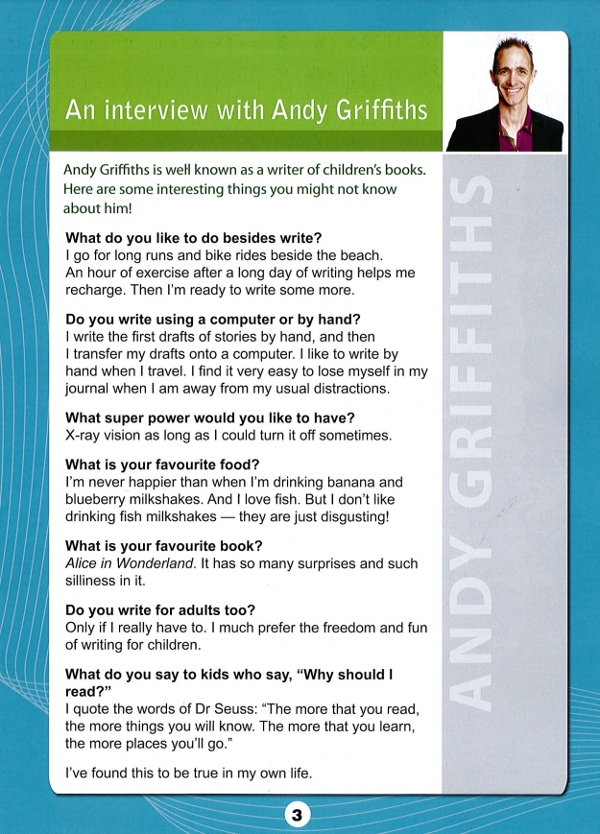
Year 5 NAPLAN Reading Magazine, 2013 ACARA

Interview with an author: accessible version
An interview with Andy Griffiths
Andy Griffiths is well known as a writer of children’s books. Here are some interesting things you might not know about him!
What do you like to do besides write?
I go for long runs and bike rides beside the beach. An hour of exercise after a long day of writing helps me recharge. Then I’m ready to write some more.
Do you write using a computer or by hand?
I write the first drafts of stories by hand, and then I transfer my drafts onto a computer. I like to write by hand when I travel. I find it very easy to lose myself in my journal when I am away from my usual distractions.
What super power would you like to have?
X-ray vision as long as I could turn it off sometimes.
What is your favourite food?
I’m never happier than when I’m drinking banana and blueberry milkshakes. And I love fish. But I don’t like drinking fish milkshakes — they are just disgusting!
What is your favourite book?
Alice in Wonderland. It has so many surprises and such silliness in it.
Do you write for adults too?
Only if I really have to. I much prefer the freedom and fun of writing for children.
What do you say to kids who say, “Why should I read?”
I quote the words of Dr Seuss: “The more that you read, the more things you will know. The more that you learn, the more places you’ll go.”
I’ve found this to be true in my own life.
Year 5 NAPLAN Reading Magazine, 2013 ACARA

Appendix 2

Identifying tone memory
Cut out each section and provide each group with a set
The wind howled and brought shivers down my spine. | Informal
Learning a new language can be super fun and exciting! | Informal
It is important that students get at least eight hours of sleep each night to ensure they can be productive in class. | Formal
It is understandable that some people are a little unsure of what to do when fishing for the first time. | Informal
Folding the paper with precision will help the paper plane to maintain its structure. | Formal
What a fabulous idea you have – I can see you have really thought about this. | Informal
Ensuring the planet’s survival is imperative. | Formal
‘I’m never happier than when I’m drinking banana and blueberry milkshakes. And I love fish. But I don’t like drinking fish milkshakes — they are just disgusting!’  Andy Griffiths* | Informal
*An interview with Andy Griffiths Year 5 NAPLAN Reading Magazine, 2013 ACARA

Identifying tone memory - extension
Cut out each section and provide each group with a set
The wind howled and brought shivers down my spine. | Dramatic | Informal
Learning a new language can be super fun and exciting! | Encouraging | Informal
Students need to get at least eight hours of sleep each night to ensure they can be productive in class. | Informative | Formal
It is understandable that some people are a little unsure of what to do when fishing for the first time. | Sympathetic | Informal
Folding the paper with precision will help the paper plane to maintain its structure. | Informative | Formal
What a fabulous idea you have – I can see you have really thought about this. | Complimentary | Informal
Ensuring the planet’s survival is imperative. | Urgent | Formal
‘I’m never happier than when I’m drinking banana and blueberry milkshakes. And I love fish. But I don’t like drinking fish milkshakes — they are just disgusting!’  Andy Griffiths * | Humorous | Informal
*An interview with Andy Griffiths Year 5 NAPLAN Reading Magazine, 2013 ACARA

Appendix 3

Identify author perspective in images
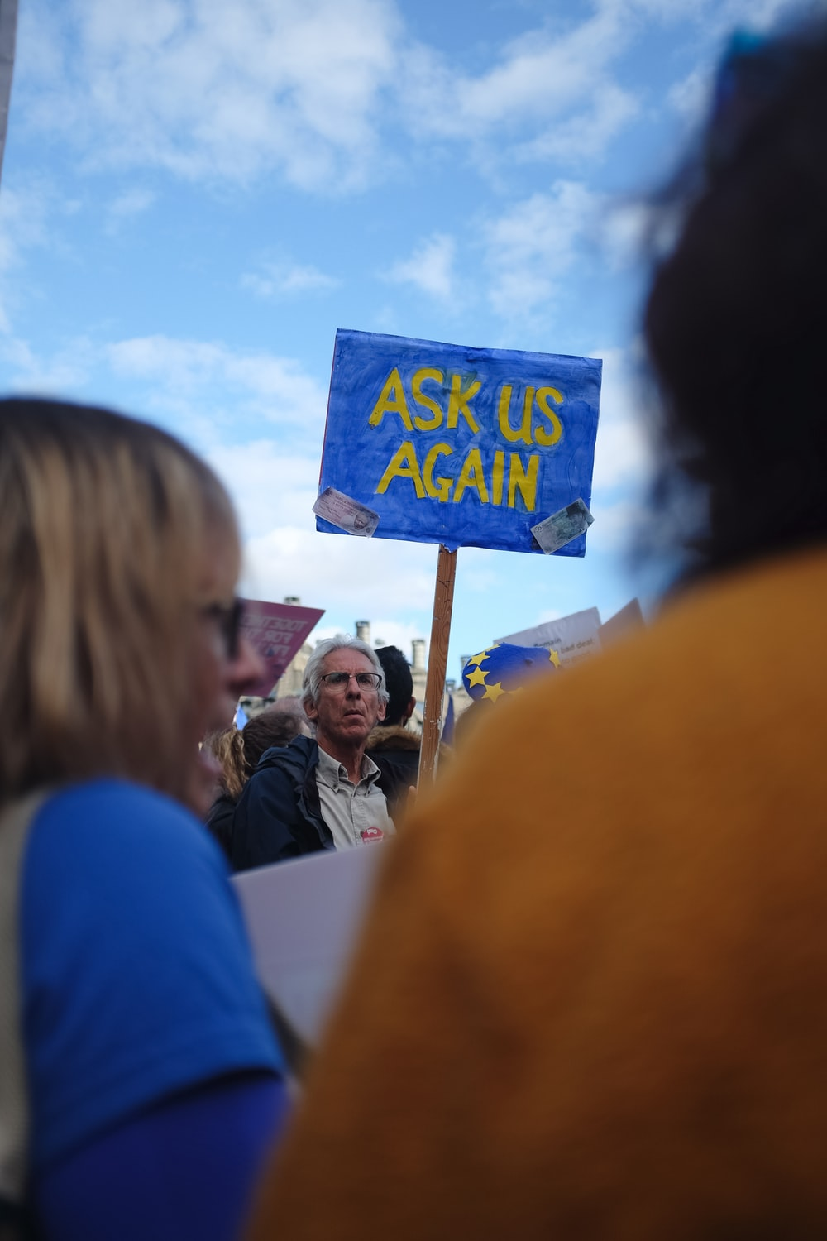
Photo by Jannes Van den Wouwer on Unsplash.com

Identify author perspective in images
Photo by mauro mora on Unsplash.com

Identify author perspective in images
Photo by Markus Spiske on Unsplash.com

Identify author perspective in images
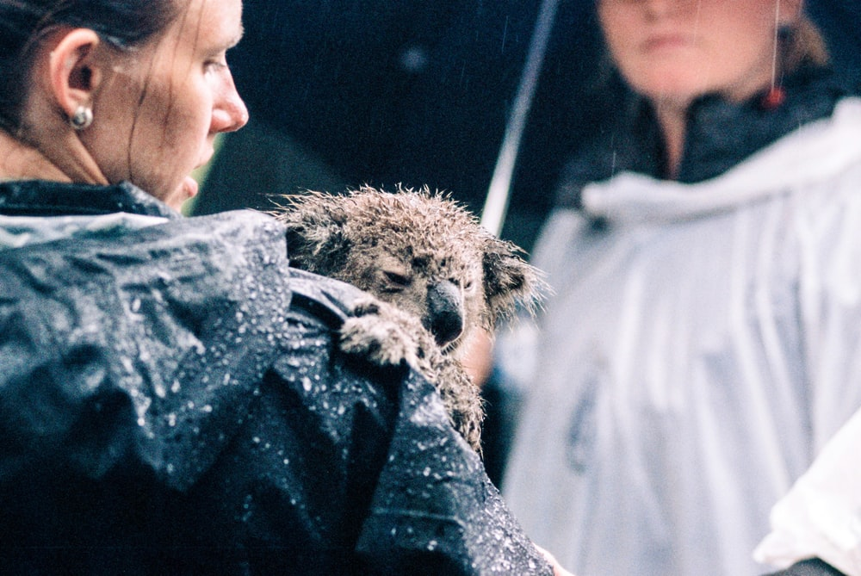
Photo by simon peel on Unsplash.com

Appendix 4

Author perspective match and sort
Topic | Fact | Opinion | Author perspective
Recycling | Aluminium and steel products are 100 per cent recyclable. | “...I am sick of trying to encourage people to recycle.” | Convincing people to recycle takes effort.
Beaches | Australia's coastline stretches almost 50,000 kilometres. | There are literally hundreds of awesome beaches in Australia. | Australia’s beaches are a drawcard for tourism and are an important part of our lifestyle.
Environment | ‘North American and European apiarists (beekeepers) have recorded losses of up to half of their bee colonies.’ | “You don’t see as many bees in the garden anymore…It must be all the pesticide people use.” | ‘Colony collapse has put bees firmly in the scientific spotlight, and it is a problem we cannot afford to ignore.’
Pollution | ‘According to the latest European Space Agency statistical modelling, there are approximately 34,000 objects greater than 10 centimetres in orbit, but up to 128 million items between one millimetre and one centimetre floating around.’ | “People need to take responsibility for all their rubbish, even in space!” | ‘Humans have left an absolute mess in space but no one wants to clean it up.’
Healthy eating | ‘Children aged 2-3 years should eat 1 serve of fruit and 2.5 serves of vegetables and children aged 4-8 years should eat 1.5 serves of fruit and 4.5 serves of vegetables, each day.’ | I like to eat fruits and vegetables. They are tasty, delicious and nutritious. | ‘Tasting and learning about new fruit and vegetables is the best way for young children to become more familiar with them.’
Sources (Fact and Author’s Perspective):
Environment: ‘The honey bee mystery’. Year 5 NAPLAN Reading Magazine, 2015 ACARA
Copied under the statutory licence in s113P of the Copyright Act.,
Healthy Eating: Munch and Move Eat more Fruit and Vegetables Fact Sheet., Munch & Move NSW Government, . Date accessed 30 August 2021..
Cecilia Duong, Pollution: ‘Space Junk: Houston we have a problem.’ University of New South Wales, Date accessed 2 June 2021.
Section 113P Warning Notice.

Colour-coded author perspective match and sort
Topic | Fact | Opinion | Author perspective
Topic  Recycling | Fact  Aluminium and steel products are 100 per cent recyclable. | Opinion  “...I am sick of trying to encourage people to recycle.” | Author perspective  Convincing people to recycle takes effort.
Topic  Beaches | Fact  Australia's coastline stretches almost 50,000 kilometres. | Opinion  There are literally hundreds of awesome beaches in Australia. | Author perspective  Australia’s beaches are a drawcard for tourism and are an important part of our lifestyle.
Topic  Environment | ‘North American and European apiarists (beekeepers) have recorded losses of up to half of their bee colonies.’ | “You don’t see as many bees in the garden anymore…It must be all the pesticide people use.” | ‘Colony collapse has put bees firmly in the scientific spotlight, and it is a problem we cannot afford to ignore.’
Topic  Pollution | Fact  ‘According to the latest European Space Agency statistical modelling, there are approximately 34,000 objects greater than 10 centimetres in orbit, but up to 128 million items between one millimetre and one centimetre floating around.’ | Opinion  “People need to take responsibility for all their rubbish, even in space!” | Author perspective  ‘Humans have left an absolute mess in space but no one wants to clean it up.’
Topic  Healthy eating | Fact  ‘Children aged 2-3 years should eat 1 serve of fruit and 2.5 serves of vegetables and children aged 4-8 years should eat 1.5 serves of fruit and 4.5 serves of vegetables, each day.’ | Opinion  I like to eat fruits and vegetables. They are tasty, delicious and nutritious. | Author perspective  ‘Tasting and learning about new fruit and vegetables is the best way for young children to become more familiar with them.’
Sources (Fact and Author’s Perspective):
Environment: ‘The honey bee mystery’. Year 5 NAPLAN Reading Magazine, 2015 ACARA
Copied under the statutory licence in s113P of the Copyright Act.,
Healthy Eating: Munch and Move Eat more Fruit and Vegetables Fact Sheet., Munch & Move NSW Government, . Date accessed 30 August 2021.Section 113P Warning Notice.
Cecilia Duong, Pollution: ‘Space Junk: Houston we have a problem.’ University of New South Wales, Date accessed 2 June 2021.
Section 113P Warning Notice.

Appendix 5

Graphic organiser for identifying author perspective
Purpose | Tone
Mood | Bias
Author’s perspective | What I think…

Appendix 6

Identifying author perspective in texts
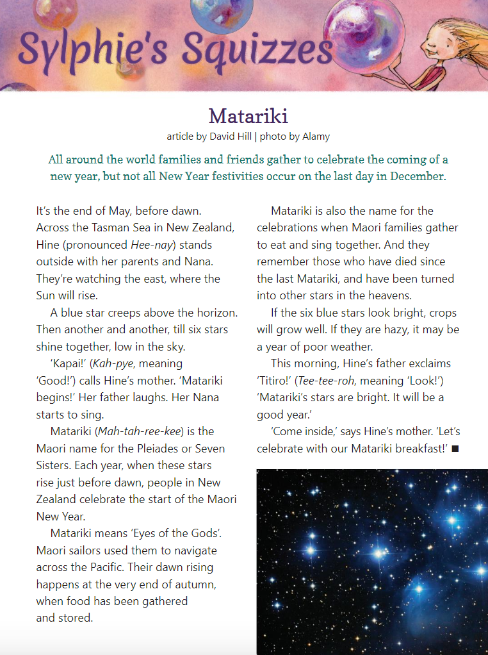
The School Magazine © NSW (Department of Education), Orbit Issue 1 2019

Identifying author perspective in texts – accessible version
Sylphie’s Squizzes
Matariki
Article by David Hill. Photo by Alamy.
All around the world families and friends gather to celebrate the coming of a new year, but not all New Year festivities occur on the last day in December.
It’s the end of May, before dawn. Across the Tasman Sea in New Zealand, Hine (pronounced Hee-nay) stands outside with her parents and Nana.
They’re watching the east, where the Sun will rise.
A blue star creeps above the horizon. Then another and another, till six stars shine together, low in the sky.
‘Kapai!’ (Kah-pye, meaning ‘Good!’) calls Hine’s mother. ‘Matariki begins!’ Her father laughs. Her Nana starts to sing.
Matariki (Mah-tah-ree-kee) is the Maori name for the Pleiades or Seven sisters. Each year, when these stars rise just before dawn, people in New Zealand celebrate the start of the Maori New year.
Matariki means ‘Eyes of the Gods’. Maori sailors used them to navigate across the Pacific. Their dawn rising happens at the very end of autumn, when food has been gathered and stored.
Matariki is also the name for the celebrations when Maori families gather to eat and sing together. And they remember those who have died since the last Matariki, and have been turned into other stars in the heavens.
If the six blue stars look bright, crops will grow well. If they are hazy, it may be a year of poor weather.
This morning, Hine’s father exclaims ‘Titiro!’ (Tee-tee-roh, meaning ‘Look!’) ‘Matariki’s stars are bright. It will be a good year.’
‘Come inside,’ says Hine’s mother. ‘Let’s celebrate with our Matariki breakfast!’
The School Magazine © NSW (Department of Education), Orbit Issue 1, 2019

Identifying author perspective in texts
The Barber Shop – Scissor Twister, by Andrew Cranna
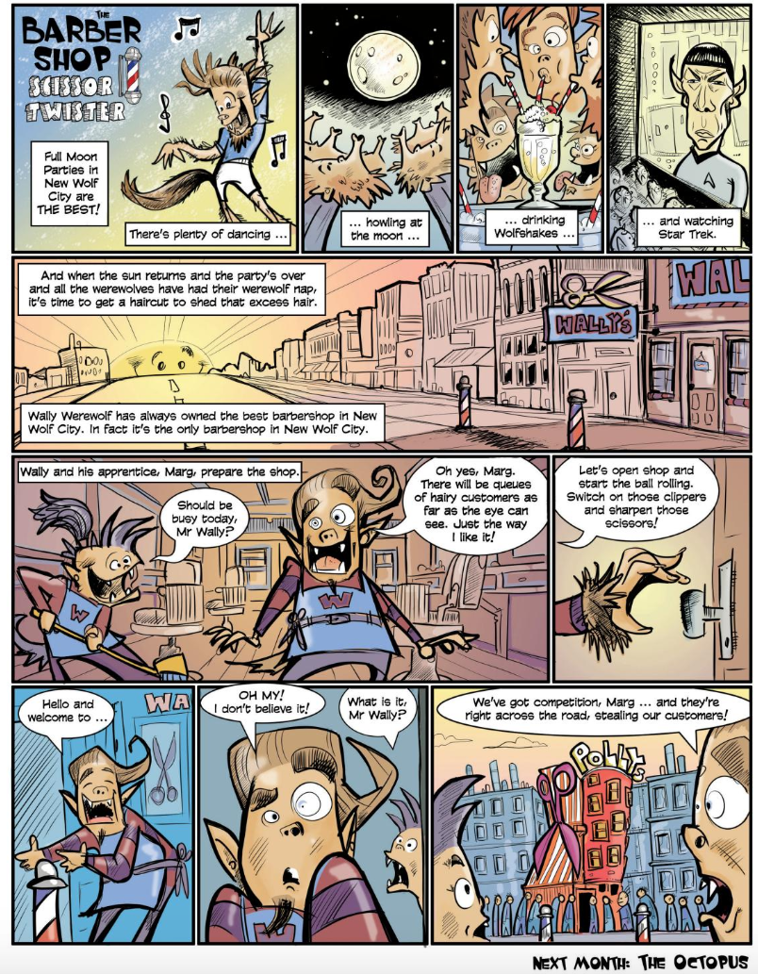
The School Magazine © NSW (Department of Education) Orbit Issue 1, 2019.

Identifying author perspective in texts – accessible version
The Barber Shop – Scissor Twister, by Andrew Cranna
Full moon parties in New Wolf City are THE BEST. There’s plenty of dancing...
...howling at the moon...
...drinking Wolfshakes...
...and watching Star Trek...
...And when the sun returns and the party’s over and all the werewolves have had their werewolf nap, it is time to get a haircut to shed that extra hair.
Wally Werewolf has always owned the best barbershop in New Wolf City. In fact, it’s the only barbershop in New Wolf city.
Wally and his apprentice, Marg, prepare the shop.
“Should be busy today Mr Wally?”
“Oh yes, Marg. There will be queues of hairy customers as far as the eye can see. Just the way I like it!”
“Let’s open shop and start the ball rolling. Switch on those clippers and sharpen those clippers.”
“Hello and welcome to...”
“OH MY. I don’t believe it.”
“What is it, Mr Wally?”
“We’ve got competition, Marg...and they’re right across the road, stealing our customers!”
The School Magazine © NSW (Department of Education) Orbit Issue 1, 2019

Identifying author perspective in texts
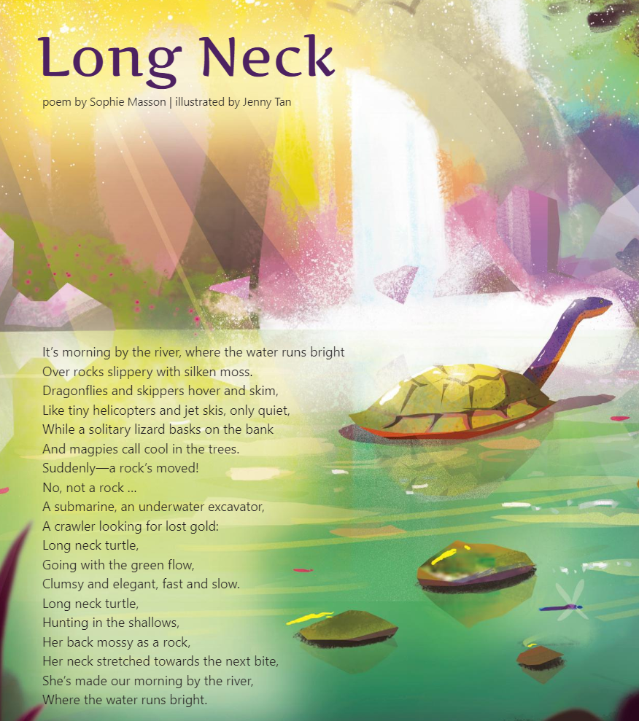
The School Magazine © NSW (Department of Education) Orbit Issue 1, 2019

Identifying author perspective in texts - accessible version
Long neck
Poem by Sophie Masson, illustrated by Jenny Tan
It’s morning by the river, where the water runs bright
Over rocks slippery with silken moss.
Dragonflies and skippers hover and skim,
Like tiny helicopters and jet skis, only quiet,
While a solitary lizard basks on the bank
And magpies call cool in the trees.
Suddenly- a rock’s moved!
No, not a rock…
A submarine, an underwater excavator,
A crawler looking for lost gold:
Long neck turtle,
Going with the green flow,
Clumsy and elegant, fast and slow.
Long neck turtle,
Hunting in the shallows,
Her back mossy as a rock,
Her neck stretched towards the next bite,
She’s made our morning by the river,
Where the water runs bright.
The School Magazine, NSW (Department of Education) Orbit Issue 1 2019

Identifying author perspective in texts
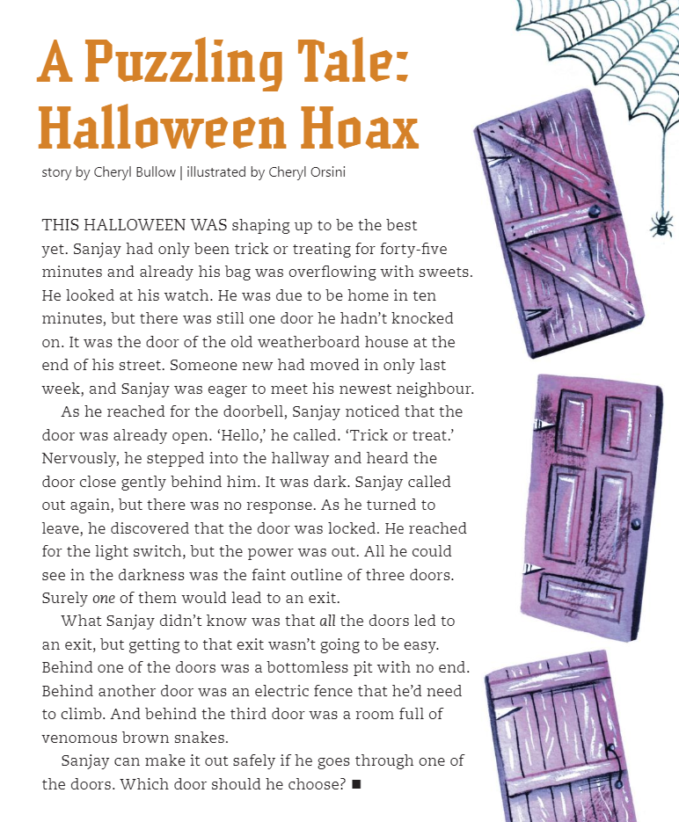
The School Magazine, NSW (Department of Education) Orbit Issue 1 2019

Identifying author perspective in texts – accessible version
A puzzling Tale:
Halloween Hoax.
Story by Cheryl Bullow. Illustrated by Cheryl Orsini.
This Halloween was shaping up to be the best yet. Sanjay had only been trick or treating for forty-five minutes and already his bag was overflowing with sweets. He looked at his watch. He was due to be home in ten minutes, but there was still one door he hadn’t knocked on. It was the door of the old weatherboard house at the end of his street. Someone new had moved in only last week, and Sanjay was eager to meet his newest neighbour.
As he reached for the doorbell, Sanjay noticed that the door was already open. ‘Hello,’ he called. ‘Trick or treat.’ Nervously, he stepped into the hallway and heard the door close gently behind him. It was dark. Sanjay called out again, but there was no response. As he turned to leave, he discovered that the door was locked. He reached for the light switch, but the power was out. All he could see in the darkness was the faint outline of three doors. Surely one of them would lead to an exit.
What Sanjay didn’t know was that all the doors led to an exit, but getting to that exit wasn’t going to be easy. Behind one of the doors was a bottomless put with no end. Behind another door was an electric fence that he’d need to climb. And behind the third door was a room full of venomous brown snakes.
Sanjay can make it out safely if he goes through one of the doors. Which door should he choose?
The School Magazine, NSW (Department of Education) Orbit Issue 1 2019

Identifying author perspective in texts
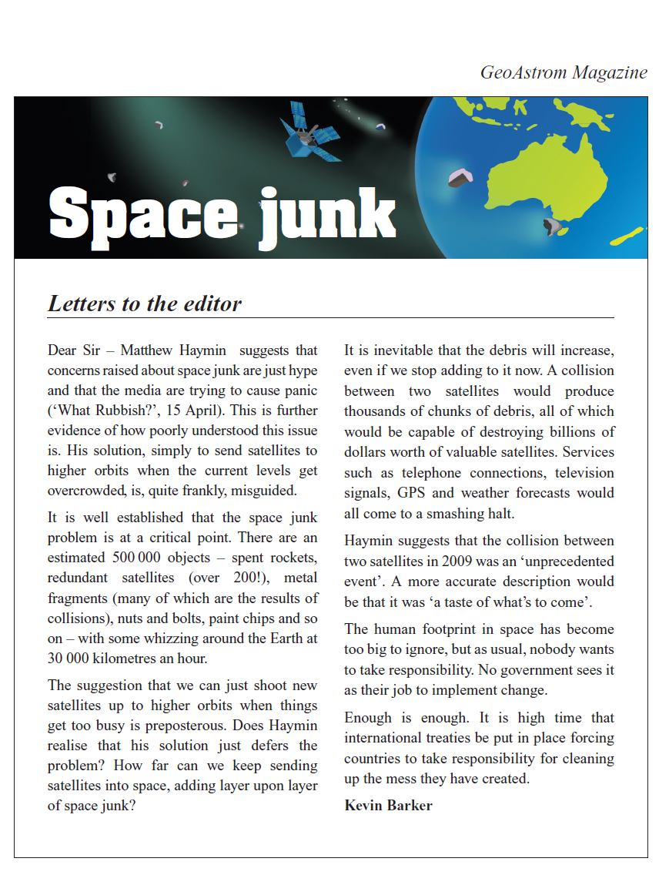
Year 5 NAPLAN Reading Magazine, 2012 ACARA

Identifying author perspective in texts – accessible version
GeoAstrom magazine
Space Junk
Letters to the editor
Dear Sir – Matthew Haymin suggests that concerns raised about space junk are just hype and that the media are trying to cause panic (‘What Rubbish?’, 15 April). This is further evidence of how poorly understood this issue is. His solution, simply to send satellites to higher orbits when the current levels get overcrowded, is, quite frankly, misguided.
It is well established that the space junk problem is at a critical point. There are an estimated 500 000 objects – spent rockets, redundant satellites (over 200!), metal fragments (many of which are the results of collisions), nuts and bolts, paint chips and so on – with some whizzing around the Earth at 30 000 kilometres an hour.
The suggestion that we can just shoot new satellites up to higher orbits when things get too busy is preposterous. Does Haymin realise that his solution just defers the problem? How far can we keep sending satellites into space, adding layer upon layer of space junk?
It is inevitable that the debris will increase, even if we stop adding to it now. A collision between two satellites would produce thousands of chunks of debris, all of which would be capable of destroying billions of dollars worth of valuable satellites. Services such as telephone connections, television signals, GPS and weather forecasts would all come to a smashing halt.
Haymin suggests that the collision between two satellites in 2009 was an ‘unprecedented event’. A more accurate description would be that it was ‘a taste of what’s to come’.
The human footprint in space has become too big to ignore, but as usual, nobody wants to take responsibility. No government sees it as their job to implement change.
Enough is enough. It is high time that international treaties be put in place forcing countries to take responsibility for cleaning up the mess they have created.
Kevin Barker
Year 5 NAPLAN Reading Magazine, 2012 ACARA

Identifying author perspective in texts
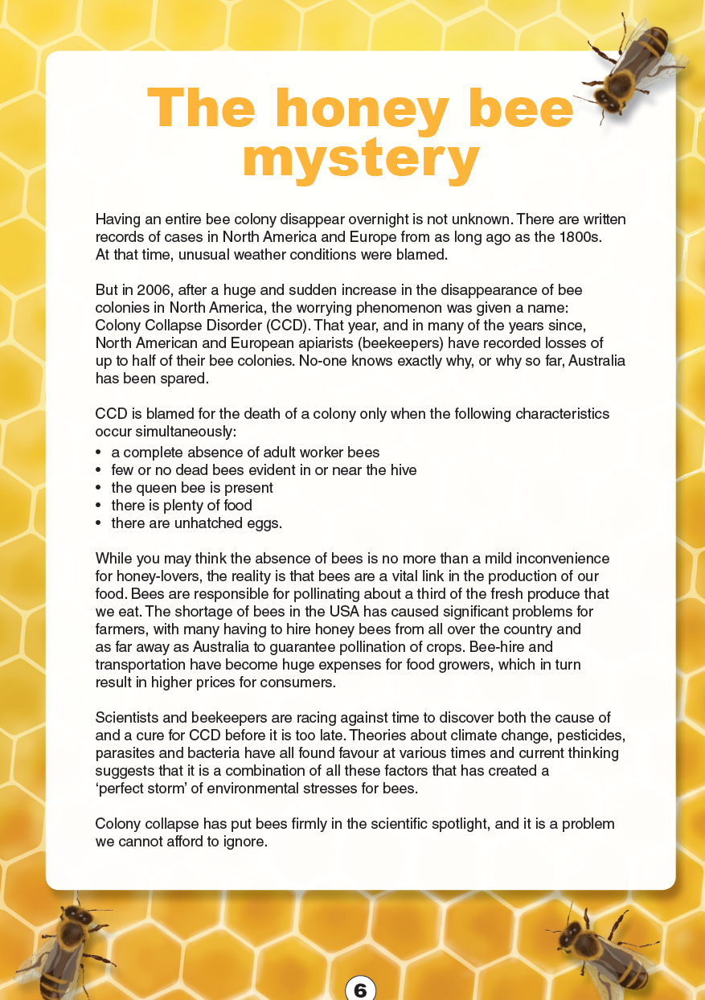
Year 5 NAPLAN Reading Magazine, 2015 ACARA
Appendix 6
Identifying author perspective in texts – accessible version
The honey bee mystery
Having an entire bee colony disappear overnight is not unknown. There are written records of cases in North America and Europe from as long ago as the 1800s. At that time, unusual weather conditions were blamed.
But in 2006, after a huge and sudden increase in the disappearance of bee colonies in North America, the worrying phenomenon was given a name: Colony Collapse Disorder (CCD). That year, and in many of the years since, North American and European apiarists (beekeepers) have recorded losses of up to half of their bee colonies. No-one knows exactly why, or why so far, Australia has been spared.
CCD is blamed for the death of a colony only when the following characteristics occur simultaneously:
• a complete absence of adult worker bees
• few or no dead bees evident in or near the hive
• the queen bee is present
• there is plenty of food
• there are unhatched eggs.
While you may think the absence of bees is no more than a mild inconvenience for honey-lovers, the reality is that bees are a vital link in the production of our food. Bees are responsible for pollinating about a third of the fresh produce that we eat. The shortage of bees in the USA has caused significant problems for farmers, with many having to hire honey bees from all over the country and as far away as Australia to guarantee pollination of crops. Bee-hire and transportation have become huge expenses for food growers, which in turn result in higher prices for consumers.
Scientists and beekeepers are racing against time to discover both the cause of and a cure for CCD before it is too late. Theories about climate change, pesticides, parasites and bacteria have all found favour at various times and current thinking suggests that it is a combination of all these factors that has created a ‘perfect storm’ of environmental stresses for bees.
Colony collapse has put bees firmly in the scientific spotlight, and it is a problem we cannot afford to ignore.
Year 5 NAPLAN Reading Magazine, 2015 ACARA

