Sequencing events in informative texts
Stage 2

Overview

Purpose
This literacy teaching strategy supports teaching and learning for Stage 2 students across all key learning areas. It targets specific literacy skills and suggests a learning sequence to build skill development. Teachers can select individual tasks, or a sequence, and embed into their teaching and learning program according to their students’ needs. While exemplar texts are provided throughout this resource, it is recommended that teachers select texts which are relevant to their students and curriculum.

Learning focus
Students will learn to sequence events in informative texts. Students will identify a logical sequence of events and use vocabulary cues and images to accurately summarise and sequence.

Syllabus outcome
The following teaching and learning strategies will assist in covering elements of the following outcomes:
- EN2-RECOM-01: reads and comprehends texts for wide purposes using knowledge or text structures and language, and by monitoring comprehension
NSW English Syllabus K-10 2022

Year 3 NAPLAN item descriptors
The following Year 3 NAPLAN item descriptors may guide teachers to develop success criteria for student learning.
- sequences events from a text
- sequences events from an informative text
- interprets a simple flow chart

National Literacy Learning Progression guide

Understanding Texts (UnT6-UnT9)
Key: C=comprehension P=process V=vocabulary

UnT6
- scans texts to locate specific information in a predictable print text (C)
- uses cohesive devices to connect ideas or events (e.g. tracks pronoun referencing) (see Grammar) (P)

UnT7
- monitors the development of ideas using language and visual features (e.g. topic sentences, key verbs, graphs) (C)
- navigates text using common signposting devices such as headings, subheadings, paragraphs, navigation bars and links (P)

UnT8
- uses knowledge of cohesive devices to track meaning throughout a text (e.g. connectives such as however, on the other hand) (see Grammar) (P)

UnT9
- uses knowledge of a broader range of cohesive devices to track meaning (e.g. word associations) (see Grammar) (P)
National Literacy Learning Progression

Evidence base
- Centre for Education Statistics and Evaluation (2017). Effective reading instruction in the early years of school, literature review.
- Konza, D. (2014). Teaching Reading: Why the “Fab Five” should be the “Big Six”. Australian Journal of Teacher Education, 39(12).
- Oakhill, J., Cain, K. & Elbro, C. (2015). Understanding and teaching reading comprehension: A handbook. Routledge.
- Quigley, A. (2020). Closing the reading gap. Routledge.
- Scarborough, H.S. (2001). Connecting early language and literacy to later reading (dis)abilities: Evidence, theory and practice. In S. Neuman & D. Dickson (Eds.), Handbook for research in early literacy (pp. 97-110). New York, NY: Guilford Press.
Alignment to system priorities and/or needs: Five priorities for Literacy and Numeracy, Our Plan for NSW Public Education, School Excellence Policy (nsw.gov.au).
Alignment to School Excellence Framework: Learning domain: Curriculum, Teaching domain: Effective classroom practice and Professional standards
Consulted with: Strategic Delivery, Teaching Quality and Impact
Author: Literacy and Numeracy
Reviewed by: Literacy and Numeracy, Teaching Quality and Impact
Created/last updated: January 2024
Anticipated resource review date: January 2025
Feedback: Complete the online form to provide any feedback
Copyright
Section 113P Notice
Texts, Artistic Works and Broadcast Notice
Some of this material has been copied and communicated to you in accordance with the statutory licence in section 113P of the Copyright Act. Any further reproduction or communication of this material by you may be the subject of copyright protection under the Act. Do not remove this notice.

Teaching strategies
Task | Appendices
Informative text: Where does honey come from? | Appendix 1 - Flow chart graphic organisers  Appendix 2 - ‘Honey Bees’ text  Appendix 3 - ‘Honey Bees’ student information (support)  Appendix 4 - Jigsaw text
Informative text: Honey recipes | Appendix 5 - Sequencing recipe: images only  Appendix 6 - Sequencing recipe: text support  Appendix 7 - Sequencing recipe: images and text

Background Information

Sequencing events
Sequencing is an important comprehension skill for students to organise and structure ideas and events in order of occurrence. Opportunities for sequencing can include using pictures, letters and numbers, recipes, pieces of music and dance steps. Students need to have opportunities to read a wide variety of texts that do not always follow the sequential pattern of first, second, third etc. but rather use texts that have embedded events or steps that require the student to question and consider the logical sequence that may not be presented in this manner.

Connectives
Words which link paragraphs and sentences in logical relationships of time, cause and effect, comparison or addition. Connectives relate ideas to one another and help to show the logic of the information. Connectives are important resources for creating cohesion in texts. The logical relationships can be grouped as follows:
- temporal – to indicate time or sequence ideas, for example first, second, next
- causal – to show cause and effect, explaining how something works or why something happens. for example because, for, so
- additive – to add information, for example also, besides, furthermore
- comparative – for example rather, alternatively
- conditional/concessive – to make conditions or concession, describes the condition that needs to be met for something to happen. For example yet, although
- clarifying – for example in fact, for example.
Reference: English K-10 Syllabus © NSW Education Standards Authority (NESA) for and on behalf of the Crown in right of the State of New South Wales, 2012 and 2022.

Where to next?
- Types of text structure
- Literal comprehension
- Text features

Overview of teaching strategies

Purpose
These literacy teaching strategies support teaching and learning from Stage 2 to Stage 5. They are linked to NAPLAN task descriptors, syllabus outcomes and literacy and numeracy learning progressions.
These teaching strategies target specific literacy and numeracy skills and suggest a learning sequence to build skill development. Teachers can select individual tasks or a sequence to suit their students.

Access points
The resources can be accessed from:
- NAPLAN App in Scout using the teaching strategy links from NAPLAN items
- NSW Department of Education literacy and numeracy website.

What works best
Explicit teaching practices involve teachers clearly explaining to students why they are learning something, how it connects to what they already know, what they are expected to do, how to do it and what it looks like when they have succeeded. Students are given opportunities and time to check their understanding, ask questions and receive clear, effective feedback.
This resource reflects the latest evidence base and can be used by teachers as they plan for explicit teaching.
Teachers can use classroom observations and other assessment information to make decisions about when and how they use this resource as they design teaching and learning sequences to meet the learning needs of their students.
Further support with What works best is available.

Differentiation
When using these resources in the classroom, it is important for teachers to consider the needs of all students, including Aboriginal and EAL/D learners.
EAL/D learners will require explicit English language support and scaffolding, informed by the EAL/D enhanced teaching and learning cycle and the student’s phase on the EAL/D Learning Progression. Teachers can access information about supporting EAL/D learners and literacy and numeracy support specific to EAL/D learners.
Learning adjustments enable students with disability and additional learning and support needs to access syllabus outcomes and content on the same basis as their peers. Teachers can use a range of adjustments to ensure a personalised approach to student learning.
Assessing and identifying high potential and gifted learners will help teachers decide which students may benefit from extension and additional challenge. Effective strategies and contributors to achievement for high potential and gifted learners helps teachers to identify and target areas for growth and improvement. A differentiation adjustment tool can be found on the High potential and gifted education website.

Using tasks across learning areas
This resource may be used across learning areas where it supports teaching and learning aligned with syllabus outcomes.
Literacy and numeracy are embedded throughout all syllabus documents as general capabilities. As the English and mathematics learning areas have a particular role in developing literacy and numeracy, NSW English and Mathematics syllabus outcomes aligned to literacy and numeracy skills have been identified.

Text selection
Example texts are used throughout this resource. Teachers can adjust activities to use texts which are linked to their unit of learning.
Further support with text selection can be found within the National Literacy Learning Progression Text Complexity appendix.
The NESA website has additional information on text requirements within the NSW English syllabus.

Teaching strategies

Informative text: Where does honey come from?
The following activities could be adapted to any suitable informative text relevant to a current unit of learning.
- Show a short clip on how bees make honey. (Please note: approach any external link with caution and check for appropriateness: How do bees make honey? Beekeeping with Maddie #13. www.youtube.com/watch?v=AECtOFpbgVs).
- Think-Pair-Share: Where does honey come from? Brainstorm ideas and record student responses. Then, students work with a partner to discuss and create a flow chart showing where they think honey comes from, using arrows and captions to sequence (refer to Appendix 1 - Flow chart graphic organisers for sample flow charts.) Teacher discusses and provides students with a bank of adverbial phrases and temporal connectives to be used in the captions.
- Barrier Game: Using the flow chart created in the previous step, students sit back-to-back with a partner. Using temporal connectives and adverbials, they instruct their partner to replicate their flow chart. Students can swap with their partner and discuss what worked, for example, “…first, the bee collects the pollen from the flower, after that…”
- Display and discuss the text ‘Honey Bees’ (Appendix 2 - ‘Honey Bees’ text), drawing attention to arrows, action verbs and sequence of events. Teacher to explicitly teach the purpose of the continuous arrows. For example, ‘What happens when we reach the end of the cycle?’ ‘What do we notice about the arrows? Do they stop?’ ‘What does this suggest (infer) about the life of the bees? Could the cycle change to adapt to the environment?’ Students use their own copy of the information and add to their flow charts created in the first part of the activity, further building their understanding.
Variation: A simplified version of ‘Honey Bees’ is in Appendix 3 - ‘Honey Bees’ student information (support) to support learners as needed, or smaller excerpts from main text can be used.
- Staging Skits: Students use the ‘Honey Bees’ text and their own flow charts to sequence and perform a short dramatic skit demonstrating where honey comes from. Students use whiteboards during peers’ skits to visually represent their sequence of events.
- Coding: Model how to identify and colour code connectives in the text ‘Honey Bees’ (Appendix 2). Explain and discuss types of temporal connectives which link paragraphs and sentences including: first, second, next. Read through the text, pausing to identify the type of connective used, for example, temporal, and explain how the connective is used to sequence events.
Variation: Use any suitable text linked to a current unit of learning.
- Jigsaw: Students work with a partner to sequence the text ‘Honey Bees’ (Appendix 4 - Jigsaw text). Teacher provides students with the cut-up text and moves between pairs prompting discussion. For example, ‘Are there any key words which are repeated?’ ‘How do these words connect ideas across paragraphs?’ ‘Has the author used connectives (when, if, then, soon) to sequence their ideas?’ Students then use the ‘think aloud’ strategy to explain and/or justify their sequencing choices to the class.

Informative text: Honey recipes
- Teacher demonstrates how to make a honey sandwich (bread, butter, honey, knife, plate). Students direct the teacher to create the sandwich with the teacher doing exactly as said. For example, if student says put honey on the bread, teacher places jar of honey on the loaf of bread. The purpose is to emphasise the importance of clear instructions, using adverbials to explain the manner in which the task is completed, and sequencing events correctly. For example, “After spreading the honey, place the other slice of bread on top”. Teacher emphasises that for a procedural text it is essential that all information is explicitly stated.
- Guided Instruction: Teacher displays images (without text) of the steps for making honey pancakes with ‘Honey pancakes teacher visual guide’ (Appendix 5 - Sequencing recipe: images only). Class sequences the images, justifying their decisions. Students use ‘Honey pancakes text support’ to aid their sequencing (Appendix 6 - Sequencing recipe: text support).
For correct sequence refer to Appendix 7 - Sequencing recipe: images and text.
- Students summarise and sequence the steps in a sequencing wheel. Students might then select or design their own graphic organiser to present their information.

Appendix 1

Graphic organiser – Flow chart

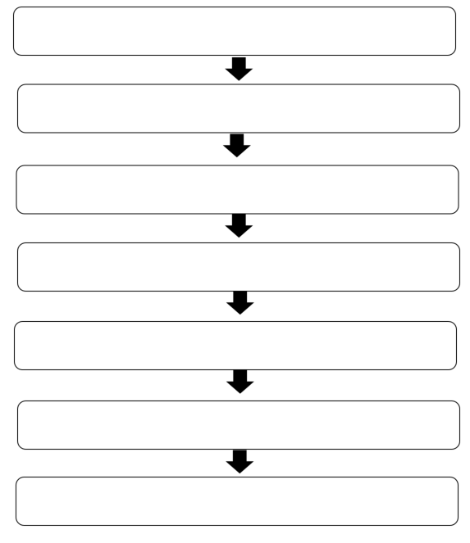

Appendix 1

Graphic organiser – sequencing wheel

Appendix 2

Sequencing events in informative texts: Honey bees
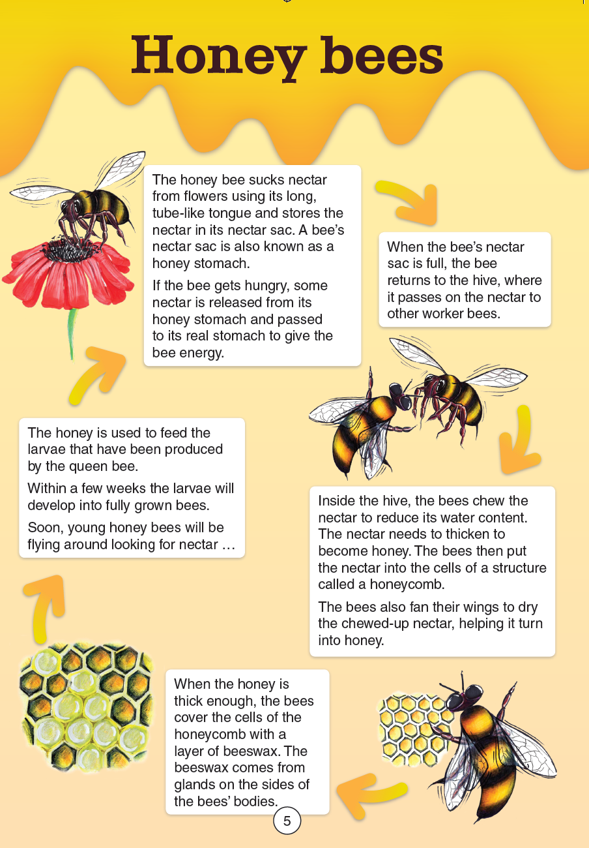
Year 3 NAPLAN Reading Magazine, 2012 ACARA
Appendix 2

Honey bees - Accessible version
The honey bee sucks nectar from flowers using its long, tube-like tongue and stores the nectar in its nectar sac. A bee’s nectar sac is also known as a honey stomach.
If the bee gets hungry, some nectar is released from its honey stomach and passed to its real stomach to give the bee energy.
When the bee’s nectar sac is full, the bee returns to the hive, where it passes on the nectar to other worker bees.
Inside the hive, the bees chew the nectar to reduce its water content.
The nectar needs to thicken to become honey. The bees then put the nectar into the cells of a structure called a honeycomb.
The bees also fan their wings to dry the chewed-up nectar, helping it turn into honey.
When the honey is thick enough, the bees cover the cells of the honeycomb with a layer of beeswax. The beeswax comes from glands on the sides of the bees’ bodies.
The honey is used to feed the larvae that have been produced by the queen bee. Within a few weeks the larvae will develop into fully grown bees. Soon, young honey bees will be flying around looking for nectar …
Year 3 NAPLAN Reading Magazine, 2012 ACARA

Appendix 3

Honey bees – Student Information (support)

Year 3 NAPLAN Reading Magazine, 2012 ACARA

Appendix 4

Jigsaw text
The honey bee sucks nectar from flowers using its long, tube-like tongue and stores the nectar in its nectar sac. A bee’s nectar sac is also known as a honey stomach.  If the bee gets hungry, some nectar is released from its honey stomach and passed to its real stomach to give the bee energy. | When the bee’s nectar sac is full, the bee returns to the hive, where it passes on the nectar to other worker bees.
Inside the hive, the bees chew the nectar to reduce its water content.  The nectar needs to thicken to become honey. The bees then put the nectar into the cells of a structure called a honeycomb.  The bees also fan their wings to dry the chewed-up nectar, helping it turn into honey. | When the honey is thick enough, the bees cover the cells of the honeycomb with a layer of beeswax. The beeswax comes from glands on the sides of the bees’ bodies.
The honey is used to feed the larvae that have been produced by the queen bee. Within a few weeks the larvae will develop into fully grown bees. Soon, young honey bees will be flying around looking for nectar …
Year 3 NAPLAN Reading Magazine, 2012 ACARA

Appendix 5

Sequencing recipe – images only
Photos from Unsplash.com
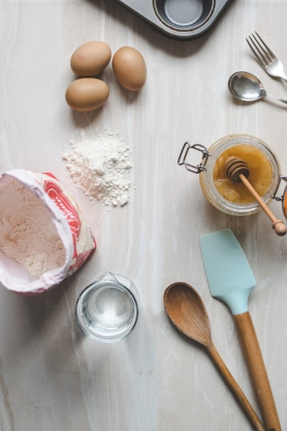 | 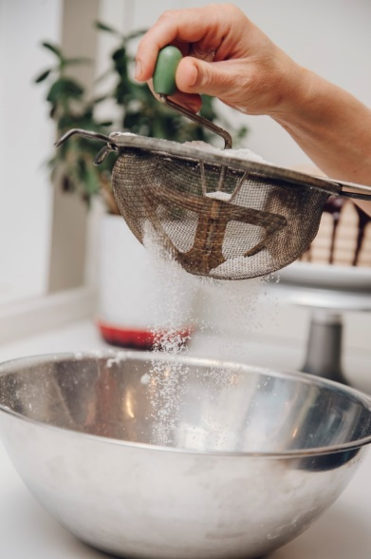
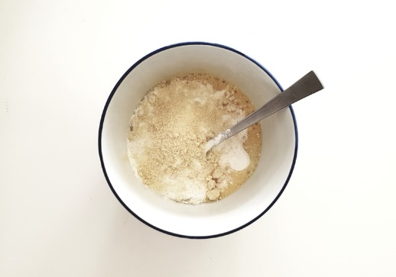 | 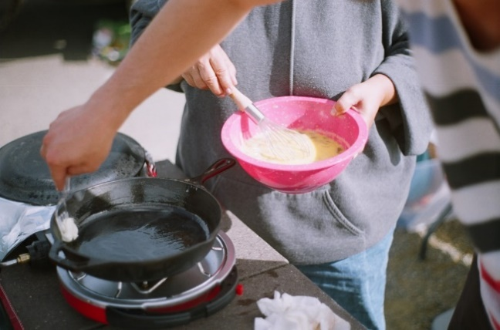

Appendix 6

Sequencing recipe – text support

Honey pancakes
This delicious honey pancake recipe is so easy and tasty – perfect for Sunday breakfast!

Ingredients:
- 1 cup self-raising flour (sifted)
- 1 tablespoon honey
- 1 egg (lightly beaten)
- ¾ cup milk
- 50g butter (melted)

Method:
- Gather all ingredients.
- Sift flour into a bowl.
- Beat the egg and honey, adding the milk a little at a time until the batter is smooth.
- Heat up the frypan with a little of the melted butter.
- Add about ¼ cup of the pancake mixture into the frypan and turn when bubbles form on the surface of the pancake.
- Serve with some extra honey!
Enjoy with some chopped banana and cinnamon to take this recipe out of this world!

Appendix 7

Sequencing recipe – images and text student copy
Gather all ingredients | 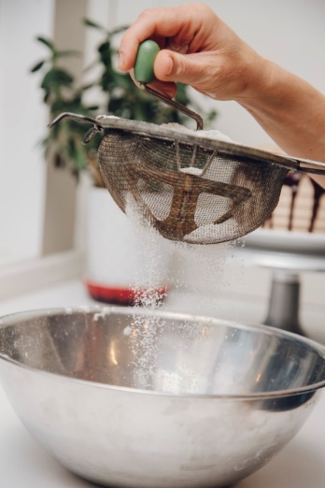  Sift flour into a bowl
Beat the egg and honey, adding the milk a little at a time until the batter is smooth. | Heat up the frypan with a little of the melted butter.
Add about ¼ cup of the pancake mixture into the frypan and turn when bubbles form on the surface of the pancake. | Serve with some extra honey!
Photos from Unsplash.com

