Sequencing imaginative texts
Stage 2

Overview

Purpose
This literacy teaching strategy supports teaching and learning for Stage 2 students across all key learning areas. It targets specific literacy skills and suggests a learning sequence to build skill development. Teachers can select individual tasks, or a sequence, and embed into their teaching and learning program according to their students’ needs. While exemplar texts are provided throughout this resource, it is recommended that teachers select texts which are relevant to their students and curriculum.

Learning intention
Students will learn to sequence events in imaginative texts. Students will identify a chronological sequence of events. Students will use vocabulary cues, such as temporal connectives, and images to accurately summarise and sequence.

Syllabus outcomes
The following teaching and learning strategies will assist in covering elements of the following outcomes:
- EN2-RECOM-01: reads and comprehends texts for wide purposes using knowledge or text structures and language, and by monitoring comprehension
NSW English Syllabus K-10 2022

Success criteria
The following Year 3 NAPLAN item descriptors may guide teachers to develop success criteria for student learning.
- sequences events from a narrative
- sequences events from a text

National Literacy Learning Progression guide

Understanding Texts (UnT6-UnT9)
Key: C=comprehension P=process V=vocabulary

UnT6
- scans texts to locate specific information in a predictable print text (C)
- uses cohesive devices to connect ideas or events (e.g. tracks pronoun referencing) (see Grammar) (P)

UnT7
- monitors the development of ideas using language and visual features (e.g. topic sentences, key verbs, graphs) (C)

UnT8
- uses knowledge of cohesive devices to track meaning throughout a text (e.g. connectives such as however, on the other hand) (see Grammar) (P)
National Literacy Learning Progression

Evidence base
- Centre for Education Statistics and Evaluation (2017). Effective reading instruction in the early years of school, literature review.
- Konza, D. (2014). Teaching Reading: Why the “Fab Five” should be the “Big Six”. Australian Journal of Teacher Education, 39(12).
- Oakhill, J., Cain, K. & Elbro, C. (2015). Understanding and teaching reading comprehension: A handbook. Routledge.
- Quigley, A. (2020). Closing the reading gap. Routledge.
- Scarborough, H.S. (2001). Connecting early language and literacy to later reading (dis)abilities: Evidence, theory and practice. In S. Neuman & D. Dickson (Eds.), Handbook for research in early literacy (pp. 97-110). New York, NY: Guilford Press.

Alignment to system priorities and/or needs: Five priorities for Literacy and Numeracy, Our Plan for NSW Public Education, School Excellence Policy (nsw.gov.au)
Alignment to School Excellence Framework: Learning domain: Curriculum, Teaching domain: Effective classroom practice and Professional standards
Consulted with: Strategic Delivery, Teaching Quality and Impact
Author: Literacy and Numeracy
Reviewed by: Literacy and Numeracy, Teaching Quality and Impact
Created/last updated: January 2024
Anticipated resource review date: January 2025
Feedback: Complete the online form to provide any feedback

Copyright
Section 113P Notice
Texts, Artistic Works and Broadcast Notice
Some of this material has been copied and communicated to you in accordance with the statutory licence in section 113P of the Copyright Act. Any further reproduction or communication of this material by you may be the subject of copyright protection under the Act. Do not remove this notice.

Teaching strategies
Task | Appendices
Sequencing events from narrative text | Appendix 1 - Storyboard  Appendix 2 - What’s the Story?
Applying sequencing events from narrative excerpts | Appendix 3 - ‘Library Magician’  Appendix 4 - Jigsaw readings

Background information

Sequencing events
Sequencing is an important comprehension skill for students to organise and structure ideas and events in order of occurrence. Opportunities for sequencing can include using pictures, letters and numbers, recipes, pieces of music and dance steps.
Students learn to sequence key parts which show a shift in behaviour, people and settings.
Students need to be able to summarise an event and find the main idea in a paragraph in order to sequence events.

Connectives
Words which link paragraphs and sentences in logical relationships of time, cause and effect, comparison or addition. Connectives relate ideas to one another and help to show the logic of the information. Connectives are important resources for creating cohesion in texts. The logical relationships can be grouped as follows:
- temporal – to indicate time or sequence ideas, for example first, second, next
- causal – to show cause and effect, for example because, for, so
- additive – to add information, for example also, besides, furthermore
- comparative – for example rather, alternatively
- conditional/concessive – to make conditions or concession, for example yet, although
- clarifying – for example in fact, for example.

Adverbials
An adverbial clause is a dependent clause that modifies a verb, adjective or another adverb. It includes words that provide information about the time, place, condition, reason, manner or purpose.
An adverbial phrase is a group of words that provides information about where, when, with what, how far, how long, with whom, about what, as what. Examples include:
- She swept the floor with an old broom.
- Throughout time people have attempted to halt old age.

An adverbial phrase or clause contributes additional information to the main clause. Generally, these will answer the questions:
- how, for example 'They walked to town very quickly.' The adverbial phrase is ‘very quickly’
- when, for example 'She had dinner after everyone had left.' The adverbial phrase is ‘after everyone had left’
- where, for example 'I spoke with him outside the house.' The adverbial phrase is ‘outside the house’
- why, for example 'Tom felt tired because he had run a marathon.' The adverbial phrase is ‘he had run a marathon’
An adverbial can also contribute evaluative interpersonal meaning to a clause, for example 'Frankly, I don't care'. Adverbs, adverb groups, prepositional phrases, nouns and noun groups can function as adverbials.
Reference: English K-10 Syllabus © NSW Education Standards Authority (NESA) for and on behalf of the Crown in right of the State of New South Wales, 2012 and 2022.

Where to next?
- Sequencing informative texts
- Literal comprehension
- Text structure

Overview of teaching strategies

Purpose
These literacy teaching strategies support teaching and learning from Stage 2 to Stage 5. They are linked to NAPLAN task descriptors, syllabus outcomes and literacy and numeracy learning progressions.
These teaching strategies target specific literacy and numeracy skills and suggest a learning sequence to build skill development. Teachers can select individual tasks or a sequence to suit their students.

Access points
The resources can be accessed from:
- NAPLAN App in Scout using the teaching strategy links from NAPLAN items
- NSW Department of Education literacy and numeracy website.
What works best
Explicit teaching practices involve teachers clearly explaining to students why they are learning something, how it connects to what they already know, what they are expected to do, how to do it and what it looks like when they have succeeded. Students are given opportunities and time to check their understanding, ask questions and receive clear, effective feedback.
This resource reflects the latest evidence base and can be used by teachers as they plan for explicit teaching.
Teachers can use classroom observations and assessment information to make decisions about when and how they use this resource as they design teaching and learning sequences to meet the learning needs of their students.
Further support with What works best is available.
Differentiation
When using these resources in the classroom, it is important for teachers to consider the needs of all students, including Aboriginal and EAL/D learners.
EAL/D learners will require explicit English language support and scaffolding, informed by the EAL/D enhanced teaching and learning cycle and the student’s phase on the EAL/D Learning Progression. Teachers can access information about supporting EAL/D learners and literacy and numeracy support specific to EAL/D learners.
Learning adjustments enable students with disability and additional learning and support needs to access syllabus outcomes and content on the same basis as their peers. Teachers can use a range of adjustments to ensure a personalised approach to student learning.
Assessing and identifying high potential and gifted learners will help teachers decide which students may benefit from extension and additional challenge. Effective strategies and contributors to achievement for high potential and gifted learners helps teachers to identify and target areas for growth and improvement. A differentiation adjustment tool can be found on the High potential and gifted education website.

Using tasks across learning areas
This resource may be used across learning areas where it supports teaching and learning aligned with syllabus outcomes.
Literacy and numeracy are embedded throughout all syllabus documents as general capabilities. As the English and mathematics learning areas have a particular role in developing literacy and numeracy, NSW English and Mathematics syllabus outcomes aligned to literacy and numeracy skills have been identified.

Text selection
Example texts are used throughout this resource. Teachers can adjust activities to use texts which are linked to their unit of learning.
Further support with text selection can be found within the National Literacy Learning Progression Text Complexity appendix.
The NESA website has additional information on text requirements within the NSW English syllabus.

Teaching strategies

Sequencing events from narrative text
- Prediction: Teacher shows the cover of an unread, quality text linked to a current unit of learning; this can be a picture book or part of a novel, or a short, more complex, fiction text. Students use visual and written clues to predict what the story is about.
- Think-Pair-Share: in pairs, students discuss predictions: “Are you saying that…?” and “I think I can also explain your thinking by…” and reasoning: “Can you explain that further?” and “What evidence did you use?” Students share their ideas with the class, agreeing/disagreeing and adding on to ideas.
- Read the chosen quality text to the students, posing questions and drawing attention to the events in the story. Let’s summarise, this event has taken place, what might happen next? What makes you think that? Emphasise the connectedness of the events and how they build.
- Teacher reads text again and records student summaries under the headings: beginning, middle and end on sticky notes. This can be further sequenced into numbered events under each heading. Using sticky notes, teacher to model sequencing information onto a storyboard (Appendix 1 - Storyboard).
Beginning | Middle | End
1.  2. | 1.  2. | 1.  2.
- Students work in small teams to verbally summarise, cut up and order one of the two stories from Appendix 2 - What’s the Story?. Students physically order themselves with their event and verbal summary. Share and discuss with the class how to order events and create a class poster about what clues to use to decide the sequence. Transfer information into a storyboard (Appendix 1 - Storyboard).
- Freeze frames: Students develop a series of three freeze frames to sequence an event from the beginning, middle and end of the chosen quality text. These can be acted out or photographed.
To challenge students, students add additional events for a predicted ending onto a story board.
To develop higher order thinking, after sharing their freeze frames with the class, students reflect on and justify why they chose to represent specific events in the narrative, comparing these choices with those of their peers.

Applying sequencing events from narrative excerpts
- Model reading a displayed copy of ‘Library magician’ (Appendix 3 - ‘Library Magician’), highlighting temporal connectives and adverbial phrases. Discuss how these phrases indicate the sequence of paragraphs, for example, in the beginning, afterwards, after that.
- Jigsaw readings: Student read a choice of three short stories (refer to Appendix 4 - Jigsaw readings) suited to their reading level and partnered with someone on a similar level. Students cut up/separate the events in the text and create a jigsaw for their partner to reorganise. Read to each other to ensure accuracy.
For further support, students might use the modelled text ‘Library magician’ (Appendix 3 - ‘Library Magician’) with teacher support to reorder. Using the illustrated text may support students with additional learning needs.

Appendix 1

Storyboard scaffold
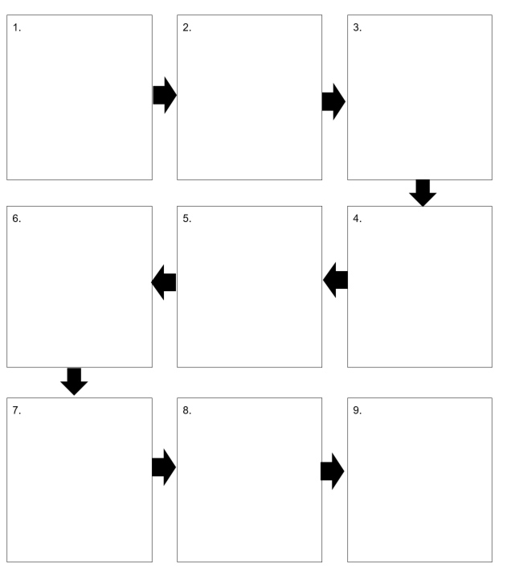

Appendix 2

What’s the story?
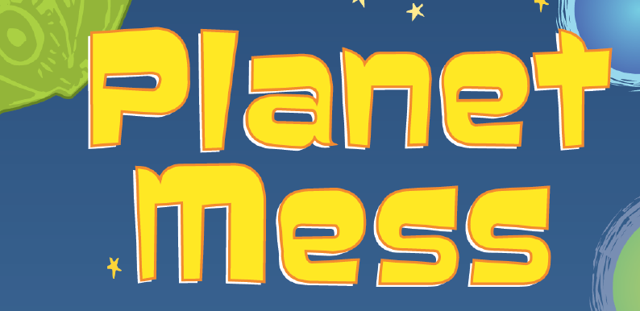
‘Clean your room, son,’ said Dad. ‘It looks like Planet Mess in there.’
Nick went to his room. He looked at the blocks on the floor and the books on his bed. He looked at his school things in a pile. Bor-ing, he thought.
Then Nick had an idea!
First, he put on his long white pants and a long-sleeved white shirt. He got the vacuum cleaner hose and attached it to his backpack. He empties his toy bucket onto the floor and then put it on his head.
All of a sudden, Mum walked past his door. ‘Nicholas!’ she cried. ‘What are you doing?’
‘I’m cleaning!’ said Nick. ‘I’m Space Agent Nick and I’m cleaning Planet Mess.’
Year 3 NAPLAN Reading Magazine, 2015 ACARA

What’s the story?
Max’s Idea
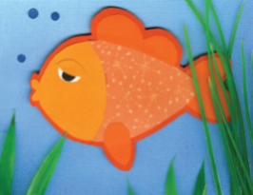
Max had a pet fish called Fin.
Max looked into the fish tank and saw that Fin was sad.
‘I have an idea,’ said Max.
Max cleaned all of mum’s shoes – Mum gave him a dollar.
Then Max helped Gran in the garden – Gran gave him a dollar.
Next, Max washed Dad’s dirty dishes – Dad gave him a dollar.
Finally, Max cleaned the dog bowl – he found a dollar under it.
Max took the money to the pet shop and bought another fish.
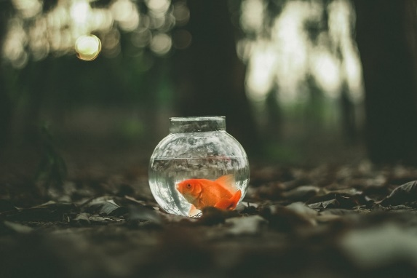
He put the fish into the fish tank.
‘Now Fin will be happy’, said Max.
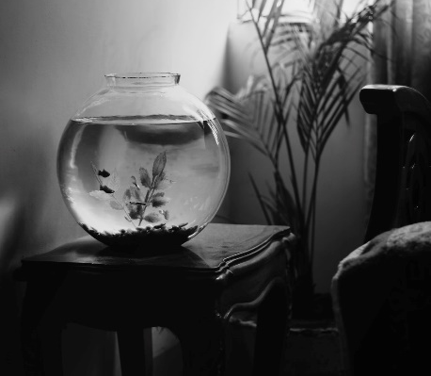
Year 3 NAPLAN Reading Magazine, 2015 ACARA
All photos from Unsplash.com

Appendix 3

Sequencing events in a narrative
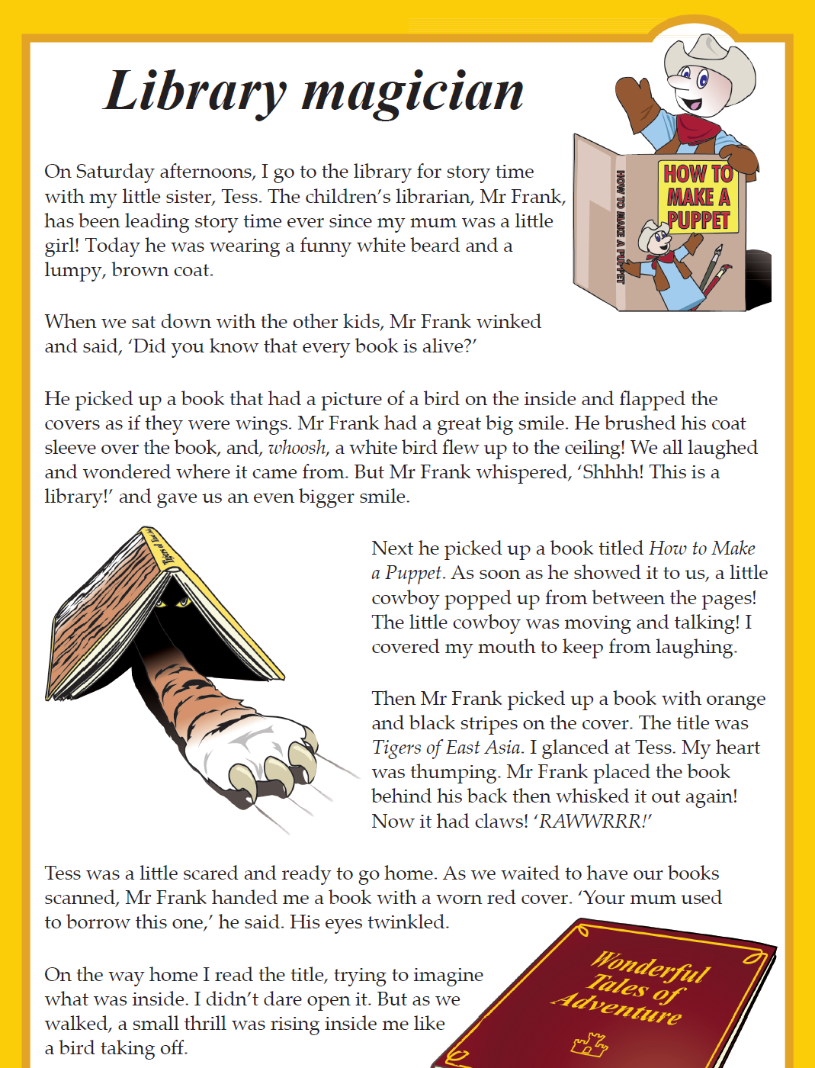
Year 3 NAPLAN Reading Magazine, 2016 ACARA

Sequencing events in a narrative – accessible version
On Saturday afternoons, I go to the library for story time with my little sister, Tess. The children’s librarian, Mr Frank, has been leading story time ever since my mum was a little girl! Today he was wearing a funny white beard and a lumpy, brown coat.
When we sat down with the other kids, Mr Frank winked and said, ‘Did you know that every book is alive?’
He picked up a book that had a picture of a bird on the inside and flapped the covers as if they were wings. Mr Frank had a great big smile. He brushed his coat sleeve over the book, and, whoosh, a white bird flew up to the ceiling! We all laughed and wondered where it came from. But Mr Frank whispered, ‘Shhhh! This is a library!’ and gave us an even bigger smile.
Next he picked up a book titled How to Make a Puppet. As soon as he showed it to us, a little cowboy popped up from between the pages! The little cowboy was moving and talking! I covered my mouth to keep from laughing.
Then Mr Frank picked up a book with orange and black stripes on the cover. The title was Tigers of East Asia. I glanced at Tess. My heart was thumping. Mr Frank placed the book behind his back then whisked it out again! Now it had claws! ‘RAWWRRR!’
Tess was a little scared and ready to go home. As we waited to have our books scanned, Mr Frank handed me a book with a worn red cover. ‘Your mum used to borrow this one,’ he said. His eyes twinkled.
On the way home I read the title, trying to imagine what was inside. I didn’t dare open it. But as we walked, a small thrill was rising inside me like a bird taking off.
Year 3 NAPLAN Reading Magazine, 2016 ACARA

Sequencing events in a narrative (teacher modelled text)

Library magician
On Saturday afternoons, I go to the library for story time with my little sister, Tess. The children’s librarian, Mr Frank, has been leading story time ever since my mum was a little girl! Today he was wearing a funny white beard and a lumpy, brown coat.
When we sat down, with the other kids, Mr Frank winked and said, ‘Did you know that every book is alive?’
He picked up a book that had a picture of a bird on the inside and flapped covers as if they were wings. Mr Frank had a great big smile. He brushed his coat sleeve over the book, and whoosh, a white bird flew up to the ceiling! We all laughed and wondered where it came from. But Mr Frank whispered, ‘Shhhh! This is a library!’ and gave us an even bigger smile.
Next, he picked up a book titled How to Make a Puppet. As soon as he showed it to us, a little cowboy popped up from between the pages! The little cowboy was moving and talking! I covered my mouth to keep from laughing.
Then Mr Frank picked up a book with orange and black stripes on the cover. The title was Tigers of East Asia. I glanced at Tess. My heart was thumping. Mr Frank placed the book behind his back then whisked it out again! Now it had claws! ‘RAWWRRR!’
Tess was a little scared and ready to go home. As we waited to have our books scanned, Mr Frank handed me a book with a worn red cover. ‘Your mum used to borrow this one,’ he said. His eyes twinkled.
On the way home I read the title, trying to imagine what was inside. I didn’t dare open it. But as we walked, a small thrill was rising inside me like a bird taking off.
Event 1: Orientation
When: adverbial phrase, ‘On Saturday afternoons’, ‘Today’
Where: library
Event 2: The children sat down
adverbial phrase – ‘When we sat down…’
Event 3: A book turned into a bird
Indicating sequence by verb group ‘picked up’
Event 4: A puppet book came alive
temporal connective – ‘Next’
Event 5: A tiger book came alive
temporal connective – ‘Then’
Event 6: Tess was scared of the tiger book and wanted to go home. Adverbial – indicating when – ‘As we waited to have our books scanned…’
Event 7: ‘On the way home’ indicating they are leaving. Adverbial phrase
Text indicating story might continue. ‘…a small thrill was rising…’

Year 3 NAPLAN Reading Magazine, 2016 ACARA

Jigsaw student readings 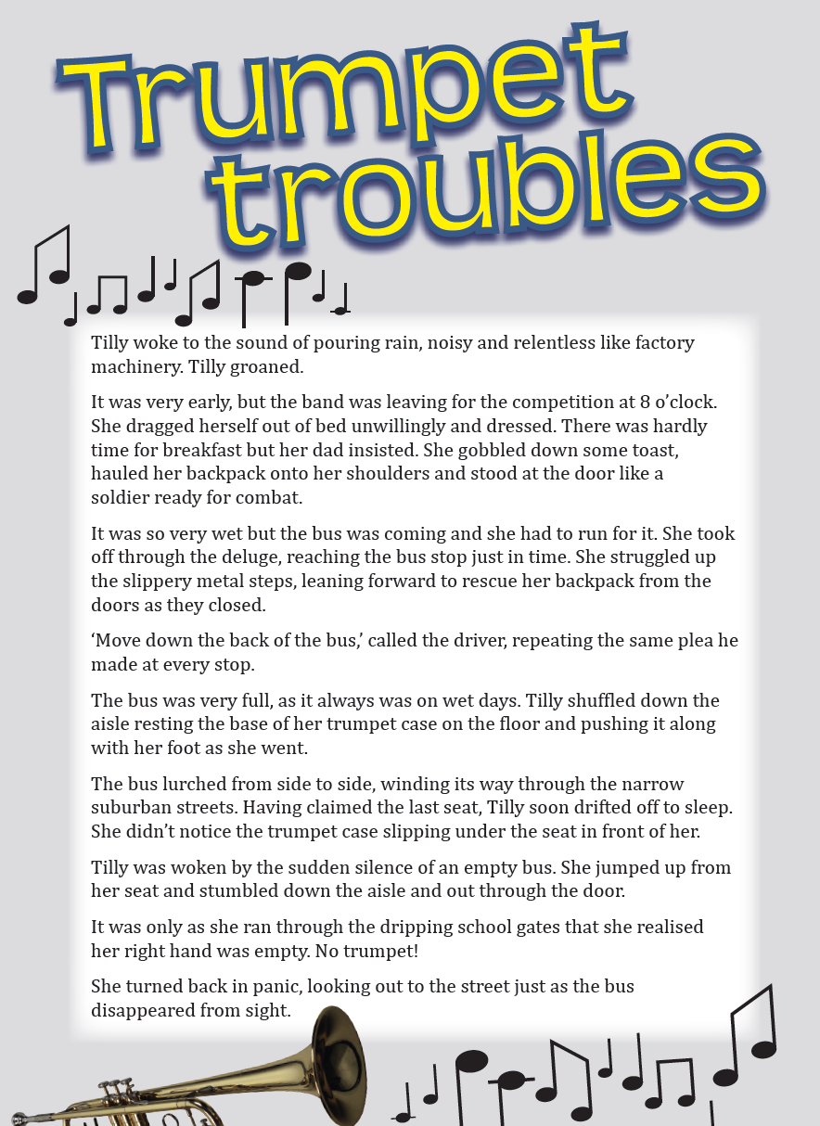
Year 3 NAPLAN Reading Magazine, 2014 ACARA

Jigsaw student readings - accessible version

Trumpet Troubles
Tilly woke to the sound of pouring rain, noisy and relentless like factory machinery. Tilly groaned.
It was very early, but the band was leaving for the competition at 8 o’clock. She dragged herself out of bed unwillingly and dressed. There was hardly time for breakfast but her dad insisted. She gobbled down some toast, hauled her backpack onto her shoulders and stood at the door like a solder ready for combat.
It was so very wet but the bus was coming and she had to run for it. She took off through the deluge, reaching the bus stop just in time. She struggled up the slippery metal steps, leaning forward to rescue her backpack from the doors as they closed.
‘Move down the back of the bus,’ called the driver, repeating the same plea he made at every stop.
The bus was very full, as it always was on wet days. Tilly shuffled down the aisle resting the base of her trumpet case on the floor and pushing it along with her foot as she went.
bus lurched from side to side, winding its way through the narrow suburban streets. Having claimed the last seat, Tilly soon drifted off to sleep. She didn’t notice the trumpet case slipping under the seat in front of her.
Tilly was woken by the sudden silence of an empty bus. She jumped up from her seat and stumbled down the aisle and out through the door.
It was only as she ran through the dripping school gates that she realised her right hand was empty. No trumpet!
She turned back in panic, looking out to the street just as the bus disappeared from sight.
Year 3 NAPLAN Reading Magazine, 2014 ACARA
Appendix 4

Jigsaw student readings
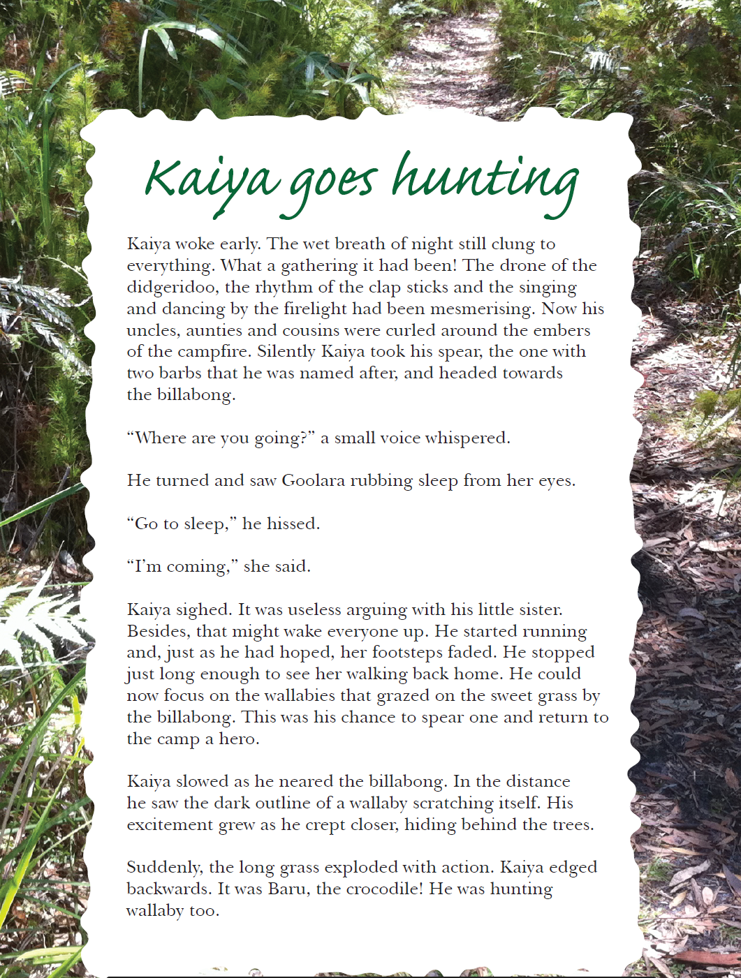
Year 3 NAPLAN Reading Magazine, 2013 ACARA
Appendix 4

Jigsaw student readings – accessible version

Kaiya goes hunting
Kaiya woke early. The wet breath of night still clung to everything. What a gathering it had been! The drone of the didgeridoo, the rhythm of the clap sticks and the singing and dancing by the firelight had been mesmerising. Now his uncles, aunties and cousins were curled around the embers of the campfire. Silently Kaiya took his spear; the one with two barbs that he was named after and headed towards the billabong.
“Where are you going?” a small voice whispered.
He turned and saw Goolara rubbing sleep from her eyes.
“Go to sleep,” he hissed.
“I’m coming,” she said.
Kaiya sighed. It was useless arguing with his little sister. Besides, that might wake everyone up. He started running and, just as he hoped, her footsteps faded. He stopped just long enough to see her walking back home. He could now focus on the wallabies that grazed on the sweet grass by the billabong. This was his chance to spear one and return to the camp a hero.
Kaiya slowed as he neared the billabong. In the distance he saw the dark outline of a wallaby scratching itself. His excitement grew as he crept closer, hiding behind the trees.
Suddenly, the long grass exploded with action. Kaiya edged backwards. It was Baru, the crocodile! He was hunting wallaby too.
Year 3 NAPLAN Reading Magazine, 2013 ACARA

Jigsaw student readings

NSW Department of Education Story-Sami’s Game
Sami’s Game
On another hot day in Broken Hill, Sami hopped out of bed with a frown. He was not looking forward to the big game this morning. He knew he would miss the ball when he was going to bat. It was not going to be a great day.
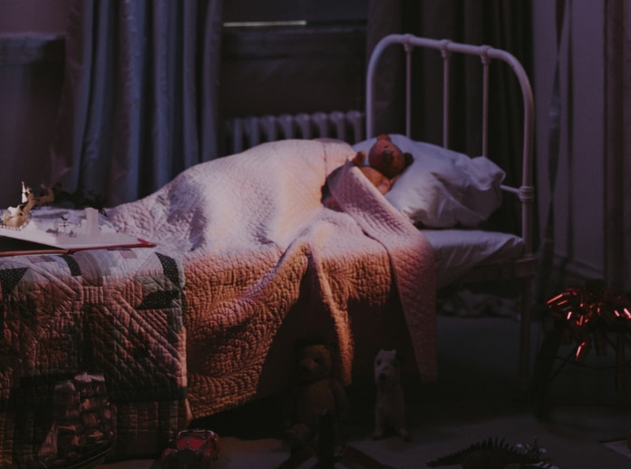
Sami went down the stairs to pour himself a glass of milk. He didn’t want his mum and dad to hear him because they would ask him how he was feeling. And he was not feeling happy at all. Sami sat down on the couch to watch cartoons. Before he knew it, he had gone back to sleep.
Next thing Sami knew, his mum was waking him and asking how he was feeling about the big game. Sami just groaned and got dressed. He was feeling even more worried now.
After the car was packed, Sami and his parents jumped out of the car and walked towards the T-ball field. Sami could see his team near the field. He started to feel really scared and his tummy felt like it was in knots.

Then it was Sami’s turn to bat. He felt so worried. He held the bat with two hands, squinted his eyes and BAM! He hit it! He hit is so hard that he ran the whole way home! His team was so happy!
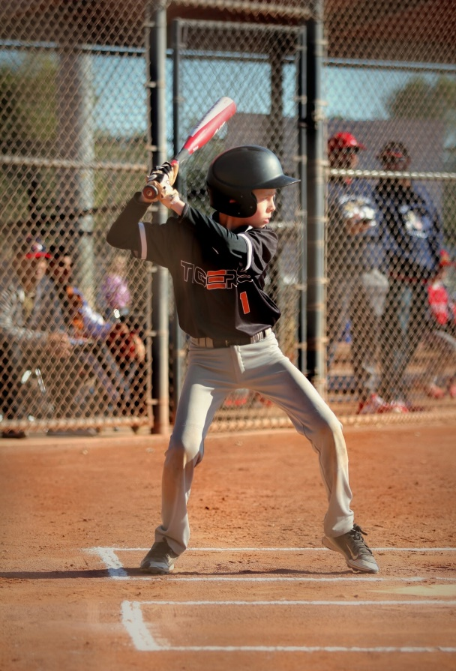

Sami ran to his mum and dad who were smiling big, happy smiles. It was a great day!
© State of New South Wales (Department of Education), 2021
Photos from unsplash.com

