Inference
Stage 2

Overview

Purpose
This literacy teaching strategy supports teaching and learning for Stage 2 students across all key learning areas. It targets specific literacy skills and suggests a learning sequence to build skill development. Teachers can select individual tasks, or a sequence, and embed into their teaching and learning program according to their students’ needs. While exemplar texts are provided throughout this resource, it is recommended that teachers select texts which are relevant to their students and curriculum.

Learning intention
Students will learn how to use their own knowledge and the clues in a text to make inferences.

Syllabus outcomes
The following teaching and learning strategies will assist in covering elements of the following outcomes:
- EN2-RECOM-01: reads and comprehends texts for wide purposes using knowledge of text structures and language, and by monitoring comprehension
- EN2-UARL-01: identifies and describes how ideas are represented in literature and strategically uses similar representations when creating texts
NSW English K-10 Syllabus (2022)

Success criteria
The following Year 3 NAPLAN item descriptors may guide teachers to develop success criteria for student learning.

- interprets a reference in an imaginative text
- interprets the meaning of a sentence in context in a text
- interprets the meaning of a phrase in context in a text
- interprets a reference in a text
- interprets the meaning of a phrase in context in a narrative
- interprets information in a narrative
- interprets the meaning of a phrase in a persuasive text
- interprets the meaning of a phrase in a narrative
- interprets the meaning of a phrase in an information text
- interprets the meaning of a description in a text
- interprets a reference in an information text
- interprets the significance of an event in an information text
- infers the reason for an event in an information text
- interprets the meaning of a phrase in a traditional tale
- interprets the meaning of a description in a persuasive text

National Literacy Learning Progression guide

Understanding Texts (UnT7-UnT9)
Key: C=comprehension P=process V=vocabulary

UnT7
- draws inferences and identifies supporting evidence in the text (C)
- navigates text using common signposting devices such as headings, subheadings, paragraphs, navigation bars and links (P)

UnT8
- draws inferences and verifies using textual evidence (C)
- uses knowledge of the features and conventions of the type of text to build meaning (e.g. recognises that the beginning of a persuasive text may introduce the topic and the line of argument) (P)
- skims and scans texts for key words to track the development of ideas (P)

UnT9
- summarises the text identifying key details only (C)
- draws inferences, synthesising clues and evidence across a text (C)
- selects reading/viewing strategies appropriate to reading purpose (e.g. scans text for evidence) (P)
National Literacy Learning Progression

Evidence base
- Centre for Education Statistics and Evaluation (2017). Effective reading instruction in the early years of school, literature review.
- Konza, D. (2014). Teaching Reading: Why the “Fab Five” should be the “Big Six”. Australian Journal of Teacher Education, 39(12).
- Oakhill, J., Cain, K. & Elbro, C. (2015). Understanding and teaching reading comprehension: A handbook. Routledge.
- Quigley, A. (2020). Closing the reading gap. Routledge.
- Scarborough, H.S. (2001). Connecting early language and literacy to later reading (dis)abilities: Evidence, theory and practice. In S. Neuman & D. Dickson (Eds.), Handbook for research in early literacy (pp. 97-110). New York, NY: Guilford Press.
Alignment to system priorities and/or needs: Five priorities for Literacy and Numeracy, Our Plan for NSW Public Education , School Excellence Policy (nsw.gov.au).
Alignment to School Excellence Framework: Learning domain: Curriculum, Teaching domain: Effective classroom practice and Professional standards
Consulted with: Strategic Delivery, Teaching Quality and Impact
Author: Literacy and Numeracy
Reviewed by: Literacy and Numeracy, Teaching Quality and Impact
Created/last updated: January 2024
Anticipated resource review date: January 2025
Feedback: Complete the online form to provide any feedback

Copyright
Section 113P Notice
Texts, Artistic Works and Broadcast Notice
Some of this material has been copied and communicated to you in accordance with the statutory licence in section 113P of the Copyright Act. Any further reproduction or communication of this material by you may be the subject of copyright protection under the Act. Do not remove this notice.

Teaching strategies
Task | Appendices
What is inference?
Using clues to infer | Appendix 1 - Image analysis
Inferring from text | Appendix 2 - Inference match and sort
Analysing texts | Appendix 3 - ‘A wrinkle in time’ text analysis  Appendix 4 - Student text analysis
Question generation | Appendix 5 - ‘Kaiya goes hunting’  Appendix 6 - Inferential question stems

Background information

Inference
A conclusion reached on the basis of evidence and reasoning.
Local inferencing requires the reader to comprehend implied information from within relatively small sections of text, such as 2 adjacent sentences.
Global inferencing requires the reader to comprehend implied information from across relatively larger sections of text and is supported by the reader’s depth of vocabulary and background knowledge.

Background knowledge
Information that is important for understanding a subject.

Connotation
The nuances or implied meaning attached to language, beyond that of its literal or dictionary meanings. Connotations may be positive, negative, or neutral.
Reference: English K-10 Syllabus © NSW Education Standards Authority (NESA) for and on behalf of the Crown in right of the State of New South Wales, 2022.

Where to next?
- Connecting ideas
- Exploring perspective
- Exploring character

Overview of teaching strategies

Purpose
These literacy teaching strategies support teaching and learning from Stage 2 to Stage 5. They are linked to NAPLAN task descriptors, syllabus outcomes and literacy and numeracy learning progressions.
These teaching strategies target specific literacy and numeracy skills and suggest a learning sequence to build skill development. Teachers can select individual tasks or a sequence to suit their students.

Access points
The resources can be accessed from:
- NAPLAN App in Scout using the teaching strategy links from NAPLAN items
- NSW Department of Education literacy and numeracy website.

What works best
Explicit teaching practices involve teachers clearly explaining to students why they are learning something, how it connects to what they already know, what they are expected to do, how to do it and what it looks like when they have succeeded. Students are given opportunities and time to check their understanding, ask questions and receive clear, effective feedback.
This resource reflects the latest evidence base and can be used by teachers as they plan for explicit teaching.
Teachers can use classroom observations and other assessment information to make decisions about when and how they use this resource as they design teaching and learning sequences to meet the learning needs of their students.
Further support with What works best is available.
Differentiation
When using these resources in the classroom, it is important for teachers to consider the needs of all students, including Aboriginal and EAL/D learners.
EAL/D learners will require explicit English language support and scaffolding, informed by the EAL/D enhanced teaching and learning cycle and the student’s phase on the EAL/D Learning Progression. Teachers can access information about supporting EAL/D learners and literacy and numeracy support specific to EAL/D learners.
Learning adjustments enable students with disability and additional learning and support needs to access syllabus outcomes and content on the same basis as their peers. Teachers can use a range of adjustments to ensure a personalised approach to student learning.
Assessing and identifying high potential and gifted learners will help teachers decide which students may benefit from extension and additional challenge. Effective strategies and contributors to achievement for high potential and gifted learners helps teachers to identify and target areas for growth and improvement. A differentiation adjustment tool can be found on the High potential and gifted education website.

Using tasks across learning areas
This resource may be used across learning areas where it supports teaching and learning aligned with syllabus outcomes.
Literacy and numeracy are embedded throughout all syllabus documents as general capabilities. As the English and mathematics learning areas have a particular role in developing literacy and numeracy, NSW English and Mathematics syllabus outcomes aligned to literacy and numeracy skills have been identified.

Text selection
Example texts are used throughout this resource. Teachers can adjust activities to use texts which are linked to their unit of learning.
Further support with text selection can be found within the National Literacy Learning Progression Text complexity appendix.
The NESA website has additional information on text requirements within the NSW English syllabus.

Teaching strategies

What is inference?
- Teacher has a bag of objects to show students. Explain to students that some things we can observe, and some things we cannot. Pull out items and ask students what they can see (red ball, blue pen, hairbrush). Explain that these are all observable things. We can do a similar thing in texts, we can find a character’s name, where a story is set or the name of the author; these are all examples of ‘directly stated information’.
- Ask students “Who might own this hairbrush? Why do you think this? What clues did you use? Discuss how this is not observable – the answer is hidden, and we need to use clues to determine the owner. We can use clues such as whether the hairbrush has short or long hair, the colour of the hair, and clues to see how often it is used such as the condition of the handle. Explain that sometimes answers and information are hidden in texts and we need to make an inference to understand what is happening.
- Teacher explains to students the definition of inference: inference is the process of drawing conclusions using your own knowledge and the evidence in texts. We use clues in the text and background knowledge to make an inference. Discuss the key terms: own knowledge, drawing conclusions and evidence in texts. For example, to explain ‘own knowledge’ the teacher and students could brainstorm elements that make up a person’s background knowledge, ideas include vocabulary, places visited, interests and hobbies, subject-knowledge, relationships and family experiences and so on. Students create a mind map, or any other graphic organiser of their choice, detailing things that make up their own background knowledge.
- Teacher displays the diagram below and visually explains the process of inference to students; we use our background knowledge and clues in the text to make an inference.
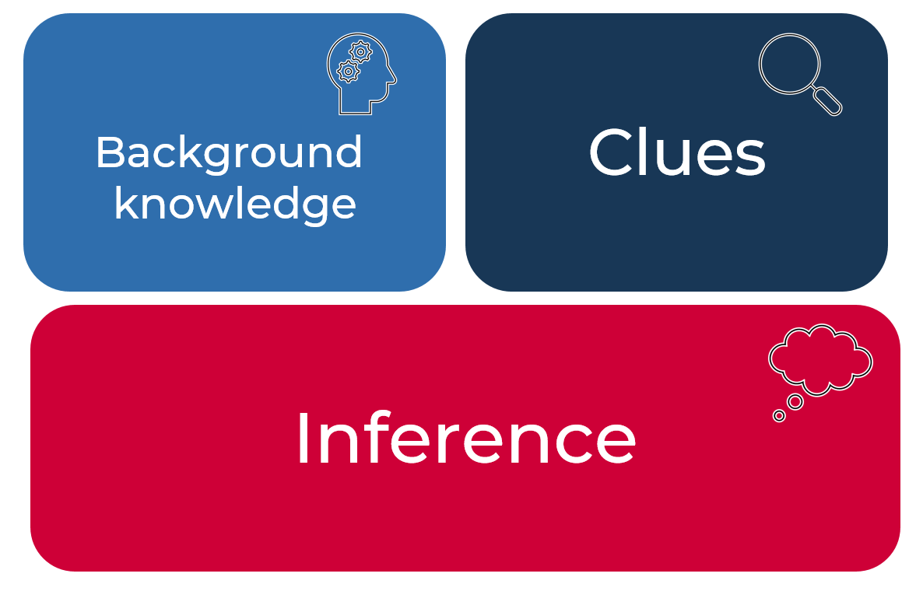

- As a class, discuss how we all infer every day. For example, students might have heard people say: “I need to buy some milk!” From this we can infer that the speaker has run out of milk. Another example might be that James was running on the soccer field but with a flinching face and lifting his foot off the ground – we can infer that James has hurt himself. Have students think of more examples. One student could state the scenario and the next student could explain what they infer from that scenario.
- Explain that a good author will give clues that something is happening rather than just say it; readers enjoy the challenge of ‘figuring out’ what is happening.
- In pairs, students create a summary about their understanding of inference, supported by an example.

Using clues to infer
- Teacher shows a bag to the class with hidden items (For example, bottle, car keys, baseball hat). Students infer who might own the bag from seeing what kind of bag it is. As items are drawn out, students begin to infer who might own the bag using clues and background knowledge. Teacher prompts students with questions, such as, who might own this bag? Is there another possibility? Where might they be going? Where might they live? What makes you say that? What evidence supports this? Discuss how we infer every day to understand a message that is not explicitly stated in the text or situation.
- Teacher displays an unfamiliar image linked to current unit of learning or uses Appendix 1 - Image analysis. Teacher could prompt with questions such as: Where and when do you think this image is set? Who might be the main person? Why do you think we can only see her back? What might she be doing? Where might she be going? Is she alone? Once this is completed as a class, students could work on another image in pairs to Think-Pair-Share questions and answers for the image.
- Teacher explains Walk and talk: Give half of the students an image from Appendix 1. When the teacher says ‘walk’, students move around the classroom. When the teacher calls out ‘talk’, students meet with the person closest to them who has an image. The students discuss what they think is happening in the picture, what might have happened before and what might happen afterwards. Repeat the process. Students with images respond to the person sharing ideas by acknowledging their thinking and drawing comparisons with other responses.
- In pairs or small groups, students could create a poster or digital text that explains inference. The teacher could support this with discussion that reflects the learning. Explain that what they have just been practising is inferring; good readers will infer ideas from clues in images and words and their background knowledge.

Inferring from text
- Teacher presents a scenario for students: seven adults, all dressed from head to toe in pink have entered the classroom; what might be happening? Students work in teams to create as many possible scenarios as they can. The class discusses these scenarios.
- Explains inferences are made based on parts of a text as well as our own background knowledge.
- Teacher models to the class using the sentence: “Archer threw his hands angrily in the air as the bus disappeared around the corner.” Teacher leads class discussion to uncover, what can we infer is happening? What words in the text indicate to us the scenario of what is happening? We make an inference when we use text clues as well as our own background information to make a conclusion as to what is happening.
- Teacher uses a ‘think aloud’ process to show how a skilled reader might make an inference: For example, ‘I am going to make an inference about what might have happened in this sentence. I am going to use both the evidence in the text, as well as my own background knowledge, to make my inference. When I read the sentence, I can see the phrase ‘...threw his hands in the air’. I am making an inference that Archer is frustrated as his hands are in the air. I know that when I have seen someone who is frustrated, or that when I am frustrated myself, I have done a similar thing. So, my background knowledge and personal experience combines with words from the text to help me make my inference. I am now going to read further to see if I can find out why Archer is frustrated. I can see clues in the text saying ‘... as the bus disappeared around the corner’. The author used the word ‘disappeared’, so this tells me the bus has left Archer behind. I can make the inference that Archer is frustrated because he has missed the bus.
- Teacher reads aloud a text linked to a current teaching and learning program. Using the example below as a model, the teacher pauses to ask the students for predictions and inferences about characters or events in the text. The teacher models the process of inference making before prompting students to explain how they linked evidence from the text with their own background knowledge to make an inference. The teacher records this as evidence, clearly linking clues from the text with the inference:
What the text says | What we can infer
“Frankie Esposito is the best kid I’ve ever known.” | - Frankie is a friend.  - Frankie is very talented at something.  - They have known each other for a while.
The vase wobbled and everyone gasped. | - The vase had been bumped and was about to break.  - The vase is valuable.
It was hard to see out the fogged window. | - It was winter and raining.  - It was warm inside.  - They are in a house.
- Students complete an inference match and sort task on a text relevant to a current unit of learning or refer to Appendix 2 - Inference match and sort. Students match actions with an inference.
Alternate task: Students search for an example from a text they are reading and write this on a sticky note. Students ‘walk and talk’, when teacher calls out ‘talk’ they stop with the nearest person, show their text example and their partner makes inferences.

Analysing texts
- Teacher displays the word ‘storm’ on the board. Students brainstorm vocabulary they would expect to see first in an informative text and then secondly, in an entertaining text (using different colours to write the suggested vocabulary words will help differentiate between the two purposes of writing, to inform or to entertain). Teacher asks students why they chose these words in relation to a storm and why they think different words may be used in different forms of texts. Did they use their background knowledge and personal experiences to choose their words? Teacher discusses different word meanings and displays these definitions for reference.
- Teacher reads aloud an excerpt from ‘A wrinkle in time’ (refer to Appendix 3 - ‘A wrinkle in time’ text analysis) stopping to draw some inferences before reading the final paragraph. The teacher guides a discussion on what ‘everything else’ and ‘everything wrong’ might mean. Students may use clues from earlier in the text and their own background knowledge to explain and justify their inferences. For example, Meg seems to be alone in her room during the storm, perhaps she has been in trouble and sent to her room? Has she had an argument with her family? A friend? Has something happened to her family? Is this the ‘everything else’? What might she have done wrong? Or think she has done wrong? Have her actions left her isolated and alone? After the discussion read the final paragraph and discuss whether the inferences were supported by the text.
- Additional task: Students highlight examples of where they made an inference on the ‘Student analysis page’ (Appendix 4 - Student text analysis) or complete a similar activity using texts relevant to a current unit of learning.

Question generation
- Teacher conducts a class brainstorm, asking students to share their own experience of the Australian bush and of Aboriginal culture. Explain to the class that when we read, we use our background knowledge to help us make connections to the text. Record and display vocabulary from discussion.
- Teacher introduces the text ‘Kaiya goes hunting’ (Appendix 5 - ‘Kaiya goes hunting’) and uses a range of questions to prompt thinking:
- What does the border suggest about this text?
- What types of plants can we see?
- Is that a path? What might a path suggest/infer/symbolise?
- What does the title suggest about the text?
- Who might be our main character?
- What words would you expect to see in this text?
- Are any of these words already on our class brainstorm?’
- Read the text aloud, pausing to highlight key vocabulary and linking back to background knowledge.
- Teacher explains the difference between information that is directly located and inferred. ‘Literal comprehension is when we can find the answers to a question which can be directly located in the text - we use skimming to help us find key words, parts of the text structure such as a paragraph or an image to find information. What happens when the answer isn’t in front of us? An inferential question is when we need to use clues from the text and our own background knowledge to interpret information.’
- Teacher uses the ‘think aloud’ strategy to model how to find the answer to a directly-locate question: When did Kaiya wake?
Suggested ‘think aloud’:
‘Let’s look at the question: When did Kaiya wake? I can see the question starts with the word ‘when’. This tells me that I am looking for an answer to do with time. I can also see in the question the key words ‘Kaiya’ and ‘wake’. I am going to highlight these key words, so I remember what I am looking for. I am now going to skim the text to find these key words. I can see the key words straight away in the text in the first sentence. ‘Kaiya woke early’. The answer to when Kaiya wakes is early.”
- Use the same text excerpt and asks an inferential question: What had happened the night before?
Suggested ‘think aloud’:
‘I can’t see information directly in the text that tells me what had happened the night before such as ‘last night there was a party’. I can, however, see clues in the text and can use my background knowledge to figure out what had happened. I am going to highlight in the text all the clues about the night before, I can see the sentence “What a gathering it had been!” I understand that a gathering is when a group of people come together. The sentence starts with “What a gathering...” and ends with an exclamation mark which tells me it was something that must have been really fun. I know I might say, “What an amazing night I had!” and this is a similar example. So, I can infer that the night before had been a party or a corroboree, as I know this is a term used in Aboriginal culture. Further along in the text I can see the clues “drone of the didgeridoo”, “rhythm of the clap sticks” and “singing” and I know that these are all things that might happen at a corroboree.”
- Teacher and students co design success criteria for writing inferential questions. Teacher leads a brainstorm of prior learning on inferential questioning, reminding students what an inferential question is (students would need to find clues in the text and use background knowledge to answer an inferential question.) The answer to these questions is not immediately clear from the text – it is hidden. Remind students of the way these questions start (who, why, what, when).
- Students use the Think-Pair-Share strategy to brainstorm and create inferential questions, using Appendix 6 - Inferential question stems to assist in locating text clues and accessing background knowledge. Students could justify with their own “think aloud” to their peers.

Appendix 1

Image analysis
Photo by Kevin Mueller on Unsplash.com

Image analysis alternate task
Photo by Erik Mclean on Unsplash.com | Photo by Sam Lau on Unsplash.com
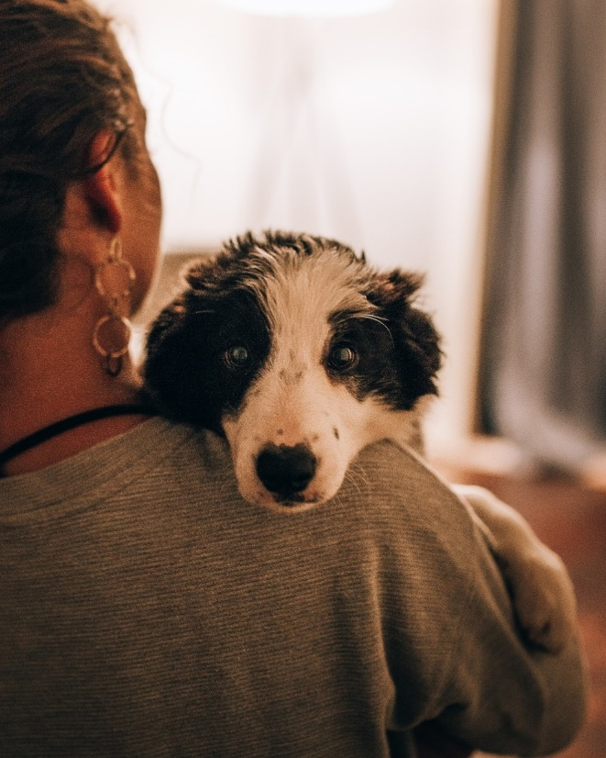  Photo by Josh Hild on Unsplash.com | Photo by Heiko Otto on Unsplash.com

Image analysis alternate task
Photo by Ben White on Unsplash.com | 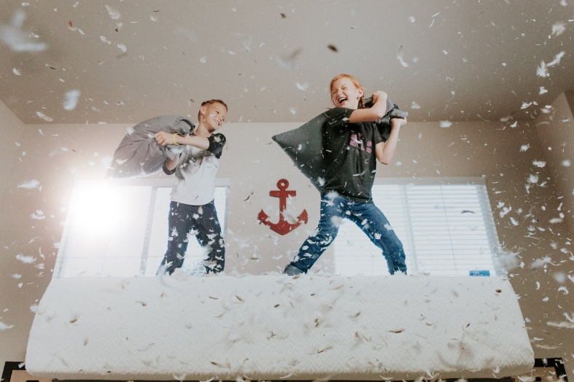  Photo by Allen Taylor on Unsplash.com
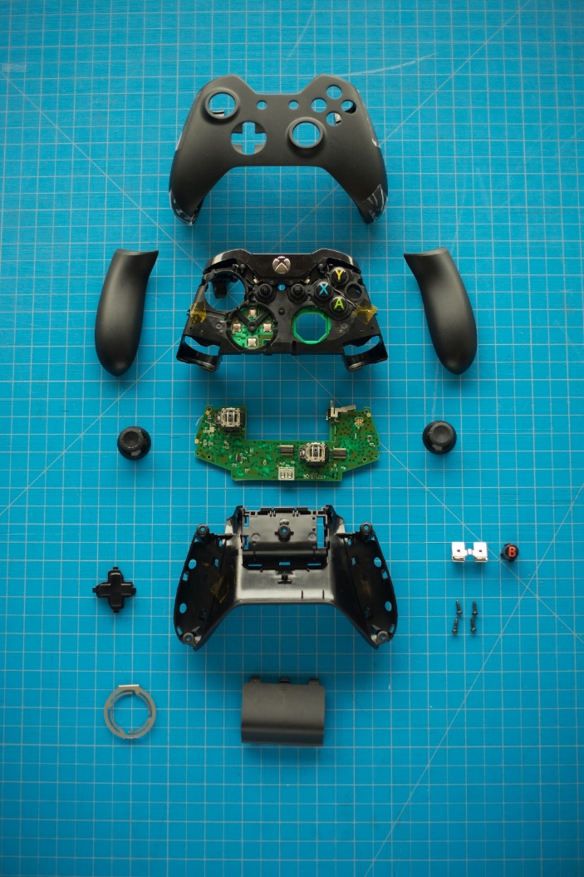  Photo by Sean Whelan on Unsplash.com | Photo by 26everything Films & Photos on Unsplash.com

Appendix 2

Inference match and sort
Cut out and match the text and inference.
What the text says | What we can infer
“Frankie Esposito is the best kid I’ve ever known.” | - Frankie is a friend.  - Frankie is very talented at something.  - They have known each other for a while.
The vase wobbled and everyone gasped. | - The vase had been bumped and was about to break.  - The vase is valuable.
It was hard to see out the fogged window. | - It was winter and raining.  - It was warm inside.  - They are in a house.
The crack in the wall was getting longer by the second. | - An earthquake was happening.  - A natural disaster was taking place.  - Something was happening beneath the Earth’s surface.  - The house might fall.
The tomatoes were ripening much quicker than usual. | - It was unusually warm weather.
The birds flew away when the smoke eddied to the top of the branches. | - A fire was approaching.
Stella knew she had only three hours, two minutes and thirty-four seconds left until the bell went. | - Stella was excited about something when the bell went.  - Stella didn’t want to be in school.
The water was filling in the boat. | - There was a leak in the boat.  - The boat may sink.  - People might be in danger.

Inference match and sort
Before cutting it up, the teacher could colour code which part is the text and which part is the inference. This may help to support learners.
Cut out and match the text and inference.
What the text says | What we can infer
“Frankie Esposito is the best kid I’ve ever known.” | - Frankie is a friend.  - Frankie is very talented at something.  - They have known each other for a while.
The vase wobbled and everyone gasped. | - The vase had been bumped and was about to break.  - The vase is valuable.
It was hard to see out the fogged window. | - It was winter and raining.  - It was warm inside.  - They are in a house.
The crack in the wall was getting longer by the second. | - An earthquake was happening.  - A natural disaster was taking place.  - Something was happening beneath the Earth’s surface.  - The house might fall.
The tomatoes were ripening much quicker than usual. | - It was unusually warm weather.
The birds flew away when the smoke eddied to the top of the branches. | - A fire was approaching.
Stella knew she had only three hours, two minute and thirty-four seconds left until the bell went. | - Stella was excited about something when the bell went.  - Stella didn’t want to be in school.
The water was filling in the boat. | - There was a leak in the boat.  - The boat may sink.  - People might be in danger.

Appendix 3

Analysing texts: A wrinkle in time

A wrinkle in time  Madeleine L’Engle, Ariel Books/Farrar, 1962  It was a dark and stormy night.  In her attic bedroom Margaret Murry, wrapped in an old patchwork quilt, sat on the foot of her bed and watched the trees tossing in the frenzied lashing of the wind. Behind the trees clouds scudded frantically across the sky. Every few moments the moon ripped through them, creating wraithlike shadows that raced along the ground.  The house shook.  Wrapped in her quilt, Meg shook.  She wasn’t afraid of weather. It’s not just the weather, she thought. It’s the weather on top of everything else. On top of me. On top of Meg Murry doing everything wrong.  School. School was all wrong. She’d been dropped down to the lowest section in her grade. That morning, one of her teachers had said crossly, “Really, Meg, I don’t understand how a child with parents as brilliant as yours are supposed to be can be such a poor student. If you don’t manage to do a little better you’ll have to stay back next year.” | Inference examples  Something bad may happen?  Light appeared and cast shadows in the room  The house was old and the storm was large and powerful.  Meg was frightened/worried  There are a lot of stressful things happening in Meg’s life  She has not been doing well in her schoolwork.

Appendix 4

Analysing texts
George’s Marvellous Medicine  Roald Dahl, Puffin Books, 1981  In the kitchen, George put the saucepan on the stove and turned up the gas flame underneath it as high as it would go.  ‘George!’ came the awful voice from the next room. ‘It’s time for my medicine!’  ‘Not yet, Grandma,’ George called back. ‘There’s still twenty minutes before eleven o’clock.’  ‘What mischief are you up to in there now?” Granny screeched. ‘I hear noises.’  George thought it best not to answer this one. He found a long wooden spoon in a kitchen drawer and began stirring hard. The stuff in the pot got hotter and hotter.  Soon the marvellous mixture began to froth and foam. A rich blue smoke, the colour of peacocks, rose from the surface of the liquid, and a fiery fearsome smell filled the kitchen. It made George choke and splutter. It was a smell unlike any he had smelled before. It was a brutal and bewitching smell, spicy and staggering, fierce and frenzied, full of wizardry and magic. Whenever he got a whiff of it up his nose, firecrackers went off in his skull and electric prickles ran along the backs of his legs. It was wonderful to stand there stirring this amazing bubbling mixture and to watch it smoking blue and bubbling and frothing and foaming as though it was alive. At one point, he could have sworn he saw bright sparks flashing in the swirling foam.  And suddenly, George found himself dancing around the steaming pot, chanting strange words that came into his head out of nowhere. | Inference examples  What can you infer from these boxed phrases and clauses?

Accessible notes: Boxed phrases in the paragraph above:
- as high as it would go
- awful voice
- There’s still twenty minutes before eleven o’clock
- What mischief are you up to in there now
- began to froth and foam
- fiery fearsome smell filled the kitchen
- George choke
- and splutter
- was a smell unlike any he had smelled before
- firecrackers went off in his skull and electric prickles ran along the backs of his legs
- saw bright sparks flashing
- And suddenly, George found himself dancing around the steaming pot, chanting strange words that came into his head out of nowhere.

Appendix 5
Kaiya goes Hunting
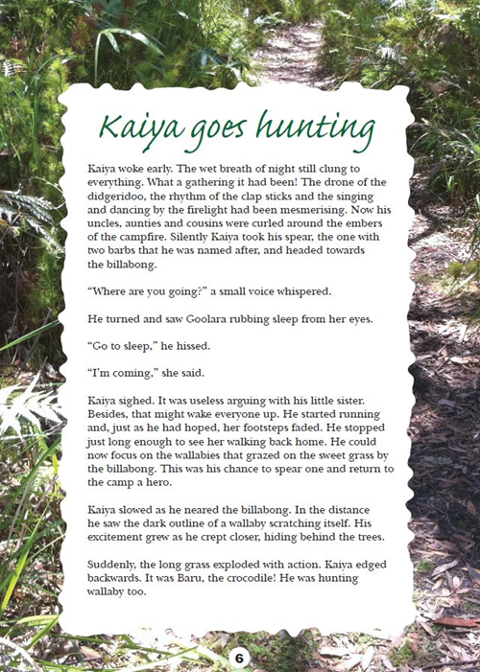
Year 3 NAPLAN reading magazine, 2013 ACARA

Appendix 5
Kaiya goes hunting – accessible version
Kaiya woke early. The wet breath of night still clung to everything. What a gathering it had been! The drone of the didgeridoo, the rhythm of the clap sticks and the singing and dancing by the firelight had been mesmerising. Now his uncles, aunties and cousins were curled around the embers of the campfire. Silently Kaiya took his spear, the one with two barbs that he was named after, and headed towards the billabong.
“Where are you going?” a small voice whispered. He turned and saw Goolara rubbing sleep from her eyes.
“Go to sleep,” he hissed.
“I’m coming,” she said.
Kaiya sighed. It was useless arguing with his little sister. Besides, that might wake everyone up. He started running and, just as he had hoped, her footsteps faded. He stopped just long enough to see her walking back home. He could now focus on the wallabies that grazed on the sweet grass by the billabong. This was his chance to spear one and return to the camp a hero.
Kaiya slowed as he neared the billabong. In the distance he saw the dark outline of a wallaby scratching itself. His excitement grew as he crept closer, hiding behind the trees.
Suddenly, the long grass exploded with action. Kaiya edged backwards. It was Baru, the crocodile! He was hunting wallaby too.
Year 3 NAPLAN reading magazine, 2013 ACARA

Appendix 6

Inferential question stems
Which words from the text suggest…?
What makes you think that…?
What effect does…?
Why are the words…used in the text?
What do you think is meant by….?

