Identify setting
Stage 2

Overview

Purpose
This literacy teaching strategy supports teaching and learning for Stage 2 students across all key learning areas. It targets specific literacy skills and suggests a learning sequence to build skill development. Teachers can select individual tasks, or a sequence, and embed into their teaching and learning program according to their students’ needs. While exemplar texts are provided throughout this resource, it is recommended that teachers select texts which are relevant to their students and curriculum.

Learning intention
Students will learn to identify the setting for a narrative. By the end of the activity, students will understand how to locate specific information in a text to identify a setting in a narrative text.

Syllabus outcomes
The following teaching and learning strategies will assist in covering elements of the following outcomes:
- EN2-RECOM-01: reads and comprehends texts for wide purposes using knowledge or text structures and language, and by monitoring comprehension
- EN2-UARL-01: identifies and describes how ideas are represented in literature and strategically uses similar representations when creating texts
NSW English Syllabus K-10 2022

Success criteria
The following Year 3 NAPLAN item descriptors may guide teachers to develop success criteria for student learning.
- identify setting of a narrative
- identify setting of a text
- identify setting of an imaginative text.

National Literacy Learning Progression guide

Understanding Texts (UnT6-UnT8)
Key: C=comprehension P=process V=vocabulary

UnT6
- scans texts to locate specific information in a predictable print text (C)
- identifies common features in similar texts (e.g. photographs in informative texts) (P)

UnT7
- identifies the purpose of a broad range of informative, imaginative and persuasive texts (e.g. advertisements, diary entry) (C)
- identifies language and text features that signal purpose in a predictable text (e.g. diagrams, dialogue) (P)
- navigates text using common signposting devices such as headings, subheadings, paragraphs, navigation bars and links (P)

UnT8
- reads and views some moderately complex texts (C)
- uses knowledge of the features and conventions of the type of text to build meaning (e.g. recognises that the beginning of a persuasive text may introduce the topic and the line of argument) (P)
National Literacy Learning Progression

Evidence base
- Centre for Education Statistics and Evaluation (2017). Effective reading instruction in the early years of school, literature review.
- Konza, D. (2014). Teaching Reading: Why the “Fab Five” should be the “Big Six”. Australian Journal of Teacher Education, 39(12).
- Oakhill, J., Cain, K. & Elbro, C. (2015). Understanding and teaching reading comprehension: A handbook. Routledge.
- Quigley, A. (2020). Closing the reading gap. Routledge.
- Scarborough, H.S. (2001). Connecting early language and literacy to later reading (dis)abilities: Evidence, theory and practice. In S. Neuman & D. Dickson (Eds.), Handbook for research in early literacy (pp. 97-110). New York, NY: Guilford Press.

Alignment to system priorities and/or needs: Five priorities for Literacy and Numeracy, Our Plan for NSW Public Education, School Excellence Policy (nsw.gov.au).
Alignment to School Excellence Framework: Learning domain: Curriculum, Teaching domain: Effective classroom practice and Professional standards
Consulted with: Strategic Delivery, Teaching Quality and Impact
Author: Literacy and Numeracy
Reviewed by: Literacy and Numeracy, Teaching Quality and Impact
Created/last updated: January 2024
Anticipated resource review date: January 2025
Feedback: Complete the online form to provide any feedback

Copyright
Section 113P Notice
Texts, Artistic Works and Broadcast Notice
Some of this material has been copied and communicated to you in accordance with the statutory licence in section 113P of the Copyright Act. Any further reproduction or communication of this material by you may be the subject of copyright protection under the Act. Do not remove this notice.

Teaching strategies
Task | Appendices
Setting the scene
Identifying setting in texts | Appendix 1 - Story settings  Appendix 2 - Narrative text: ‘The storm’

Where to next?
- Sequencing imaginative texts
- Text structure
- Literal comprehension

Overview of teaching strategies

Purpose
These literacy teaching strategies support teaching and learning from Stage 2 to Stage 5. They are linked to NAPLAN task descriptors, syllabus outcomes and literacy and numeracy learning progressions.
These teaching strategies target specific literacy and numeracy skills and suggest a learning sequence to build skill development. Teachers can select individual tasks or a sequence to suit their students.

Access points
The resources can be accessed from:
- NAPLAN App in Scout using the teaching strategy links from NAPLAN items
- NSW Department of Education literacy and numeracy website.
What works best
Explicit teaching practices involve teachers clearly explaining to students why they are learning something, how it connects to what they already know, what they are expected to do, how to do it and what it looks like when they have succeeded. Students are given opportunities and time to check their understanding, ask questions and receive clear, effective feedback.
This resource reflects the latest evidence base and can be used by teachers as they plan for explicit teaching.
Teachers can use classroom observations and other assessment information to make decisions about when and how they use this resource as they design teaching and learning sequences to meet the learning needs of their students.
Further support with What works best is available.
Differentiation
When using these resources in the classroom, it is important for teachers to consider the needs of all students, including Aboriginal and EAL/D learners.
EAL/D learners will require explicit English language support and scaffolding, informed by the EAL/D enhanced teaching and learning cycle and the student’s phase on the EAL/D Learning Progression. Teachers can access information about supporting EAL/D learners and literacy and numeracy support specific to EAL/D learners.
Learning adjustments enable students with disability and additional learning and support needs to access syllabus outcomes and content on the same basis as their peers. Teachers can use a range of adjustments to ensure a personalised approach to student learning.
Assessing and identifying high potential and gifted learners will help teachers decide which students may benefit from extension and additional challenge. Effective strategies and contributors to achievement for high potential and gifted learners helps teachers to identify and target areas for growth and improvement. A differentiation adjustment tool can be found on the High potential and gifted education website.

Using tasks across learning areas
This resource may be used across learning areas where it supports teaching and learning aligned with syllabus outcomes.
Literacy and numeracy are embedded throughout all syllabus documents as general capabilities. As the English and mathematics learning areas have a particular role in developing literacy and numeracy, NSW English and Mathematics syllabus outcomes aligned to literacy and numeracy skills have been identified.

Text selection
Example texts are used throughout this resource. Teachers can adjust activities to use texts which are linked to their unit of learning.
Further support with text selection can be found within the National Literacy Learning Progression Text Complexity appendix.
The NESA website has additional information on text requirements within the NSW English syllabus.

Teaching strategies

Setting the scene
- Explain to students that in imaginary texts, such as narratives, authors need to create believable and engaging settings or worlds for their characters and their stories. When building their world authors could consider the physical location, environmental features, the weather, buildings – both inside and outside, plants and animals, objects, sights, sounds and smells. The setting can be used to establish mood; sometimes it can even seem like the setting is a character itself! Discuss a range of stories that students are familiar with, identifying key features of setting in each. Students might consider how the setting contributed to the storyline, supported characterisation and/or created mood.
- Use a range of items such as tables, items of clothing, stationery and toys to create a setting. Students use these props to imagine where and when this scene may be set. (Teacher may take students to a quiet outdoor learning space to help visualisation.)
- In pairs, students spend time visualising and building images of their ‘imagined’ setting. Spend time building vocabulary and immersing students into the environment using prompts with sight, sound, taste, touch, smell.
- Teacher instructs students to take some time to think about a narrative they have written or read about. Discuss with your partner what you think a setting is. I am going to give you time to think of a response to share. Students record and share ideas with another pair (quads). The four students synthesise ideas into one on a graphic organiser of their choice and shares with the class.
- Teacher prompts ‘What makes you say that?’ to elicit justifications for reasoning.
To increase complexity, students could add or remove items and change the setting, justifying the impact of their choices to peers.

Identifying setting in texts
- Gallery Walk: Students think of stories that have both real and imaginary settings using Story Settings cards (Appendix 1 - Story settings) which have been displayed as posters in the classroom. Students add ideas to the posters individually, in pairs or in small groups.
- Explain to students that the beginning of a narrative is often used to ‘set the scene’ or build the world in which the story is set. Teacher reads aloud the opening section of a text relevant to a current unit of learning, or refer to Appendix 2 - Narrative text: ‘The storm’. Prompt students to share where they think the story is set. Add to a class bank of texts and settings on either paper or a digital version (table below). Teacher uses the think aloud strategy to note clues in the text such as proper nouns and nouns to indicate where, and temporal adverbial phrases such as ‘in the night’, ‘a long time ago’ to indicate when. Teacher should model how to find information at the sentence and paragraph level.
Text | Setting | How do we know?  Vocabulary examples
The storm
- Display a range of picture books, book covers or excerpts from orientations of narratives in work stations around the classroom with an accompanying recording page (paper, white boards, student workbooks, device). Students identify the setting and discuss the clues which indicate where and when in the texts. Group students to support all learners, for example, pair a developing reader with a proficient reader. Students will explore 3-4 texts during this time and record their findings on a graphic organiser of their choice.
- Think Pair Share. In pairs students move around the workstations to review settings and clues from each text using thinking and talking prompts to guide conversation.
To encourage higher order thinking, students categorise these book covers and excerpts into genres, based on the setting for each text. Students could also locate their own examples. In pairs, students justify their choices to the class.

Appendix 1

Story settings
What are some stories that are set in?  The future | What are some stories that are set in?  The past | What are some stories that are set in?  A desert
What are some stories that are set in?  Outer space | What are some stories that are set in?  Under the sea | What are some stories that are set in?  A forest
What are some stories that are set in?  Ancient times | What are some stories that are set in?  The digital world | What are some stories that are set in?  On a mountain or alpine range
What are some stories that are set in?  A polar or icy environment | What are some stories that are set in?  An imaginary world | What are some stories that are set in?  The countryside

Appendix 2

Narrative text: ‘The storm’
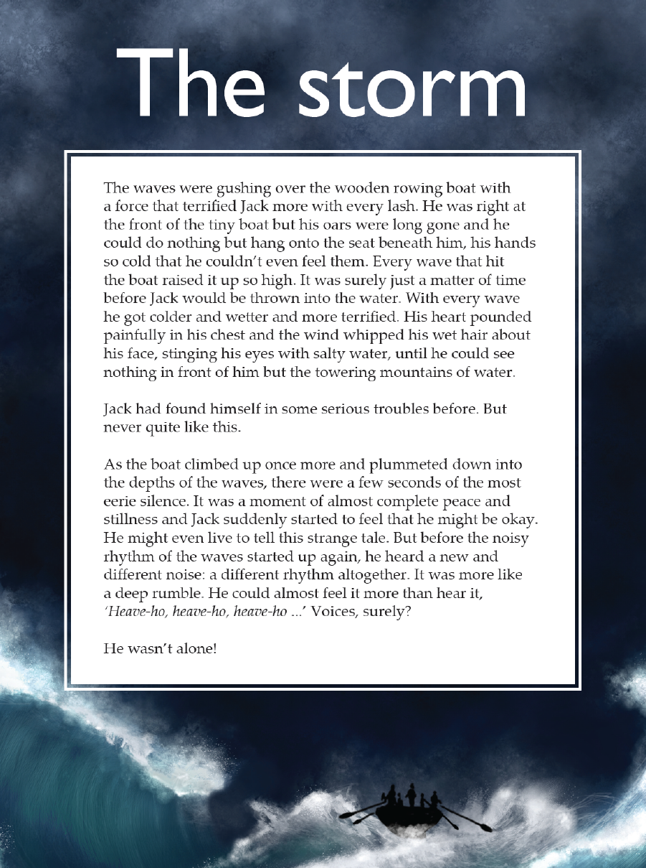,
Year 3 NAPLAN Reading Magazine, 2015 ACARA.

Narrative text: ‘The storm’ - accessible version
The storm
The waves were gushing over the wooden rowing boat with a force that terrified Jack more with every lash. He was right at the front of the tiny boat but his oars were long gone and he could do nothing but hang onto the seat beneath him, his hands so cold that he couldn’t even feel them. Every wave that hit the boat raised it up so high. It was surely just a matter of time before Jack would be thrown into the water. With every wave he got colder and wetter and more terrified. His heart pounded painfully in his chest and the wind whipped his wet hair about his face, stinging his eyes with salty water, until he could see nothing in front of him but the towering mountains of water.
Jack had found himself in some serious trouble before. But never quite like this.
As the boat climbed up once more and plummeted down into the depths of the waves, there were a few seconds of the most eerie silence. It was a moment of almost complete peace and stillness and Jack suddenly started to feel that he might be okay. He might even live to tell this strange tale. But before the noisy rhythm of the waves started up again, he heard a new and different noise: a different rhythm altogether. It was more like a deep rumble. He could almost feel it more than hear it, ‘Heave-ho, heave-ho, heave-ho...’ Voices surely?
He wasn’t alone!
Year 3 NAPLAN Reading Magazine, 2015 ACARA.

