Exploring perspective

Stage 2

Overview

Purpose
This literacy teaching strategy supports teaching and learning for Stage 2 students across all key learning areas. It targets specific literacy skills and suggests a learning sequence to build skill development. Teachers can select individual tasks, or a sequence, and embed into their teaching and learning program according to their students’ needs. While exemplar texts are provided throughout this resource, it is recommended that teachers select texts which are relevant to their students and curriculum.

Learning intention
Students will learn about perspective and how to identify an author’s perspective in a text.

Syllabus outcomes
The following teaching and learning strategies will assist in covering elements of the following outcomes:
- EN2-RECOM-01: reads and comprehends texts for wide purposes using knowledge of text structures and language, and by monitoring comprehension
- EN2-UARL-01: identifies and describes how ideas are represented in literature and strategically uses similar representations when creating texts
NSW English K-10 Syllabus (2022)

Success criteria
The following Year 3 NAPLAN item descriptors may guide teachers to develop success criteria for student learning.
- identifies the author's perspective in an information text
- analyses an author's perspective in a persuasive text
- analyses the author's perspective at the end of an information text
- identifies an author's assumption in a text
- analyses the author's perspective in a text
- infers the author's perspective at the end of an information text

National Literacy Learning Progression guide

Understanding Texts (UnT6-UnT9)
Key: C=comprehension P=process V=vocabulary

UnT6
- draws inferences and explains using background knowledge or text features (e.g. infers character’s feelings from actions) (C)
- identifies parts of text used to answer literal and inferential questions (P)

UnT7
- reads and views predictable texts (see Text Complexity) (C)
- draws inferences and identifies supporting evidence in the text (C)

UnT8
- reads and views some moderately complex texts (see Text Complexity) (C)
- draws inferences and verifies using text evidence (C)
- identifies and explains techniques used to present perspective (e.g. emotive or descriptive language, order in which ideas are presented) (P)

UnT9
- draws inferences, synthesising clues and evidence across a text (C)
- identifies language used to create tone or atmosphere (V)
National Literacy Learning Progression

Evidence base
- Centre for Education Statistics and Evaluation (2017). Effective reading instruction in the early years of school, literature review.
- Konza, D. (2014). Teaching Reading: Why the “Fab Five” should be the “Big Six”. Australian Journal of Teacher Education, 39(12).
- Oakhill, J., Cain, K. & Elbro, C. (2015). Understanding and teaching reading comprehension: A handbook. Routledge.
- Quigley, A. (2020). Closing the reading gap. Routledge.
- Scarborough, H.S. (2001). Connecting early language and literacy to later reading (dis)abilities: Evidence, theory and practice. In S. Neuman & D. Dickson (Eds.), Handbook for research in early literacy (pp. 97-110). New York, NY: Guilford Press.

Alignment to system priorities and/or needs: Five priorities for Literacy and Numeracy, Our Plan for NSW Public Education, School Excellence Policy (nsw.gov.au).
Alignment to School Excellence Framework: Learning domain: Curriculum, Teaching domain: Effective classroom practice and Professional standards
Consulted with: Strategic Delivery, Teaching Quality and Impact
Author: Literacy and Numeracy
Reviewed by: Literacy and Numeracy, Teaching Quality and Impact
Created/last updated: January 2024
Anticipated resource review date: January 2025
Feedback: Complete the online form to provide any feedback

Copyright
Section 113P Notice
Texts, Artistic Works and Broadcast Notice
Some of this material has been copied and communicated to you in accordance with the statutory licence in section 113P of the Copyright Act. Any further reproduction or communication of this material by you may be the subject of copyright protection under the Act. Do not remove this notice.

Teaching strategies
Task | Appendices
What is perspective?
What is your perspective?
Differing perspectives
Author perspective | Appendix 1 - Interview with an author  Appendix 2 – Interview with an author worksheet  Appendix 3 - Finding clues about author perspective
Author perspective through images | Appendix 4 - Visual image analysis
Get to the heart | Appendix 5 – Student copy ‘Adopt-a-Dog’  Appendix 5 – Teacher guide ‘Adopt-a-Dog’  Appendix 6 - Get to the heart
Understanding what to look for to identify an author’s perspective. | Appendix 7 - Identifying author’s perspective  Appendix 8 - Think aloud
Comparing two texts to understand author perspective. | Appendix 9 - Comparing two texts
Understanding author perspective within a video text. | Appendix 10 - Author perspective table

Background information

Perspective
Perspective is a lens through which the author perceives the world and creates a text, or the lens through which the reader or viewer perceives the world and understands a text. Readers may also temporarily adopt the perspectives of others as a way of understanding texts.
‘English K-10 Syllabus © NSW Education Standards Authority (NESA) for and on behalf of the Crown in right of the State of New South Wales, 2022.’
Further information on English textual concepts can be found on the curriculum textual concepts web page.

Where to next?
- Exploring character
- Audience and purpose
- Inference

Overview of teaching strategies

Purpose
Purpose
These literacy teaching strategies support teaching and learning from Stage 2 to Stage 5. They are linked to NAPLAN task descriptors, syllabus outcomes and literacy and numeracy learning progressions.
These teaching strategies target specific literacy and numeracy skills and suggest a learning sequence to build skill development. Teachers can select individual tasks or a sequence to suit their students.

Access points
The resources can be accessed from:
- NAPLAN App in Scout using the teaching strategy links from NAPLAN items
- NSW Department of Education literacy and numeracy website.

What works best
Explicit teaching practices involve teachers clearly explaining to students why they are learning something, how it connects to what they already know, what they are expected to do, how to do it and what it looks like when they have succeeded. Students are given opportunities and time to check their understanding, ask questions and receive clear, effective feedback.
This resource reflects the latest evidence base and can be used by teachers as they plan for explicit teaching.
Teachers can use classroom observations and assessment information to make decisions about when and how they use this resource as they design teaching and learning sequences to meet the learning needs of their students.
Further support with What works best is available.

Differentiation
When using these resources in the classroom, it is important for teachers to consider the needs of all students, including Aboriginal and EAL/D learners.
EAL/D learners will require explicit English language support and scaffolding, informed by the EAL/D enhanced teaching and learning cycle and the student’s phase on the EAL/D Learning Progression. Teachers can access information about supporting EAL/D learners and literacy and numeracy support specific to EAL/D learners.
Learning adjustments enable students with disability and additional learning and support needs to access syllabus outcomes and content on the same basis as their peers. Teachers can use a range of adjustments to ensure a personalised approach to student learning.
Assessing and identifying high potential and gifted learners will help teachers decide which students may benefit from extension and additional challenge. Effective strategies and contributors to achievement for high potential and gifted learners helps teachers to identify and target areas for growth and improvement. A differentiation adjustment tool can be found on the High potential and gifted education website.

Using tasks across learning areas
This resource may be used across learning areas where it supports teaching and learning aligned with syllabus outcomes.
Literacy and numeracy are embedded throughout all syllabus documents as general capabilities. As the English and mathematics learning areas have a particular role in developing literacy and numeracy, NSW English and Mathematics syllabus outcomes aligned to literacy and numeracy skills have been identified.

Text selection
Example texts are used throughout this resource. Teachers can adjust activities to use texts which are linked to their unit of learning.
Further support with text selection can be found within the National Literacy Learning Progression Text Complexity appendix.
The NESA website has additional information on text requirements within the NSW English syllabus.

Teaching strategies

What is perspective?
- Discuss with students the meaning of the word ‘lens’. Brainstorm a list of items that have a lens and what the lens does, for example, it allows us to see more clearly – glasses - or see something close-up as with a magnifying glass, or from further away as with binoculars. Explain that ‘lens’ can also have a figurative meaning, a lens could symbolise being able to see or perceive something. If we look through a different ‘lens’ or from someone else’s perspective, we might see the world differently.
- Watch the video on the NSW Department of Education English curriculum website to then create a class definition of perspective. Perspective shapes what you see in a text and the way you see it.
- Source or make a range of eyeglasses, magnifying glass or a telescope with different ‘lenses’ to see the world through, for example, the eyeglasses might show the attitudes, values and beliefs of someone who loves pets, a person who has grown up in the country, a person who plays a musical instrument or someone who enjoys protecting the environment. The eyeglasses, magnifying glasses or telescopes can have decorations or images of the ‘lens’ on them so students know how they might be viewing the world.
- A student stands behind a screen or curtain with their eyeglasses on and answers some questions by the teacher and class as they try to guess what lens or perspective the reader brings to the text. Questions might include: How are you feeling today? What has been troubling you recently? Have you read anything interesting in the newspaper? What would you like to be when you are older?
- Students guess the perspective and take turns behind the screen.
To increase creative and higher order thinking, students could explain different details depending on which lens they look through. For example, if looking through the magnifying glass lens, they would need to provide very minute details about the topic/text/object they are perceiving, if looking through the telescope they may have a more distanced or impersonal perspective of the object/topic.
- Students brainstorm different perspectives people might have in a Think-Pair-Share scenario to support learners developing their understanding.
To increase complexity, prompt students to think analogically: How is perspective like a paperclip? How is perspective like a camera?

What is your perspective?
- What are your own values, beliefs and personal experiences? Students might answer this in response to a topic such as ‘school’, ‘healthy eating’ and ‘holidays’. Teachers might need to brainstorm values, such as compassion, honesty, friendship, to guide discussion and to support students further.
- Discuss how we all have our own values, beliefs and personal experiences and that these form our perspective – we always approach things with these as a ‘lens’ that we see through.
- Teacher shares their own perspective with the class. For example, the teacher might enjoy reading, has travelled to different places around the world, and was raised in the city, living there for their whole life. This might influence the teacher’s perspective on life in the country vs the city.
- A mind map can be constructed to show what makes up someone’s perspective.
- Students spend time determining what perspectives they bring to a text. This can be done by interviewing a partner or working independently to reflect on life experiences, likes and dislikes, beliefs.
To increase higher order thinking, teacher prompts students to consider what perspective may tell us about ourselves and others as readers and discusses why it is important to bring a range of perspectives to a text.
- To increase complexity, prompt students with the questions: Can perspectives change? What factors might lead to such a change? How can we change perspective?

Differing perspectives
This task is to begin to develop an understanding of what author perspective is.
- Teacher asks students for their idea of what the word perspective means or perhaps when and where they have heard it. Brainstorm and record all ideas. Perspective is a lens through which we learn to see the world. Perspective provides a dynamic basis for the relationship between composer, text and responder.
- Teacher asks students what their perspective is on a range of familiar topics; homework, chores, school, hamburgers, apples (students could be further supported with images). Take notice of times when opinions are different. Ask why they think differently.
- This activity could take the format of a polarised debate. Place the position cards; agree/unsure /disagree around the room. Read out a statement related to a classroom topic such as ‘All students should wear school uniform’. Once students have thought about the statement, they move to the position card that best represents their thoughts about the statement. They can be given time to share their opinion with the person next to them before sharing their views with the rest of the class.
To increase complexity, students provide evidence for their opinion which needs to be different from the others in their ‘polarised’ group.
To increase challenge, ask a pair of students to role-play convincing a family member to let them stay up to watch TV late. What would their arguments be? What would their parents’ arguments be? Why are they different? Have students role-play the scenario from both perspectives. Ask students to consider what they did as they were playing a particular role. They may say they left out certain ideas, made the role’s ideas more emphasised or maybe they used certain emotive words or phrases to support their perspective.

Author perspective
- Discuss and define ‘perspective’ with the class: a way of regarding situations, facts and texts.
- Discuss how authors, just like the reader, have their own perspectives, beliefs, values and attitudes, towards things they are writing about. Authors all have a perspective and a reason for writing a text; it might be to teach an idea, persuade someone to try something new or that something is important.
- Discuss why it is important for a reader to be able to identify the perspective of an author.
- Discuss what clues might exist in a text to show an author’s perspective? We can try to determine an author’s perspective with questions such as:
- What is the author’s purpose for writing?
- What is the author’s opinion or attitude about the subject?
- What is the author’s purpose for expressing this opinion or attitude?
- Using Appendix 1 - Interview with an author, teacher models highlighting evidence in the text which might indicate perspective, discuss how we look for clues such as opinion vocabulary (believe, wonderful, frightening) and modal verbs (should, must, should not). Teacher records this information on the worksheet, using the think aloud strategy to draw conclusions about the author’s perspective. (Refer to Appendix 2 – Interview with an author worksheet.)
- Using a collection of texts linked to a current unit of learning, students work in teams to read the text and discuss why they think the text was written and what the author’s perspective on the topic might be. (Apply Appendix 3 - Finding clues about author perspective.) Encourage students to use accountable talk to support the conversation i.e. “I agree with … but I can also see that…”, “Building on this idea, I would like to add…” and “I can see the text says …this makes me think…”
- Interview with an author: Students use their own work sample of a text they have composed and conduct panel interviews with a small group of three (a persuasive text may work better in this scenario as a clear perspective is evident). Each student takes turns sharing their text with the panel. The panel then takes time to create and ask questions about what was shared in order to understand why the text was created and to ascertain the author’s perspective.

Author perspective through images
This activity needs students to have prior knowledge of elements of visual literacy.
- Discuss how texts will show perspective of the author or composer. Prompt students with the question: can we interpret someone’s perspective through an image?
- Introduce an image from Appendix 4 - Visual image analysis and ask students to brainstorm what they can identify.
- Prompt students to consider what each element they have identified might indicate. For example, having a person using a string bag rather than a plastic bag can show the composer’s perspective as caring for the environment.
To increase complexity, prompt students with the questions: Would the message be the same if _____ was missing? What could we add to the image to show the composer has a different perspective?
- Use images from Appendix 4 - Visual image analysis and have students annotate elements and possible composer perspectives. Alternatively, students can choose images from magazines and newspapers that give a clear message about an author’s perspective.

Get to the heart
- Review perspective and how authors show their perspective in their compositions. We can determine an author’s perspective by looking at the message.
- Discuss that we can determine the author’s perspective by looking critically at a text and asking questions such as:
- What is the author’s purpose for writing?
- What is the author’s opinion or attitude about the subject?
- What is the author’s purpose for expressing this opinion or attitude?
- Students are given a copy of Appendix 5 - ‘Adopt-a-Dog’ to discuss with a small group (refer to accompanying teacher guide for some evidence in text to indicate author perspective Appendix 5 – Teacher guide ‘Adopt-a-Dog’.)
- Using Appendix 6 - Get to the heart, students analyse the text and enter information onto the graphic organiser ‘Get to the heart’.

Understanding what to look for to identify an author’s perspective.
- The teacher chooses an informative text that is relevant to a current unit of learning. The teacher annotates the text – makes notes - around the clues given to identify the author’s perspective under the headings; vocabulary, tone, images and text structure as these can all provide clues to the perspective of the author (refer to Appendix 7 - Identifying author’s perspective).
- The teacher uses the notes to write a script, unpacking the clues that were found in the text and discussing how it leads to understanding the perspective of the author (refer to Appendix 8 - Think aloud for a sample ‘think aloud’).
Sample teacher notes are included below under the headings of text feature, images, tone and vocabulary:

Text features:
- Rhetorical question
- ‘In fact’, to identify the factual statements
- Paragraphs- to organise the ideas in an easily readable way
- Repetitive sentence beginnings to emphasis the versatility of bamboo, as well as captions under the images. Bamboo…

Images:
- Many images to show the different uses for bamboo + the split image that shows the abundance of bamboo
- Position of images surround the text
- Each image is captioned with ‘Bamboo…’

Vocabulary:
- Amazing, incredible, favourite, extremely, huge
- High modality words that describe the versatility of bamboo – note how these words are used in everyday language

Tone:
- Heading – pun, play on words. Use of the exclamation mark to engage the reader.
- Rhetorical question to the reader – to make a close connection and engage the reader
- Use of second person point of view – you feel like the author is speaking directly to you as the reader.
- Use of descriptive words to emphasise the author’s opinion, for example, amazing, incredible

What does the author think?
- Author perspective: the author is excited by the usefulness of bamboo – descriptive vocabulary, images. Author uses second person to create a connection with the reader to excite them as well. Author uses factual statements to emphasise the uniqueness and usefulness of bamboo. The author thinks that bamboo is an important material that we should all use because it is plentiful and versatile.
- After the think aloud the teacher could ask for student thoughts and questions about the text. This might take the form of a written exit slip.

Comparing two texts to understand author perspective.
The aim of this task is to deepen the exploration of author perspective by comparing two texts on the same topic.
- Teachers choose two appropriate texts on the same subject or use ‘Two park signs’ (Appendix 9 - Comparing two texts).
- Plan a series of questions to assist readers to explore the idea of perspective. Students could discuss the answers in small groups and share back to larger group.
  - Which park would you like to visit? Why?
  - How do the two signs make you feel?
  - Both begin with Welcome… Do both parks make you feel welcome? Why or why not?
  - Look at the words that start each dot point in the green park sign. What type of words are they? What impact do they have? What do you notice about the dot points on the blue sign? What impact does that have?
- Compare the images that illustrate the signs. What do you notice?
- Choose a word from the list to describe how each author feels about visitors in the park. Justify your choice. List: welcoming, concerned, angry, excited, happy, irritated, annoyed, at ease, suspicious, devoted, alarmed, calm.

Understanding author perspective within a video text.
This is a guided reading and listening task to deepen student understanding of author perspective within a visual/video text. Students will have already explored tone and text structure prior to this task.
- Teacher to choose an appropriate video text relevant to a current unit of learning. Sample text is a link in a history unit stored in DoE Curriculum – HSIE - Key learning areas – Early stage one to stage 3 – History – resources Source: Who we are: Country/Place, Reconciliation Australia, 6:29min).
Overview of video text: Six young Aboriginal and Torres Strait Islander peoples speak about their connection to Country. Their reflections provide an insight into what Country means to Aboriginal and Torres Strait Islander peoples and the complexity of the relationships they have with the land, sea, sky and waterways.
- Explain to students that a video is also a text and has an ‘author’, someone who decides on vocabulary, images, text structure and tone in order to give a message. Explain to students that we are looking for evidence to determine what perspective the author might be showing and we will be using the ‘Author perspective’ table (Appendix 10 - Author perspective table) to help us identify perspective. Before viewing, explain the context of the text to the students and brainstorm expected vocabulary. Teacher should explicitly discuss and explain any Tier 2 and 3 vocabulary from the film prior to viewing to support student comprehension. Play text for students. While viewing, ask students to record any vocabulary which could be added to the word wall. Teacher discusses language at the end of the film, adding to the word wall and ensuring to explicitly teach any unfamiliar vocabulary. Review each part of the ‘Author perspective’ table and model using the text, pausing, and deciding where information should be placed in the table.
- Continue guided discussion with student groups using a variety of texts until they can move from modelled to guided to independent categorising of information using the table. Texts could be print, video or web- based and could be texts that are useful for learning across other KLA’s. Sample ideas: Geography text about a country, PDHPE text about healthy eating, Science text about sustainability, Mathematics text about a famous mathematician, Visual arts text reviewing an artwork, CAPA text such as a dance video.
- Teachers may use an exit slip where students record wows (things that surprised them) and wonders (what they would like to know more about) from the session as a formative assessment tool.

Appendix 1

Interview with an author
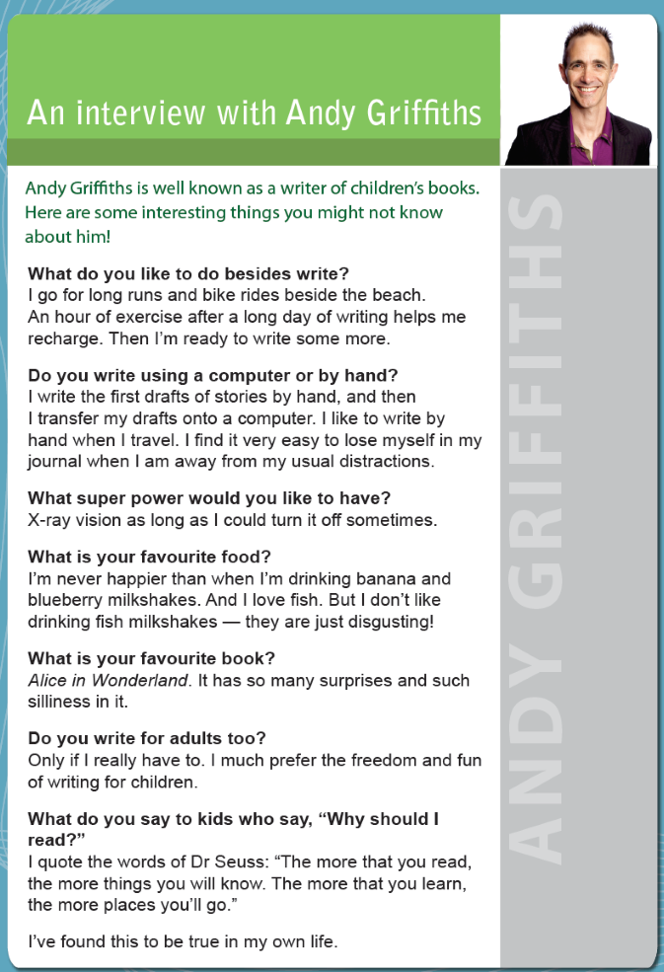
Year 3 NAPLAN Reading magazine, 2013 ACARA

Interview with an author
An interview with Andy Griffiths
Andy Griffiths is well known as a writer of children’s books. Here are some interesting things you might not know about him!
What do you like to do besides write?
I go for long runs and bike rides beside the beach. An hour of exercise after a long day of writing helps me recharge. Then I’m ready to write some more.
Do you write using a computer or by hand?
I write the first drafts of stories by hand, and then I transfer my drafts onto a computer. I like to write by hand when I travel. I find it very easy to lose myself in my journal when I am away from my usual distractions.
What super power would you like to have?
X-ray vision as long as I could turn it off sometimes.
What is your favourite food?
I’m never happier than when I’m drinking banana and blueberry milkshakes. And I love fish. But I don’t like drinking fish milkshakes — they are just disgusting!
What is your favourite book?
Alice in Wonderland. It has so many surprises and such silliness in it.
Do you write for adults too?
Only if I really have to. I much prefer the freedom and fun of writing for children.
What do you say to kids who say, “Why should I read?”
I quote the words of Dr Seuss: “The more that you read, the more things you will know. The more that you learn, the more places you’ll go.”
I’ve found this to be true in my own life.
Year 3 NAPLAN Reading magazine, 2013 ACARA

Appendix 2

Interview with an author worksheet
Evidence from the text… | This makes me think… | This makes me think the author’s perspective is…
“Only if I really have to. I much prefer the freedom and fun of writing for children.” | Andy Griffith likes writing for children. | Freedom and fun with writing is important to creating children’s stories.

Appendix 3

Finding clues about author perspective
Evidence in text | I think… | Author thinks…
Without bees, we cannot have flowers, without flowers, we don’t eat. | Bees are important | Our lives are at risk if we lose bees  Something needs to be done to ensure we keep bees safe

Appendix 4

Visual images to determine composer’s perspective
Photo by Markus Spiske on Unsplash.com

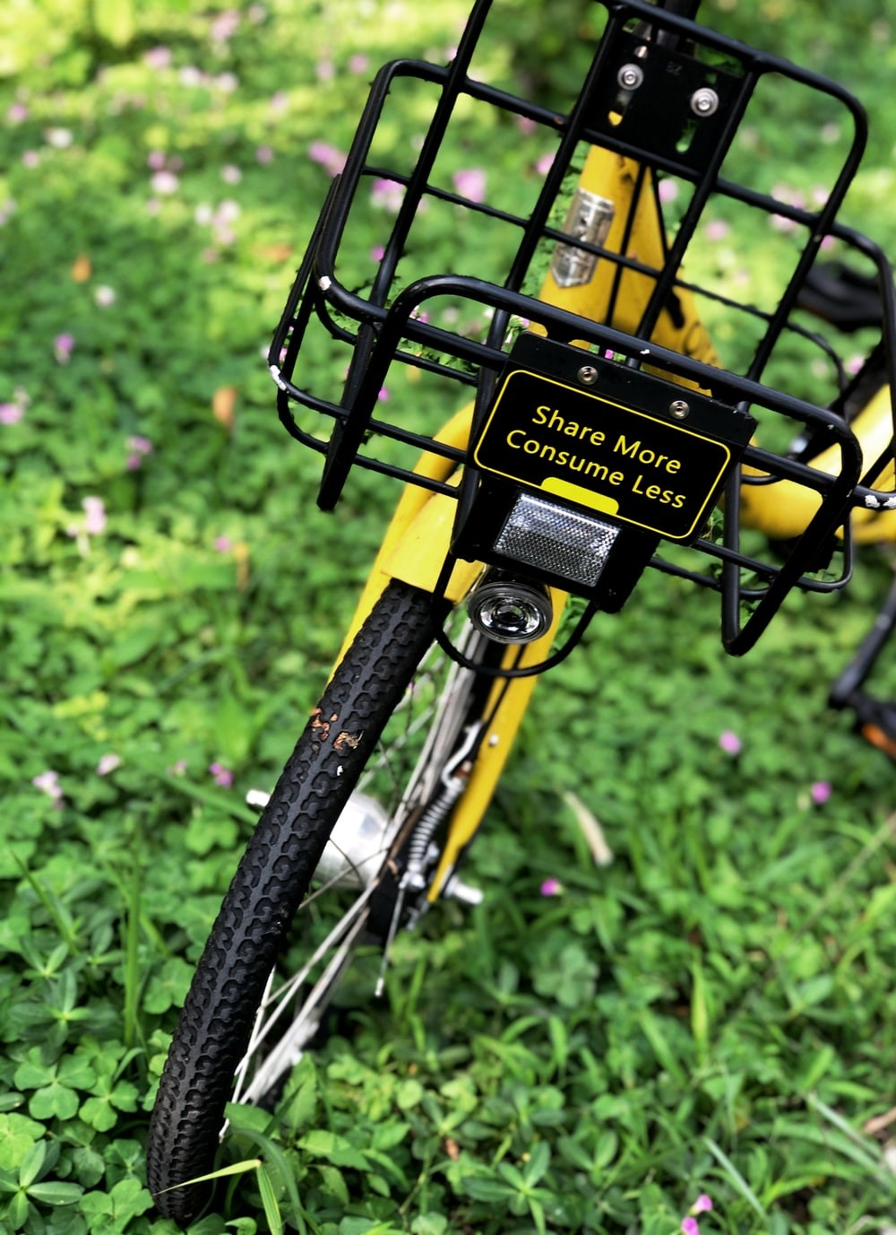
Photo by Pop & Zebra on Unsplash.com
Photo by NOAA on Unsplash.com

Appendix 5

Teacher guide: Identifying author perspective in text
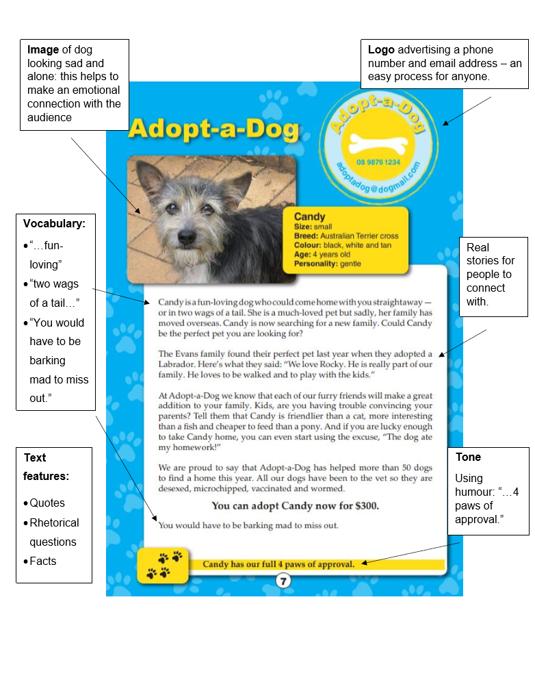
Year 3 NAPLAN Reading Magazine, 2013 ACARA

Student copy: Identifying author perspective in text
Year 3 NAPLAN Reading Magazine, 2013 ACARA
Appendix 5

Identifying author perspective in text – accessible version

Adopt –a-Dog
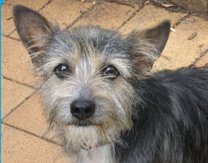

Candy is a fun-loving dog who could come home with you straightaway-or in two wags of a tail. She is a much-loved pet but sadly, her family has moved overseas. Candy is now searching for a new family. Could Candy be the perfect pet you are looking for?
The Evans family found their perfect pet last year when they adopted a Labrador. Here’s what they said: “We love Rocky. He is really part of our family. He loves to be walked and to play with the kids.”
At Adopt-a-Dog we know that each of our furry friends will make a great addition to your family. Kids, are you having trouble convincing your parents? Tell them that Candy is friendlier than a cat, more interesting than a fish and cheaper to feed than a pony. And if you are lucky enough to take Candy home, you can even start using the excuse, “The dog ate my homework!”
We are proud to say that Adopt-a-Dog has helped more than 50 dogs to find a home this year. All our dogs have been to the vet so they are desexed, microchipped, vaccinated and wormed.

You can adopt Candy now for $300.
You would have to be barking mad to miss out.
Candy has our full 4 paws of approval.
Year 3 NAPLAN Reading Magazine, 2013 ACARA

Appendix 6

Get to the heart
Feelings that you had | Explain
Evidence | Link to author’s perspective

Appendix 7

Identifying author’s perspective
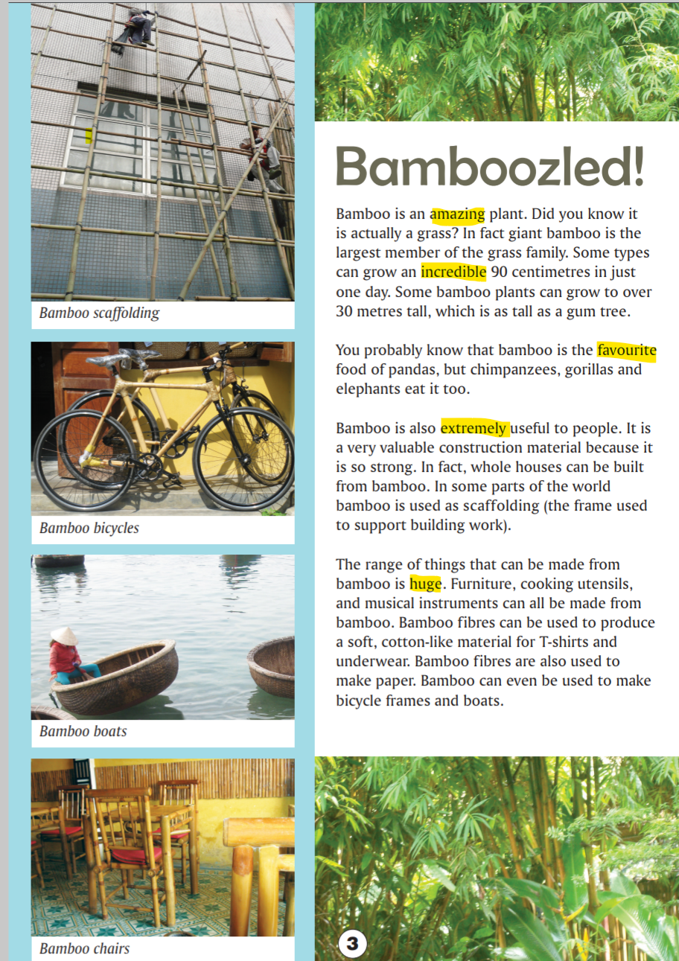
Year 5 NAPLAN Reading Magazine, 2016 ACARA.

Identifying author’s perspective – accessible version

Bamboozled!
Bamboo is an amazing plant. Did you know it is actually a grass? In fact giant bamboo is the largest member of the grass family. Some types can grow an incredible 90 centimetres in just one day. Some bamboo plants can grow to over 30 metres tall, which is as tall as a gum tree.
You probably know that bamboo is the favourite food of pandas, but chimpanzees, gorillas and elephants eat it too.
Bamboo is also extremely useful to people. It is a very valuable construction material because it is so strong. In fact, whole houses can be built from bamboo. In some parts of the world bamboo is used as scaffolding (the frame used to support building work).
The range of things that can be made from bamboo is huge. Furniture, cooking utensils, and musical instruments can all be made from bamboo. Bamboo fibres can be used to produce a soft, cotton-like material for T-shirts and underwear. Bamboo fibres are also used to make paper. Bamboo can even be used to make bicycle frames and boats.

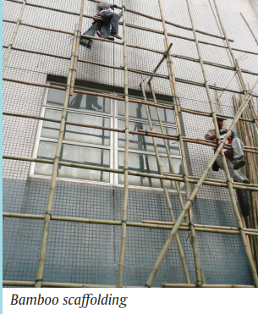
Bamboo scaffolding
Bamboo boats
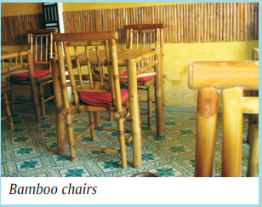
Bamboo chairs
Key language used to identify author’s perspective: amazing, incredible, favourite, extremely useful, huge.

Year 5 NAPLAN Reading Magazine, 2016 ACARA.

Appendix 8

Think aloud
I am going to describe to you the thinking that is going on in my head when I am reading a text to understand what the author is thinking and telling me.
This text looks like it is a factual text because it is organised into paragraphs and has photographs of real bamboo things to illustrate it. So, I am guessing it will have the purpose of informing me about bamboo.
The title is Bamboozled! This is a funny word because it is a play on the word bamboo and the text is about bamboo. The word bamboozle also has another meaning. It is a verb that means to fool or cheat or confuse. I am wondering if the writer wanted me to think that the amazing material bamboo has been kept a secret or that we would be confused because we did not know how great it is. When a writer uses a word with two meanings as a joke manipulating or playing with the different meanings it is called a pun. This makes me think the author wants to be funny with this text and not just tell me really serious facts.
When I read this text, I noticed that the writer uses lots of descriptive words to describe how great and useful bamboo is. Words like amazing, incredible and extremely make me feel that the author really likes bamboo. These are high modality words, meaning that they really emphasise and make strong the writer’s perspective or what they think about the topic.
The author has created a tone of familiarity or informal style of writing. They have used the pun on bamboozled in the title to set up the tone. The use of slang style words like amazing also helps set up the informal tone. The way the author used second person point of view by using the word you a lot makes me feel like they are talking directly to me. This personal approach is continued with the use of a question asked directly to me as the reader and this makes me feel connected to the topic. This type of question used in a text where the reader can’t actually answer is called a rhetorical question.
The author has added facts to the text to give it authority. Authority is created by the particular facts that the writer has chosen to include such as bamboo growing 90 cm in a day or that it can grow to the height of 30 metres or is a strong building material. These facts make the text sound factual and true, not made up.
There are facts that the writer has chosen to leave out such as the fact that some bamboos are very invasive and considered a weed in Australia. A writer makes choices about which facts they include and which facts they leave out and this helps me as a reader decide what the author thinks. Some of the sentences with the facts the author wants me to know, begin with ‘In fact’ to let me know that these are important facts to pay attention to. They have emphasised the usefulness of bamboo by starting many of the sentences that tell me what bamboo is used for with the word bamboo. Five out of the fifteen sentences begin with this word. The author really wants me to know that a lot of things are made out of bamboo. The text has a lot of photos to illustrate it and this emphasises the many uses of bamboo and each of these is captioned with the word bamboo… like bamboo chairs or bamboo boats. The text also has a split photograph at the top and bottom of the text to show how well bamboo grows.
This writer has used a lot of clues in the way the text has been written and illustrated to help me understand how this writer thinks and feels about the topic of bamboo.
All these clues make me think that the author feels that bamboo is an important material that we should all use because it is plentiful and versatile. That is the author’s perspective.

Appendix 9

Comparing two texts to identify author perspective
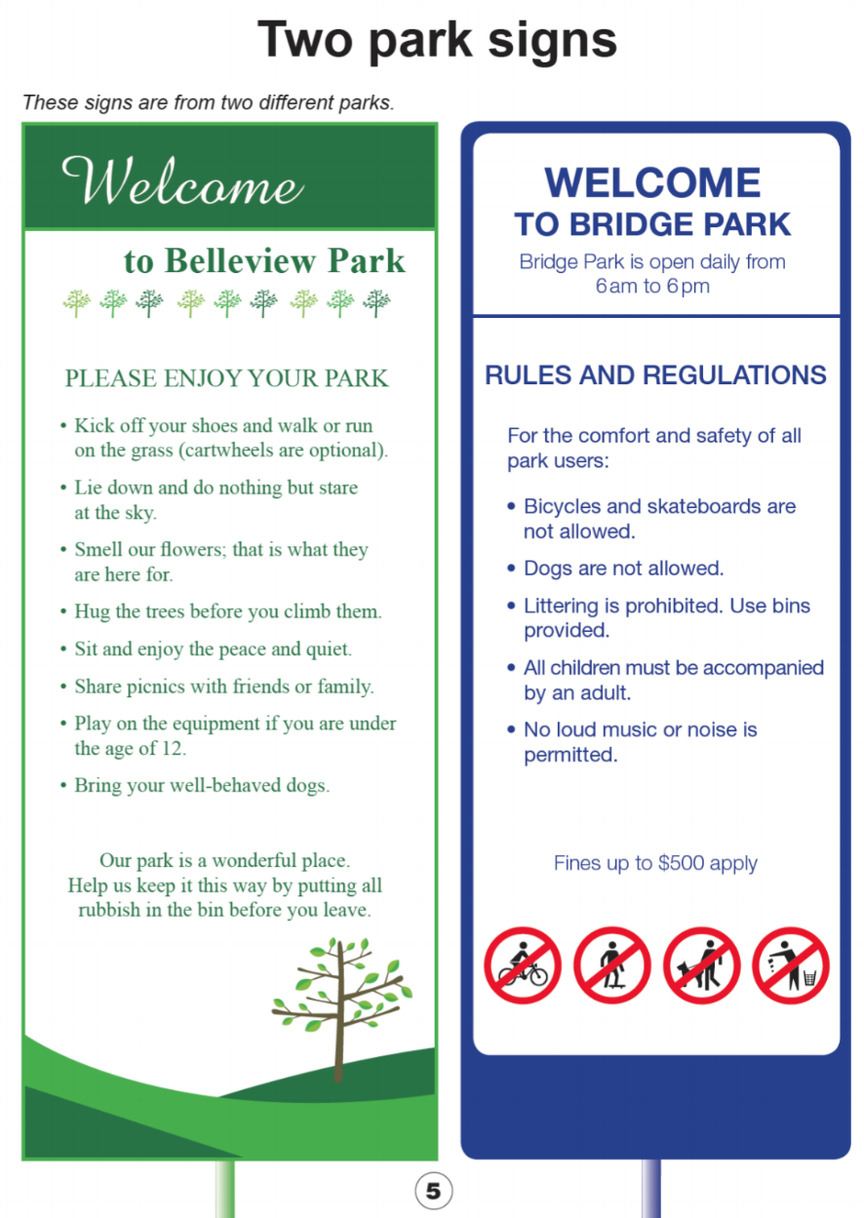
Year 5 NAPLAN Reading Magazine, 2015 ACARA.

Comparing two texts to identify author perspective – accessible version

Two park signs
These are signs from two different parks

Sign one uses green colours and images of tress to decorate.

Welcome to Belleview Park
PLEASE ENJOY YOUR PARK
- Kick off your shoes and walk or run on the grass (cartwheels are optional).
- Lie down and do nothing but stare at the sky.
- Smell our flowers; that is what they are here for.
- Hug the trees before you climb them.
- Sit and enjoy the peace and quiet.
- Share picnics with friends or family.
- Play on the equipment if you are under the age of 12.
- Bring your well-behaved dogs.
Our park is a wonderful place.
Help us keep it this way by putting all rubbish in the bin before you leave.

Sign two uses blue colours and has images of a bike rider, skate boarder, person walking their dog and someone littering in red circles with crosses through them.

WELCOME TO BRIDGE PARK
Bridge Park is open daily from 6am to 6pm
RULES AND REGULATIONS
For the comfort and safety of all park users:
- Bicycles and skateboards are not allowed.
- Dogs are not allowed.
- Littering is prohibited. Use bins provided.
- All children must be accompanied by an adult.
- No loud music or noise is permitted.
Fines up to $500 apply

Year 5 NAPLAN Reading Magazine, 2015 ACARA.

Appendix 10

Author perspective table
Images: What images did you notice and how did they make you feel? | Vocabulary: What words did you hear and how did they make you feel?

Text structure: What did you notice about how the text was structured? | Tone: What words would describe how the video makes you feel or think?

What does the author think and what evidence shows this?

