Literacy and numeracy teaching strategies
Guide for using resources

Purpose
Literacy and numeracy teaching strategies support teaching and learning from Stage 2 to Stage 5. They are linked to NAPLAN task descriptors, syllabus outcomes and literacy and numeracy learning progressions.
These teaching strategies target specific literacy and numeracy skills and suggest a learning sequence to build skill development. Teachers can select individual tasks or a sequence to suit their students.

Access points
The resources can be accessed from:
- NAPLAN App in Scout using the teaching strategy links from NAPLAN items
- NSW Department of Education literacy and numeracy website

Features
Each teaching strategy has the following features:
Feature | Description
Title | - focus skill  - reference to stage
Learning focus | - focus of the learning sequence  - may be framed as a learning intention
Syllabus outcomes | - targeted outcomes from English or mathematics syllabuses  - strategy will assist in achieving elements of the outcome
NAPLAN Item Descriptors | - descriptions of specific literacy and numeracy skills assessed in NAPLAN as captures in SCOUT  - teachers may identify a skill to target through NAPLAN data and can select teaching strategies designed to support the skill development.
Literacy and Numeracy Learning progression guide | - selection of indicators from the progressions relevant to supporting learning of the focus skill  - guided by NESA mapping of the progressions to the NSW English and mathematics K-10 syllabuses  enables literacy and numeracy focus across key learning areas
Resources | - appendix of resources which can be printed
Background information | - information for teachers to support classroom implementation  - key terminology and metalanguage defined
Where to next | - suggestions for further learning
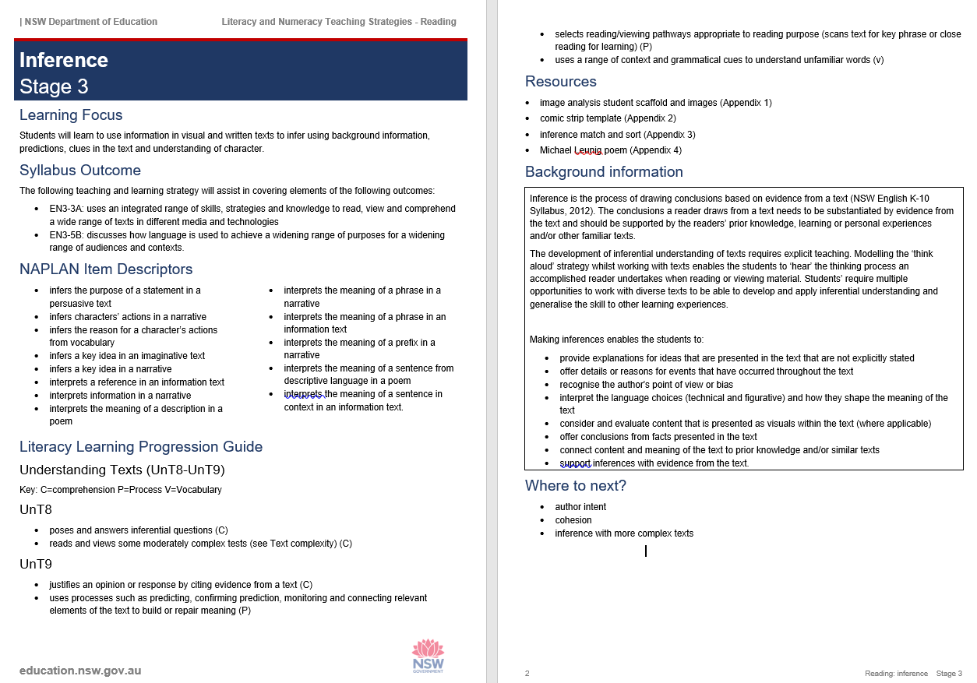Example of teaching strategy layout and features

Coding
Code | Description
Italics | - used to indicate teaching strategies (see Teaching Strategies page in this resource)  - used for metalanguage or subject-specific terminology
Appendix | - appendices are attached to support the teaching strategy
Variation | - opportunity to vary the learning to support or challenge learners. Teachers will differentiate and make adjustments within programming.
Alternate Task | - a different suggestion to achieve the same purpose
Additional Task | - an opportunity to further build on an idea

Teaching strategies
Embedded within each task is a range of teaching strategies which encourage collaboration, communication and critical and creative thinking.
Strategy | Purpose
Anchor chart | This is a central reference place where key information is recorded. The anchor chart can be built upon and understanding of a topic or concept increases. Anchor charts are commonly written on butcher’s paper and colour-coded as appropriate. It is visual and referred to throughout learning.
Brainstorm | Students share ideas with sticky notes, whiteboards, google docs etc. All ideas are included. Ideas can be categorised and coded.
Concept map | Students summarise ideas and map thoughts with details stemming from a main idea or topic.
Gallery walk | Students add ideas to texts and posters around a room. Students move from one poster to the next, identifying themselves with their initials.
Jigsaw task | Information is separated into sections where students become an expert in their part. Importantly, students share this information so all students are exposed to the idea and to build a global understanding of the text or topic.
KWL Chart | Three column chart: What I know, what I want to know and what I learnt (what I learnt column is completed after learning and can be used as a formative assessment.
Modelled instruction | Teacher directs learning and demonstrates by thinking aloud and explicitly showing how to complete the task.
Newsflash | Students synthesise information and ideas into three components: headline, visual representation and key information.
T-Chart | Simple comparison graphic organiser with title at the top and broken down into two sections underneath.
Think aloud | Verbalising thinking and ideas for students to understand a process
Think, pair, share | Students work with partners to think about an idea or question, share with a partner and share. Pairs can become quads (2 people in a group, then 4) to further refine ideas.
Walk and Talk | Premise: Students move around the classroom to share ideas with different partners. This can couple as a physical break and learning transition, as well as a way to incorporate targeted discussion.  How it works: Teacher informs students of topic for discussion. Teacher calls out ‘walk’ and students move around the classroom until hearing the word ‘talk’. Students match with the person standing closest to them. Students discuss topic until teacher calls out ‘walk’ and the process starts again.
Y-Chart | Three part graphic organiser in the shape of Y

