Subject vocabulary – Stage 6 PDHPE

Sequence
To get the most from these resources they should be used as a teaching and learning sequence. One set of activities leads on to the next.
- Improve student writing through subject vocabulary (this document)
- Improve student writing through planning for writing (DOCX | PDF)
- Improve student writing through writing and feedback (DOCX | PDF).

Learning focus
With these literacy activities teachers use content that they have planned in their teaching and learning cycle. For each literacy activity an example from Community and Family Studies (CAFS) has been provided. The example provided is a model for teachers. Teachers can modify the specific examples, learning intentions and success criteria to suit their student and school context.

Syllabus outcomes
For each PDHPE subject, relevant syllabus outcomes have been provided in the Stage 6 PDHPE syllabus links (PDF 85 KB) document. However, to support professional practice teachers are strongly advised to always refer to the syllabus documents on the NESA website.

Learning intentions
- Students become familiar with subject vocabulary.
- Students increase understanding of specific vocabulary terms.
- Students investigate how vocabulary will support their knowledge of content.

Success criteria
- Students are able to define terms that are specific to their subject.
- Students are able to effectively use terminology that is specific to their subject.
- Students understand how vocabulary will support their knowledge of content.

Teaching strategies
- Activity 1: Select
- Activity 2: Explain
- Activity 3: Explore
- Activity 4: Consolidate.
(Adapted from: Alex Quigley ‘Closing the Vocabulary Gap’ Routledge 2018)

Activity 1: Select
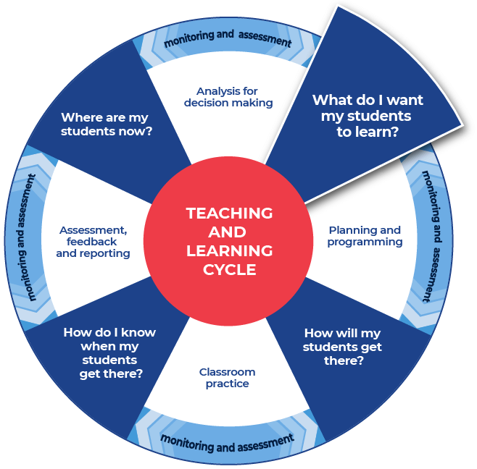

Required resources
Teachers choose a resource that they are currently using in class. It could be an article, video, website, textbook page, or other resource.
Teachers provide their students with access to the chosen resource.
Examples of potential resources are listed below:
- Specific pages or a chapter from a textbook.
- A video or TED Talk on the topic.
- Appropriate government websites.
- Copies of, or access to the syllabus, such as the PDHPE Stage 6 Syllabus or CAFS Stage 6 Syllabus.
In the example provided, from CAFS, the text reflects understanding of the specific needs of individuals and factors affecting resource management: Youth Homelessness Fact Sheet from SBS Learn (PDF 2.18 MB).
The content used in the CAFS example relates to syllabus content from Preliminary core: Resource Management. Understanding this language is essential as it forms the building blocks for the following preliminary content and all HSC content.
When selecting the text to work with, consider the text complexity and reason for using that text. It is also important to read texts carefully before using them with students and pre-identify any terms or subject specific language that students may find challenging. Further information on text complexity can be found National Literacy and Numeracy Learning Progressions, Literacy Progression, Appendices 6 – Text Complexity (PDF 388 KB).
To support students with understanding the chosen text and its relationship to the course content, teachers may choose to engage with the following strategies: using a core thinking routine such as think, puzzle, explore (PDF 212 KB) or connect, extend, challenge (PDF 182 KB) to draw connections between new ideas and prior knowledge within the CAFS content; providing students with clues for navigating the text; summarising what the text will be about; and explaining specific terms that will appear in the text.

Instructions:
- Students access the text and select ten unfamiliar words that they do not feel confident that they know the meaning of.
- Students engage with the text that the teacher has provided.
- Students write the words into a table or in their workbook after they have engaged with the text.
- Teachers model their own example to share with students. An example from CAFS has been included.
Differentiation:
- Teachers could pre-select the ten words.
- Teachers could pre-select some of the words and then allow the students to select the rest.
- Teachers could alter the amount of words to be selected.
- Teachers could support comprehension by altering the font of the text to make it more readable and presenting the information in smaller sections.
- Teachers may want to use some pre-reading activities such as: providing students with clues for navigating the text, summarizing (locating specific information) what the text will be about, and explaining specific terms that will appear in the text.
- Teachers may also be to read the text to students to allow them to hear the text, including the pronunciation of key terms.
- Teachers could use videos and other multi-modal texts to support learning.
Further support:
- An example from CAFS has been provided using the text, Youth Homelessness Fact Sheet from SBS Learn (PDF 2.18 MB).

Example

service
workforce
affected
homelessness
youth
experiencing
social behaviours
security and stability
suitable housing
substance abuse

Activity 2: Explain
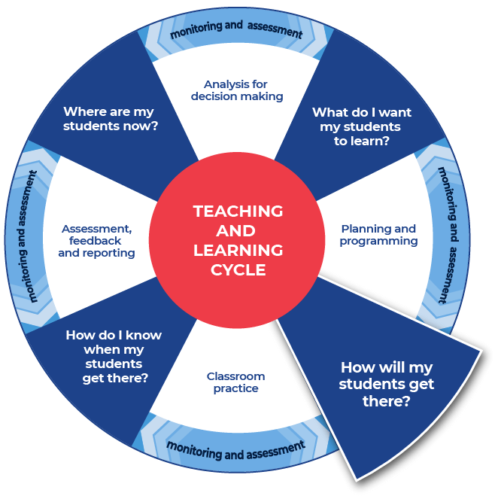

Instructions:
- Teachers replicate the example structure using the text that their students are working with. Teachers provide their example to their students.
- Students research the formal technical definition for each of their words and write it in the table provided, or in their workbook. Students can use online or hard copy dictionaries.
- Students create their own informal ‘student’ definition for each word. It should be written in plain English. This is the way they might explain it to a friend.
- Students should write their informal definition in the table.
- Students will need to complete this task for all ten words.
Differentiation:
- Modifications for EAL/D students may include explicitly teaching how to use the dictionary and support in choosing which definition is relevant to PDHPE or CAFS.
- Teachers may provide the words and scaffold the definitions. For example, create mini cloze passages inside the definition spaces and provide a word bank for students.
- Teachers could supply the link to the online dictionary and students can write the definition in the table.
- Teachers could encourage students to work together to create informal definitions first. Students could then source the formal definitions and refine their informal definitions.
- Teachers could support students by discussing the word as it is used in the context of the sentence.
- Teachers could support students by discussing multiple meanings and that being literate includes understanding that some words can have multiple meanings.
- Students could work in pairs, then they should join their word lists together and complete definitions for twenty words.

Template
Use the dictionary or legal definition of the word together with the links to the syllabus to create your own definition.
Word | Dictionary definition or recognised site such as ABS, AIHW, AIFS | How is this word used in this subject? | Your definition
word | From name-of-dictionary:  ‘dictionary definition.’ | Link to subject content | Student definition.
… | … | … | …
… | … | … | …
… | … | … | …
… | … | … | …
… | … | … | …
… | … | … | …
… | … | … | …
… | … | … | …
… | … | … | …

Completed example
This example has been filled in for teachers as a model.
Word | Dictionary definition or recognised site such as ABS, AIHW, AIFS | How is this word used in this subject? | Your definition
service | From Macmillan Dictionary:  ‘a system provided by government or official organisation for the needs of the public.’ | Objective: knowledge and understanding about resource management and its role in ensuring individual, group, family and community wellbeing.  Preliminary core: Resource Management  Module focus: Influences on resources management.  Students learn about factors affecting resource management:  - personal values and past experiences  - factors influencing availability of and access to resources, eg age, gender, disability, culture, socioeconomic status  - access to support  - informal, eg relatives, friends, neighbours  - formal, eg government agencies, community organisations | In society when people need support and help to manage their resources they can access external support. Government organisations or community groups organise ways to help to meet the needs of community members. This could be counselling or police or ambulance services, or housing or food services.
social behaviours | From enotes:  ‘Social behaviour is a set of actions performed by individuals of the same species when they interact with each other. Both humans and animals engage in social behaviour; social interaction can be both verbal and nonverbal.’ | Objective: knowledge and understanding about the influence of a range of societal factors on individuals and the nature of groups, families and communities.  Preliminary core: Individuals and Groups  Module focus: Roles individuals adopt within groups.  Students learn about specific roles of individuals:  - norms, conformity and cohesiveness within and amongst groups. | Social behaviours are how people interact with each other. There are norms or expectations of ways for people to behave in social situations, these are tied to people’s and community’s values. When people adopt these behaviours they conform to meet societal expectation.
homelessness | From Australian Bureau of Statistics:  ‘when a person does not have suitable accommodation alternatives they are considered homeless if their current living arrangement:  - is in a dwelling that is inadequate; or  - has no tenure, or if their initial tenure is short and not extendable; or  - does not allow them to have control of, and access to space for social relations.’  Note: Teachers could investigate the 3 levels or categories of homelessness described at the Homelessness Australia website. | Preliminary core: Resource Management  Module focus: Fundamental concepts of resource management.  Students learn about needs and wants:  - specific needs  - adequate standard of living (food, clothing, shelter)  - health  - education  - employment  - safety and security  - sense of identity.  Module focus: Influences on resources management.  Students learn about factors affecting resource management:  - personal values and past experiences  - factors influencing availability of and access to resources, eg age, gender, disability, culture, socioeconomic status. | Inadequate access to safe and secure housing. These include sleeping rough (primary), frequent movement between boarding houses or temporary accommodation (secondary) and couch surfing (tertiary).

Activity 3: Explore

Instructions:
- Teachers provide their own completed example and a template to their students.
- Students explore each word to deepen their understanding of the subject vocabulary.
- Students complete this task for all ten of their words.
Differentiation:
- Teachers can choose between the two template options provided.
- Teachers could explicitly discuss with students if they know this word from another subject and if the meaning of the word is the same or different from the other class. This allows students to connect learning across KLAs.
Further support:
- Teachers model their own example to share with students. An example from CAFS has been included.
- By completing the following templates, students are aiming to build up a set of characteristics and features of the chosen word. These characteristics and features are designed to support students to demonstrate their knowledge and understanding of the content.
- Teachers support students to recognise that a single concept can be viewed or have an impact in a broad range of situations.

Example 1

Template: Vocabulary map
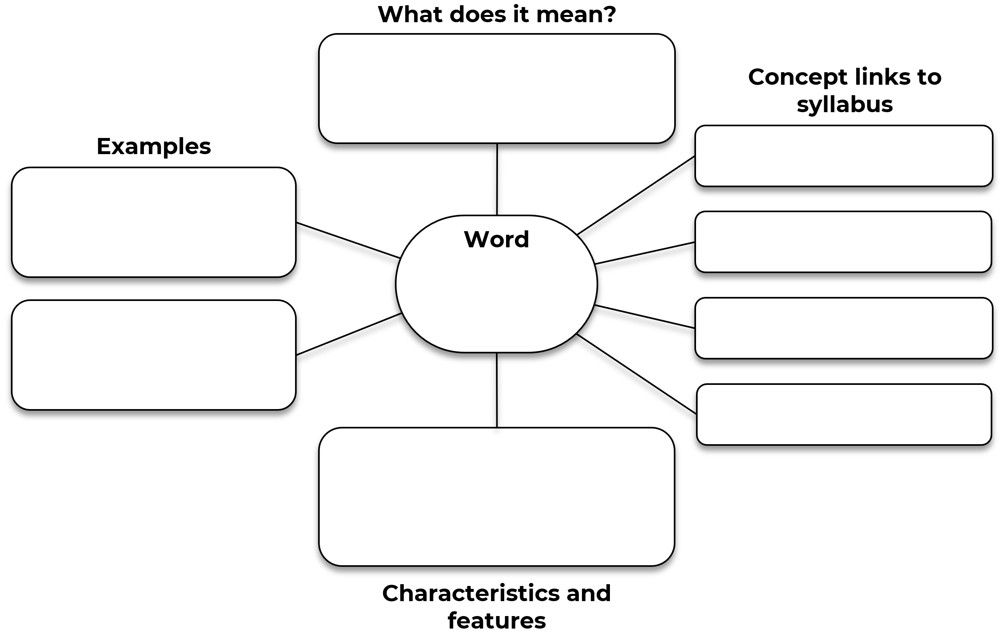

Completed example: Vocabulary map
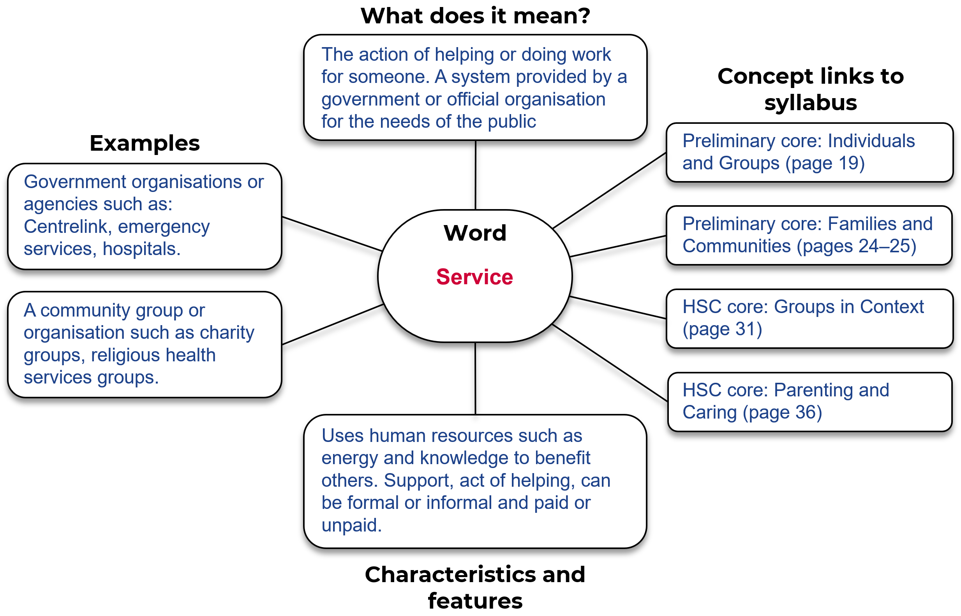

Teacher note (for completed example vocabulary map): For CAFS, ‘services’ can be referred to across the syllabus in many ways. Within the HSC course (Groups in Context and Parenting and Caring.) ‘services’ can be referred to in language such as: formal support, government agencies, government organisations, community groups, community organisations, services – financial support, transport, accommodation and housing, health care, counselling, education and legal aid, child care and respite care.

Example 2

Template
Word:
Write the sentence, from the text, that contains the word.

In the text, what are some other words associated with this word?

Find an example, in the text, of a sentence that hints at the meaning of the word?

Does the text make a comparison for the chosen word, or could you create a comparison? This could be a literal comparison or an analogy.

Outline your understanding of this word for your specific subject. This could include characteristics and features.

Completed example
Word: Service
Write the sentence, from the text, that contains the word.
‘Less likely to know about homeless services.’
In the text, what are some other words associated with this word?
Youth refuge, pathways program, support, caseworker, transitional housing, boarding houses, supported accommodation.
Find an example, in the text, of a sentence that hints at the meaning of the word?
‘Supported accommodation’, ‘safest places for young people’, ‘stability offered by a long term home’, ‘a place to call home’, ‘I felt welcomed’, ‘go home somewhere safe and I’ve got somewhere to go’.
Does the text make a comparison for the chosen word, or could you create a comparison? This could be a literal comparison or an analogy.
Yes. The use of services through the Vinnies team at Bowral Youth Refuge and pathways program supported Hannah. This was compared with the support that she accessed through informal support networks when she was couch surfing at her uncle’s girlfriend’s house.
Both provided temporary housing and some support, the structured nature and professional standard the services have to meet when compared with informal support meant that she was supported in her temporary house and found security and safety as opposed to having a temporary roof over her head and informal care that came with exposure to substance abuse at her uncle’s girlfriend’s house.
Outline your understanding of this word for your specific subject. This could include characteristics and features.
A service is an organisation or system that is able to provide for a public need to offer support towards an individual through the action of helping someone or doing work for someone. This aims to satisfy their needs and promote their wellbeing.

Activity 4: Consolidate
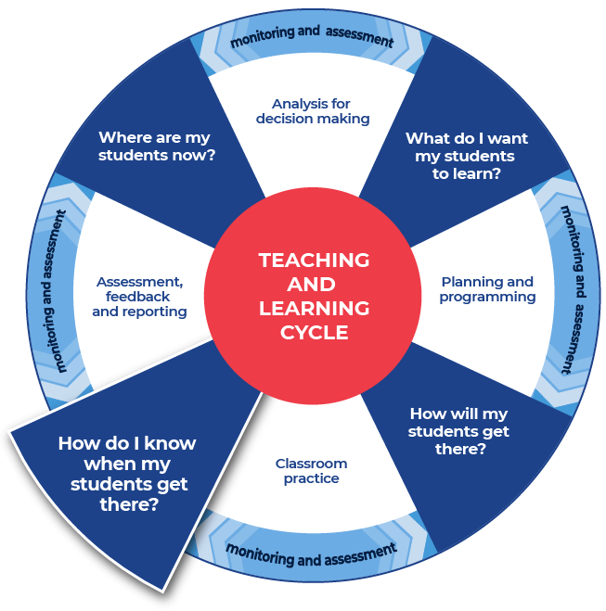

Instructions:
- Students consolidate their subject vocabulary by writing a PEEL (or preferred scaffold) paragraph on the topic that summarises the information provided in the text, using the vocabulary words investigated. A template is provided.
- Teachers provide a question for students to respond to.
Differentiation
- Students could consolidate their subject vocabulary learning by creating a match-up worksheet. Students create a worksheet using the template provided by writing their ten words in the boxes listed down the middle of the worksheet. Students fill in the outer squares with their personal definitions of the words. They should ensure that they are out of order. Students provide the teacher with an answer sheet for the match-up that they create. The word and correct definition should be clearly indicated. Teachers swap student’s match-up worksheet with a peer who aims to get ten out of ten as they attempt the worksheet.
- Students could create a match-up worksheet using graphic organisers from the Digital Learning Selector.
- Students split into two groups. Half of the class has a word and half of the class has a definition. Students move about the space to locate their partner.
- Students could create flash cards on paper or using graphic organisers from the Digital Learning Selector.
- Students could source an alternate article that uses the same or similar vocabulary words in a different context and with a different focus. Students could then discuss and compare how the same term is used in different ways. Student responses are strengthened by providing many examples of a concept, for example, services. This reflects a deep understanding of the impact of the concept across a broad range of situations.

Templates

PEEL paragraph
For more information on the PEEL writing process go to HSC minimum standard – paragraphs.
Question:
POINT: Make your point in relation to the topic. This is your topic sentence that tells the reader what your paragraph will be about.

ELABORATE: Expand or elaborate on your point by providing characteristics and features of the content. This is where you give more detail to make your point clearer.

EXAMPLE: Provide an example that supports your point. This is where you give the reader evidence that validates your point.

LINK: Link back to what the question is asking you. This is where you link your evidence back to what the question is asking, so that the reader knows you have concluded your point and connected everything together.

Completed example
Question: How do support services address youth homelessness in Australia?
POINT: Make your point in relation to the topic. This is your topic sentence that tells the reader what your paragraph will be about.
Homelessness amongst youth is a major problem in Australia. Tonight there could be 28,000 young people who are aged between 12 years and 24 years old who are homeless. Support services meet the most basic needs for these young Australians.
ELABORATE: Expand or Elaborate on your point by providing characteristics and features of the content. This is where you give more detail to make your point clearer.
These young people require support and services to meet their specific needs. Services help to deliver an adequate standard of living by providing crisis housing, and health care. Services can also help by supporting those who are experiencing substance abuse issues. Services can provide for the security and safety of young people in place support from their family.
EXAMPLE: Provide an example that supports your point. This is where you give the reader evidence that validates your point.
For example, Hannah was 14 years old when she started experiencing homelessness. Her parent’s situation of incarceration and substance abuse meant that Hannah sought support from informal networks such as friends and relatives. This situation remained unstable for her and she sought access a to refugee and used services provided by St Vincent De Paul to be in control of her life and the support meant that she was able to make long term positive changes to create stability for herself.
LINK: Link back to what the question is asking you. This is where you link your evidence back to what the question is asking, so that the reader knows you have concluded your point and connected everything together.
Youth homelessness is a major problem in Australia and organisations such as St Vincent De Paul (Vinnies) aim to support the needs of youth to ensure that many of the effects are not long lasting and to break the homelessness cycle.
Note: The templates on the following pages relate to the first differentiation activity described in the Activity 4 instructions.

Name of worksheet:
Student name:
Match-up the words with the appropriate definitions.

Definitions

Words

Definitions

Name of worksheet:
Student name:
Answer sheet.

Definitions

Words

Definitions

This is the end of the activities for: Improve writing through subject vocabulary.
Teachers should move on to the next set of activities: Improve student writing through planning for writing (DOCX | PDF)

Additional resources

Cohesion
Cohesion is useful to help students stich ideas together over one or more paragraphs. It can help support students to link the point that they are making with their evidence and conclusion. Cohesion is ‘that quality in a text determined by its parts being related and contributing to its overall unity. Cohesion is achieved through shaping the form, creating a structure that the responder can recognise and use to navigate the text …’ (English K–10 Syllabus Glossary). For more ready-to-use teaching and learning activities on cohesion visit HSC minimum standard – Cohesion.

HSC hub
CAFS teachers can view the video – Glossary of key terms focus on: Evaluate, Assess and To what extent on the HSC hub.
Further PDHPE and CAFS resources can be found in the PDHPE section of the HSC hub.

Learning Resource Hub
Evidence-based resources and tools are accessible to all schools via the Learning Resources Hub (staff only).
Teachers can use these resources to support integration of reading and numeracy instruction into teaching and learning programs.

Question verbs
We have included a glossary of question verbs and activities (DOCX 80 KB) that are ready to use. These will get your students thinking about what the question is asking.

Topic Vocabulary
For more ready-to-use teaching and learning activities on topic vocabulary go to HSC minimum standard – Topic vocabulary.

Vocabulary
For more ready-to-use teaching and learning activities on vocabulary go to HSC minimum standard – Vocabulary.

