The National Literacy Learning Progression and Stage 6 PDHPE

How the progression could support writing in Stage 6 PDHPE
This document is part of the Stage 6 Literacy in context – Writing resource. It outlines ways that the National Literacy Learning Progression can support development of student writing through Stage 6.
The element of Writing in the National Literacy Learning Progression provides indicators that reflect the increasing sophistication of skill development in writing for students in Years K–10. It is important to note that these skills are unconstrained and will continue to develop as students work through their final years of school and beyond.
In addressing the Objectives and Outcomes in the Stage 6 PDHPE syllabuses, students need to use subject specific terminology to describe, analyse, argue, and explain in a variety of written forms.
A student’s ability to communicate their knowledge and understanding will influence the quality of their written responses. For example, marking criteria and HSC feedback for written short and extended response questions for PDHPE and CAFS may include statements such as:
- provides an argument
- demonstrates a detailed understanding of
- makes an accurate judgement
- provides examples and detailed reasons
- demonstrates an accurate understanding of the relationship
- provides characteristics and features.
It can be difficult for teachers to articulate what effective writing ‘looks like’ in a student response, and therefore to be able to explicitly support their students to improve their writing. Certain indicators within the Creating texts sub-element of the National Literacy Learning Progression can amplify these criteria and support teachers and students to identify features of writing that can be targeted to improve students’ ability to answer extended response questions.
Some examples of these connections between the criteria and the Creating texts sub-element are provided here:
Provides an argument:
- organises related information and ideas into paragraphs/sections (CrT10 Generic indicators)
- creates sustained, informative texts that precisely explain, analyse and evaluate concepts or abstract entities (CrT11 Crafting ideas)
- uses structural features flexibly to organise ideas strategically (e.g. includes a defined, cogent conclusion / summation) (CrT11 Crafting ideas).
Demonstrates a detailed understanding of:
- uses discipline-specific terminology to provide accurate and explicit information (e.g. discipline metalanguage) (CrT10 Vocabulary)
- uses vocabulary for precision (e.g. the underwhleming performance of the opening batsmen) (CrT11 Vocabulary)
- uses complex abstractions (e.g. economic, sociocultural) (CrT11 Vocabulary).
Make an accurate judgement:
- creates sustained, robust arguments on complex learning area topics (e.g. should bushrangers be afforded hero status?) (CrT11 Crafting ideas)
- uses sophisticated evaluative language devices such as allusion, evocative vocabulary and extended metaphor (CrT11 Text forms and features)
- Provide examples and detailed reasons:
- uses citation and referencing from authoritative sources (CrT11 Crafting ideas)
- uses evidence and research including digital resources to expand upon information and elaborate concepts (CrT10 Crafting ideas)
- uses evidence and references (CrT11 Crafting ideas).
Demonstrates an accurate understanding of the relationship:
- maintains tone appropriate to the audience (CrT11 Text forms and features)
- skilfully uses a range of cohesive devices to make connections between arguments (e.g. foreshadows key points in introduction and reinforces key points in topic sentences) (CrT11 Text forms and features)
- uses structural features flexibly to organise ideas strategically (e.g. includes a defined, cogent summation or call to action) (CrT11 Crafting ideas)
- positions the reader effectively by providing a clear thesis and relevant context (e.g. by previewing the arguments) (CrT11 Crafting ideas)
Provides characteristics and features:
- uses discipline-specific terminology to provide accurate and explicit information (e.g. discipline metalanguage) (CrT10 Vocabulary)
- judiciously selects evidence and language to strengthen arguments (CrT10 Text forms and features)
- creates texts to compare and contrast phenomena (e.g. identify the similarities and differences between species of animals) (CrT10 Crafting ideas).

Literacy Learning Progression to inform feedback
Before you begin you may like to learn more about the National Literacy Learning Progression through the online professional learning course: Introduction to the Literacy and Numeracy Progressions.
For example, Writing sub-elements include:
- Creating texts – Crafting ideas
- Creating texts – Text forms and features
- Creating texts – Vocabulary
- Grammar
- Punctuation
- Spelling
- Handwriting/keyboarding.
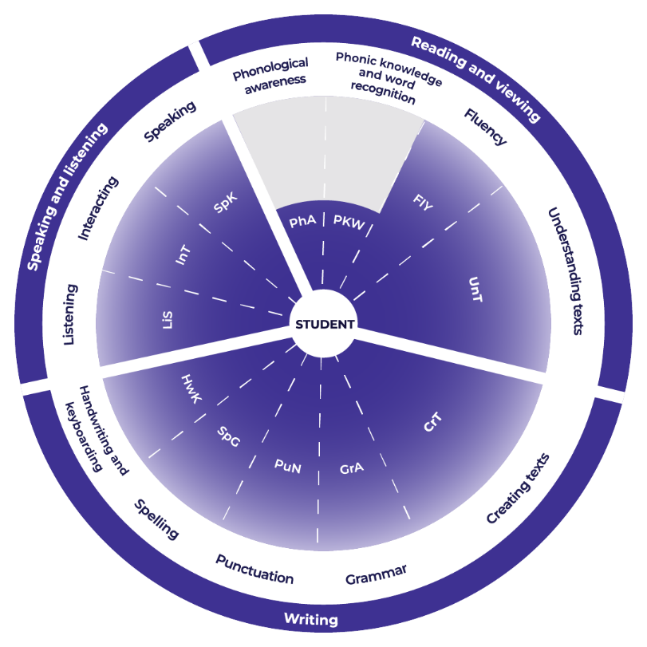

Teachers could use the student’s written response to assess where the student is at now and what they could do next to improve.

Example analysis
For this example, Crafting ideas has been selected.
The teacher reads through the sub-element description to match characteristics that the student’s text is currently displaying. An example from CAFS is provided.
CrT10 Crafting ideas
- creates texts to compare and contrast phenomena (e.g. identify the differences between species of animals)
- orients the reader clearly to the topic or concept (e.g. using a definition or classification in the opening paragraph)
- intentionally selects structural elements for effect (e.g. includes an appropriate conclusion that sums up, recommends or reiterates)
- uses evidence and research including digital resources to expand upon information and elaborate concepts
While there may have been secrecy around adoption in the past, ‘Open adoption means that adoptive and birth families now know about each other, exchange information and often have direct contact to enable children to connect with and understand their background.’ Whenever there is change to a law it is often driven by community voice, ‘We have listened to the calls from adopted people and legal experts, and are delighted to be introducing the first change to birth certificates for adopted people in 55 years.’ Before these reforms the law was that when people were adopted their birth certificates were altered to remove their birth families. After these reforms birth certificates will have ‘information about their parents and siblings at birth, as well as their parents and siblings after they have been adopted.’
Reading the next element descriptor the teacher could work out where to next for the student.
CrT11 Crafting ideas
- creates sustained, informative texts that precisely explain, analyse and evaluate concepts or abstract entities
- uses structural features flexibly to organise ideas strategically (e.g. includes a defined, cogent summation or call to action)
- uses citation and referencing from authoritative sources.
For example, in the written response the student could:
- edit to be more concise. They could change the order of the sentences. They could also try to decrease the amount of words that they have used overall. Additionally, they could include evaluation of the issue.
- use classification to organise ideas and information e.g. NSW state government.
- cite the references for the quotes.

Example of written feedback to the student
Name: Rose Yeung
Is able to:
Compare and contrast phenomena.
Orientate the reader.
Use supporting evidence
Expand upon ideas and concepts in her writing.
To continue to improve:
Rose could:
- edit to be more concise. She could change the order of the sentences and could also try to decrease the amount of words that they have used overall. Additionally, Rose could include evaluation of the issue
- use classification to organise ideas and information e.g. NSW state government
- cite the references for the quotes.

Template
Name: ____________________________________
Is able to:

To continue to improve:

