Student writing and feedback – Stage 6 Mathematics

Sequence
To get the most from these resources they should be used as a teaching and learning sequence. One set of activities leads on to the next.
- Improve student writing through subject vocabulary (DOCX | PDF)
- Improve student writing through planning for writing (DOCX | PDF)
- Improve student writing through writing and feedback (this document).

Learning focus
With these literacy activities teachers use content that they have planned in their teaching and learning cycle. For each literacy activity an example from Mathematics Standard has been provided. The example is a model for teachers. Teachers create their own specific examples for their subject and class. Teachers can modify the learning intentions and success criteria to reflect their context. Students draw upon their vocabulary and planning to complete a written response and engage with feedback to enable them to continue to build their skills.

Syllabus outcomes
For each mathematics subject, relevant syllabus outcomes have been provided in the Stage 6 Mathematics syllabus links (PDF 80 KB) document.

Learning intentions
- Students complete a writing task.
- Students provide effective peer feedback.
- Students engage with effective feedback.

Success criteria
- Students are able to effectively complete a written response.
- Students are able to effectively provide feedback to a peer.
- Students are able to reflect on their learning needs.

Teaching strategies
- Activity 1: Turn and talk
- Activity 2: Writing activity
- Activity 3: Peer feedback
- Activity 4: Teacher feedback
- Activity 5: Student self-reflection.

Activity 1: Turn and talk
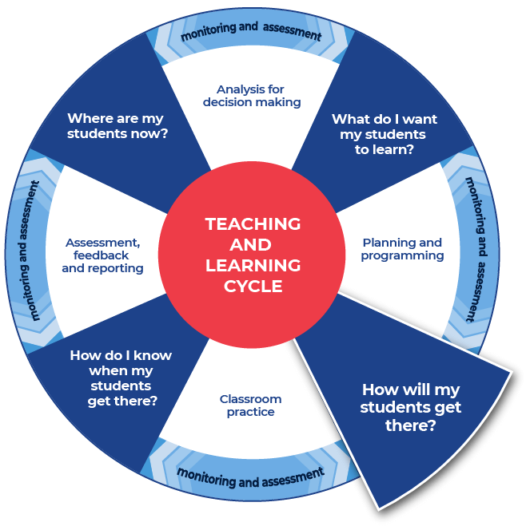

Instructions:
- Teachers provide time in class for students to discuss, in pairs or small groups, the notes that they have taken and how they will respond to the driving question.
- Students plan to use words and sentences that they have created in their note taking.
- Teachers model their own example to share with students. An example from Mathematics Standard has been included.
Differentiation:
- Teachers could provide a completed written response for students to use as a model for their own writing.
- Teachers could support students by providing specific questions for ‘turn and talk’.
- Teachers could modify this activity for specific contexts through sentence starters, scaffolded sentences or word banks.
- Students and teacher could co-write and produce one written piece of work.
- Students could think of an analogy or metaphor for the topic that they are investigating.
- Students could present the topic in another form, for example as a poem, artwork, found or constructed artefact, song.
Further support:
- Paragraph construction can be found at HSC minimum standard – Paragraphs.
- Classroom talk is a powerful tool for both teaching and learning. Rich, dialogic talk supports students in making sense of complex ideas and builds classroom communities centred on meaning-making. Tools to support rich talk in the classroom were outlined in Christine Edwards-Groves 2014 paper, Talk moves: A repertoire of practices for productive classroom dialogue (PETAA paper 195). For an example of how these tools were applied to Mathematics ‘Talk moves’ posters, flashcards and a chart are available. These practices could also be applied in the classroom in other learning areas including Mathematics.

Example driving question
How are mathematical concepts reflected in Aboriginal navigational methods?

Teacher task evaluation:
This driving question enables students to investigate and clearly communicate a position. The task is designed to develop student’s interest in navigation and trigonometry. This task addresses the syllabus in reference to investigating navigational methods used by different cultures, including those of Aboriginal and Torres Strait Islander Peoples. Students are taught explicitly to note take and organise their notes into an individual piece of writing which incorporates the key points.

Example response
Mathematics Standard 1 Year 12 content – MS-M3 Right-angled triangles:
- understand various navigational methods
- investigate navigational methods used by different cultures, including those of Aboriginal and Torres Strait Islander Peoples

Written response
How are mathematical concepts reflected in Aboriginal navigational methods?
Mathematical features reflected in Aboriginal navigational methods include using the stars in the sky to correlate to landforms on the ground and to use these landforms as waypoints. Aboriginal peoples used these star maps to navigate outside familiar regions.
Mathematical tools such as the use of cardinal points were used, for example, some Aboriginal peoples have cardinal points and they call them, as stated on the website, ‘In the Warlpiri culture, north corresponds to “law”, south to “ceremony”, west to “language”, and east to “skin”. “Country” lies at the intersection of these directions, at the centre of the compass – i.e. “here”.’ Furthermore, calculations by Aboriginal peoples were used, such as the position of the Southern Cross to indicate the cycle of teachings from the dreaming throughout the year.
Even though there are some restrictions on the mathematical aspects because measurement is not mentioned and there may be limitations when sight is heavily relied upon. The navigational methods of Aboriginal peoples do seem reliable because today there are highways such as the Kamilaroi Highway from The Hunter Valley to Bourke which reflect the star map waypoints and route. There are also towns such as Roma in Queensland and Goodooga in New South Wales which are built on the route of star maps. This would indicate that the navigational method is reliable as it has been repeated and replicated.
Analysis colour coding:
- addresses the question
- provides examples from the text as supporting evidence
- addressing the counter argument enhances the sophistication of the response
- comes to a conclusion that states a position.

Activity 2: Writing activity

Instructions
- Teachers allocate enough time to complete the written response.
- Students complete their written response.
Differentiation:
- Teachers could provide a scaffold for the response, with sentence starters or layout outlines.
- Students could have their notes and planning with them for the writing task.
Further support:
- Paragraph construction can be found at HSC minimum standard – Paragraphs.

Optional PEEL response template
Further support on using the PEEL process can be found at HSC minimum standard – Paragraphs.
POINT: Make your point in relation to the topic. This is your topic sentence that tells the reader what your paragraph will be about.

EXAMPLE: Provide an example that supports your point. This is where you give the reader evidence that backs up your point.

EXPLAIN: Elaborate on your point by explaining. This is where you give more detail about your example to make your point clearer.

LINK: Link back to your main point. This is where you restate your point so that the reader knows you have concluded your point and connected everything together.

Activity 3: Peer feedback
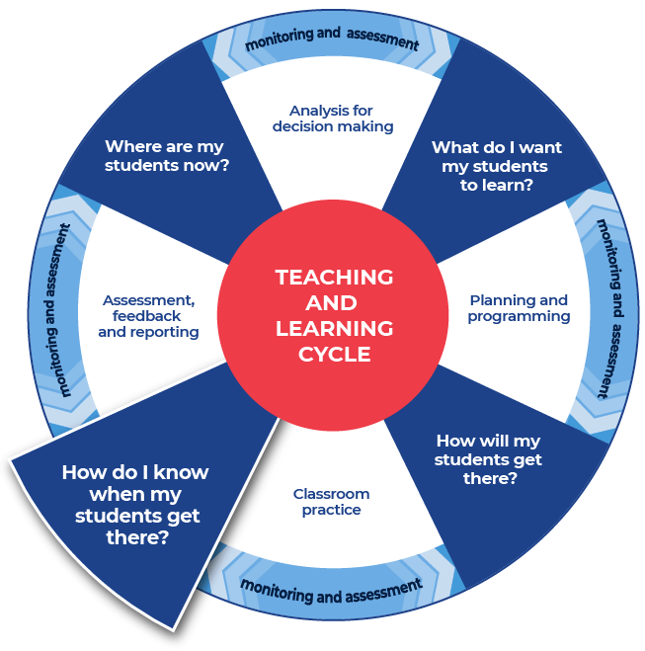

Instructions:
- Teachers facilitate pairs of students to swap their written responses.
- Teachers brief the students on acceptable peer feedback behaviors. Including ‘two stars and a wish’ or ‘I like, I wonder’ protocols. This activity may be anonymous.
- Students are provided with the template and they fill it in to provide feedback to their peer.
- Students tick where they think the writing aligns on the template.
Additional peer feedback options:
- Teachers could give students a focus to look for, such as use of vocabulary, and assign this focus to a coloured highlighter. This could be repeated with different focusses and highlighters.
- Teachers could support students to create their own class agreed feedback template.

Template
Criteria | Developing | Developed | Highly developed
The response answers the question.
Idea being written about is clear.
The writing has a logical structure. It makes sense when you read it through.
There is topic specific vocabulary in the response.
Sentences make sense.
Capital letters, full stops and some other punctuation is used.
Accurate spelling of challenging words.
Handwriting is consistently legible.
Two successful things about this written response are:

One aspect of writing to keep working on is:

Activity 4: Teacher feedback

Instructions
- Teachers support their students with timely and effective feedback. Remembering that effective feedback:
  - focuses on the intended learning
  - identifies specific strengths
  - points to areas needing improvement
  - suggests a pathway that students can take to close the gap between where they are now and where they need to be
  - chunks the amount of corrective feedback the student can handle at one time
  - is provided in a short time frame.
- Teachers select areas to provide feedback from the templates provided or modify and use the student feedback template from Activity 3.
- Teacher comments could include, ‘working towards’, ‘achieved’, and ‘working beyond’.
- Teachers may choose to engage with the National Literacy Learning Progression to provide feedback to their students. To use this tool more effectively teacher could first engage with the online professional learning course: Introduction to the Literacy and Numeracy Progressions.

Feedback templates
- More information on aspects of literacy can be found at: HSC minimum standard – Writing. The hyperlinks contained within the feedback templates below link to these specific resources.
- Teachers can modify or remove the included definitions.
- Some teachers may choose to leave the definitions in place to support students’ skill development.
- There are three templates to choose from:
  - Control of language
  - Structure and sequence of ideas
  - Relevance of writing to the topic.

Control of language
Spelling. Correct spelling is consistent and some difficult words are spelled correctly. In the written response spelling is:

Vocabulary. Subject vocabulary has been used effectively in context. In the written response vocabulary is:

Tense. Past, present and future references within sentences, and the response, as a whole are logical and consistent. For example, ‘Alex laughed’, ‘Alex laughs’, ‘Alex will laugh’. In the written response tense is:

Punctuation. There is correct sentence punctuation, including capital letters and full stops. There are some correct examples of commas, proper nouns, apostrophes. In the written response punctuation is:

Formal and informal language. The tone matches the audience and purpose. The language use is consistently appropriate. Informal language is every day and conversational. Formal language uses correct sentence structures and has a feeling of authority. In the written response formal and informal language are:

Two successful things about this written response are:

One aspect of writing to keep working on is:

Structure and sequence of ideas
Text structure is the way that the information is organised. This could include: headings and sub-headings, is there an introductory and concluding paragraph. In the written response text structure is:

Paragraphs. Text in a distinct section that reflects a logical cohesive point. In the written response paragraphs are:

Sentence types. A sentence begins with a capital letter and ends with a full stop, question mark or exclamation mark. There are different types of sentences:
- simple sentence – a single main clause that expresses a complete thought. It has a subject and a finite verb and may also have an object, for example ‘Mary is beautiful.’, ‘The ground shook.’, ‘Take a seat.’
- compound sentence – contains two or more clauses that are coordinated or linked in such a way as to give each clause equal status. In the following example and is the coordinating conjunction: ‘We went to the movies and bought an ice cream.’
- complex sentence – contains a main (or independent) clause and one or more subordinate (or dependent) clauses. The subordinate clause is joined to the main clause through subordinating conjunctions like when, while and before, as in the following examples: ‘We all went outside when the sun came out.’, ‘Because I am reading a long book, my time is limited.’
(NSW English K–10 Glossary © NSW Education Standards Authority (NESA) for and on behalf of the Crown in right of the State of New South Wales, 2020.)
In the written response sentence types are:

Cohesion. Features can include connectives such as ‘furthermore’ and ‘therefore’, cross-references to different parts of the text, and reiteration of the title or terms of the topic or question being addressed in the text.
(NSW English K–10 Glossary © NSW Education Standards Authority (NESA) for and on behalf of the Crown in right of the State of New South Wales, 2020.)
In the written response cohesion is:

Two successful things about this written response are:

One aspect of writing to keep working on is:

Relevance of writing to the topic
Audience and purpose. Audience is the intended readers. Purpose can include, to entertain, to inform, to persuade, to educate. ‘Composers use a number of ways to achieve these purposes: persuading through emotive language, analysis or factual recount; entertaining through description, imaginative writing or humour, and so on.’
(NSW English K–10 Glossary © NSW Education Standards Authority (NESA) for and on behalf of the Crown in right of the State of New South Wales, 2020.)
In the written response audience and purpose are:

Ideas. An idea is a thought or notion that is being explained and explored. Students are encouraged to develop their ideas and create insightful and impacting points. Students will support their ideas with evidence and examples. In the written response ideas are:

Topic vocabulary. Have specific words from the subject area been used effectively in the writing. In the written response topic vocabulary is:

Two successful things about this written response are:

One aspect of writing to keep working on is:

See Literacy Learning Progression and Stage 6 Mathematics (DOCX | PDF) for information on how the National Literacy Learning Progression could support student writing and feedback in Stage 6 Mathematics.

Activity 5: Student self-reflection
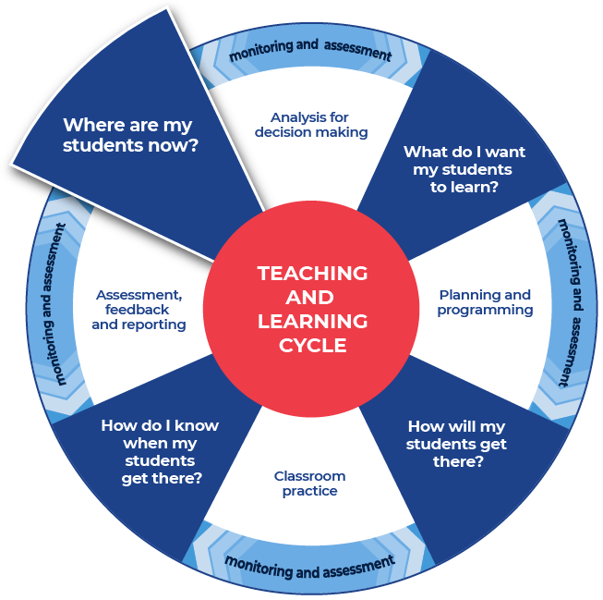

Instructions:
- Teachers provide students with a copy of an ‘exit slip’.
- Students complete the exit slip and detail one skill that they learnt through the literacy lessons and one skill they that they need to work on further.
- Teachers collect and review the completed exit slips to plan where to next for improving their students’ literacy skills.
Differentiation:
- Teachers and students could collaboratively plan future learning focuses.

Exit slip template
Name:
One skill that I have learnt that improved my writing:

One skill to continue to work towards:

