Planning for writing – Stage 6 Mathematics
To get the most from these resources they should be used as a teaching and learning sequence. One set of activities leads on to the next.
- Improve student writing through subject vocabulary (DOCX | PDF)
- Improve student writing through planning for writing (this document)
- Improve student writing through writing and feedback (DOCX | PDF).

Learning focus
With these literacy activities teachers use content that they have planned in their teaching and learning cycle. For each literacy activity an example from Mathematics Standard has been provided. The example is a model for teachers. Teachers create their own specific examples for their subject and class. Teachers can modify the learning intentions and success criteria to reflect their context.
Through engaging with this resource teachers may find that their students could benefit from support in other areas of their learning. For more ideas and teaching strategies on literacy and numeracy go to the HSC minimum standard website. Here you will find teaching ideas and activities on:
Writing, including: text structure, paragraphs, cohesion, sentence types, tense, punctuation, formal and informal language, spelling, vocabulary, topic vocabulary, audience and purpose, ideas, language devices, and unpacking the writing prompt.
Numeracy, including: division, multiplication, fractions, decimals, percentages, rates, time, ratio, area, length and perimeter, mass, volume and capacity, mean, median and mode, chance, 3D objects, 2D shapes, patterns, formulae and substitution, positioning and locating, angles, tables graphs and charts, vocabulary in numeracy, interpreting questions and grammar for numeracy.
Reading, including: audience and purpose, locating explicit information, inferring, common language devices, parts of speech, cohesive devices, sentence types, tense, subject-verb agreement, punctuation, spelling, antonyms and synonyms, and inferring word meanings.

Syllabus outcomes
For each mathematics subject, relevant syllabus outcomes have been provided in the Stage 6 Mathematics syllabus links (PDF 80 KB) document.

Learning intentions
- Students will investigate effective writing.
- Students will analyse sample written responses.
- Students will develop note taking skills.
- Students will develop confidence with writing.

Success criteria
- Students are able to recognise aspects of effective writing.
- Students are able to practise their writing skills.
- Students are able to take effective notes.
- Students are able to prepare for a written response.

Teaching strategies
Focus on skills:
- Activity 1: Unpacking questions and solutions
- Activity 2: Warm up writing activity.
Prepare to write:
- Activity 3: Prepare to write.

Focus on skills

Activity 1: Unpacking questions and solutions
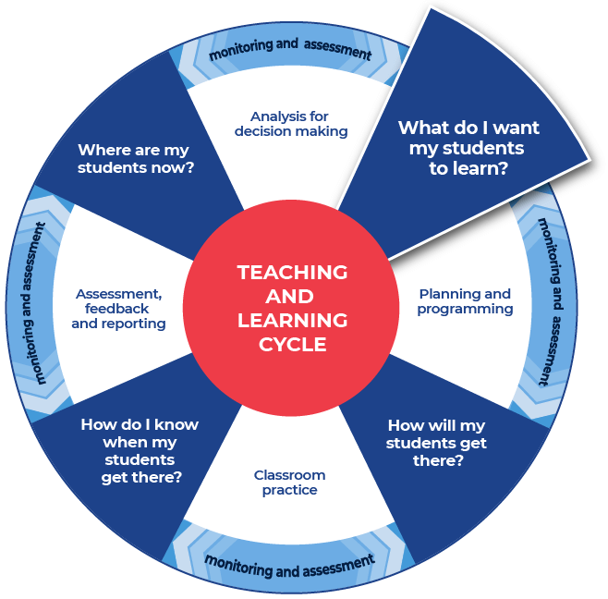
This activity is divided into 2 parts: unpacking questions and unpacking solutions. Unpacking questions focuses on the importance of accurately comprehending written questions. The key message is to read and re-read the question multiple times. This activity reflects the impact of writing as a thinking tool.

Instructions – unpacking questions:
- Teachers provide an exam style question.
- Teachers read through the question with the students and emphasise the importance of reading questions with care and re-reading questions.
- Teachers emphasise the importance of creating diagrams to help students visualise the question.
Differentiation:
- Teachers could facilitate a class discussion around, ‘What could be problematic about this question?’
- Teachers could facilitate a discussion of prior knowledge for topic requirements.
Further support:
- Below is an example of an exam style question that covers content from the Mathematics Standard course. Teachers may choose to share this example with their students or create their own.

Example question
The base of a lighthouse, D, is at the top of a cliff 158 metres above sea level.
The angle of depression from D to a boat at C is 25°. The boat heads towards the base of the cliff, A, and stops at B. The distance AB is 116 metres.
- What is the angle of depression from D to B, correct to the nearest minute?
(3 marks)
- How far did the boat travel from C to B, correct to the nearest metre? (2 marks)

Unpacking the question

Step 1
Highlight the important information within the scenario.
For example:
The base of a lighthouse, D, is at the top of a cliff 158 metres above sea level.
The angle of depression from D to a boat at C is 25°. The boat heads towards the base of the cliff, A, and stops at B. The distance AB is 116 metres.

Step 2
Read the question again and draw a diagram that depicts all of the relevant information. Once the diagram has been created, re-read the scenario to ensure that the diagram accurately reflects the information.
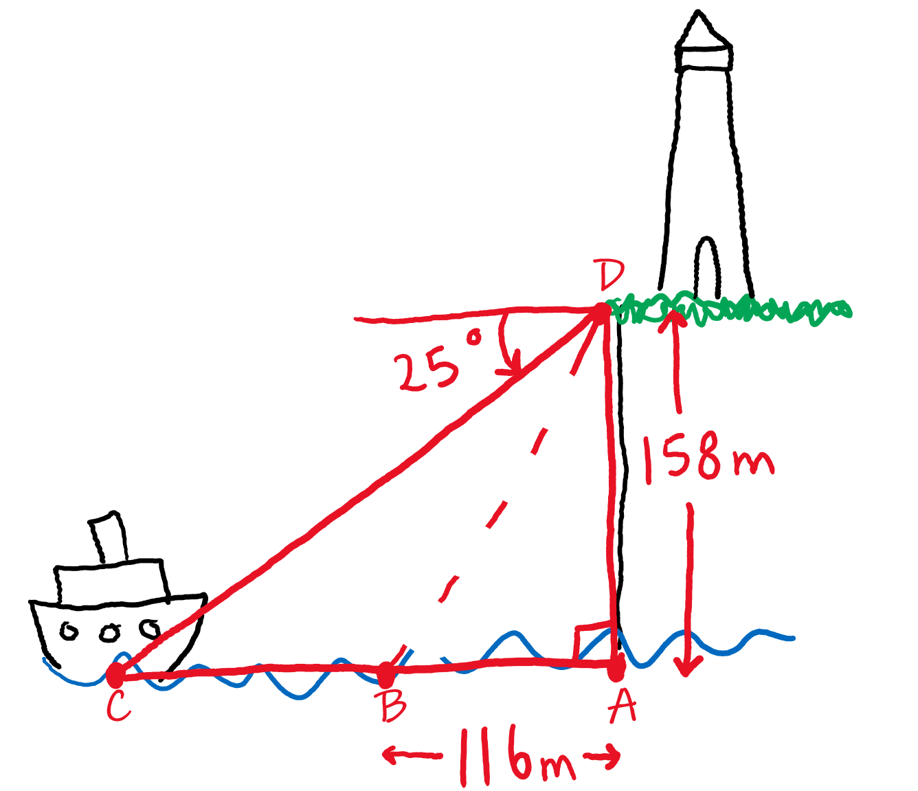

Step 3
Read the first part of the question and indicate on your diagram which measurement the question is asking to find.
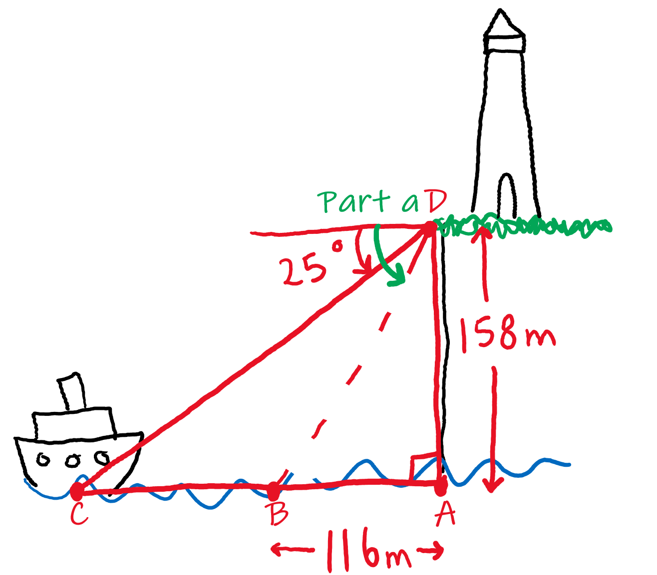
Note: There are a variety of ways that a student could go about answering this question. Drawing a simplified diagram, showing only the required information for this particular part of the question, will help students to make connections to previous examples and guide their thought process.
For example: In this question students may find the following diagram easier to use.
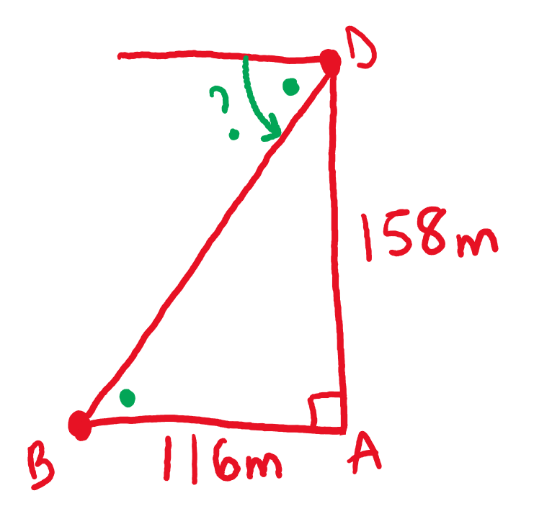

Step 4
Once the student has determined what mathematical process they will use to answer the question and calculate an initial answer, they should re-read the question again and assess how reasonable their answer is and ensure that they have written their solution in the required format (e.g. to the correct number of decimal places or units of measurement).
Note: students should follow the same process as outlined in steps 3 and 4 to then answer part (b) of the question.

Unpacking solutions
This section focuses on the language used in mathematical solutions.

Instructions
- Teachers display an exam style question on the board and read through the question with their students.
- Teachers unpack the question and outline the necessary steps in answering the question.
- Students complete a review of samples for unpacking questions and solutions. A template is provided.
Further support:
- Below is an example of an exam style question that covers content from the Mathematics Standard course. Teachers may choose to share this example with their students or create their own.

Example question
Three raffles were held with 100 tickets sold in each. One prize was awarded in each raffle. Ari bought one ticket in each of the first two raffles. Rose bought two tickets in the last raffle. Determine who had the better chance of winning at least one prize. Justify your answer with calculations.

Procedure (instructions for working and solution)
After carefully reading the question and highlighting important information students would need to follow a sequence of steps in solving this particular question.

First step
Calculate the probability of Ari winning at least one prize.
Students recognise that each raffle is an independent event. The outcome of one raffle will not influence the outcome of another raffle. Students draw a tree diagram to assist in calculating the probability of Ari winning at least one prize. An example of a tree diagram reflecting Ari’s probability of winning or alternatively losing the two raffles is shown below.
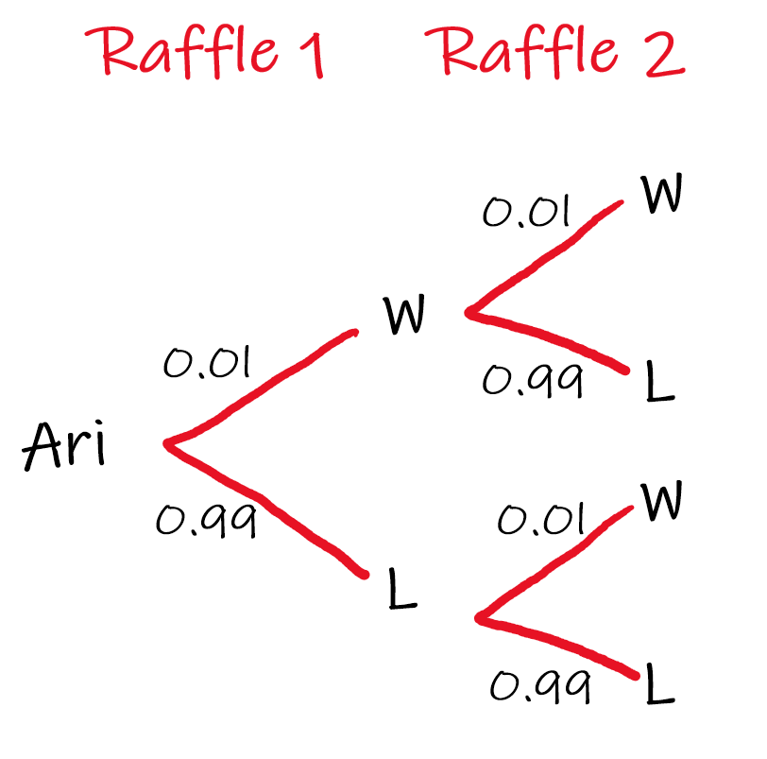
Of the four possible outcomes there are three in which Ari wins at least once:
- Win, Win → 0.01 x 0.01 = 0.0001
- Win, Lose → 0.01 x 0.99 = 0.0099
- Lose, Win → 0.99 x 0.01 = 0.0099.
Probability of Ari winning at least one prize is 0.0001 + 0.0099 + 0.0099 = 0.0199 (1.99%)

Next step
Calculate the probability of Rose winning at least one prize.
This is easier to calculate as Rose only entered one raffle. As Rose had two tickets out of a possible 100 she has a 2% chance of winning a prize. Note: this could be written as 2%, 0.02 or $\frac{1}{50}$.

Final step
The final step is for students to re-read the question and draw a conclusion based on their mathematical findings.
For example:
Rose has a greater chance of winning at least one prize. The chance of Rose winning a prize is 0.02 (2%), which is greater than the chance of Ari winning at least one prize 0.0199 (1.99%).

Review of samples
- Students engage with the example responses in unpacking questions and unpacking solutions.
- Students respond to the analysis questions on the template provided.

Template

What do you notice?
Explain how drawing diagrams supports understanding question requirements?

What did you notice about the procedure that was written out?

Completed example

What do you notice?
Explain how drawing diagrams supports understanding question requirements.
Drawings help to understand the question because when I first did the lighthouse question I would have looked for the wrong angle. I would have looked for the difference between the first angle of depression and the second angle of depression. Whereas the question asks for the total of the entire second angle of depression.
What did you notice about the procedure that was written out?
Writing out the instructions means that I have to slow down my thinking. My written instructions need to be precise.

Using the National Literacy Learning Progression to unpack written solutions
Teachers can use the National Literacy Learning Progression to help track students’ literacy skills. Improving students’ literacy skills will enable students to communicate their ideas in a more succinct manner. This means that students can construct mathematical arguments that draw conclusions and make judgements based on the reasonableness of measurements and calculations.
An example of how to use the National Literacy Learning Progression to unpack a written solution is shown below.
Rose has a greater chance of winning at least one prize. The chance of Rose winning a prize is 0.02 (2%), which is greater than the chance of Ari winning at least one prize 0.0199 (1.99%).
- created informative texts to explain and analyse (CrT10)
- uses evidence and references (CrT11)
- uses discipline-specific terminology to provide accurate and explicit information (e.g. discipline metalanguage) (CrT10)
- creates succinct short-answer explanatory texts as well as complex, multi- staged extended texts (CrT11)
For example, in response to the question the student is asked to justify their response with calculations. They have shown their working and also put evidence of their calculations in their written response.

Additional support for Activity 1
Please note that there are several supports to help teachers improve writing.
Teachers could use their marking criteria to assess written responses and provide feedback.
In some contexts you could use the National Literacy Learning Progression. While primarily focused at K–10, it will provide sound ideas on aspects of writing and how to improve.
For more ideas on what to look for in literacy you may like to complete the online course: Introduction to the Literacy and Numeracy Progressions.

Activity 2: Warm up writing activity
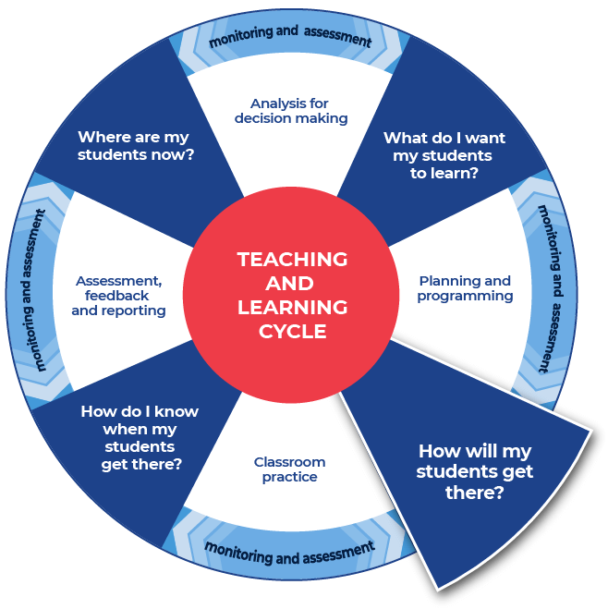
In approaching a written question it is useful to deconstruct and break down the question to support understanding. The following activities provide structure for improving writing skills. They highlight the importance of writing as an explaining tool.

Instructions:
- Teachers should create and use examples that are relevant to their topic.
- Teachers may need to re-size the response spaces allocated for the student work.
- Students will unpack questions, provide answers, write instructions, and create and answer their own questions.
Differentiation ideas include:
- Teachers may scaffold material and/or provide a word bank to support student understanding and engagement.
- Students could work in pairs to support learning.
- Teachers could facilitate discussion where solutions to questions could be compared and discussed. That is did someone else use a different method. This could encourage students to use a variety of strategies to solve problems.

Example template

Question
A train departs Sydney at 3.00pm and travels to Wollongong. Its average speed for the journey is 80 km/hr, and it arrives at 5.00pm. A second train departs from Sydney at 3.10pm and arrives in Wollongong at 4.30pm.
What is the average speed of the second train?
- 120 km/h
- 150 km/h
- 116 km/h
- 200 km/h.

Unpack the question (use diagrams where neccesary)

Procedure (instructions for working and solution)
This layout is a guideline only and teachers should enable students to use as many steps as they need to write the instructions.
First:

Then:

Then:

Next:

Finally:

Working and solution

New question (student created)

Unpack the question (use diagrams where neccesary)

Procedure (instructions for working and solution)
This layout is a guideline only and teachers should enable students to use as many steps as they need to write the instructions.
First:

Then:

Then:

Next:

Finally:

Working and solution

This is the end of Focus on Skills section

Prepare to write

Activity 3: Prepare to write
The NESA school-based assessment requirements for Mathematics courses require the completion of an ‘assignment or investigation-style task’. For Mathematics Standard, one of these tasks must be completed in Year 11 and one in Year 12. The requirements reference a set of outcomes, including:
- MS11-10: justifies a response to a given problem using appropriate mathematical terminology and/or calculations
- MS1-12-10: uses mathematical argument and reasoning to evaluate conclusions, communicating a position clearly to others
- MS2-12-10: uses mathematical argument and reasoning to evaluate conclusions, communicating a position clearly to others and justifying a response
The following activities and the activities in the Student writing and feedback – Stage 6 Mathematics (DOCX | PDF) document support students’ literacy skills as they answer a driving question in an investigation-style task.
Students could be asked to research, compare, justify, annotate, represent in their own words and context, analyse, critically evaluate, provide a description, provide a statement, explain, reason, and make a recommendation.
Marking criteria for this task could include:
- Provide a convincing argument to support their opinion of the driving question.
- Justify their response to the driving question by providing a sophisticated response.
Examples of investigation-style tasks can be found on the Stage 6 Mathematics curriculum resources page.
These literacy resources support communication skills in mathematics and the General Capabilities requirement of Literacy.

Step 1: Select your resource

Instructions:
- Teachers support their students as they research and prepare to create a written response. Students are note taking and building the field.
- The teacher chooses an appropriate website, article, video, or a text that is part of their lesson planning. This could be the same text that you have used for the vocabulary activities or a new text that you would like you students to engage with.
- Teachers provide the selected text to their students.
Differentiation:
- Teachers should ensure that they pre-read or view all texts provided to students and communicate the purpose and focus for using the source with students.
- Teachers could read the texts to or with students.
- Students could be working in pairs to read and summarise the information presented in the text.
- Teachers could plan an alternate task where students collect graphs from newspapers and analyse them instead of bodies of text.
Further support:
- An example from Mathematics Standard has been provided using: Australian Indigenous Astronomy – Navigation & Star Maps.

Example
Mathematics Standard 1 Year 12 content – MS-M3 Right-angled triangles:
- understand various navigational methods
- investigate navigational methods used by different cultures, including those of Aboriginal and Torres Strait Islander Peoples
This example reflects the Year 12 Mathematics Standard 1 unit of work: MS-M3 Right-angled triangles sample unit of learning (DOCX 53 KB) from the Mathematics Standard 1 curriculum page.
These activities could be in response to the content within the sample unit or as a research component of an investigation-style task for right-angled triangles.
For our example the following website has been used: Australian Indigenous Astronomy – Navigation & Star Maps.
Note: To introduce Aboriginal content in your classroom consideration should be given to protocols for communicating knowledge about Aboriginal culture, peoples and histories. This would include:
Understanding that not all Aboriginal stories are the same and that different communities may have different stories.
That when possible it is best to work with local community and local Aboriginal knowledge.
Always acknowledge the origin of the story, artefact and local knowledge. For example, if the story you are telling originates in Wiradjuri country acknowledge that and indicate to your students where Wiradjuri country is located.
Assistance and support can be found by contacting the NSW Aboriginal Education Consultative Group (NSW AECG Inc.).
Information can also be found on the department’s Working in partnership with the NSW AECG Inc. webpage.

Step 2: Take effective notes

Instructions
- Teachers model their own example to share with students. An example from Mathematics Standard has been included.
- Students take notes as they engage with the text that their teacher has provided. A suite of note taking resources is provided.
- Students will write the information on their note taking template as they locate it in the text.
Differentiation:
- Teachers could provide different students with different scaffolds.
- Teachers may pre-fill some of the note taking template or include sentence starters to support student engagement and achievement.
- Teachers may provide a completely pre-filled example for students to work from.
Further support:
- Teachers may want to take the time to use the pre-written ides and teaching strategies regarding Locating explicit information on the HSC minimum standard website.
- An example from Mathematics Standard has been provided using: Australian Indigenous Astronomy – Navigation & Star Maps.

Templates

Option 1
Title of text:
Type of text:
Outline mathematical steps that are explored in the text:

Are mathematical tools or technology apparent?

Are calculations used, if so explain them:

Are there restrictions to the accuracy of the mathematical aspects shown in the text?

How reliable is the method associated with this information?

Now that you have engaged with the text. Use the information to create sentences that begin with the following:
When

Even though

Because

Put some of the points that you have recorded above into a summarising paragraph of 3 to 4 sentences.

Option 1 – Completed example
Title of text: Australian Indigenous Astronomy – Navigation & Star Maps
Type of text: website
Outline mathematical steps that are explored in the text: Star maps correlate to landscape features.
Are mathematical tools or technology apparent? Understanding and use of cardinal directions is discussed. Star maps are used to teach navigation outside of familiar regions. The pattern of stars in the sky are used to teach way points on land. Songs are created to memorise the routes.
Are calculations used, if so explain them: The position of the Southern Cross is used to denote the cycle of teachings from the dreaming throughout the year. Use the position of the stars to tell time.
Are there restrictions to the accuracy of the mathematical aspects shown in the text? Measurements do not seem to be included. Sight is heavily relied upon which may be influenced by weather.
How reliable is the method associated with this information? Today there are highways such as the Kamilaroi Highway from The Hunter Valley to Bourke which reflect the star map waypoints and route. There are also towns such as Roma in Queensland and Goodooga in New South Wales which are built on the route of star maps. This would indicate that the navigational method is reliable as it has been repeated.
Now that you have engaged with the text. Use the information to create sentences that begin with the following:
When travelling, Aboriginal peoples used star maps to teach navigation outside of familiar regions. The pattern of stars in the sky was used to teach way points on land. Songs were created to memorise the routes.
Even though some Aboriginal peoples do not call the cardinal points north, south, east, and west. They do have the same cardinal point and they call them, as stated in the article, ‘In the Warlpiri culture, north corresponds to “law”, south to “ceremony”, west to “language”, and east to “skin”. “Country” lies at the intersection of these directions, at the centre of the compass – i.e. “here”.’
Because there are highways such as the Kamilaroi Highway from The Hunter Valley to Bourke which reflect the star map waypoints and route. There are also towns such as Roma in Queensland and Goodooga in New South Wales which are built on the route of star maps. This would indicate that the navigational method is reliable as it has been repeated and replicated.
Put some of the points that you have recorded above into a summarising paragraph of 3 to 4 sentences.
When travelling, Aboriginal peoples used star maps to teach navigation outside of familiar regions. The pattern of stars in the sky was used to teach way points on land. Songs were created to memorise the routes. Even though some Aboriginal peoples do not call the cardinal points north, south, east, and west. They do have the same cardinal point and they call them, as stated in the article, ‘In the Warlpiri culture, north corresponds to “law”, south to “ceremony”, west to “language”, and east to “skin”. “Country” lies at the intersection of these directions, at the centre of the compass – i.e. “here”.’ Because there are highways such as the Kamilaroi Highway from The Hunter Valley to Bourke which reflect the star map waypoints and route. There are also towns such as Roma in Queensland and Goodooga in New South Wales which are built on the route of star maps. This would indicate that the navigational method is reliable as it has been repeated and replicated.

Option 2
Title of text:
Type of text:
Topic:
Events
People
Facts
Mathematical connections
Summary

Option 2 – Completed example
Title of text: Australian Indigenous Astronomy – Navigation & Star Maps
Type of text: website
Topic: Navigation (MS-M3)
Events
Aboriginal peoples navigational methods using the stars and correlating them to landforms is explained.
People
- Aboriginal peoples
- Contemporary readers.
Facts
Some Aboriginal peoples have cardinal points and they call them, as stated in the article, ‘In the Warlpiri culture, north corresponds to “law”, south to “ceremony”, west to “language”, and east to “skin”. “Country” lies at the intersection of these directions, at the centre of the compass – i.e. “here”’.’
Mathematical connections
- Star maps coordinating to landforms
- cardinal points
- Queensland township layout matches star layout.
Summary
Some Aboriginal peoples navigated using the stars. They followed the stars as turning points or way points, kind of like maps on your phone. Once they had travelled the route they would create songlines to be able to follow the route again in a different season when the stars were in a different place. Today there are examples of towns laid out in Queensland that match the star maps in the sky. People think this is because Aboriginal peoples travelled these routes and made tracks, these tracks where followed and became roads, settlements turned into towns.

Step 3: Where to next
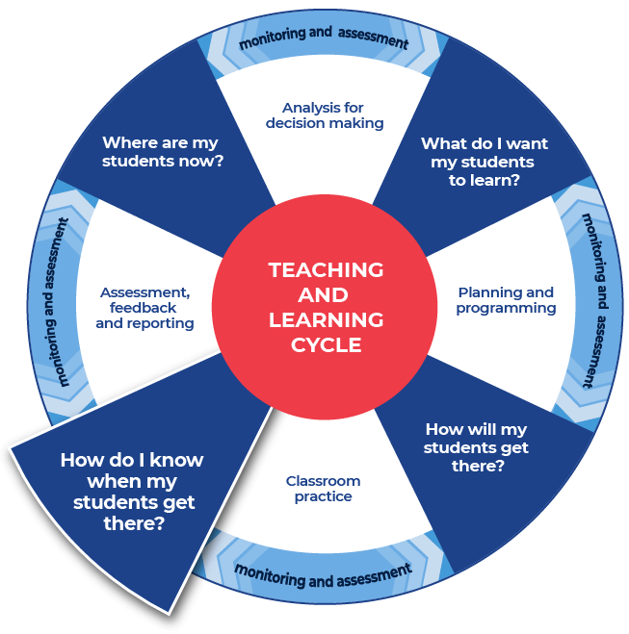

Instructions:
- Teachers provide the specific question or stimulus that their students will respond to.
- Students should create a plan and draft for their written response. Students can use the notes that they have taken and any other additional information.
- Teachers provide students with time to draft their writing.
- Teachers provide students with formative feedback during the drafting process.
Differentiation:
- The task could respond to a practice examination question, or it could be writing in response to other aspects of the ‘assignment or investigation-style task’.
Further support:
- Teachers and students could engage with the pre-written lesson content in the Ideas section on the HSC minimum standard website to support strengthening ideas.
- Teachers may also want to engage with the Text structure section on the HSC minimum standard website and use the persuasive text structure template provided on the website.

Example driving question
How are mathematical concepts reflected in Aboriginal navigational methods?
This is the end of the activities for: Improve student writing through planning for writing.
Teachers should move on to the next set of activities: Improve student writing through writing and feedback (DOCX | PDF).

