The National Literacy Learning Progression and Stage 6 Mathematics

How the progression could support writing in Stage 6 Mathematics
This document is part of the Stage 6 Literacy in context – Writing resource. It outlines ways that the National Literacy Learning Progression can support development of student writing through Stage 6.
The element of Writing in the National Literacy Learning Progression provides indicators that reflect the increasing sophistication of skill development in writing for students in Years K–10. It is important to note that these skills are unconstrained and will continue to develop as students work through their final years of school and beyond. In addition, while the progression reflects the literacy development necessary for successful learners, many students will continue to develop and consolidate these skills beyond this timeframe.
In addressing the Objectives and the General Capabilities in the Stage 6 Mathematics syllabuses, students need to use subject specific terminology to apply reasoning, construct arguments, interpret and communicate mathematics in a variety of written forms.
“Literacy is used throughout mathematics to understand and interpret word problems and instructions containing particular language featured in mathematics. Students have the opportunity to learn the vocabulary associated with mathematics, including synonyms, technical terminology, passive voice and common words with specific meanings in a mathematical context. Literacy is used to pose and answer questions, engage in mathematical problem solving and to discuss, produce and explain solutions.”
(Stage 6 Mathematics Syllabuses © NSW Education Standards Authority (NESA) for and on behalf of the Crown in right of the State of New South Wales, 2019.)
It can be difficult for teachers to articulate what effective writing ‘looks like’ in a student response, and therefore to be able to explicitly support their students to improve their writing. Certain indicators within the Creating texts sub-element of the progression can amplify these criteria and support teachers and students to identify features of writing that can be targeted to improve the ability to answer extended response questions.
Some examples of these connections between the criteria and the creating texts sub-element are provided below.
To justify a response to a given problem using appropriate mathematical terminology the student:
- uses evidence and research including digital resources to expand upon information and elaborate concepts (CrT10)
- uses discipline-specific terminology to provide accurate and explicit information (e.g. discipline metalanguage) (CrT10)
- includes persuasive points with effective elaborations and supporting evidence (CrT10)
- uses more elaborate noun groups that include classifying adjectives and specific nouns (e.g. mineral component of sedimentary rocks) (CrT10)
- judiciously uses language, visual and audio features to emotionally or intellectually affect the audience (CrT10)
- uses topic-specific vocabulary to add credibility and weight to arguments (e.g. cadence, interplanetary, silt) (CrT10)
- uses structural features flexibly to organise ideas strategically (e.g. includes a defined, cogent summation or call to action) (CrT11)
- uses citation and referencing from authoritative sources (CrT11)
- creates succinct short-answer explanatory texts as well as complex, multi-staged extended texts (CrT11)
- uses complex abstractions (e.g. economic, sociocultural) (CrT11)
- uses sophisticated evaluative language such as allusion, evocative vocabulary and extended metaphor (CrT11)
- uses vocabulary for precision (e.g. the underwhelming performance of the opening batsmen) (CrT11)
- uses a wide range of cohesive devices such as text connectives that link sentences and paragraphs, and patterns of meaning (e.g. part-whole, class-subclass, compare-contrast, cause and effect) (GrA7)
- writes well-structured sentences, rarely making grammatical errors (GrA7).

Using the National Literacy Learning Progression to inform feedback
Before you begin you may like to learn more about the National Literacy Learning Progression through the online professional learning course: Introduction to the Literacy and Numeracy Progressions.
For example, Writing sub-elements include:
- Crafting texts – Crafting ideas
- Crafting texts – Text forms and features
- Crafting texts – Vocabulary
- Grammar
- Punctuation
- Spelling
- Handwriting/keyboarding.
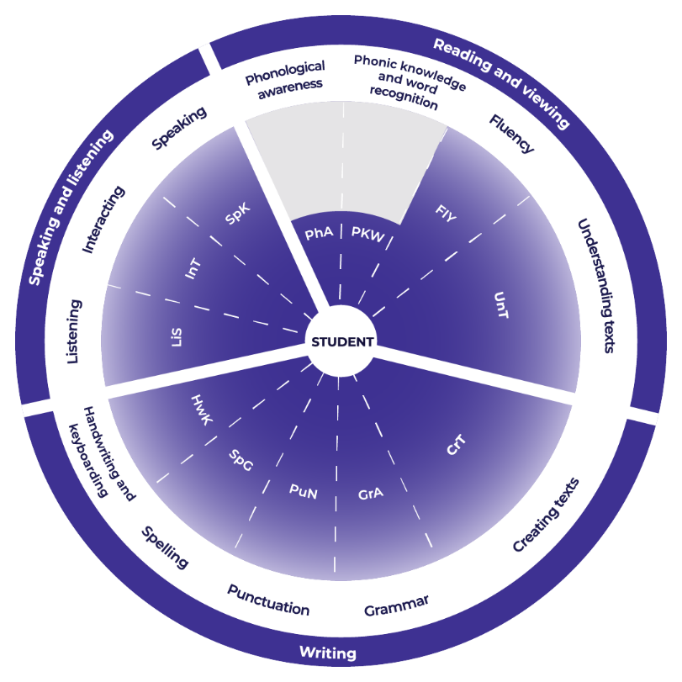
Teachers could then use the student’s written response to assess where the student is at now and what they could do next to improve.

Example analysis
For this example, the sub-element of Creating texts has been selected. With a specific focus on crafting ideas.
Teachers read through the sub-element description to match characteristics that the student’s text is currently displaying. An example from Standard Mathematics is provided.
CrT10 Crafting ideas:
- writes to compare and contrast phenomena (e.g. identify the similarities and differences between species of animals)
- orients the reader clearly to the topic or concept (e.g. using a definition or classification in the opening paragraph)
- intentionally selects structural elements for effect (e.g. includes an effective conclusion that synthesises complex ideas)
- uses evidence and research including digital resources to expand upon information and elaborate concepts
Student writing sample*:
Before you think the only way to navigate is with a compass or your google maps app, you need to know that for thousands of years Aboriginal Australians have been using the stars as maps. Even though Aboriginal Australians do not call the cardinal points north, south, east, and west, they do have the same cardinal points and they call them, as stated in the article, ‘In the Warlpiri culture, north corresponds to “law”, south to “ceremony”, west to “language”, and east to “skin”. “Country” lies at the intersection of these directions, at the centre of the compass – i.e. “here”.’ Although this knowledge is thousands of years old it is still relevant and useful today.
*Question can be found in Improve student writing through writing and feedback (DOCX | PDF).
Reading the next sub-element descriptor the teacher could work out where to next for the student.
CrT11 Crafting Ideas:
- uses structural features flexibly to organise ideas strategically (e.g. includes a defined, cogent conclusion / summation) For example in the written response, ‘you think the only way to navigate’ – could become – ‘systems of navigation’
- creates texts with forms and features combined strategically for purpose (e.g. describes a historical event from the perspective of a secondary source). For example, in the written response, the student could include ‘Researchers have shown …’, or reference the article writers or researchers
- uses evidence and references
- creates succinct short-answer explanatory texts as well as complex, multi-staged extended texts. For example, in the written response, the student could engage in a final round of editing for precision.

Example of written feedback to the student
Name: Rose Yeung
Is able to:
Compare and contrast phenomena.
Orientate the reader.
Craft a conclusion.
Expand upon ideas and concepts in her writing.
To continue to improve:
Rose could:
- Classify, give overall names, to ideas and information. ‘you think the only way to navigate’ – could become – ‘systems of navigation’.
- Cite references within her text. ‘Researchers have shown …’, or reference the article writers or researchers.
- Refine her writing. Engage in a final round of editing for precision.

Template
Name: ____________________________________
Is able to:

To continue to improve:

