Planning for writing – Stage 6 HSIE

Sequence
To get the most from these resources they should be used as a teaching and learning sequence. One set of activities leads on to the next.
- Improve student writing through subject vocabulary (DOCX | PDF)
- Improve student writing through planning for writing (this document)
- Improve student writing through writing and feedback (DOCX | PDF).

Learning focus
With these literacy activities teachers use content that they have planned in their teaching and learning cycle. For each literacy activity an example from Modern History has been provided. The example provided is a model for teachers. Teachers create their own specific examples for their subject and class. Teachers can modify the learning intentions and success criteria to reflect their context.
Through engaging with this resource teachers may find that their students could benefit from support in other areas of their learning. For more ideas and teaching strategies on literacy and numeracy go to the HSC minimum standard website. Here you will find teaching ideas and activities on:
Writing, including: text structure, paragraphs, cohesion, sentence types, tense, punctuation, formal and informal language, spelling, vocabulary, topic vocabulary, audience and purpose, ideas, language devices, and unpacking the writing prompt.
Numeracy, including: division, multiplication, fractions, decimals, percentages, rates, time, ratio, area, length and perimeter, mass, volume and capacity, mean, median and mode, chance, 3D objects, 2D shapes, patterns, formulae and substitution, positioning and locating, angles, tables graphs and charts, vocabulary in numeracy, interpreting questions and grammar for numeracy.
Reading, including: audience and purpose, locating explicit information, inferring, common language devices, parts of speech, cohesive devices, sentence types, tense, subject-verb agreement, punctuation, spelling, antonyms and synonyms and inferring word meanings.

Syllabus outcomes
For each HSIE subject, relevant syllabus outcomes have been provided in the Stage 6 HSIE syllabus links (PDF 151 KB) document.

Learning intentions
- Students investigate what makes effective writing.
- Students analyse sample written responses.
- Students develop note taking skills.
- Students develop confidence writing in response to stimulus.

Success criteria
- Students are able to recognise aspects of effective writing.
- Students are able to practise their writing skills.
- Students are able to take effective notes.
- Students are able to prepare for a written response.

Teaching strategies
Focus on skills:
- Activity 1: Review annotated samples
- Activity 2: Warm up writing activity.
Prepare to write:
- Activity 1: Select your resource
- Activity 2: Take effective notes
- Activity 3: Where to next.

Focus on skills

Activity 1: Review annotated samples
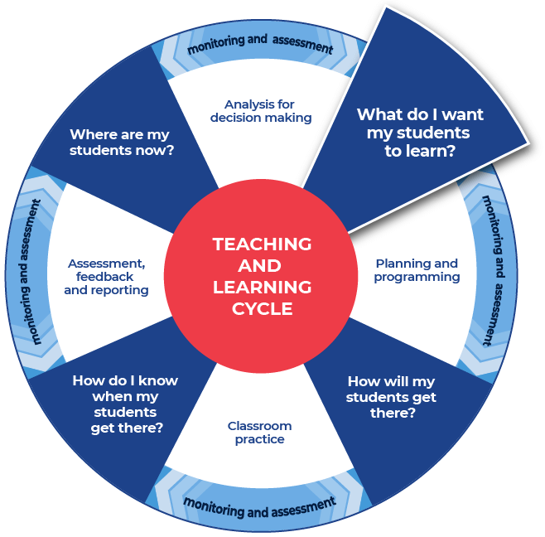

Instructions:
- Teachers provide a sample question with sample written response and annotate some of the features of effective writing on that response.
- Teachers create examples themselves or source them from: the HSIE statewide staffroom, previous year groups, local teacher networks, NESA publications or professional associations.
- Teachers can use the National Literacy Learning Progression to help track students’ literacy skills. Improving students’ literacy skills will enable students to communicate their ideas in a more succinct manner.
- Students will be asked to complete an analysis of the writing, after discussing and reviewing the written samples. A template is provided.
- An example has been provided from Modern History; Year 12; Core Study: Power, Authority in the Modern World 1919–1946; The Nazi regime to 1939:
- the various methods used by the Nazi regime to exercise control, including, laws, censorship, repression, terror, propaganda, cult of personality (ACHMH131, ACHMH132).

Example question
Asses the usefulness of Source A for an historian studying the role of family in Nazi propaganda.
Source A:
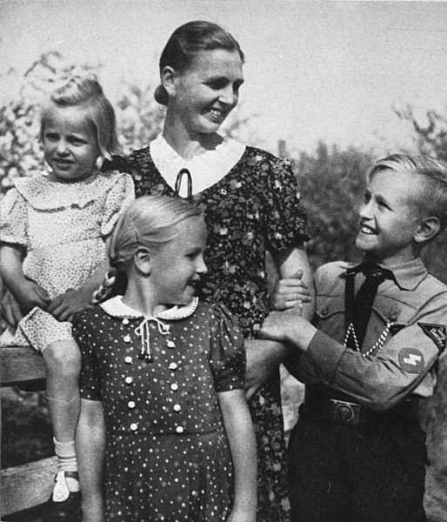
Nazi propaganda photo: A mother, her daughters and her son in the uniform of the Hitler Youth pose for the magazine SS-Leitheft, February 1943. (Creative Commons Attribution-Share Alike 3.0 Germany)

Sample low-range response
- Assess the usefulness of Source A for an historian studying the role of family in Nazi propaganda.
Source A would be very useful for a historian because it is a photo of what happened at the time and this means it is reliable. You can see there is a happy family because they are all smiling and this would show that some people were happy with the Nazis. You can tell the boy is especially happy because he has a new uniform. The family look like they are dressed up for a special occasion.

Annotations
Source A would be very useful for a historian because it is a photo of what happened at the time and this means it is reliable. You can see there is a happy family because they are all smiling and this would show that some people were happy with the Nazis. You can tell the boy is especially happy because he has a new uniform. The family look like they are dressed up for a special occasion.
- uses words from the question to reflect engagement with the specific question
- creates informative texts that describe, explain and document (e.g. describe an art work, document the materials and explain why it was created) (CrT9 Crafting ideas)
- develops ideas with details and examples (CrT9 Crafting ideas)
- uses more sophisticated words to express cause and effect (e.g. therefore, subsequently) (in this case – ‘because’) (CrT9 Vocabulary).
To improve:
- varies sentence structure for effect (see Grammar) (CrT10 Text forms and features)
- crafts both compact and lengthy sentences with challenging structures, such as embedded/relative clauses, non-finite clauses, interrupting clauses, nominalisations, passive voice (GrA7 Grammar – Sentence level)
- uses punctuation conventions for quotations and referencing (PuN7 Punctuation)
- creates persuasive texts that take a position and supports it with arguments (e.g. examines the benefits of physical activity to health and wellbeing) (CrT9 Crafting ideas)
- the student could support their judgement with explicit references to methods used by the Nazi regime to exercise control therefore demonstrating their engagement with the course content.

Sample high-range response
Source A would be quite useful for a historian studying the role of the family in Nazi propaganda. The primary source is a typical example of the types of photos and images used as propaganda by the Nazis throughout the war, with the representation of a smiling, happy, Aryan family being a key feature of the type of magazine in which it originally featured. The image highlights the importance the Nazis placed on the wholesome, blonde, German family in their propaganda, depicting the family as positive, healthy and natural. Setting the photograph outside in nature, with the son wearing a Hitler Youth uniform, adds to this sense of health and nature that was emphasised in Nazi propaganda. The addition of the Hitler Youth uniform also highlights the way the Nazis focused on children in their propaganda and recruitment efforts, representing the Hitler Youth as a positive aspect of family life. This image would also be very useful as evidence of the focus placed on mothers in Nazi propaganda, and the central role that motherhood and family played in the continuation of the Nazi ideal. The mother is at the centre of the image and the children are all connected to her physically, placing her in an esteemed position that replicated that of the position of motherhood in the Nazi regime. Historians studying the role of the family in Nazi propaganda would need to use this image in combination with a range of other propaganda examples, so there are limits to its usefulness, however it provides a clear snapshot of one of the ways that the Nazis used the ideal of family in their propaganda.

Annotations
Source A would be quite useful for a historian studying the role of the family in Nazi propaganda. The primary source is a typical example of the types of photos and images used as propaganda by the Nazis throughout the war, with the representation of a smiling, happy, Aryan family being a key feature of the type of magazine in which it originally featured. The image highlights the importance the Nazis placed on the wholesome, blonde, German family in their propaganda, depicting the family as positive, healthy and natural. Setting the photograph outside in nature, with the son wearing a Hitler Youth uniform, adds to this sense of health and nature that was emphasised in Nazi propaganda. The addition of the Hitler Youth uniform also highlights the way the Nazis focused on children in their propaganda and recruitment efforts, representing the Hitler Youth as a positive aspect of family life. This image would also be very useful as evidence of the focus placed on mothers in Nazi propaganda, and the central role that motherhood and family played in the continuation of the Nazi ideal. The mother is at the center of the image and the children are all connected to her physically, placing her in an esteemed position that replicated that of the position of motherhood in the Nazi regime. Historians studying the role of the family in Nazi propaganda would need to use this image in combination with a range of other propaganda examples, so there are limits to its usefulness, however it provides a clear snapshot of one of the ways that the Nazis used the ideal of family in their propaganda.
- uses words from the question to reflect engagement with the specific question. For example, there is more sophistication in the use of ‘quite’ (high range sample) as opposed to ‘very’ (in the low range sample)
- orients the reader clearly to the topic or concept (e.g. using a definition or classification in the opening paragraph) (CrT10 Crafting ideas)
- uses evidence and research including digital resources to expand upon information and elaborate concepts (CrT10 Crafting ideas)
- skilfully uses a range of cohesive devices to makes connections between arguments (e.g. foreshadows key points in introduction and reinforces key points in topic sentences) (CrT10 Text forms and features)
- judiciously selects evidence and language to strengthen arguments (CrT10 Text forms and features)
- intentionally selects structural elements for effect (e.g. includes an effective conclusion that synthesises complex ideas) (CrT10 Crafting ideas).
Overall:
- the question is explored and engagement with the word ‘usefulness’ is demonstrated
- uses evidence and references (CrT11 Crafting ideas)
- clearly identifies how Source A reflects Nazi ideology and demonstrates explicit understanding of Nazi ideology about families (Marking criteria).

Review annotated samples
- Students read through the example responses to the question.
- Students choose one of the sample responses.
- Students respond to the analysis questions on the template provided.

Template

What do you notice?
How was the answer structured?

Were words from the question used in the answer?

What do you notice about the sentences?

Identify and re-write an idea that was contained in the sample response?

What did you like about the response?

Completed example

What do you notice?
How was the answer structured?
The answer is structured in a logical way. It builds up the information and explanation making it more detailed and provides supporting evidence.
Were words from the question used in the answer?
The question was explored and engagement with the word ‘usefulness’ is demonstrated.
What do you notice about the sentences?
Complex sentences were used to give detailed explanations of the ideas being related. For example, the following sentence uses punctuation and cohesion (in the following example the word ‘representing’) to extend the idea and provide details.
The addition of the Hitler Youth uniform also highlights the way the Nazis focused on children in their propaganda and recruitment efforts, representing the Hitler Youth as a positive aspect of family life.
Identify and re-write an idea that was contained in the sample response?
The primary source is a typical example of the types of photos and images used as propaganda by the Nazis throughout the war, with the representation of a smiling, happy, Aryan family being a key feature of the type of magazine in which it originally featured.
Re-write = The photo is a primary source that reflects the types of photos and images that were used by the Nazis as propaganda throughout the war. The photo shows an Aryan family as smiling and happy and this type of representation was typical for the magazine in which it was published.
What did you like about the response?
I appreciated the details. The ideas were built up with supporting evidence and often a sentence led on to another sentence that gave further evidence and support. This demonstrated that the writer knew the content and was able to apply their knowledge to answer the specific question. For example, the representation of a family that supported Nazi ideals as healthy and the importance of the role of the mother in leading her family in what was being promoted as the ‘right’ way. Both of these ideas were detailed with respect to how they were employed by the Nazi regime as propaganda.

Additional support for Activity 1
Please note that there are several supports to help teachers improve writing.
Teachers could use their marking criteria to assess written responses and provide feedback.
In some contexts, teachers could use the National Literacy Learning Progression. While primarily focused at K–10, it will provide sound ideas on aspects of writing and how to improve.
For more ideas on what to look for in literacy you may like to complete the online course: Introduction to the Literacy and Numeracy Progressions.

Activity 2: Warm up writing activity
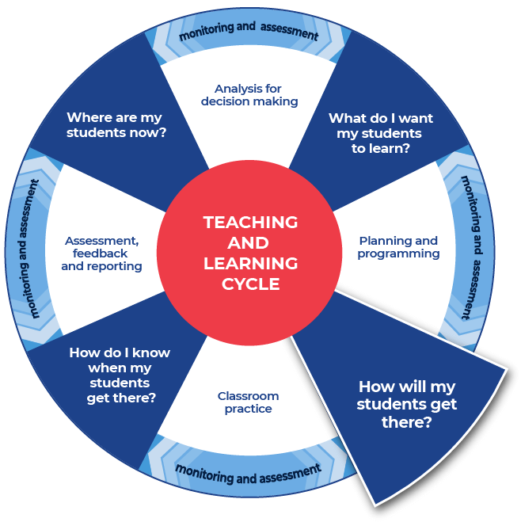

Instructions:
- Students create their own written response to a question (different to the question in Activity 1) that the teacher provides for their subject.
- Teachers could create and use modelled writing that is relevant to their topic and chosen focus.
Further support:
- An example of the question for students to respond to has been provided from Modern History. Teachers should create a question for their own context.

Example
Outline 3 features that were common to dictatorships that arose after World War I.
This is the end of Focus on skills section.

Prepare to write

Activity 1: Select your resource

Instructions:
- Teachers support students as they prepare to create a written response.
- Teachers choose an appropriate website, article, video, or a source that is part of their lesson planning. This could be the same source that has been used for the vocabulary activities or a new source for students to engage with.
- Teachers provide the selected source to their students. Suggested sources could include course textbooks, journals, media articles, History journals and magazines. For example: History Now, History Revealed, All About History and The History Association of NSW Journal.
Differentiation:
- Teachers ensure that they pre-read or view all sources provided to students and communicate the purpose and focus for using the source with students.
- Teachers could read the sources to students or discuss the sources with students.
- Teachers ensure they have the question that their students will answer prepared and that engaging with the chosen source will support students in answering the set question for ‘Student writing and feedback’.
Further support:
- Modern History Stage 6 Syllabus.
- Modern History Stage 6 programming: Option E the nuclear age 1945 to 2011.
- An example from Modern History has been provided.

Example
This example is linked to the Modern History Stage 6 Syllabus: Change in the Modern World; Option E: The Nuclear Age 1945–2011.
Content Focus: Students investigate key features in the history of the Nuclear Age 1945–2011.
Focus of study
- The nuclear threat and weapons testing, including:
- selection of Maralinga for British nuclear tests, state secrecy, and impact of the tests on local Aboriginal people and Australian service personnel (ACHMH189)
Perspectives of Maralinga
From the McClelland Royal Commission students investigate the paper: “CONTAMINATION OF THE ENVIRONMENT – PAST PROBLEMS AND CONTEMPORARY RESPONSES” (PDF 231 KB), pages 1–7, focussing on:
- access to the contaminated site by Aboriginal people and Australian service personnel
- state secrecy surrounding the tests.
Aboriginal and Torres Strait Islander People are advised that resources related to this example may contain images and names of deceased persons. Read the Principles and Protocols relating to teaching and learning about Aboriginal and Torres Strait Islander histories and cultures and the involvement of local Aboriginal communities.
Note: To introduce Aboriginal content in your classroom consideration should be given to protocols for communicating knowledge about Aboriginal culture, peoples and histories. This would include:
Understanding that not all Aboriginal stories are the same and that different communities may have different stories.
That when possible it is best to work with local community and local Aboriginal knowledge.
Always acknowledge the origin of the story, artefact and local knowledge. For example, if the story you are telling originates in Wiradjuri country acknowledge that and indicate to your students where Wiradjuri country is located.
Assistance and support can be found by contacting the NSW Aboriginal Education Consultative Group (NSW AECG Inc.).
Information can also be found on the department’s Working in partnership with the NSW AECG Inc.

Activity 2: Take effective notes

Instructions:
- Teachers model their own example to share with students. An example from Modern History has been included.
- Students take notes as they engage with the source that their teacher has provided. A suite of note taking resources to choose from is provided.
- Students will write the information on their chosen note taking template as they locate it in the source.
Differentiation:
- Teachers could provide different students with different scaffolds.
- Teachers may pre-fill some of the note taking template or include sentence starters to support student engagement and achievement.
- Teachers may provide a completely pre-filled example for students to work from.
Further support:
- Teachers may want to take the time to use the pre-written ideas and teaching strategies regarding Locating explicit information on the HSC minimum standard website.
- For the Modern History example, a specific source has been chosen:
From the McClelland Royal Commission students investigate the paper: “CONTAMINATION OF THE ENVIRONMENT – PAST PROBLEMS AND CONTEMPORARY RESPONSES” (PDF 231 KB), pages 1–7, focussing on:
  - access to the contaminated site by Aboriginal people and Australian service personnel
  - state secrecy surrounding the tests.
- Teachers use the examples provided as support to create their own examples for their students and context.

Example 1

Template
Title of source:
Type of source:
Who it is about:

When it occurred:

Where it occurred:

What happened?

Why did it happen?

How are people reacting to it?

Put 3 of the points that you have recorded in the categories above into a summarising paragraph of 3 to 4 sentences.

Completed example
Title of source: “CONTAMINATION OF THE ENVIRONMENT – PAST PROBLEMS AND CONTEMPORARY RESPONSES”.
Type of source: A paper presented at the International Seminar on Global Environment and Disaster Management: Law & Society.
Who it is about:
The paper is about British nuclear tests that took place on Australian soil during the 1950’s and 1960’s. Further, the paper is about the impact of testing on Aboriginal people and military personnel.
When it occurred:
Nuclear testing at Maralinga, 1952–1963.
Where it occurred:
Maralinga, South Australia.
What happened?
The British government couldn’t do nuclear testing in the United States anymore. The Australian Prime Minister at the time, Robert Menzies, said that the British Government could do their nuclear testing in Australia. The Menzies government did not engage in consultation around this.
Why did it happen?
Contextually countries around the world considered having the best nuclear weapons as ideal. America and Russia had weapons, but Britain was lagging behind and wanted to increase its testing.
How are people reacting to it?
Historically people have denied that anything from the nuclear testing would impact people. Then they tried to clean it up, unsuccessfully. This source talks about the royal Commission into these events and the new clean up recommendations.

Put 3 of the points that you have recorded in the categories above into a summarising paragraph of 3 to 4 sentences.
The British government couldn’t do nuclear testing in the United States anymore. The Australian Prime Minister at the time said that the British Government could do their nuclear testing in Australia. The Prime Minister did not engage in consultation around this. Contextually countries around the world considered having the best nuclear weapons as ideal. America and Russia had weapons, but Britain was lagging behind and wanted to increase its testing. Historically people have denied that anything from the nuclear testing would impact people. Then they tried to clean it up, unsuccessfully. This source talks about the royal Commission into these events and the new clean up recommendations.

Example 2

Template
As you engage with the source create sentences that begin with the following:
Title of source:
Type of source:
Before

After

If

When

Even though

Although

Since

While

Unless

Whenever

Put some of the points that you have recorded in the categories above into a summarising paragraph of 3 to 4 sentences.

Completed example
As you engage with the source create sentences that begin with the following:
Title of source: “CONTAMINATION OF THE ENVIRONMENT – PAST PROBLEMS AND CONTEMPORARY RESPONSES”.
Type of source: A paper presented at the International Seminar on Global Environment and Disaster Management: Law & Society.
Before the British government received permission to test nuclear weapons on Australian soil the Australian Prime Minister did not consult with other bodies.
After the nuclear testing there were impacts on the health of the humans nearby to the testing sites. The people impacted were both Aboriginal people and government employees.
If the dangers of nuclear testing had been widely known, then perhaps the testing would not have occurred or would have occurred differently.
When the government chooses remote locations and fails to consider the people living in those regions it appears as disrespect towards those people.
Even though people have symptoms that match to the time and place of the nuclear testing doctors are loathed to diagnose the subsequent illnesses as caused by the nuclear testing.
Although the effects of nuclear testing are now known to be dangerous the responsibility for the cleanup of the testing sites has been shunned by the British Government.
Since people were living in these areas and were badly affected by the nuclear testing they have been compensated by the government.
While the testing site areas will always have nuclear contamination, efforts are being made to clean the areas to an acceptable inhabitable level of safety.
Unless cleanup efforts are taken seriously the problem will simply continue to exist unresolved.
Whenever humans ignore the rights and safety of other humans and the environment the negative repercussions are felt for many years.
Put some of the points that you have recorded in the categories above into a summarising paragraph of 3 to 4 sentences.
Before the British government received permission to test nuclear weapons on Australian soil the Australian Prime Minister did not consult with other bodies. After the nuclear testing there were impacts on the health of the humans nearby to the testing sites. The people impacted were both Aboriginal people and government employees. If the dangers of nuclear testing had been widely known then perhaps the testing would not have occurred or would have occurred differently. Unless cleanup efforts are taken seriously the problem will simply continue to exist unresolved.

Example 3

Template
Title of source:
Type of source:
Topic:
Events
People
Facts
Key words
Summary

Completed example
Title of source: “CONTAMINATION OF THE ENVIRONMENT”.
Type of source: transcript of a paper presented at a conference.
Topic: Nuclear testing, Maralinga.
Events
Cold War tensions.
USA not allowing British nuclear testing on their soil anymore.
Britain testing on Australian soil.
Unsafe testing and health and environmental impacts.
People
British Government.
Australian Government.
Aboriginal people.
Armed forces personnel and government employees.
Facts
Elements in nuclear testing do not leave human bodies or the environment and they have harmful impacts.
Who will take responsibility and clean up the contaminated areas?
Britain was given permission to test in Australia after the USA refused them.
Key words
Maralinga
Government
Black mist
1952–1963
Summary
The British government received permission to test nuclear weapons on Australian soil. The Australian Prime Minister did not consult with others about this decision. The nuclear testing resulted in harmful impacts on the health of the humans nearby to the testing sites. The people impacted were both Aboriginal people and government employees. Seventy years later, unless cleanup efforts are taken seriously the problem will simply continue to exist unresolved.

Activity 3: Where to next
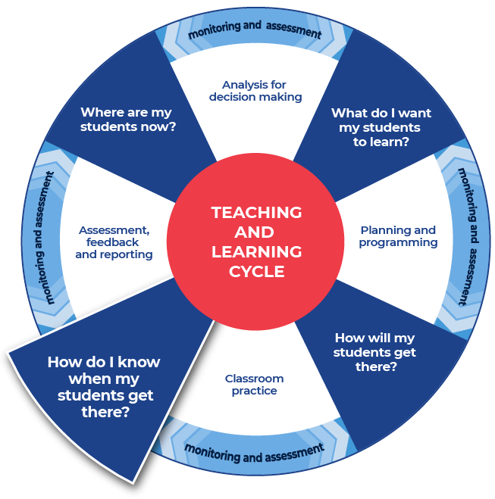

Instructions:
- Teachers provide the specific question or stimulus that their students will respond to.
- Students should create a plan and draft for their written response. Students can use the notes that they have taken and any other information.
- Teachers provide students with time to draft their writing.
- Teachers provide students with formative feedback during the drafting process.
Differentiation:
- The task could respond to a practice examination question, or it could be writing in response to source material.
Further support:
- Teachers and students could engage with the pre-written lesson content in the Ideas section on the HSC minimum standard website to support strengthening ideas.
- Teachers may also want to engage with the Text structure section on the HSC minimum standard website and use the persuasive text structure template provided on the website.

Example
Evaluate the social and environmental effects of the Nuclear Age. In your answer, include references to the source provided.
Source A
A legacy of damage
Harm was done to Aboriginal people who lived nearby to all three testing sites at Maralinga. This harm included injury, death, and displacement. The impact on Aboriginal people is immeasurable. Additionally, service personnel from many countries including Britain and Australia were also impacted and suffered. This includes their continuing battle for any recognition of the dangers that they faced. A source of ongoing distress for those involved and impacted is that even though there were many injuries and deaths allegedly caused by the British tests they have not been formally linked.
In the late 1990’s the cost of the clean-up exceeded A$100 million. Of this amount, Britain paid less than half and only did so after protracted pressure and negotiations.
Extract adapted from Tynan, L. (2016) Sixty years on, the Maralinga bomb tests remind us not to put security over safety. The Conversation.
This is the end of the activities for: Improve student writing through explicit planning.
Teachers should move on to the next set of activities: Improve student writing through writing and feedback (DOCX | PDF).

