The National Literacy Learning Progression and Stage 6 HSIE

How the progression could support writing in Stage 6 HSIE
This document is part of the Stage 6 Literacy in context – Writing resource. It outlines ways that the National Literacy Learning Progression can support development of student writing through Stage 6.
The element of Writing in the National Literacy Learning Progression provides indicators that reflect the increasing sophistication of skill development in writing for students in Years K–10. It is important to note that these skills are unconstrained and will continue to develop as students work through their final years of school and beyond.
In addressing the objectives and outcomes of the Stage 6 HSIE syllabuses, students need to use subject specific terminology to describe, identify, demonstrate, analyse, communicate, support with evidence, propose arguments, evaluate, and assess.
A student’s ability to communicate their knowledge and understanding will influence the quality of their written responses. For example, marking criteria from the HSC for written short and extended response questions in HSIE may include statements such as:
- demonstrates explicit understanding
- makes a clear judgement
- communicates ideas logically
- integrates evidence
- appropriately structures response.
It can be difficult for teachers to articulate what effective writing ‘looks like’ in a student response, and therefore to be able to explicitly support their students to improve their writing. Certain indicators within the Creating texts sub-element of the National Literacy Learning Progression can amplify these criteria and support teachers and students to identify features of writing that can be targeted to improve students’ ability to answer extended response questions.
Some examples of these connections between the criteria and the Creating texts sub-element are provided here:
Demonstrates explicit understanding:
- uses discipline-specific terminology to provide accurate and explicit information (e.g. discipline metalanguage) (CrT10 Vocabulary)
- uses vocabulary for precision (e.g. the underwhelming performance of the opening batsmen) (CrT11 Vocabulary)
- uses complex abstractions (economic, sociocultural) (CrT11 Vocabulary).
Makes a clear judgement:
- writes sustained, robust arguments on complex learning area topics (e.g. should bushrangers be afforded hero status?) (CrT11 Crafting ideas)
- uses sophisticated evaluative language devices such as allusion, evocative vocabulary and extended metaphor
Communicates ideas logically:
- organises related information and ideas into paragraphs/sections (CrT10 Generic indicators)
- writes sustained, informative texts that precisely explain, analyse and evaluate concepts or abstract entities (CrT11 Crafting ideas)
- uses structural features flexibly to organise ideas strategically (e.g. includes a defined, cogent summation or call to action) (CrT11 Crafting ideas).
Integrates evidence:
- includes persuasive points with effective elaborations and supporting evidence (CrT10 Crafting ideas)
- uses evidence and research including digital resources to expand upon information and elaborate concepts (CrT10 Crafting ideas)
- uses evidence and references (CrT11 Crafting ideas).
Appropriately structures response:
- maintains tone appropriate to the audience (CrT11 Text forms and features)
- skilfully uses a range of cohesive devices to make connections between arguments (e.g. foreshadows key points in introduction and reinforces key points in topic sentences) (CrT10 Text forms and features)
- uses structural features flexibly to organise ideas strategically (e.g. includes a defined, cogent summation or call to action) (CrT11 Crafting ideas)
- positions the reader effectively by providing a clear thesis and relevant context (e.g. by previewing the arguments) (CrT11 Crafting ideas)
Demonstrate coherent and logical progression of thought:
- maintains tone appropriate to the audience (CrT11 Text forms and features)
- skilfully uses a range of cohesive devices to make connections between arguments (e.g. foreshadows key points in introduction and reinforces key points in topic sentences) (CrT10 Text forms and features)
- uses structural features flexibly to organise ideas strategically (e.g. includes a defined, cogent summation or call to action) (CrT11 Crafting ideas)
- positions the reader effectively by providing a clear thesis and relevant context (e.g. by previewing the arguments) (CrT11 Crafting ideas)

Using the National Literacy Learning Progression to inform feedback
Before you begin you may like to learn more about the National Literacy Learning Progression through the online professional learning course: Introduction to the Literacy and Numeracy Progressions.
For example, Writing sub-elements include:
- Creating texts – Crafting ideas
- Creating texts – Text forms and features
- Creating texts – Vocabulary
- Grammar
- Punctuation
- Spelling
- Handwriting/keyboarding.
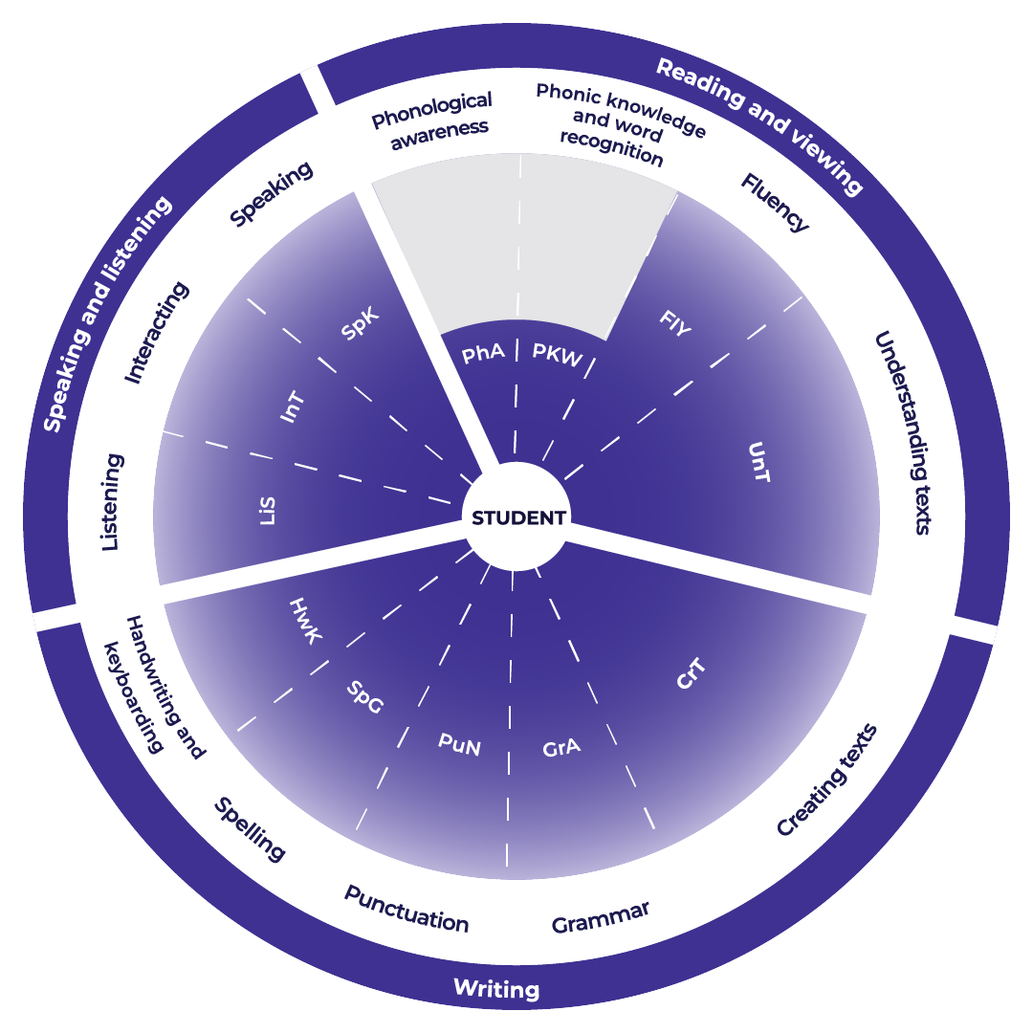

Teachers could use the student’s written response to assess where the student’s skills are and what they could do next to improve.

Example analysis
For this example, the sub-element of Creating texts has been selected with specific focus on crafting ideas.
Teachers read through the sub-element description to match characteristics that the student’s writing is currently displaying. An example from Modern History is provided.
CrT10 Crafting ideas:
- orients the reader clearly to the topic or concept (e.g. using a definition or classification in the opening paragraph)
- intentionally selects structural elements for effect (e.g. includes an appropriate conclusion that sums up, recommends or reiterates)
- uses evidence and research to expand upon information and elaborate concepts
- creates informative texts to explain and analyse (e.g. analyses how artists use visual conventions in artworks)
- uses language that evokes an emotional response (e.g. a piercing scream echoed through the valley).
Student writing sample*:
The social and environmental effects of the Nuclear Age were significant and continue to be felt by the global world today. The testing regimes by various countries had clear and ongoing impacts on both the physical environments within which they were held, as well as on the people that resided nearby. This is highlighted specifically in the extract in Source A, in terms of both the human and environmental effects. The level of societal anxiety around nuclear testing and potential war has varied over time, but has altered the social fabric of many nations, as well as political relationships on a global level. Nuclear accidents at sites like Chernobyl and Fukushima have been disastrous for the environment, whilst also providing a catalyst for change and development in regard to safety measures and protocols for dealing with nuclear energy. Thus, although there are many negative effects, both socially and environmentally, the Nuclear Age has seen some positive measures to improve and combat the environmental impacts.
*Question and Source A can be found in Improve student writing through writing and feedback (DOCX | PDF).
Reading the next sub-element descriptor the teacher could work out where to next for the student.
CrT11 Crafting ideas:
- uses evidence and references.
For example, in the written response the student could:
- include direct references to the source and/or evidence to support the response.

Example of written feedback to the student
Name: Rose Yeung
Is able to:
Orientate the reader.
Use supporting evidence.
Expand upon ideas and concepts in her writing.
Structure her responses.
Use language to affect the reader.
To continue to improve:
Rose could:
- include direct references to the source and/or evidence to support the response.

Template
Name: ____________________________________
Is able to:

To continue to improve:

