Planning for writing – Stage 6 Creative Arts
To get the most from these resources they should be used as a teaching and learning sequence. One set of activities leads on to the next.
- Improve student writing through subject vocabulary (DOCX | PDF)
- Improve student writing through planning for writing (this document)
- Improve student writing through writing and feedback (DOCX | PDF).

Learning focus
With these literacy activities teachers use content that they have planned in their teaching and learning cycle. For each literacy activity an example from Music 1 has been provided. The example provided is a model for teachers. Teachers create their own specific examples for their subject and class. Teachers can modify the learning intentions and success criteria to reflect their context.
Through engaging with this resource teachers may find that their students could benefit from support in other areas of their learning. For more ideas and teaching strategies on literacy and numeracy go to the HSC minimum standard website. Here you will find teaching ideas and activities on:
Writing, including: text structure, paragraphs, cohesion, sentence types, tense, punctuation, formal and informal language, spelling, vocabulary, topic vocabulary, audience and purpose, ideas, language devices, and unpacking the writing prompt.
Numeracy, including: division, multiplication, fractions, decimals, percentages, rates, time, ratio, area, length and perimeter, mass, volume and capacity, mean, median and mode, chance, 3D objects, 2D shapes, patterns, formulae and substitution, positioning and locating, angles, tables graphs and charts, vocabulary in numeracy, interpreting questions and grammar for numeracy.
Reading, including: audience and purpose, locating explicit information, inferring, common language devices, parts of speech, cohesive devices, sentence types, tense, subject-verb agreement, punctuation, spelling, antonyms and synonyms and inferring word meanings.

Syllabus outcomes
For each Creative Arts subject, relevant syllabus outcomes have been provided in the Stage 6 Creative Arts syllabus links (PDF 118 KB) document. However, to support professional practice teachers are strongly advised to always refer to the syllabus documents on the NESA website.

Learning Intentions
- Students will investigate effective writing.
- Students will analyse sample written responses.
- Students will develop note taking skills.
- Students will develop confidence with writing.

Success criteria
- Students are able to recognise aspects of effective writing.
- Students are able to practise their writing skills.
- Students are able to take effective notes.
- Students are able to prepare for a written response.

Teaching strategies
Focus on skills:
- Activity 1: Review annotated samples
- Activity 2: Warm up writing activity.
Prepare to write:
- Activity 1: Select your resource
- Activity 2: Take effective notes
- Activity 3: Where to next.

Focus on skills

Activity 1: Review annotated samples
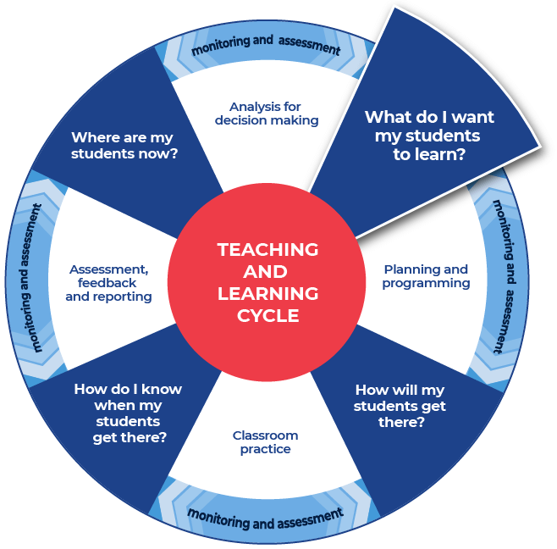

Instructions:
- Teachers provide a sample question with sample written response and annotate some of the features of effective writing on that response.
- Teachers create examples themselves or source them from: the Creative Arts statewide staffroom, previous year groups, local teacher networks, NESA publications or professional associations.
- Teachers can use the National Literacy Learning Progression to help track students’ literacy skills. Improving students’ literacy skills will enable students to communicate their ideas in a more succinct manner.
- Students will be asked to complete an analysis of the writing, after discussing and reviewing the written samples. A template is provided.
- As an example, for teachers, we have provided samples from Music 1.

Example question
This example reflects an 8-mark question.
An excerpt (first 1:45 minutes) from O Vertigo! by Kate Miller-Heidke and the Melbourne Symphony Orchestra will be played SIX times for you to answer the question below.
Times (pauses to allow students to take notes):
- First playing – 5 second pause
- Second playing – 30 second pause
- Third playing – 1 minute pause
- Fourth playing – 1 minute pause
- Fifth playing – 1 minute pause
- Sixth playing – 2 minute pause.
Discuss the use of pitch in this excerpt.

Sample low-range response
In this excerpt the melody is held by the voice and the accompaniment is by the guitar and the orchestra. All instruments play in the same key which gives a happy vibe. The singer’s voice is very high and the instruments follow her when she is at the top of her voice, while the guitar keeps a steady beat.

Annotations
In this excerpt the melody is held by the voice and the accompaniment is by the guitar and the orchestra. (compound sentence) All instruments play in the same key which gives a happy vibe. (compound sentence) The singer’s voice is very high and the instruments follow her when she is at the top of her voice, while the guitar keeps a steady beat. (complex sentence)
- writes a range of compound and complex sentences (CrT7 Text forms and features)
- includes ideas which are relevant to the topic and purpose of the text (CrT8 Crafting ideas)
- uses articles accurately (e.g. a, an, the) (CrT8 Generic indicators)
- uses a range of learnt, technical and discipline-specific terms (e.g. adapt, survive) (CrT9 Vocabulary)
- provides a basic outline of how pitch techniques are used (adapted from the 2019 HSC Marking Criteria Music 1 (PDF 111 KB))
- demonstrates a basic aural understanding (adapted from the 2019 HSC Marking Criteria Music 1 (PDF 111 KB)).
To improve:
- consistently writes sentences correctly and uses a greater range of complex sentences (CrT8 Generic indicators)
- develops ideas with details and examples (CrT9 Crafting ideas)
- organises related information and ideas into paragraphs/sections (CrT10 Generic indicators)
- uses discipline-specific terminology to provide accurate and explicit information (discipline metalanguage) (CrT10 Vocabulary)
- explore in detail how pitch techniques are used for example tonality, melody, harmony, and relate this to other concepts (adapted from the 2019 HSC Marking Criteria Music 1 (PDF 111 KB))
- demonstrate a highly developed aural understanding, using well supported observations and appropriate examples, for example provide detailed examples of each section of the song (adapted from the 2019 HSC Marking Criteria Music 1 (PDF 111 KB)).

Sample high-range response
The excerpt is in a major key and all instruments play in their upper register which results in a bright and happy tone colour.
Introduction A consists of a solo guitar playing fast, strummed chords. The harmonic progression is slow with chords changing approximately every second bar. There is a slight descending melody in the upper notes of the chords in the guitar.
As the introduction progresses to a B section, the guitar chords move to a slightly arpeggiated descending melodic riff which continues through the same chord progression. In this section the violins enter with high pitched, long, bowed notes for each chord change. Each violin note concludes with a trill.
Introduction B becomes the accompaniment of the Verse which introduces a female soprano singing in her upper-mid register. The vocal melody for the verse is in short, symmetrical fragments that both ascend and descend. On the second vocal phrase, the first violins begin a high countermelody that descends, whilst the second violins continue with the accompaniment.
The pre-chorus brings some depth to the excerpt with a change in the chord progression, one chord per bar, and lower notes being played by all instruments. The static vocal melody is performed in the vocalist’s lower chest register and is contrasted at the end of the section with a large melodic leap back to her upper register leading into the chorus. The vocal melody is complemented by a counter-melody introduced on woodwind instruments.
In the chorus the texture thickens as the whole orchestra is introduced. The strings and guitar continue to provide harmonic accompaniment, while the melody provides a call and response interplayed between ascending, scale-like vocal passages which are imitated by the woodwinds, harp and tuned percussion. The second phrase of the chorus melody is symmetrical to the first, with descending fragments in the vocal melody which are finally answered in the last bar with a fast ascending scale by woodwinds and tuned percussion building to a climax. The excerpt ends with the solo vocal singing “I just wanted to let you know” on a single repeated lower register note.

Annotations
The excerpt is in a major key and all instruments play in their upper register which results in a bright and happy tone colour.
Introduction A consists of a solo guitar playing fast, strummed chords. The harmonic progression is slow with chords changing approximately every second bar. There is a slight descending melody in the upper notes of the chords in the guitar.
As the introduction progresses to a B section, the guitar chords move to a slightly arpeggiated descending melodic riff which continues through the same chord progression. In this section the violins enter with high pitched, long, bowed notes for each chord change. Each violin note concludes with a trill.
Introduction B becomes the accompaniment of the Verse which introduces a female soprano singing in her upper-mid register. The vocal melody for the verse is in short, symmetrical fragments that both ascend and descend. On the second vocal phrase, the first violins begin a high countermelody that descends, whilst the second violins continue with the accompaniment.
The pre-chorus brings some depth to the excerpt with a change in the chord progression, one chord per bar, and lower notes being played by all instruments. The static vocal melody is performed in the vocalist’s lower chest register and is contrasted at the end of the section with a large melodic leap back to her upper register leading into the chorus. The vocal melody is complemented by a counter-melody introduced on woodwind instruments.
In the chorus the texture thickens as the whole orchestra is introduced. The strings and guitar continue to provide harmonic accompaniment, while the melody provides a call and response interplayed between ascending, scale-like vocal passages which are imitated by the woodwinds, harp and tuned percussion. The second phrase of the chorus melody is symmetrical to the first, with descending fragments in the vocal melody which are finally answered in the last bar with a fast ascending scale by woodwinds and tuned percussion building to a climax. The excerpt ends with the solo vocal singing “I just wanted to let you know” on a single repeated lower register note.
- Writes texts to compare and contrast phenomena (e.g. identifies the similarities and differences between species of animals) (CrT10 Crafting ideas)
- orients the reader clearly to the topic or concept (e.g. using a definition or classification in the opening paragraph) (CrT10 Crafting ideas)
- uses more elaborate noun groups that include classifying adjectives and specific nouns (e.g. mineral component of sedimentary rocks) (CrT10 Text forms and features)
- uses discipline-specific terminology to provide accurate and explicit information (e.g. discipline metalanguage) (CrT10 Vocabulary).
Overall structure and content of written response:
- uses evidence and research including digital resources to expand upon information and elaborate concepts (CrT10 Crafting ideas)
- creates sustained, informative texts that precisely explain, analyse and evaluate concepts or abstract entities (CrT11 Crafting ideas)
- organises related information and ideas into paragraphs/sections (CrT10 Generic indicators)
- explores in detail how pitch techniques are used for example tonality, melody, harmony, and relate this to other concepts (adapted from the 2019 HSC Marking Criteria Music 1 (PDF 111 KB))
- demonstrates a highly developed aural understanding, using well supported observations and appropriate examples, for example provide detailed examples of each section of the song (adapted from the 2019 HSC Marking Criteria Music 1 (PDF 111 KB))
- this high range sample has used the terminology of the elements of pitch.
To improve students could:
- use structural features flexibly to organise ideas strategically (e.g. includes a defined, cogent conclusion /summation) (CrT11 Crafting ideas)
- note that the elements of pitch have been used in this response. For example, the student has used the words ‘tonality’, ‘melody’ and ‘harmony’ as they are the elements of pitch. These elements cannot really be interchanged with the word ‘pitch’. Additionally, students could note that the response avoids writing that the pitch is major/minor because that would reflect a low range response. Also, if students were to write the pitch is ascending that would be a middle range response. Therefore, the more precise answer is the melody is ascending.

Review annotated samples
- Students read through the example responses to the question.
- Students choose one of the sample responses.
- Students respond to the analysis questions on the template provided.

Template

What do you notice?
How was the answer structured?

Were words from the question used in the answer?

What do you notice about the sentences?

Identify and re-write an idea that was contained in the sample response?

What did you like about the response?

Completed example

What do you notice?
How was the answer structured?
The answer is structured in a logical way. It clearly explains what happens in the excerpt. It does this by having sections of information. As each aspect is explained there are supporting details and evidence from the excerpt.
Were words from the question used in the answer?
The ‘Discuss’ aspect of the question was well explored. Additionally, the student has used the words tonality, melody and harmony as they are the elements of pitch. This high range sample has used the terminology of the elements of pitch to address that aspect of the question.
What do you notice about the sentences?
Complex sentences were used to give detailed explanations of the ideas being communicated. For example, the following sentence uses punctuation and cause and effect, “On the second vocal phrase, the first violins begin a high countermelody that descends, whilst the second violins continue with the accompaniment.” Many of the complex sentences use cause and effect words, overall in the high-range sample response these words are often; which, whilst, and while.
Identify and re-write an idea that was contained in the sample response?
‘On the second vocal phrase, the first violins begin a high countermelody that descends, whilst the second violins continue with the accompaniment.’
Re-write: On the second part of the singer’s section the violins that are called the first violins start with high notes and play a melody that goes down in pitch and is sub-ordinate to the singer. At the same time the group of violins that is called the second violins continues to accompany and support the singer.
What did you like about the response?
I appreciated the details. The ideas were built up with supporting evidence and often a sentence led on to another sentence that gave further evidence and support. This demonstrated that the writer knew the content and was able to apply their knowledge to answer the specific question. For example, “On the second vocal phrase, the first violins begin a high countermelody that descends, whilst the second violins continue with the accompaniment”.
Additional support for Activity 1
Please note that there are several supports to help teachers improve writing.
Teachers could use their marking criteria to assess written responses and provide feedback.
In some contexts, you could use the National Literacy Learning Progression. While primarily focused for K–10, it will provide sound ideas on aspects of writing and how to improve.
For more ideas on what to look for in literacy you may like to complete the online course: Introduction to the Literacy and Numeracy Progressions.

Activity 2: Warm up writing activity
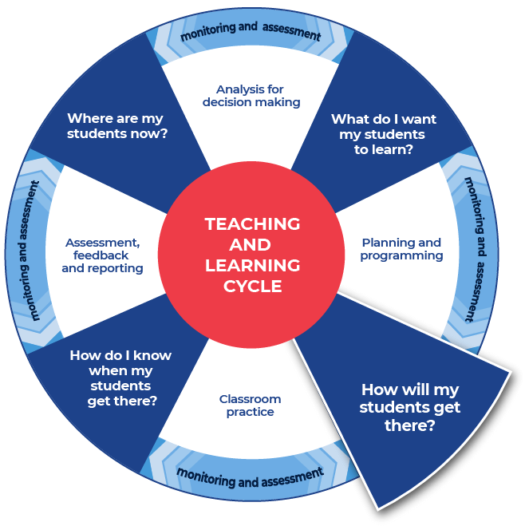

Instructions:
- Students create their own written response to a question (different to the question in Activity 1) that the teacher provides for their subject.
Differentiation:
- Teachers could create and use modelled writing that is relevant to their topic and chosen focus.
- Teachers could provide a structure that can be used to approach the writing.
- Teachers could model or scaffold sentences to demonstrate how the task could be approached, as well as illustrate the language used to address each level of complexity or depth in terms of the verbs in the question.
Further support:
- An example of the question for students to respond to has been provided from Music 1. Teachers should create a question for their own context.

Example
This example reflects an 8-mark question.
An excerpt (first 1:45 minutes) from The Last Day on Earth! by Kate Miller-Heidke and the Melbourne Symphony Orchestra will be played SIX times for you to answer to question below.
Times (pauses to allow students to take notes):
- First playing – 5 second pause
- Second playing – 30 second pause
- Third playing – 1 minute pause
- Fourth playing – 1 minute pause
- Fifth playing – 1 minute pause
- Sixth playing – 2 minute pause.
Discuss the use of pitch in this excerpt.
This is the end of Focus on skills section

Prepare to write

Activity 1: Select your resource

Instructions:
- Teachers support students as they prepare to create a written response.
- Teachers choose an appropriate website, article, video, or a source that is part of their lesson planning. This could be the same source that has been used for the vocabulary activities or a new source for students to engage with.
- Teachers provide the selected source to their students.
Differentiation:
- Teachers ensure that they pre-read or view all sources provided to students and communicate the purpose and focus for using the source with students.
- Teachers could read/discuss the sources to or with students.
- Teachers ensure they have the question that their students will answer prepared and that engaging with this chosen source will support students in answering the set question for ‘Student writing and feedback’.
Further support:
- Creative Arts – Stage 6 curriculum resources.
- Creative Arts HSC Hub.
- Creative Arts Statewide Staffroom.
- Teachers may find useful information within the An instrument and its repertoire resource.
- An example from Music 1 has been provided: The modern harpsichord and its potential by Goska Isphoring (2020), backtrack.com.

Example
This example is linked to the Music 1 Stage 6 Syllabus.
Topic: An instrument and its repertoire.
Research how your instrument has been used in music over the past 200 years. Discuss how developments in your instrument and various playing techniques manipulate the concepts of music in its repertoire.
Text: The modern harpsichord and its potential by Goska Isphoring (2020), backtrack.com.

Activity 2: Take effective notes

Instructions:
- Teachers model their own example to share with students. An example from Music 1 has been included.
- Students take notes as they engage with the source that their teacher has provided. A suite of note taking templates is included in this resource.
- Students will write the information on their note taking template as they locate it in the text.
Differentiation:
- Teachers could provide different students with different scaffolds.
- Teachers may pre-fill some of the note taking template or include sentence starters to support student engagement and achievement.
- Teachers may provide a completely pre-filled example for students to work from.
Further support:
- Teachers may want to take the time to use the pre-written ideas and teaching strategies regarding Locating explicit information on the HSC minimum standard website.
- For the Music 1 example the following text has been used: The modern harpsichord and its potential by Goska Isphoring (2020), backtrack.com.
- Teachers use the example provided as support to create their own examples for their students and context.

Example 1

Template
Title of text:
Type of text:
Who it is about:

When it occurred:

Where it occurred:

What happened?

Why did it happen?

How are people reacting to it?

Put 3 of the points that you have recorded in the categories above into a summarising paragraph of 3 to 4 sentences.

Completed example
Title of text: The modern harpsichord and its potential
Type of text: written article on a website.
Who it is about:
Goska Isphording who specialises in contemporary music played on the harpsichord.
When it occurred:
The article is from 13 February 2020 so it is contemporary. It is about how this musician is using a baroque instrument to play contemporary music.
Where it occurred:
She was born in Poland but lives in Amsterdam in the Netherlands and also plays in London.
What happened?
The harpsichord is often only thought of with music from its time. However, modern day composers are also writing for it. The way to play the harpsichord was tightly structured and informed what good practice was. Now new players want to be as rigorous with quality but allow the instrument to branch out in its repertoire. Electronics and the harpsichord are making an exciting new match.
Why did it happen?
Musicians are exploring the instrument anew. “Yet the most significant change we can observe in the last two decades has been the genuine interest of composers in the instrument itself. No parts of the harpsichord and its mechanism have been left unexplored, giving new musical meaning to elements of the instrument that are not traditionally heard (such as handstops, tuning pins, lid, casing, etc).’ The harpsichord is being used to express emotions and experiences. Musicians are excited for its potential, ‘The contemporary harpsichord has so much to offer and there is still so much to be discovered when we look at this instrument's potentialities instead of its limitations”.
How are people reacting to it?
People are excited for the harpsichord’s potential. They are playing it with electronics and film accompaniment. “All of these reveal the harpsichord’s qualities across a broad scope, making use of its resonant and singing potential as much as its percussiveness.” Musicians are also keen to work with the old and new together. “We can also observe a great deal of democracy concerning the use of instruments, where both historical and revival harpsichords may be present on one concert programme and seen not as rivals but used by composers as exemplifying different sound qualities.”
Put 3 of the points that you have recorded in the categories above into a summarising paragraph of 3 to 4 sentences.
Whilst the harpsichord is often only thought of with music from its time, modern day composers are writing for it also. New players want to remain rigorous with quality but allow the instrument to branch out in its repertoire. For example, electronics and the harpsichord are making an exciting new match. Musicians are excited for its potential, “The contemporary harpsichord has so much to offer and there is still so much to be discovered when we look at this instrument's potentialities instead of its limitations”. Goska Isphording who specialises in contemporary music played on the harpsichord would like to continue to increase the instruments popularity.

Example 2

Template
As you engage with the text create sentences that begin with the following:
Title of text:
Type of text:
Before

After

If

When

Even though

Although

Since

While

Unless

Whenever

Put some of the points that you have recorded in the categories above into a summarising paragraph of 3 to 4 sentences.

Completed example
As you engage with the text create sentences that begin with the following:
Title of text: The modern harpsichord and its potential
Type of text: written article on a website.
Before learning that the harpsichord is an instrument that is striving to maintain its relevancy and appeal in a contemporary world, musicians may have thought that is was simply an old-fashioned instrument for old-fashioned music.
After having success with popularising the harpsichord in Europe, Goska Isphording is working to organise groups of musicians from different areas around the globe to popularise the harpsichord and support its contemporary relevance.
If audiences know that music is being composed to include electronics and all aspects of the harpsichord as an instrument, then they may become more interested in supporting it.
When composers, over the last twenty years, have been using the instrument they have been considering the whole instrument. “Yet the most significant change we can observe in the last two decades has been the genuine interest of composers in the instrument itself. No parts of the harpsichord and its mechanism have been left unexplored, giving new musical meaning to elements of the instrument that are not traditionally heard (such as handstops, tuning pins, lid, casing, etc).”
Even though it is often seen as an old-fashioned instrument, contemporary musicians are working with it to increase its relevance and popularity.
Although there are new works for the harpsichord they are often only known in the local area where they have been created. Modern harpsichordists are working together to widen the reach of the instrument’s popularity.
Since the instrument is good at communicating people’s experiences and emotions modern day musicians feel that it is an instrument to experiment with and “achieve new, unique experiences and to show to the listener the values that are shared between you and the composer.”
While Goska Isphording has created and premiered hundreds of new works she is open to new challenges from composers.
Unless Goska Isphording and her fellow harpsichordist can promote the instrument and its modern repertoire more globally it will not get the international recognition that they feel it deserves.
Whenever people used to think of the harpsichord they thought of its music as being very 17th Century, but modern musicians are working to alter that perception.
Put some of the points that you have recorded in the categories above into a summarising paragraph of 3 to 4 sentences.
Whenever people used to think of the harpsichord they thought of its music as being very 17th Century but modern musicians are working to alter that perception. Even though it is often seen as an old-fashioned instrument, contemporary musician are working with it to increase its relevance and popularity. After having success with popularising the harpsichord in Europe, Goska Isphording is working to organise groups of musicians from different areas around the globe to popularise the harpsichord and support its contemporary relevance. Although there are new works for the harpsichord they are often only known in the local area where they have been created. Modern harpsichordists are working together to widen the reach of the instrument’s popularity.

Example 3

Template
Title of text:
Type of text:
Topic:
Events
People
Facts
Key words
Summary

Completed example
Title of text: The modern harpsicord and its potential.
Type of text: written article.
Topic: The harpsichord and its modern relevance.
Events
Harpsichords were seen as instruments for old-fashioned music.
Musicians such as Goska Isphording are modernising the instrument’s repertoire.
The instrument is being used with electronics, film, and physically in creative ways.
People
Musicians world-wide.
Goska Isphording.
Audiences.
Composers.
Tertiary institutions.
Facts
Harpsichordists’ are working to make their instrument contemporary and relevant.
Tertiary institutions and students are supporting this.
The harpsichord is full of potential as a contemporary instrument.
Key words
Harpsichord
Contemporary
Electronic
Internationally
Summary
Harpsichords were seen as instruments for old-fashioned music. Musicians such as Goska Isphording are modernising the instrument’s repertoire. The instrument is being used with electronics, film, and physically in creative ways. Tertiary institutions and students are supporting this. The harpsichord is full of potential as a contemporary instrument.

Activity 3: Where to next
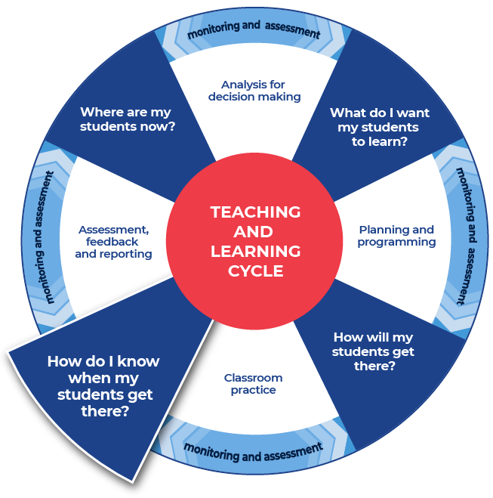

Instructions:
- Teachers provide the specific question or stimulus that their students will respond to.
- Students should create a plan and draft for their written response. They can use the notes that they have taken and any other additional information.
- Teachers provide students with time to draft their writing.
- Teachers provide students with formative feedback during the drafting process.
Differentiation:
- The task could respond to a practice examination question, or it could be writing in response to a formative class task.
Further support:
- Teachers and students could engage with the pre-written lesson content in the Ideas section on the HSC minimum standard website to support strengthening ideas.
- Teachers may also want to engage with the Text structure section on the HSC minimum standard website and use the persuasive text structure template provided on the website.
- An example question and response template from Music 1 is provided.

Example question
Music 1 topic: An instrument and its repertoire
Task: Prepare for your viva voce (see below for further details)
You have researched how your instrument has been used in music over the past 200 years. Discuss how developments in your instrument and various playing techniques manipulate the concepts of music in its repertoire.
Text: The modern harpsichord and its potential by Goska Isphoring (2020), backtrack.com.
Students should draw on their own knowledge and other sources, such as the Knowledge and skills creative arts – KASCA music framework.
Musicology viva voce
The Musicology viva voce is a two-way discussion between examiner and candidate in which the candidate must demonstrate an understanding of the concepts and stylistic features of music in the topics studied. The viva voce must have a musical focus based on extensive listening. Candidates may focus on a specific area of the topic studied, which they will outline for the examiners on the Viva Voce Outline Summary Sheet available on NESA’s Schools Online.
Candidates present one copy of their Viva Voce Outline Summary Sheet to examiners and may keep a copy of the same document for use during the examination. No other cue cards, digital slides or prepared notes are to be brought into the examination. See Assessment and Reporting in Music 1 Stage 6.

Response template example
Title of viva voce:
Course topic represented:
Outline summary:

This is the end of the activities for: Improve student writing through explicit planning.
Teachers should move on to the next set of activities: Improve student writing through writing and feedback (DOCX | PDF).

