The National Literacy Learning Progression and Stage 6 Creative Arts

How the progression could support writing in Stage 6 Creative Arts
This document is part of the Stage 6 Literacy in context – Writing resource. It outlines ways that the National Literacy Learning Progression can support development of student writing through Stage 6.
The element of Writing in the National Literacy Learning Progression provides indicators that reflect the increasing sophistication of skill development in writing for students in Years K–10. It is important to note that these skills are unconstrained and will continue to develop as students work through their final years of school and beyond.
In addressing the Objectives and Outcomes in the Stage 6 Creative Arts syllabuses, students need to use subject specific terminology to: describe, identify, demonstrate understanding, analyse, explain, support with evidence and discuss.
A student’s ability to communicate their knowledge and understanding will influence the quality of their written responses. For example, marking criteria from HSC feedback for written responses for Creative Arts may include concepts such as:
- Student is able to write to a word limit
- Student uses key words from the question throughout their response
- Student develops a thesis
- Student integrates evidence
- Student appropriately structures written responses.
It can be difficult for teachers to articulate what effective writing ‘looks like’ in a student response, and therefore to be able to explicitly support their students to improve their writing. Certain indicators within the Creating texts sub-element of the National Literacy Learning Progression can amplify these criteria and support teachers and students to identify features of writing that can be targeted to improve students’ ability to answer extended response questions.
Some examples of these connections between the criteria and the Creating texts sub-element are provided here:
Student is able to write to a word limit:
- creates succinct short-answer explanatory texts as well as complex, multi-staged extended texts (CrT11 Crafting ideas).
Student uses key words from the question throughout their response:
- maintains tone appropriate to the audience (CrT11 Text forms and features).
Student develops a thesis:
- orients the reader to the topic or concept (e.g. using a definition or classification in the opening paragraph) (CrT10 Crafting ideas)
- positions the reader effectively by providing a clear thesis and relevant context (e.g. by previewing the arguments) (CrT11 Crafting ideas)
- writes sustained, robust arguments on complex learning area topics (e.g. should bushrangers be afforded hero status?) (CrT11 Crafting ideas)
- writes sustained, informative texts that precisely explain, analyse and evaluate concepts or abstract entities (CrT11 Crafting ideas)
- uses structural features flexibly to organise ideas strategically (e.g. includes a defined, cogent summation or call to action) (CrT11 Crafting ideas).
Student integrates evidence:
- includes persuasive points with effective elaborations and supporting evidence (CrT10 Crafting ideas)
- uses evidence and research including digital resources to expand upon information and elaborate concepts (CrT10 Crafting ideas)
- uses evidence and references (CrT11 Crafting ideas).
Student appropriately structures response:
- maintains tone appropriate to the audience (CrT11 Text forms and features)
- skilfully uses a range of cohesive devices to make connections between arguments (e.g. foreshadows key points in introduction and reinforces key points in topic sentences) (CrT10 Text forms and features)
- uses structural features flexibly to organise ideas strategically (e.g. includes a defined, cogent summation or call to action) (CrT11 Crafting ideas)
- positions the reader effectively by providing a clear thesis and relevant context (e.g. by previewing the arguments) (CrT11 Crafting ideas)
- intentionally selects structural elements for effect (e.g. includes an appropriate conclusion that sums up, recommends or reiterates) (CrT10 Crafting ideas)

Using the National Literacy Learning Progression to inform feedback
Before you begin you may like to learn more about the National Literacy Learning Progression through the online professional learning course: Introduction to the Literacy and Numeracy Progressions.
For example, Writing sub-elements include:
- Creating texts – Crafting ideas
- Creating texts – Text forms and features
- Creating texts – Vocabulary
- Grammar
- Punctuation
- Spelling
- Handwriting/keyboarding.
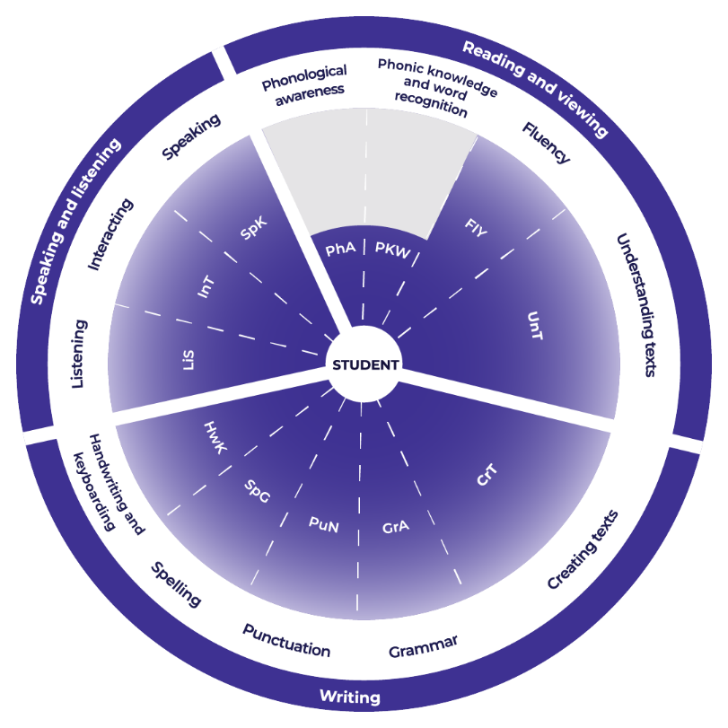

Teachers could use the student’s written response to assess where the student is at now and what they could do next to improve.

Example response
“Composer and scholar Bogusław Schaeffer said that the activities of contemporary composers cannot be assessed by the standards of previous centuries.” (The modern harpsichord and its potential. By Goska Isphording, 13 February 2020). Composers today are seeing new potential in the 19th Century harpsichord and are pushing the boundaries of tone colour, and dynamics and expressive techniques to bring the instrument into the 21st Century.
Tone colour
Composers are using electronics, video and live sound processing to alter the tone colour of the Harpsichord.
Examples:
Harpsichord and Electronics and MIDI controller – Squitur XII by Karlheinz Essl.
Harpsichord and digital augmentation – Pentacle by Jen Claude Risset.
Dynamics and Expressive Techniques
Composers are exploring all elements of the instrument such as the handstops, tuning pins, lids and casing to discover and use all possible expressive qualities of the harpsichord.
Example:
Evan Johnson, concerto, Linke hand eines Apostels – the key attack is split across different registers, and his notation indicates the key depression and release in various dynamics and articulations. He also creates a percussive effect by “playing” the key up, rather than down.

Example analysis
For this example, the sub-element of Crafting ideas and Generic indicators have been selected.
Teachers read through the sub-element description to match characteristics that the student’s text is currently displaying. An example from Music 1 is provided.
CrT10 Crafting ideas:
- uses evidence and research including digital resources to expand upon information and elaborate concepts
- orients the reader to the topic or concept (e.g. using a definition or classification in the opening paragraph)
- includes persuasive points with effective elaborations and supporting evidence
- creates informative texts to explain and analyse (e.g. analyses how artists use visual conventions in artworks).
CrT10 Generic indicators:
- organises related information and ideas into paragraphs/sections
Reading the next element descriptor, the teacher could work out where to next for the student:
CrT11 Crafting ideas:
- writes succinct short-answer explanatory texts as well as complex, multi-staged extended texts
- uses structural features flexibly to organise ideas strategically (e.g. includes a defined, cogent conclusion / summation)
- Uses evidence and references
For example, in the written response the:
- student could ensure that their viva voce notes are concise yet clear enough to enable the student to remember and be able to make their points in discussion.
- student could also ensure that their references are clearly recorded and that they are able to draw on them during the viva voce.
Overall, the student needs to ensure that the document that they have written is clear and concise and will support them in effectively communicating their understanding.

Example of written feedback to the student
Name: Rose Yeung
Is able to:
- use evidence and research to expand upon information and concepts and add authority
- orient the reader to the topic
- write to explain and analyse
- organise related information and ideas into paragraphs/sections.
To continue to improve:
Rose could:
- ensure that she writes succinct short-answer responses as clearly as possible to support herself in the viva voce
- ensure that in her sections of information she includes references of the sources that she has used.

Template
Name: ____________________________________
Is able to:

To continue to improve:

