Premier’s HTA History Scholarship

Curriculum, Collaboration and Creative Classrooms
Debbie Locke
Kooringal High School
Sponsored by

Since the early years of my career I have been interested in incorporating local history into the History Syllabus. It is important to look out into the world and understand our role at a national and international level, but it is equally important for us to understand where we came from.
My proposal looked at how to better engage students in the classroom and with their community by re-introducing local history into the 7 to 10 History Syllabus with a focus on year 10. With the introduction of the New Curriculum there was an opportunity to ensure that we were still making connections with community and finding the relevance for students. I am interested in the multiple ability environment that makes up the majority of our classrooms across regional areas. There is an opportunity to bring about community engagement through our local museums, which themselves are facing an uncertain future. In providing templates for introducing history in year 10 study I will firstly address each part of my proposal separately.
As part of the National Professional Standards for Teachers, the domain of professional knowledge includes the standard that teachers know their students and how they learn (AITSL, 2011). This means according to Standard 1 that every teacher should be aware of the physical, social and intellectual development and characteristics of their students (1.1); understand how they learn (1.2); and differentiate teaching to meet the specific learning needs of students across the full range of abilities (1.5). Further to this, Standard 4 says we should be supporting student participation (4.1) and including student participation and engagement in classroom activities (AITSL, 2011). As part of our job we are beholden to look for opportunities to know, understand and seek out ways to meaningfully engage our students in activities that will build their skills for a lifetime.

Multiple Ability Classrooms and Engagement of Students
Every regional school I visited agreed that the majority of our classrooms could be described as multiple ability (Locke, 2014). This means that there is a range of abilities in the classroom that includes those at either end of the ability spectrum who experience literacy difficulties and those who benefit from extension work. There are also some students who have learning difficulties due to such other issues as behaviour or mental health problems. Across the board, our classrooms are a melting pot of students with a range of needs. There are also differences in class size from school to school and some schools are able to take advantage of additional funding to address learning needs in small withdrawal groups.
When working with the multiple ability classroom it is important to ensure that differentiation is occurring and that each student is working at a level suited to their ability (AITSL, 2011). For those who struggle with literacy, learning becomes an insurmountable obstacle, while those who need extending are often bored because they are not being challenged. Both these issues can develop into management and disengagement issues in the classroom if not addressed.
Students’ engagement in their learning is clearly a key issue here. A survey measuring the indicators of student engagement revealed that the strongest result came from student feedback at 28 per cent followed by assessment results at 22per cent (see Graph 1). The better the result, the better the engagement. Anecdotal feedback from parents and other teachers is also often used to measure engagement. Others look at how many students are taking up senior
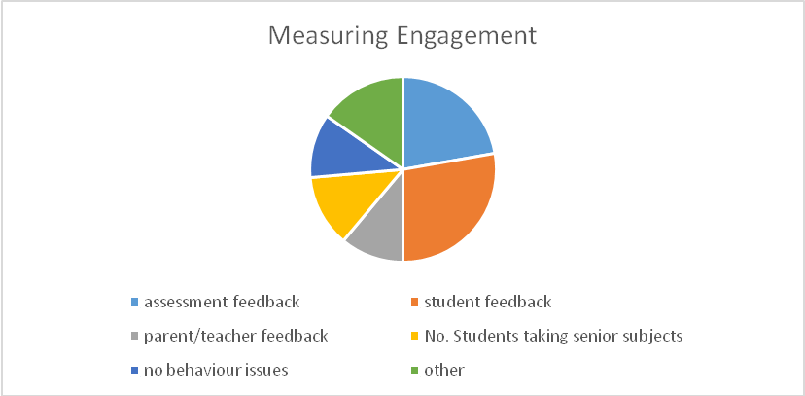
Graph 1
subjects and 11 per cent of teachers measured engagement by what is happening in the classroom. In other words, if there are no management issues then students are most likely to be engaged.
In New South Wales attainment and retention of students is generally used to measure engagement because they are readily attainable figures (Australian Institute for Teaching and School Leadership, 2013). At present there is probably some truth in the fact that we as teachers are not always very good at identifying the engagement of students in our classrooms. We ‘identify un-cooperative and low level disruptive behaviour as … not engaged with learning’ (Australian Institute for Teaching and School Leadership, 2013) but easily read other students as engaged because they are quietly getting on with their work.
Each student may have a different engagement catalyst, varying from making a connection with their real life to a topic they are very interested into simply being the type of learner they are. Those teachers I interviewed commented that students were more enthusiastic when taught in particular ways. A number of teachers mentioned a field trip to a local cemetery and a guest speaker as eliciting a better response from students than other methods such as note taking and writing. Self-directed research was also tipped as engaging students to a higher degree. Students having some choice in how and what they learnt has also been mentioned (Locke, 2014). When attempting to engage hard to reach learners a prominent suggestion is including the learner in determining the design and content of the course to help maintain engagement (Nechvoglod & Beddie, 2010). Improving engagement through classroom and community activities has the potential to build stronger community relationships for all those involved.
Subject content does relate to engagement in the classroom. Teacher feedback suggested that students were more engaged with topics about Australian involvement in wars at 45 per cent, and this was closely followed by decade studies at 28 per cent, now part of Depth Study 6 (Locke, 2014). It is too early to judge the appeal to students of topics in the New Australian Curriculum.

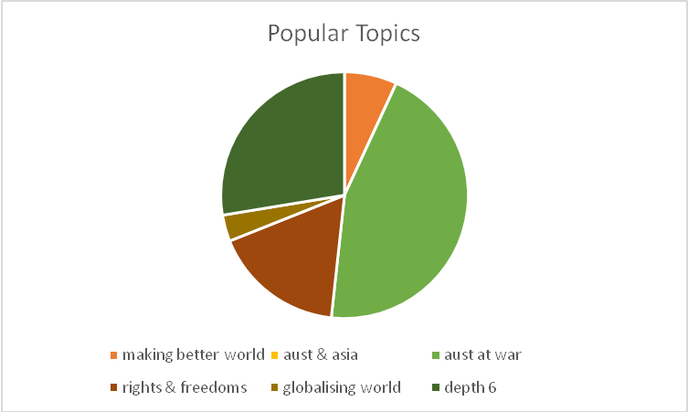
Graph 2
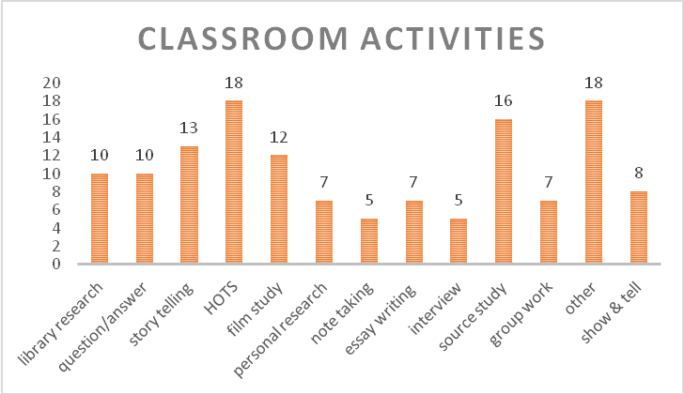
Graph 3
Types of activities in the classroom could perhaps tell the story of student engagement as well. My study showed that teachers are using a wide variety of activities in the classroom in order to teach concepts and content. Amongst other activities guest speakers were mentioned along with web quests and video production. Teachers saw students being most engaged when there was a personal connection and involvement in the study (Locke, 2014).

Project-based Learning
Problem-based Learning (PBL) can be described as self-directed learning where the skills and processes involved have particular relevance and significance for the learner. Importantly, the skills can be applied to many walks of life. For example, if I learn how to research, I can use this in many different fields; if I learn how to write a report I can use this in a wide range of situations. If I problem solve, I can apply these skills to many different situations. The learner can say ‘I don’t know the answer, but I know how to find it out.’
PBL has been used for a number of years in a wide variety of classrooms from primary school to university. PBL allows for a high degree of ‘student voice and choice’, although it needs careful planning, management and assessment (Ravitz, et al., 2012). Project-based learning may take in some or all of a number of skills, including critical thinking, collaboration, communication, creativity and innovation, self-direction, global connections and technology (Ravitz et al., 2012).
In the history classroom PBL can involve a range of activities culminating in the student discovering and constructing their own meaning for a topic. Activities include individual and group work and research involving traditional note taking from primary and secondary sources. These could be available on the internet and in the library but also derived from interviewing sources and collecting unique resources. Other skills emphasised include brainstorming, comparing and contrasting, assessing, debating, identifying, organising, constructing, creating and writing.
One way to ensure that all these activities are used in a project-based study is by using the Pirozzo Grid (Pirozzo 1997, 2004). Ralph Pirozzo of Promoting Learning International has developed a learning grid using Bloom’s Taxonomy and Gardner’s Multiple Intelligences (Pirozzo 1997, 2004). This 54-square grid identifies the wide range of intelligences or learning styles and suggests learning and assessment activities that cater to students’ strengths while still providing academic rigour. This template can be adjusted to suit any study and works particularly well in the multiple intelligence classrooms as it means that to the left of the grid students with lower literacy abilities can work in the knowing, understanding and applying section, while students with higher literacy abilities can work to the right of the grid in the analysing, creating and evaluating section. Wade High School in Griffith has a local-based decade study which uses the Pirozzo Grid with great success (Bastianion, 2011).
Another school which has developed a local area study uses a range of authentic tasks to research local war heroes based on those who served in WW1. Developed by Peter Morrissey of Coonabarabran and called ‘Not just a name on a wall’ (Morrisey, 2010), the task and links are available online to all and only need to be adapted to the local area. A downloadable research scaffold is available which outlines exactly what information students need to research and in what order. Once all the information is gathered, the rough notes are used to write a narrative about the chosen soldier. Goondiwindi State School does a similar activity called ‘Gundy to Gallipoli’ (Hawker, 2014).

New Australian Curriculum
Because the Australian curriculum is ‘new’ there has not been a great deal of time for high school teachers to interact and look for those opportunities for inserting local history in both the year 9 and year 10 component (Stage 5 NSW). In some states the new curriculum has been differently interpreted to suit local needs and that this has led to slight differences.
The most obvious topics in in Stage 5 (Year 9) that lend themselves to local history research are World Wars I and II which have had programs developed around local themes. Peter Morrissey’s previously mentioned soldier research project ‘Not just a name on a wall ‘has an excellent online site’(Morrisey, 2010). This project-based learning task asks the student to be a historian and investigate and eventually present the story of a soldier on the Coonabarabran Cenotaph.

NSW New Australian History Syllabus 2013
Year 9
Making a Better World | Australia and Asia | Core Study – Depth Study 3: Australians at War
1a – The Industrial Revolution  1b – Movement of Peoples  1c – Progressive ideas and movements | 2a – Making a Nation  2b – Asia and the world | World Wars I and II
Year 10
Core Study – Depth Study 4 | The Globalising World | Depth Study 6 – developed topic from either of the stage 5 overviews.
Rights & Freedoms (1945 to present) | 5a – Popular Culture  5b – The Environment movement  5c – Migration Experiences | Some suggestions;  Decade Study  Vietnam War  The Roaring Twenties  The Great Depression  *School developed.

The most obvious topics in in Stage 5 (Year 9) that lend themselves to local history research are World Wars I and II which have had programs developed around local themes. Peter Morrissey’s previously mentioned soldier research project ‘Not just a name on a wall ‘has an excellent online site’ (Morrisey, 2010). This project-based learning task asks the student to be a historian and investigate and eventually present the story of a soldier named on the Coonabarabran Cenotaph.
This activity connects students to their local community through the personal research of former residents, members of their families and neighbours. It provides a very human touch for students to connect through research and interview. Goondiwindi and Gundagai do similar studies.
There are many opportunities in the new syllabus to incorporate local studies. Many rural towns had displays of changing machinery which can be worked into Depth Study 1 Making a Nation, The Industrial Revolution. Local museums also have a wealth of information on early settlers which can be used with The Movement of People from the same depth study.
In particular, if we look at Depth Study 6, there is an opportunity to develop a school-based study which incorporates large aspects of local history.
In the NSW version of the New Australian Curriculum, Depth Study 6 offers many examples of studies that can be conducted from the Roaring Twenties and Depression to the Vietnam War. If we were to look at a Decade Study it is the perfect opportunity to introduce local history. The old curriculum Decade Study had very mixed reviews from teachers. Comments varied from not being mentioned at all, to it being ‘squashed’ in at the end of the year, but significantly that it was very popular with students (Locke, 2014).

Community Engagement through Local History
I also visited 23 regional museums and historical societies and spoke to many dedicated locals who were interested in preserving their history and who were keen to increase the involvement of local schools and students in their work. The majority that I visited had little interaction with high schools and had the perception that the teachers were not interested.
The most successful regional museums and historical societies were multiple purpose locations that were community hubs and attracted a wide range of people for many reasons. In Tenterfield the Sir Henry Parkes Museum is also a cinema and café. In Temora the Rural Museum is an information centre, museum, genealogy centre, art space, hire space for functions and men’s shed. It also hires out some of its vehicles for movies and television. They have ensured that they are unique by not only providing the history of the area but also having the history of the NSW Ambulance Service on display.
Many local centres are struggling because of ageing membership, limited financing and sometimes entrenched ideas that are resistant to change. Those that were successfully engaging school students and the local area were very active in seeking this participation and some had greater ability to do this often through a local council that recognised the importance of protecting culture and heritage. Organisations that are struggling need to change to attract and maintain the attention of young 21st century students who have lives filled with technology.
Some of the things I believe that local regional museums need to do to attract a younger crowd in a sustainable fashion include:
- actively seeking contact with schools
- setting up website and Facebook pages
- maintaining regular contact with the community through quarterly newsletters
- finding something unique about their communities and making that central to their displays
- avoiding overkill; not trying to display everything.
Local regional museums need to be actively contacting schools and opening up conversations with teachers. This is not always easy because of the very busy schedule of many teachers, but it needs to be attempted. Operators need to know the curriculum and the opportunities available that could attract students to their museums. I believe they need to actively seek this information themselves and offer to collaborate with schools to build programs that will better engage students.
Importantly, in this day and age I believe that local museums need to have websites and Facebook pages where basic information can be found. In NSW this is easily achieved with Museums and Galleries NSW offering a free basic website setup. If students cannot travel to the museum, the museum needs be accessible from the classroom.
In conjunction with this I would like to see regular communication between the organisation and community. For example, a quarterly newsletter can be uploaded on to a website and Facebook page and emailed to a network of followers. A newsletter offers the opportunity to keep people informed about changing displays, new information and what’s happening.
Museums need to find what is unique to their communities. To be sustainable they need to have a reason for visitors to make a stop. In Gayndah they have working steam engines and machinery; in Temora they have the NSW Ambulance Service History; and in Coolamon they have the Up to Date Store, the original grocer/haberdasher/come everything store with a working Lamson Cash Machine.
Lastly, I would suggest that small museums not try to put everything out on display. The focus should be on creating areas and themes, and changing their displays a couple of times a year. At Corowa Federation Museum, a celebration of electricity featured an excellent display showing the evolution of home appliances since the invention of electricity. There is no need to have every old iron out on the floor; show what is different or unique, but not everything. In this case, less rather than more is a more effective way of telling a local story. I walked into many museums where I lost the narrative of the place because it was too busy. They need to look for opportunities where students can interact with displays – put out what can be touched and held. Feedback from schools and museums suggested that students were most engaged when activities were hands-on (Locke, 2014).

The Result
Using the Pirozzo Grid to scaffold work for the multiple ability classroom and incorporating a site study and assessment task, a Program for Depth Study 6 School-based unit of work has been developed. I believe that it can be used in the classroom in a number of ways. There are lessons suited to every ability and it involves a site study. This could be undertaken via an excursion to a local site such as museum, cemetery or main street. If that is not possible, a museum website could be used to gather local information. Students have the opportunity to gather information themselves and produce a report on an aspect of their local area which can be assessed. I believe this gives students an opportunity to engage with their local community in a number of ways. Depending on the student group, teachers can adjust this program to target a specific decade such as the Twenties or Thirties or a specific event that was important to the development of their local town or area.
Importantly, activities and tasks allow students to develop a range of skills such as observing, mapping, interviewing, writing (including note taking), historical research, source studies, presenting and analysing information. They can also develop skills necessary to work with a range of people through group activities.
Engaging students in the multiple ability classroom involves allowing them some choice in what they do and the opportunity to be involved in their community. Teaching staff need to engage themselves with their local community museums and historical societies. It is not a one-way street, but a richly travelled road with many opportunities to engage our students and build up the community connections with rewards that extend far beyond the history classroom.

Bibliography
AITSL, 2011. Education Services Australia, Carlton South, Vic: Australian Institute for Teaching and School Leadership.
Australian Institute for Teaching and School Leadership, 2013. Engagement in Australian Schools. [Online]
Available at: http://www.aitsl.edu.au/verve/_resources/Engagement_in_Australian_Schools__Grattan.pdf
[Accessed 8 August 2013].
Bastianion, A., 2011. Decade Study - Assessment Task. Griffith: PLI.
Board of Studies NSW, 2014. Educational Resources: Board of Studies NSw. [Online]
Available at: http://www.boardofstudies.nsw.edu.au/
[Accessed 22 April 2014].
Gallup, 2013. 21st Century Skills and the Workplace: A 2013 Microsoft partners in learning and Pearson Foundation Study, WA: Microsoft Partners in Learning; The Pearson Foundation; Gallup.
Hawker, B., 2014. Gundy to Gallipoli. Goondiwindi: s.n.
Kiley, M., Mullins, G., Peterson, R. & Rogers, T., 2000. Leap into Problem-based learning. [Online]
Available at: http://digital.library.adelaide.edu.au/dspace/handle/2440/71220.
[Accessed 13 August 2013].
Locke, D., 2009. Stage 5 Local History Site Study: Regional Partnerships. Teaching History , December,
p. 38.
Locke, D., 2014. Curriculum, Collaboration and Creative Classrooms. Wagga Wagga: NA.
Morrisey, P., 2010. Not Just a Name on a Wall. [Online]
Available at: http://www.notjustanameonawall.com/
[Accessed 20 April 2014].
Nechvoglod, L. & Beddie, F., 2010. Hard to reach learner:; What works in reaching and keeping them?. [Online]
Available at: http://www.education.vic.gov.au/documents/about/research/hrl.doc.
[Accessed 6 April 2014].
Lavrencic, Tamara, Museums & Programs Director, Museums and Galleries of NSW, Woolloomooloo, http://mgnsw.org.au/ , Interviewed 2nd April, 2014.
Ravitz, J., Hixson, N., English, M. & Mergendoller, J., 2012. Using project based learning to teach 21st century sills: Findings from a statewide initiative. Vancouver, BC, American Educational Research Association.
Shrapnel, Emma, Engaging Young Adults in Museums: An Audience Research Study, Australian Museum, 2012, Downloaded 4/9/2013.
Shrapnel, Emma, Sydney Living Museums, Interviewed 3rd April, 2014
Virago, Fabienne, Education, Sydney Living Museums, Interviewed 3rd April, 2014

