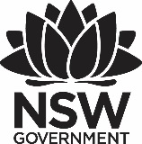
Premier’s Creative Arts Scholarship

Ceramics Revival
Melissa Grahovac
Colyton High School

Introduction
Ceramics appears to be going through a re-evaluation, often scorned as ‘craft’ and the ‘poor’ cousin of Art. Most schools teach ceramics within Visual Arts, some school offer the ceramics course, but many of the art resources and text books lack contemporary ceramic examples. Yet it is always so popular with students, mesmerised by its tactile quality. It can be poured as a slip, drawn, painted, glazed on, like paper or canvas, modelled, carved or assembled. The very nature of ceramics nature makes it a medium that can unify most students into a rewarding and valued learning experience.
The charm of ceramics has been felt in such important events as the last Venice Biennale and much of the contemporary art scene has revelled at the subversive and political ceramics by Barnaby Barford, Penny Byrne, Grayson Perry and Ai Wei Wei.
This return to material practice, craft and skill acquisition has been investigated in my travel opportunity. My study tour opportunity has provided me with the skills to critique and re-define the role of ceramics in case studies and programs to teach back in the classroom.

Focus of Study
The focus of my study tour was to investigate and support students and teachers in using clay creatively and confidently, optimising its educational value for students and creating sustainable local links and revitalising an ancient material and practice with contemporary art education. Whilst harnessing the rich history of clay, my tour focused on providing the opportunity to critique and re-define the role of this medium today.
With a combination of artist led workshops curators, artist and educator visits and interactions I aimed to use my study tour to reinvigorate one of the oldest materials in the classroom. The popularity of ceramics has risen with many artists turning to clay as the catalyst for their imagination, to articulate their ideas. Made of the earth and the artist's hand, ceramics has infiltrated the conceptually sleek, saleable aesthetics present in so much contemporary art. Clay has an innate truth, equally in touch with modern design and prehistoric fetish-objects. Sensory experience is essential to learning.
My study tour has nurtured a better understanding of ceramics in the 21st century, developing strategies and resources for study in the classroom that will benefit both teachers and students.

Significant Learning

22-25 March 2017 – Future Flux NCECA Conference Portland Oregon, USA
With 6,000 other clay aficionados I attended the Future Flux Conference that explored and celebrated clay’s expressive possibilities, dimensions and issues related to new sustainable practices. The focus of lectures, demonstrations, gallery visits and discussions centred on:
- How will more sustainable models of ceramic art and education continue to evolve?
- What are the essential competencies and capacities for ceramic artists and educators today and for the future?
- How can we continue to draw from rich historic traditions while reinvigorating their relevance in rapidly changing global societies?
The schedule of events was full with panels, workshops, live demonstrations, marketplace, resource fair, and 100 or so exhibitions staged at galleries, museums, schools, and art centres throughout the region.
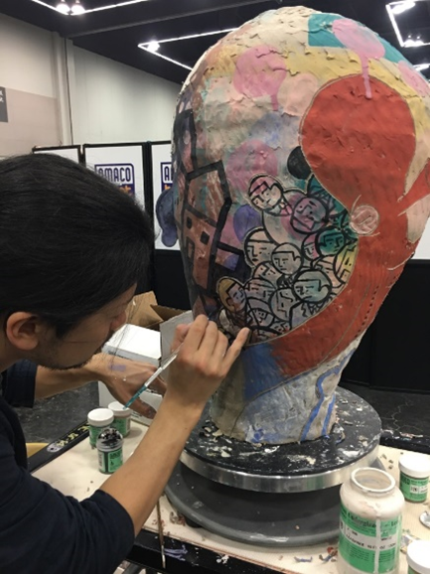
Figure 1: Live demonstration by En Iwamura at NCECA 2017 (Photo by Melissa Grahovac)
A keynote address by well-known and colourful art critic, Jerry Saltz, began the four days of learning and engagement. Saltz was humorous and solemn at times, but his talk was a severe reminder for artists to get back to work during these times of political uncertainty, to engage in art criticism, and to avoid getting bogged down by intentionality and labels. He advised the crowd: "Art is not about understanding. It is about experience." The days following the keynote were a full of activity. I attended some fascinating lectures and exhibitions which are already impacting positively in the classroom.
The National K-12 Ceramic Exhibition is an annual juried ceramic competition for Kindergarten through Grade 12 (K-12) students in the United States. Designed to showcase the best K-12 ceramic work made in the country, the exhibition takes place in a different city each year in conjunction with the annual conference of The National Council on Education for the Ceramic Arts (NCECA). It was a showcase of what happens when good teachers and students combine the ceramic process with their own creativity and imagination. Here in Australia, Clay Gulgong has just begun to exhibit K-12 ceramic works, and I will contribute to this exhibition after my time in Portland.
The Evocative Garden was a feature of the union of creativity and ceramics. The theme will influence a case study for a ceramics unit later in 2017/18. I will investigate the theme of nature and the environment, collaboration and sustainability with Stages 5 and 6 students. This exhibition, curated by Gail. M Brown referenced nature and gardens, real and imagined, ‘echoing the human need for sustainment and solace’.
The art department at the beautiful Lewis and Clark College was the host of five exciting exhibitions featuring some of the finest artists working in clay today.

Insights
- investigating rich social programs for communities that focus on empowering students in a variety of social situations
- allowing a deeper understanding of the complexities of practice and providing a richer understanding of ceramic techniques
One of my key areas of my study tour was to observe and examine how the material of clay could reach out to the community to start conversations about issues in contemporary culture. This exhibition featured artists who are expressing themes of the human condition reflected in social and political concerns of our time. The exhibition includes internationally recognised artists Arthur Gonzalez, Michelle Gregor, Marc Lancet, Richard Notkin, Mark Messenger, Lisa Reinertson, Richard Shaw, Ehren Tool, Monica Van den Dool, Stan Welsh, and Wanxin Zhang.
Imaginary Border: Ceramics as a Transcultural Language featured ceramics work by artists from Chile, the United States, Brazil, Jamaica, Japan, and Venezuela, who have contributed to the development of the Chilean Curaumilla Art Centre. For these artists, the centre serves as an invisible edge, where our humanity engages our spirit through learning, sharing, and creating art.

NCECA – ceramics art education and the classroom
Lectures such as ‘How to teach art for social justice’ and ‘The art of curiosity’ offered great insight into teaching conceptually challenging work and designing effective programs that teach art that makes a difference. Clay can be a powerful and engaging medium to bring about change, insight into the human condition, empathy and civic regard.
Jamie Moon uses visual arts as a tool in and out of the classroom to celebrate children who are at risk or endure the challenges of special needs. She shared experiences and techniques in many areas of visual arts to create a positive and empowering environment for all children in K-12 and beyond. Her lecture ‘Art and the Distracted Child’ was so relevant to my teaching craft and school. Engaging students creatively can teach problem solving as well as developing confidence and calm through art making.
‘Nature reimagined’ a lecture by Mary Carlisle has also been influential in developing ideas and concepts for a Stage 5 and 6 case study involving an artist study such as Georgia O’Keefe, photography and ceramics.
The emerging artists lectures on the final day were inspirational. Artists Jessica Brandl, Rachel Eng, Christina Erives, Brookes Oliver, Kate Roberts and Judd Schiffman shared their work and ideas with the audience. Rachel Eng’s work was both haunting, ephemeral and sublime. “I have yet to completely understand where my predilection for the repetitive stems from, but it is always present in my work. The process of making many small parts has become meditative, the way to work through unattainable knowledge or obsessive memories.” Rachel Eng
Jim Melchert, the legendary ceramist, educator, gave the closing lecture. He presented an emotional account of the value of the arts through his experience as a former director of its Visual Arts Program and challenged the audience to consider the ways in which ceramic artists relate to and differ from one another.
NCECA was instrumental for connecting with other art educators, artists, and students. Periscope led by my ceramics instructor in Tuscany was influential. It is a new way of learning techniques, watching someone, anywhere on the planet working with clay live in the studio. It is a way of learning/teaching and connecting and building a community. NCECA captured the spirit of the contemporary clay renaissance. It was a huge event and influential in my learning.

Galleries and workshops – New York
The Museum of Arts and Design (MAD) in New York offers a different gallery experience. The MAD Artist Studios Program is both a platform for creativity and an innovative model of engagement that has served more than 140 artists and designers. The studios are open to the public; the residents welcome dialogue around concepts, materials, and processes, and visitors are encouraged to spend time in the studios exchanging ideas. This is an exciting chance for museum visitors to meet working artists, and a remarkable opportunity for the residents to actively participate in the public’s engagement with their work. Meeting artists on the upper levels of this incredible museum watching them work and discussing material practice, provided a personal and very giving approach by the artists.

Clay Art Centre – New York
The Clay Art Centre has been serving ceramic artists and the community, providing studio space, workshops and exhibition opportunities for sixty years.
“Believing strongly that the arts has the ability to touch and enrich lives; Clay Art Centre’s mission is to offer a stimulating space for studio practice, exhibition and educational opportunities to better serve the community.”
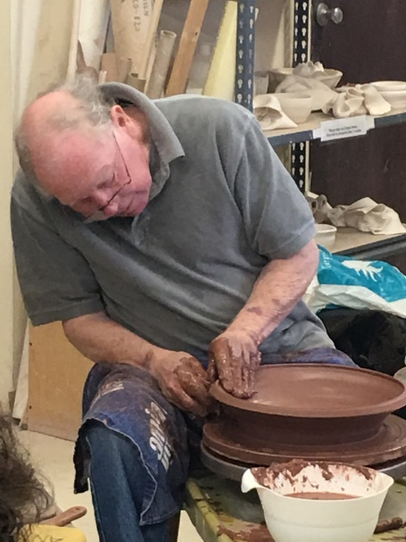
Figure 2: Ron Meyers (Photo by Melissa Grahovac)
I met with program manager Adam Chau and Executive Director, Leigh Taylor Mickelson who also joined the NCECA board as their Exhibitions Director. Chau had also presented a demonstration class at NCECA. The world of ceramics was becoming smaller and smaller on this study tour. Both staff members are practising artists and were extremely helpful in discussing community arts events, workshops and ceramic networks. The Clay Art Centre was founded in 1957 by Katherine Choy and Henry Okamoto, it is a nationally recognised non-profit centre for the advancement and practice of the ceramic arts, in Port Chester, New York.
The class I attended was by an icon of the American ceramics community, Ron Meyers. He has been ever present in the field of ceramics, serving as a judge for exhibits and participant in countless, workshops, demonstrations, and exhibitions, in both solo and group shows. Meyers makes tableware from a red earthenware body, all beginning on the wheel. Loose and casually thrown, his vessel forms reflect the soft material properties of clay, with his hand and finger marks present in every piece. His work is incredibly fresh with lively, narrative coloured slip paintings floating on the surface. He shared his thoughts on art, animals and human characteristics, while creating his paintings in his fluid and expressionistic style.

Florence, Italy
I flew from New York to Italy, where I was totally immersed in clay, namely terracotta and porcelain. Marco Polo described porcelain as a material that is beautiful beyond comparison. As Edmund De Waal in his book, ‘The White Road’ says, Porcelain is the Arcanum. It is a mystery. For 500 years no one in the West knew how porcelain was made.’
"The Way of Man between Art and Faith. From Ugo Guidi to Igor Mitoraj "is the title of the exhibition, inside San Lorenzo in the Donatello Salon. The life of Ugo Guidi crosses the century and his making follows the classic school, based on the sculptural tradition. With this artistic growth, his art is classical and at times abstract. Influences from Romanesque and Tuscan traditions, memories of Etruscan artefacts, Renaissance portraits and then the figures become more free and abstract.

Italian Inspiration and Italian Techniques
As an art educator and artist, my study tour has proved to be a source of stimuli. Seeing new things especially the antiquities makes your mind race with new ideas. The itinerary for the tour provided historical and contemporary visual inspiration as a valuable teaching and learning tool. The Italian term terracotta (“cooked earth”) refers to objects produced by sculpting clay and then firing it in a kiln at high temperatures to harden the material. During the Renaissance, terracotta was believed to be the oldest form of sculpture, invented in the ancient world.

La Meridiana-Certaldo -Significant Learning
La Meridiana was my final study destination. It is situated just outside Certaldo, Tuscany and is owned by Pietro Elia Maddalena. It began in 1981 as a summer school. It has become the most important private ceramic school in Italy because of its high standard of organisation and teaching and facilities
In this two-week workshop, ‘Nature and Tradition’ Adam Field and Heesoo Lee demonstrated methods of working that have led them to create distinctive, yet complimentary, bodies of functional and decorative work. Both Field and Lee share a love of nature and history while incorporating completely different sources, techniques and materials into their pots. He demonstrated his method of wheel-throwing porcelain vessels and carving intricate pattern on a variety of forms, using laser technology.
Lee shared her more intuitive approach from throwing, hand-building, and painting with porcelain along with her ideas about designing pots with specific slip and underglaze paintings. Field’s discussions about his time as a potter’s apprentice in Korea, personal aesthetics, and photographic journaling methods for the studio potter encouraged individual discovery, growth, and development of fresh ideas. Lee shared stories about her life and work from her early years drawing and painting on 2-D surfaces in Korea to her current exploration with underglaze painting on porcelain vessels.
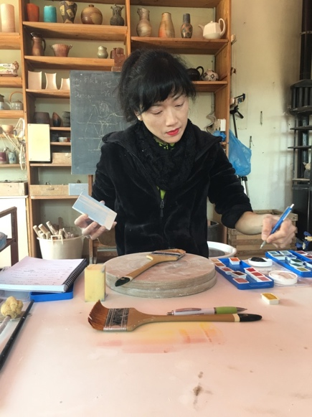
Figure 3: Heesoo Lee demonstrating her glazing technique (Photo by Melissa Grahovic)

There was a strong emphasis on informative discussions as a group and activities that would lead towards finding inspiration through personal exploration of one’s own practice both in and out of the studio. Being a student again and developing skills and confidence necessary to explore form, texture, line, and colour was invigorating. My own craft began to flourish and in two weeks my skill base improved and I made discoveries about techniques, about materials and personal expression.

Impruneta
Our class went on a day trip to Impruneta, a Tuscan town with a long and rich ceramics tradition such as fired brick production, dating back to the 1300s, and making relics and objects for villas, palaces and churches. Terracotta artefacts, glazed earthenware or majolica are produced in workshops and factories within the town itself.
We visited Mario Mariani’s workshop, which prides itself in tradition, using a wood fired kiln and making hand coiled traditional Tuscan pots. Watching him make these huge pots by hand was a real honour. He worked with precision and skill, owing to his talent and years of work. Our instructor Adam Field discussed the similarities between Onggi pots of Korea and the traditional Tuscan pot making techniques. Both are made from hand, moving around the pot backwards, paddled and coil construction.

Conclusion
Ceramics has been re-energized from the depths of the dusty, craft bunker. This study tour has exposed me to the new and exciting global clay studio, to explore the studio experience to see the cross section of styles, experiences and teaching of ceramics.
In 2003 Grayson Perry won the Turner Prize and fame was granted back to ceramics. It has always been there, entrenched in all cultural paradigms, from Aboriginal painting and body decoration to Tuscan potters, holy shrines and votive figures which are hidden high on the ancient walls, to challenging contemporary clay pieces.
Ceramics is under the ‘artworld’ spotlight with new stars reflecting the flashes of light. In Australia, Juz Kitson, Penny Byrne, Vipoo Srivilasa, Ramesh Mario Nithiyendran and the Aboriginal artist Pepai Jangala Carroll are capturing clay’s transformative and creative qualities. In Portland, Kirsten Scmick’s performance piece, with clay literally as the centre, the catalyst is a key component of a ritual that celebrates and embraces contemplation through repetition. It is an act of centering for the performer (artist) and it provides a meditative object for the viewer.
“People are looking to have their humanity reflected back at them,” said the veteran potter David Reid, a co-founder of KleinReid, a ceramics company in New York. “People are moving back from slick and stainless steel to something warmer.”
Just like the slow-food movement, ceramics and its innate earthy nature share a new gratitude of the hand-made, allowing for mistakes, proud of the artists’ hand mark. It is the new mindfulness in making, in its meditative qualities; as one NCECA educator titled it rather aptly, ‘muditations’. His lecture ‘Holding the earth in our hands’, reflected on the healing and spiritual qualities of clay and how students have been profoundly affected by working with clay. I see this first hand in the classroom setting, clay has a calming and meditative quality.
Travelling to the USA and Italy on my study tour has had a profound influence on my teaching and artistic practice. It was an experience of a life time. Summing up with words from Portland artist Matt Wedel, who has a passion for clay that began when he was a toddler: “From sculpture to craft, functional to frivolous, the potential of clay is both liberating and fecund,” Wedel explains. “It allows for the limitless interpretation that gives room and shape to the urgency of my imagination.”
I agree with Wedel’s words, I too believe in the power of the arts. This study tour is a potential starting point for art educators, students, and artists. It is not just the therapeutic qualities of clay, but also the challenge of the material and the intellectual rigour that the study of ceramics provides. For each art genre, style or interpretation, clay can simply transform and ignite the artist and art educators’ imagination and creativity.

Acknowledgement of Programs and Organisations

References
De Waal,Edmund The White Road, A Journey Into Obsession
The Budding Ceramics-to-Table Movement December 17, 2015, on Page D6 of the New York
NCECA The Evocative Garden 2017, Catalogue
The 20th Annual National K-12 Ceramic Exhibition, Portland

Websites
http://www.disjecta.org
http://nceca.net/2017-portland-future-flux/
http://nceca.net
http://www.k12clay.org/k12-ceramic-exhibition/index.asp
http://www.lameridiana.fi.it

Blogs
http://blog.nceca.net/nceca-emerging-artists-2017
https://www.jenniward.com/nceca-blog-evocative-garden/

Curatorial Statement, Gail M Brown, Curator of Contemporary Craft, NCECA The Evocative Garden, Disjecta, Contemporary Art Center, Portland Oregon 2017.
http://blog.nceca.net/nceca-emerging-artists-2017, Rachel Eng
https://www.clayartcenter.org/history-mission/
Edmund De Waal, The White Road, A journey Into Obsession, pg 10
http://www.deccanherald.com/content/521791/handmade-ceramics-white-hot-right.html https://www.artsy.net/article/artsy-editorial-20-artists-shaping-future-ceramics

