Premier’s Kingold Chinese Language Teacher Scholarship

Project Based Learning
  - A method for 21st Century Teaching/Learning
Ming Urwin
Abbotsleigh Girls An Anglican Pre K-12 School for Girls
Wahroonga
Sponsored by

Introduction
It is essential to redefine teaching methodologies because the world of learning is changing, and the world of leaners is also changing. What is 21st Century learning? Professor Machumu from Vrjie University in Brussel believes that it “is about knowing the world beyond the classroom wall. As we embrace technological innovations, learning requires education settings to teach the so-called labour-demand-driven skills by enforcing the use of technology to solving societal problem, imparting digital skills, employing e-learning and blended learning”. (Machumu 2014).
Others think that 21st Century learning is about the high “effectiveness, especially for the recruiting and training of teachers along with high standards in pedagogical skills which demands subjects to be treated in an interdisciplinary way, thus teachers have to be very flexible to keep up with the pace.” (Becker 2014)
In recognition of the evolving 21st century school learners’ needs, the NSW Education Standards Authority (NESA) released the NSW Syllabus for the Australian Curriculum which stated that ‘Learning Across the Curriculum, including the cross-curriculum priorities, general capabilities and other areas identified as important learning for all students. (NESA 2018). The aim of the study of language in K-10 is to enable students to communicate with others in the target language and to reflect on and understand the nature and role of language and culture in their own lives and the lives of others. (NESA 2018).
This acknowledges that textbook or topic driven teaching methodologies are no longer enough to cater for students’ needs and to achieve the desired outcomes stated in the new syllabus.
Understanding the significant impact of how students identify with their learning experience and engagement levels is the focus on Project Based Learning (PBL) as a way of bringing it all together.

Focus of Study
My interest in PBL has led me to research, develop and practise elements of it in my Chinese language teaching programs. I understand PBL to be essentially student-centred, giving students ownership and control of their own learning. PBL schools have no prescribed textbooks and teachers are facilitators. To further explore this method and observe examples of it in action and share insights on PBL with a range of fellow educators, I chose to visit seven elementary schools, four high schools and three universities in North America and China between the 26 November and 29 December 2017.
- High Tech High (HTH) (Chula Vista Campus) San Diego, California, USA
- HTH Junior and Elementary School (Chula Vista Campus)
- Pear Tree Elementary School, Vancouver, Canada
- Handsworth High School, Vancouver, Canada
- The Avenue World Bilingual School, New York, America
- Xin Hua Nan Lu Primary School, Tian Jing, China
- Hang Zhou Shi Xin Cheng Shi Yan Primary School, Hang Zhou, China
- Hang Zhou Shi Da Guan Primary School, Hang Zhou, China
- Beijing Shi Fan University, Beijing, China
- Beijing Gang Tie University, Beijing, China
- Shanghai Jiao Tong University, Shanghai. China

My aim was to see how these very different schools are applying PBL to create ‘opportunities for greater student engagement, for collaborative team work, for developing students’ critical thinking skills, for managing time and resources, for emphasizing global themes’ (Doehla 2011).
I also wanted to see how they have developed authentic assessments to evaluate students’ target language proficiencies.

This report provides information obtained through professional learning sessions at these institutions, focus-group discussions on language teaching methodologies, class observations and individual and group interviews with students and teachers. The report also provides information on sharing knowledge while on tour by giving demonstration lessons using PBL and Total Physical Response Method (TPR) to young students at several schools in China, and to a group of university students who are in the process of completing their Master of Education degrees at the Shanghai Jiao Tong University. The schools visited on the study tour could be categorised into three types - Project-based learning (PBL), Project-orientated learning (POL) and Service Learning Project.(SLP) PBL schools deliver the entire syllabus through projects. POL schools deliver contents through the combination of methods, with students at the end of the subject assigned to complete a project based on the knowledge acquired from the unit of work. SLP schools are using projects as an additional tool to help students develop empathy and understand the needs of others. This report focuses on significant learnings about PBL as an immersive methodology with practical examples.

Significant Learning

PBL and the real world connection

No prescribed textbooks, teachers as facilitators
Textbooks are a thing of the past for a couple of the schools visited, High Tech High (HTH), San Diego and Pear Tree Elementary, Vancouver.
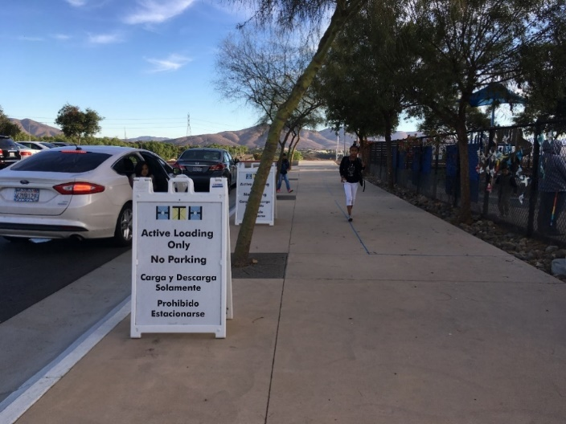

Figure 1: HTH San Diego (Photo: Ming Urwin with permission of HTH)

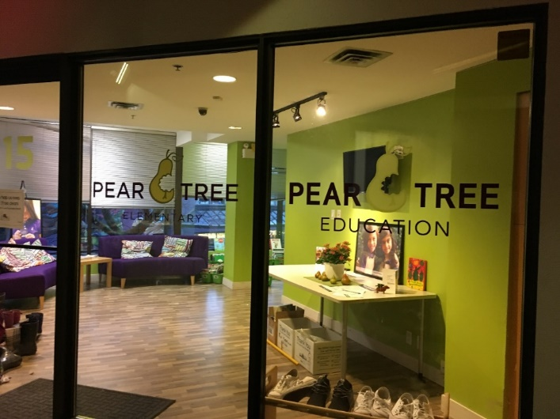

Figure 2: Pear Tree Elementary School, Vancouver (Photo: Ming Urwin with permission of Pear Tree)
Various comments were made by teachers at HTH when queried about textbooks. Most of them felt that the regimented textbook driven and exam driven style of teaching burns teachers out and the negative impact on students is even worse. How important is a textbook? How much should teachers reply on a textbook? At what level that it will impact the creativity on both teachers and students? Can the textbook driven curriculum design/program deliver the desired outcomes or cater for the diverse needs of students? I believe these questions are very important for teachers of NSW to consider when planning the units of work.
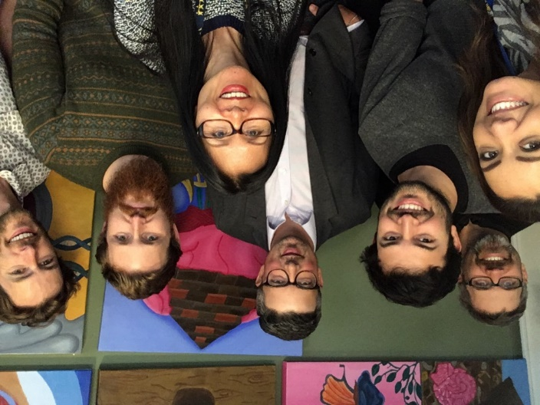

Figure 3: With HTH San Diego Senior Campus Teachers Discussion Group (Photo: Ming Urwin with permission from HTH)

Since all subjects are delivered in a multidisciplinary format, no single textbook can cater for the outcomes that relate to the real-world situations that PBL involves. For example: In humanity (English and history) and legal study at HTH, students study the legal system and the process of lodging the application and acting as a defendant team on behalf of ‘criminals’ who are currently in gaol and believe themselves to be wrongfully accused, seeking to overturn their case.
The prisoners put their name on the waiting list for the students’ legal team at HTH to research and examine his/her case by interviewing the applicant, then studying legal systems, lodging an application then offering a defence on behalf of their client at the local court. The team is guided by teachers and local legal professionals.
In projects like these, students learned about the legal system, the procedures, the appropriate language used, the communication skills, presentation skills, collaboration among their peers and also what it is like working as in the legal profession.
Students see the value of PBL
Projects I saw at HTH San Diego provided opportunities for students to engage in real life communication, in context, with real people, and across the globe. Students’ positive response to this was evident from informal interviews conducted with those doing PBL courses. They said:
It gave them a lot of freedom in learning and widens their interest and awareness of communities, both local and global. “To see our project helping to contribute to a better society makes us eager to learn more in order to help more” were the comments made by a group of Year 11 students at HTH.
As all the projects are related to the real audience, we feel like that we are helping the world by solving problems for example: we have so many Mexican people here, to build the awareness and understanding of another culture, we linked up with the country museum created the exhibition on what is like to be a Mexican living in San Diego. We interviewed them, produced a written story, video recorded the interview, collated and produced a book about them. These works were exhibited at the museum.” (Year 11 Students HTH San Diego,)
[PBL] allows us to do things that are interesting and fun. We’ve learned about the endangered animals, we get to research whichever one that we like, by finding out where do they live, why they are endangered, how we can protect them. We draft the information report, then in art class, we drew this animal, we all display our work. At the end of the project, we learned about so many different animals, we practised art and improved our writing skills.” (Year five students, at HTH Junior School, San Diego).
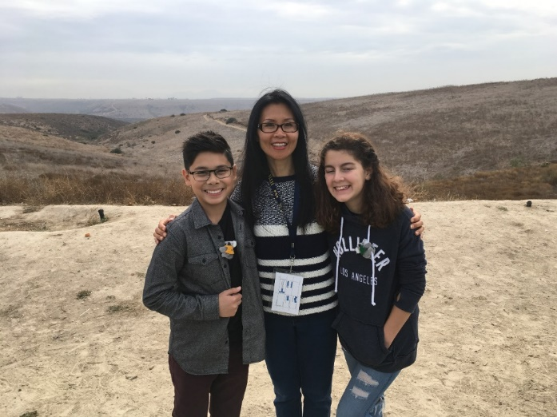

Figure 4: HTH Junior Campus San Diego with my school tour guides (Photo: Ming Urwin with permission of HTH)

PBL encourages higher-order thinking skills
PBL encourages the use of higher-order thinking skills which coincide with Bloom’s taxonomy hierarchical models of educational learning objectives: students to learn and be able to do. All projects were launched with a driving question, this question provides the breadth for students to explore and the depth for each to discover and to relate to him/herself. The learning objectives for the projects were clearly outlined at the very beginning and referred to throughout the completion process. The objectives are generally in one or two of the following three domains: Knowledge-Based, Skills-Based or Affective Goals orientated,
The driving question of the project ‘Health and Youth’ for Year 11 students at HTH was ‘What is the power that can help to overcome personal issues: physical or emotional?’ Through group discussions and openly sharing ‘what troubles him/her the most?’ with their peers, students felt empowered to deal with the issues raised. Based on the individual’s response student chose to research the ‘power’ that he/she believes that it could help them to overcome their issues. The students’ artworks displayed reflected the ‘power’ which can be the heart system, the function of the brain, the skin, the relationships, music or the community.
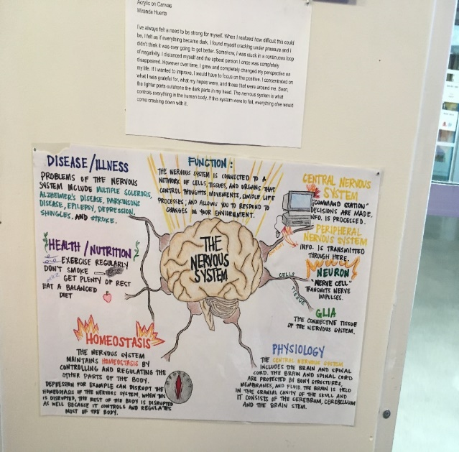

Figure 5: HTH Student’s Art Work for the project on Health and Youth (Photo: Ming Urwin with permission of HTH)

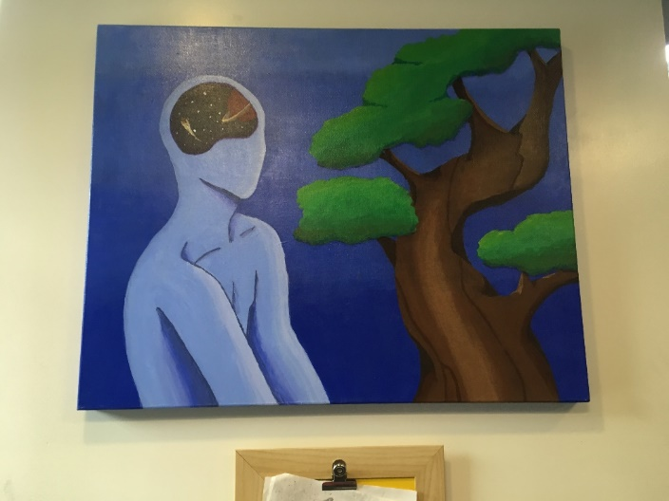

Figure 6: HTH Student ‘s Art Work for the project on Health and Youth (Photo: Ming Urwin with permission of HTH)

PBL giving students a voice and choice
Although all subjects were delivered through a multidisciplinary format, subjects like maths and Spanish require basic building blocks that are need systematic teaching/learning. To help children build the foundation for those disciplines, there was one period per day scheduled in the afternoon, that students have the freedom of choice. They can choose to learn the math fundamentals, Spanish grammar, or join various clubs including art, craft, music, sport. This freedom of choice allows students to pursue their own interests.
At junior level in HTH, however, maths is no longer being taught as a subject. Instead, it is called ‘MASH’ – Math, Art, Science and Humanity (English and history). All these elements are taught through projects.
Is it possible for schools at NSW to model the example by reducing the overcrowded timetables and giving students and teachers the freedom of choice for one afternoon per week, so that they can join a group, a class, or an activity to work and to collaborate with people (teachers and students) who have similar interests without age boundaries? Are there possibilities for NSW junior schools to trial the method of delivering outcomes cross curriculum?

PBL is a great tool for differentiated learning
Second language acquisition in PBL is taught with other subjects. For example, Spanish as a second language was delivered in the humanity (English and history) domain at HTH. Based on students’ language proficiency, they were grouped to ensure each has at least one background speaker, and one or two intermediate students as well as beginners. These groups were organised by teachers at the beginning of the year, and throughout the year students regroup by themselves, according their interests and level of Spanish.
In projects like Introducing Self and Families, the fluent speakers wrote passages, the middle level students made a PowerPoint with sentences, while the beginner students wrote simple phrases about themselves and their families. Students use various online tools to translate and to discover new phrases, and the higher level students acted as peer support by correcting pronunciation and spelling.
PBL and formative assessment
PBL immersive schools have no summative assessments at the end of the semester. Instead, students were given many small quizzes throughout the term to help them to reflect on the progress they have made, so they can seek help if needed.
What they do have in the system at HTH and Pear Tree Elementary, for example is called Presentation of Learning. At the completion of the project, the POL will be conducted before a real audience including: parents, classmates‘ parents, peers, teachers and sometimes industry representatives. All the people present at the session are invited to give constructive feedback at the end of each presentation.
No student has ever failed a subject; however, if they didn’t put enough time and effort into their course work, he/she will be given another chance to work on the task, then re-present it. The belief at HTH and Pear Tree Elementary is that summative assessment is too narrow and standardised and does not reflect the individual student’s achievement and capability. They believe that students can acquire the curriculum content they need through projects, without letting the test dictate the curriculum.

Applying PBL in second language teaching/learning
I saw that using the PBL pedagogical approach to second language acquisition has exceptional advantages. It can cater for different language levels and abilities of learners and motivates students as they are involved in projects related to real life situations. The opportunity to show their knowledge, skills and special talents on the great variety of topics in a wide range of forms at the end of the project makes the learning process more engaging.
Projects-based teaching became a topic theme during French lessons at Pear Tree Elementary, Vancouver. The themes like ‘Making a Restaurant Menu’; ‘Introducing Yourself and Families to a Pen-pal; ‘Murder Investigation’; ‘My School’ are used to deliver the contents in the syllabus.
Students are always organised at the beginning of the year by the teacher to ensure that each group has a combination of mixed language levels and abilities of students, so they can work collaboratively to complete the project. Since projects are multi-skilled, activities are focused on topics or themes rather than specific language targets. The initial choice of subject matter, the methods, the timetable and the eventual project product are at the students’ discretion. They concentrate their efforts and attention on reaching an agreed goal, providing students with opportunities to recycle known language and skills in a relatively natural context. In this approach rather than “learning to use the target language”, students “use the language to learn it” (Collier 2017).
Limitations
In discussions with the second language teachers at HTH and Pear Tree Elementary, it was apparent that although PBL is great for differentiation and fostering interests, it’s lacking in helping students to establish a solid foundation, especially for the beginner students. Language is like maths, certain building blocks need to be laid as a foundation to expand the knowledge.
Dr. Conti in his book The Language Teacher toolkit pointed out several pitfalls in the PBL paradigm for L2 acquisition. One of the disadvantages “is the relative lack of control the teacher has over the language the students will process receptively and produce”. They may be creative, however “by insufficient recycling of phrases” (Conti 2016), students will not remember much.
To overcome these pitfalls, a set of core target language as building blocks need to be planned carefully for students to recycle throughout the project to ensure the linguistic outcomes have been achieved. It is also necessary to permeate the formative assessment throughout the whole process of the project to warrant the linguistic acquisition.

Sharing professional knowledge
Sharing professional knowledge and skills formed part of this study journey for the second half of the tour in China. I delivered lessons to primary school children while being observed by teachers of a second language, followed by group discussions or Q & A sessions to reflect on practices and to learn from each other. Using game based activities helping students to practise and to memories new phrases; using total physical response method to engage students with movement and body language; using songs and rhymes to make learning interesting are among the many methodologies that displayed in my demonstration lessons.
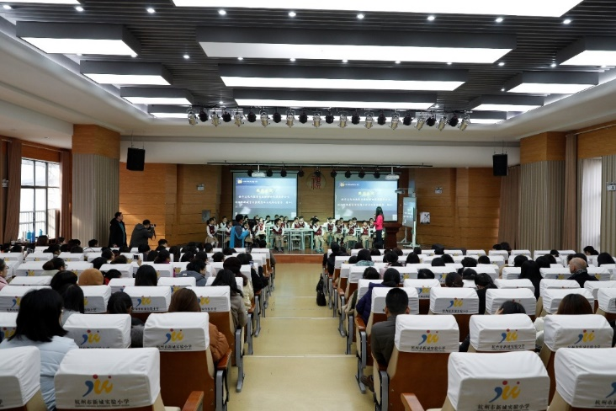

Figure 7: Teachers from 25 schools in Hang Zhou observing a demonstration lesson onstage (Photo from – Hang Zhou Shi Xin Cheng Shi Yan Primary School, with permission to use)

Figure 8: Demonstration lesson on stage (Photo from – Hang Zhou Shi Xin Cheng Shi Yan Primary School, with permission to use)

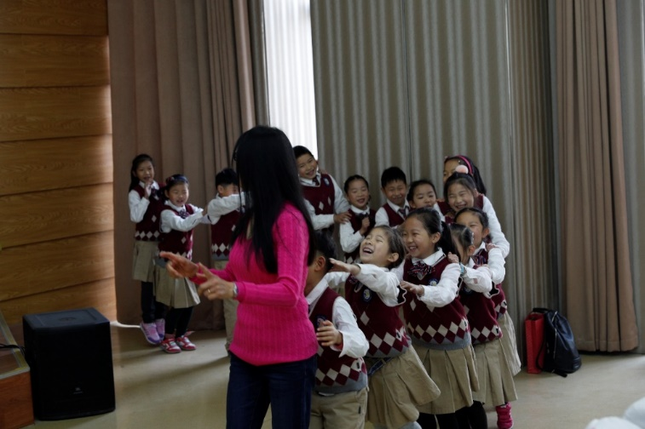

Figure 9: Demonstration lesson on stage at Hang Zhou (Photo from – Hang Zhou Shi Xin Cheng Shi Yan Primary School, with permission to use)

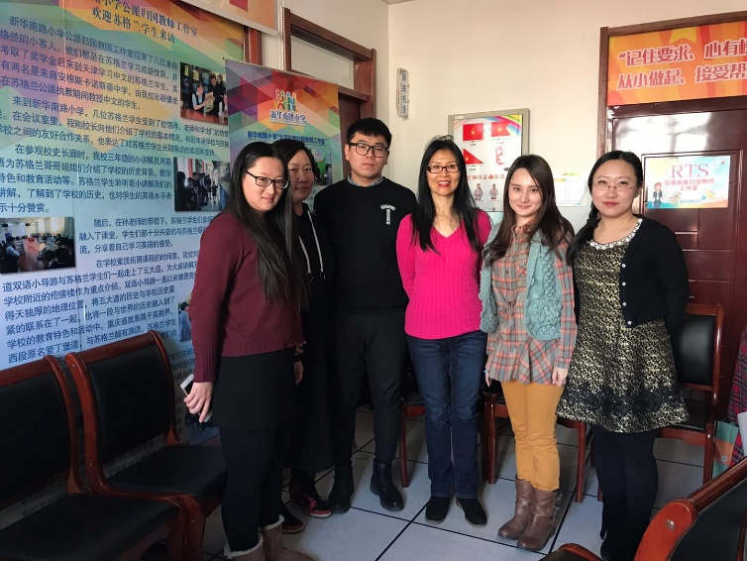

Figure 10: Focus group at Xin Hua Nan Lu Primary School Tian Jing, China (Photo from – Ming Urwin with the permission to use from teachers in the group).

Conclusion
There are always those adventurers in education who are wanting to push the frontiers of what passionate belief in what schooling should and could be like. It is such people who have always found ways to unlock the future for many youngsters who would otherwise spend their lives realising only a fraction of their potential (Brighouse 2006).
The study tour showed me that the PBL methodology has great potential for teaching/learning in all subjects including second language acquisition. It can foster a wide range of skills, such as time management, collaboration, creativity, researching and problem solving that students need at the university and in the workforce. Well designed and implemented projects are excellent tools for differentiation that can be tailored to suit students with a wide range of abilities and learning needs. Projects that are linked to the real world, helping real people, solving problems and contributing to society are essential elements to be considered in the designing process. It is vital for teachers to collaborate by brainstorming ideas, discussing whether it will help students to achieve the desired outcomes, modifying along the way, before launching. It is also necessary to involve students in the designing process. Students’ reflection and feedback will form the relevant input for future projects.
Since my study tour, I have created and implemented many projects in my teaching practice. Many of them were welcomed by teachers at AISNSW (Association of Independent Schools NSW) professional learning session where I did my presentation on PBL for differentiated teaching/learning. More opportunities to share at 2019 CLTANSW (Chinese Language Teachers Association of NSW) annual conference as well as MLTA’s professional learning sessions.

References
Doehla, D., 2011. Using Project-Based Learning to Teach World Languages. [Blog] Edutopia. Available at: https://www.edutopia.org/blog/world-language-project-based-learning-education-curriculum-don-doehla

Machumu, H., 2014. What is 21st Century Learning. [Blog] ResearchGate. Available at: https://www.researchgate.net/post/What_is_21st_century_learning

Becker, D., 2014. What is 21st Century Learning. [Blog] ResearchGate. Available at: https://www.researchgate.net/post/What_is_21st_century_learning

NSW Education Standards Authority, 2018. NSW SYLLABUS FOR THE AUSTRALIAN CURRICULUM CHINESE K-10 SYLLBUS. NSW Sydney, p.11, 13.

Collier, L.D., 2017. Using a Project-Based Language Learning Approach in the High School Spanish Classroom: Perceived Challenges and Benefits. ed. Utah: Brigham Young University, p.5.

Brighouse, H., 2006. On Education Thinking in Action. ed. London: Routledge, p.18.

Conti, G., Smith, S., 2016. Language Teacher Toolkit. ed. UK: Amazon.co.uk, p.18.

