Premier’s Anika Foundation Youth Depression Awareness Scholarship

Dialectical Behaviour Therapy (DBT) in Schools.
A proactive, Multi-Tiered System of Support.
Emma Sue San
School Counsellor, Redbank School, NSW Department of Education
Sponsored by
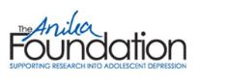

Introduction
According to the Living Well Strategic Plan (NSW Mental Health Commission, 2014), school-based social and emotional learning programs are extremely effective in the prevention and early intervention of mental health issues in adolescents. Implementing empirically supported programs such as Dialectical Behaviour Therapy (DBT) skills training within the school setting can help support adolescents by educating them in adaptive strategies to improve mental health and reduce self-harm and suicidal behaviour. DBT is an effective intervention for young people who self-harm or make a suicide attempt as a result of mental health issues such as depression (Headspace, 2017). DBT is a cognitive behavioural treatment that integrates four core skills including: mindfulness, emotional regulation, distress tolerance and interpersonal effectiveness (Williams, 2010) and it has been adapted for self-harming and suicidal adolescents as well as mainstream student populations (Brausch and Girresch, 2012).

DBT Skills Training for Emotional Problem Solving for Adolescents (DBT STEPS-A) is a program specifically designed for adolescents to develop their emotional management, interpersonal and decision-making skills (Mazza et al, 2016). This program is designed to be run within the school setting by teachers in collaboration with wellbeing staff such as school counsellors. Such programs can reduce stigma towards mental health issues by providing school staff and students with a common language and shared understanding of how to manage when their emotions begin to escalate.

Focus of Study
How can school communities proactively promote the wellbeing of their students through implementing evidence-based social and emotional programs to decrease the risk of students developing depression and suicidial behaviour?

This study tour involved visiting internationally recognised leaders and practitioners of DBT in New Zealand, USA, Ireland and England, to observe how DBT skills are currently being implemented within schools overseas. A multi-tiered system of support was explored to inform development of DBT skills based program that can be implemented into NSW mainstream high schools to target student mental health and proactively prevent self-harm and suicidal behaviour. This model explores the application of DBT in schools through DBT skills groups, individual DBT therapy and engagement with community support teams who are implementing comprehensive DBT. This research also aims to promote the use of DBT within the school counselling community so that individual school counsellors can support their students who are already experiencing mental health difficulties.

Significant Learning

Multi-Tiered System of Support – DBT applied to the Australian context
It is fundamental to co-ordinate both Health and Education Department initiatives for effective intervention. As community mental health teams are already using DBT intervention, it is logical that schools adopt a consistent approach to support students in prevention of and intervention in mental health issues.

Schools in the USA such as Lincoln High School in Portland, Oregon, have estabilished the implementation of a multi-tiered system of support grounded in DBT. This model involves providing DBT skills and support to all students, with a variety of programs based on need. These schools successfully implement a universal program of DBT Skills in Schools – Skills Training for Emotional Problem Solving for Adolescents (DBT STEPS-A) for Tier 1 students (non-clinical populations in mainstream high school). Tier 2 students (those with developing mental health problems) received targeted individual school based DBT – a model of therapy. Tier 3 students (those with significant mental health problems) received a full model of DBT including individual and group sessions, in crisis counselling as well as parent groups delivered by the school based school psychology departments. Due to differences in the USA and Australian systems (such as time/caseload demands of school counsellor/psychologists), the following model has been devised for effective application to the Australian school context.

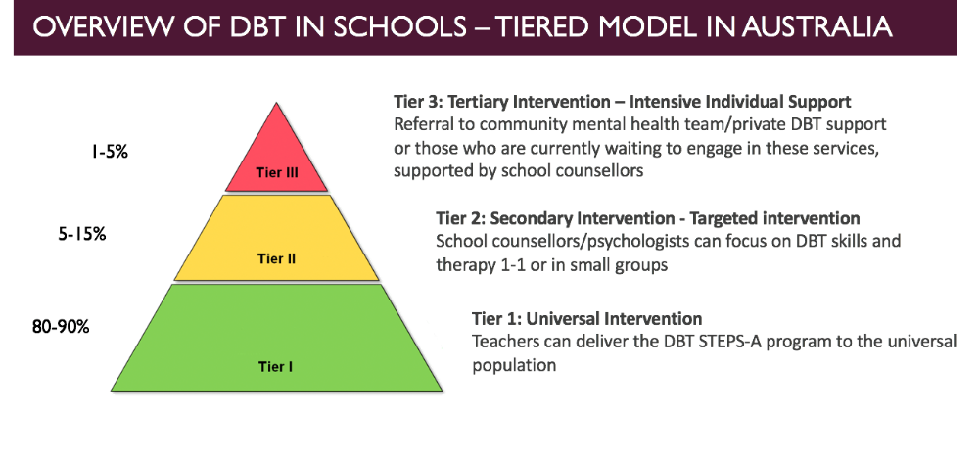
DBT Multi-Tiered System of Support – Application in Australian Schools
DBT Multi-Tiered System of Support – Application in Australian Schools
Percentage | Tier | Tier Description
80-90% | Tier 3 | Universal Intervention – Teachers can deliver the DBT STEPS-A program to the universal population
5-15% | Tier 2 | Secondary Targeted Intervention – School Counsellors/psychologists can focus on DBT skills and therapy 1-1 or in small groups
1-5% | Tier 1 | Tertiary Intensive Individual Support Intervention – Referral to community mental health team/ private DBT support or those who are currently waiting to engage in these services, supported by school counsellors

Tier 1: DBT Skills in Schools (DBT STEPS-A Program)
DBT Skills Training for Emotional Problem Solving for Adolescents (DBT STEPS-A) is a program specifically designed for adolescents to develop their emotional management, interpersonal and decision-making skills (Mazza et al, 2016). This program is designed to be run within the school setting by teachers supported by wellbeing staff such as school counsellors/psychologists.

DBT STEPS-A focuses on proactive skill development and consists of four core modules; Mindfulness, Distress Tolerance, Interpersonal Effectiveness and Emotional Regulation. Kelly Graling, Clinical Psychologist and Director of Consultation Services at Cognitive Behavioral Consultants based in White Plains, New York USA, uses the following guide when describing the modules to teachers:

- Distress Tolerance
  - Teaches skills for making distress endurable, so that an upsetting situation is not made worse by an impulsive action
  - Important for students who act impulsively
- Emotional Regulation
  - Teaches skills for decreasing unpleasant, distressing emotions and increasing positive emotions
  - Important for students that are commonly up and down in mood
- Interpersonal Effectiveness
  - Teaches skills for asking for something or saying no to another person, while maintaining a good relationship and self-respect
  - Important for students who have difficulty keeping and maintaining friends or difficulty setting limits with friends
- Mindfulness
  - Teaches skills for increasing self awareness, becoming less judgemental, and gaining control of one's attention
  - Important for students who have trouble shifting from negative thought, maintaining focus and have limited awareness

Mazza et al (2016) have manualised DBT STEPS-A providing lesson plans, scripts and resources to assist teachers to deliver this program effectively. This program has been designed to be run over approximately 30 weeks (one class per week) taught in 50 minute blocks. The curriculum and pace is flexibile to adjust for the learning needs of your students.

Brausch and Girresch (2012) indicate that there is a link between self-harm and both emotional dysregulation and distress tolerance whereby those who engage in self-harm often do so to alleviate overwhelming negative emotions. Through explicit teaching of strategies to tolerate distress and regulate emotions, adolescents can enhance their wellbeing and prevent the use of maladaptive strategies such as self-harm or suicidal behaviour. DBT STEPS-A explores real life issues and provides a scaffold of strategies and skills that students can utlilise to adequately manage difficulty situations and feelings.

The short term goals of DBT STEPS-A for Tier1 students is to teach students a set of skills to apply to their own personal situation and to provide ongoing support during this skill development. Long term goals include students practising skills so they become automatic and can be generalised across different environments. Thus, teaching students skills to manage distress, can help them to generalise these skills when they are in crisis (Hanson and Mazza, 2014).
Another vital component of DBT in schools is the necessity to have weekly consultation meetings. Kelly Graling (Clinical Psychologist and Director of Consultation Services, CBC Consultants) indicates that these meetings are important as it gives the DBT facilitators a forum to “practice what they preach” and apply DBT skills to their work. Members of this meeting commonly include all teachers who are facilitating DBT STEPS-A groups, school psychologists/counsellors and executive members of staff.

Within these meetings, the team starts with a mindfulness activity, discuss their own burnout ratings and self care strategies the team members need support with, and then the members are asked to submit (ahead of time) agenda items that they would like to talk about. They also identwhat they need support with and how long they expect to talk for and the urgency (1-5). An example agenda item could be “A. Smith, 16yrs old, Need problem solving support for therapy interfering behaviour – 15mins, 4=urgency”. The group then collaborative discusses the issues at hand to support the DBT practitioner. This is supposed to be brief and very succinct so ideally members would offer a short context to the case and then ask the team directly what exactly what support they want from the team.. Although time is a precious commodity for both teachers and school counsellors/psychologists, such meetings are fundamental in supporting teachers to problem solve difficult group dynamics, as well as monitor and support each team member’s self care.
The Wellbeing Framework for Schools (2015) represented a commitment by the NSW Department of Education to support the cognitive, physical, social, emotional and spiritual needs and development of our young people. In support of this framework, DBT skills based schools programs can promote awareness of depression and develop education and skills for adolescents and school communities to cultivate wellbeing. A school based mental health initiative such as DBT STEPS-A, can create a community of shared knowledge about mental health issues. This proactive, universal initiative focuses on making “wellness” a school wide mission and not just the job of the school counsellor/psychologist. Due to the manualisation of this program, teachers are also explicitly taught the necessary language and skills required to support their students who are in distress. Furthermore, the universal application of this program will assist in upskilling students to further support their peers who are at risk of using maladaptive coping strategies. It is normative for adolescents to confide in their peers more readily than adults or school staff and thus delivering such a comprehensive program can ensure that students are explicitly aware of empirically supported adaptive coping strategies. Thus, by providing a universal program of DBT STEPS-A, we can not only target students at risk but we can target students who are supporting their friends who are at risk.

Tier 2: DBT and School Counsellors/Psychologists
The next level of support in the Multi-Tiered System of Support is Tier 2 for students who are achieving far below their potential in school due to emotional interference such as depression, anxiety, substance abuse etc. (Reches, 2014). School counsellors/psychologists can work directly with these students in individual or small target groups to apply DBT skills and strategies to support the decreased engagement of maladaptive target behaviours. This is a more individualised application to DBT. Lizz Dexter-Mazza (one of the authors of DBT Skills in Schools, 2016) discussed the importance of determining goals with our students to ensure we make our work with them relevant. By identifying the goals of our students, we can more easily identify target behaviours. Lizz Dexter-Mazza advocates the following method to determine goals:

- Is a skill deficit or performance deficits?
- Skills Deficit = they do not know how or what they can do to help themselves.
  - Therefore, we need to upskill our students as to how to manage eg. Teach them specific DBT skill.
  - For example astudent has an urge to self-harm and has not been taught how to manage this distress
- Performance deficit = they know what they are supposed to do but have trouble doing it.
  - Therefore, we need to help them use the skill and generalise it to a difficult situation
  - For example, a student has been taught distress tolerance strategies however has difficulty using these strategies when they escalate.
- Skills generalisability
- Can the skill be used in some environment? What is different in those situations?
- We need to consider where the student is able to use the necessary skill and where they need assistance in transferring the skill.
- We can model correct use of the strategy through role plays to practice generalising the skill
- Contingency problem
- Decrease negative reinforcers
  - For example a student harms self and discloses the harm, consequently gets to come to the counsellor’s office
- Increase reinforcements

This scaffold can inform sessions and therapy goals for students and their school counsellor/psychologist and clarify the direction of individualised therapy. In addition, these goals can be monitored by DBT diary cards. An example of a diary card is shown below.

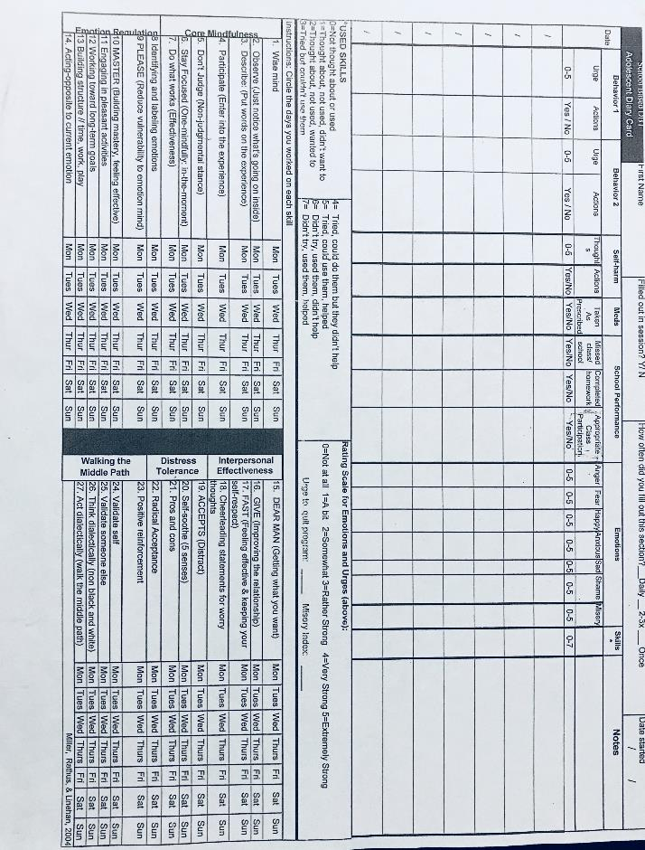
Adolescent Diary Card (Rathus and Miller, 2015)

It is common in DBT to use diary cards, where students can self-rate their urges and actions (of their target behaviours) each day. On such cards, there is a section to indicate which skills you have practised. This allows students to reflect on which DBT skills they have used and what they found helpful to manage distress.

Within this support level, the school counsellors/psychologists and student also explore behaviours through chain analysis, where the maladaptive behaviour is analysed to examine its cause and how that behaviour is maintained. A chain analysis examines one specific event. For example, if a student commonly leaves class, we focus on the time they left class today. It is then possible to do a chain analysis for other times (individually) and then look at patterns if necessary.

DBT Chain Analysis (Turner, 2013)

Elements of a hain Analysis
- Vulnerability factors
  - We can consider what made the student more vulnerable at that time eg. no sleep, recent fight, sick, recent loss, anniversary of loss
- Prompting event
  - The actual event that set off a chain of events
- Problem Behaviour
  - Very specific details about the behaviour
    - Time and date
    - What exactly happened
- Consequences of Behaviour
  - Immediate punisher or reinforcer
    - For example. emotional release, left school grounds
  - Long-term punisher or reinforcer
    - For example. missed classwork and feels more behind
    - Associated emtions examples; shame and guilt
- Other key links
  - Thoughts
    - What was going through their mind?
  - Emotions
    - How they were feeling?
    - Rate emotions on scale 1-10
  - Sensations
    - What they were feeling?
    - Bodily sensations eg. heart racing, stomach tighten, felt nauseous
  - Urges
    - Urges that they had (but not necessarily acted on)
    - For example to cry, to fight, to scream?
  - Behaviours
    - What the student actually did
  - Other people’s actions
    - What did they say/do?
Students in Tier 2 can also be supported by mobile phone apps to assist in the generalisation of DBT skills at home. Calm Harm by Stem 4 was developed by Dr Nihara Krause, Consultant Clinical Psychologist based in London, England. As students in England do not have as easy access to school psychologists/counsellors, this app was developed to help students ‘ride the wave’ of distress so that they can resist and manage urges to engage in unhelpful behaviours. Calm Harm has been developed based on the principles of DBT and has functions within the app to help adolescents experience comfort, distraction, expression, release and breathing exercises. Such apps can be used with Tier 2 students to reinforce strategies discussed in individual sessions.

Tier 3: DBT and Community Psychological Teams
The next level of support, Tier 3, is for students who are in need of external treatment for mental health problems such as self harm, suicidal ideation etc. Adolescent Community Health Teams including Prevention, Early Intervention and Recovery Services (PEIRS) are already using DBT, in both group and individual applications to support our young people. There is a clear opportunity for schools and health services to work together to provide holistic continuity of care and support for those at risk and those experiencing mental health issues through a shared understanding and language about distress and effective coping strategies. Within this Tier, students may be engaged in DBT Individual or Group therapy through a Community Health organisation and teachers can support the generalisation of DBT skills in their schools and classrooms.

Conclusion

Due to the continuing rise of suicide and mental health issues in adolescent populations, it is imperative that schools continue to focus on supporting the wellbeing of students. Evidence suggests that school based universal programs and interventions are effective in the prevention and intervention of mental health (Mission Australia, 2017). A multi-tiered system of support grounded in (empirically supported) DBT skills and theory can provide our students with the support they need to effectively regulate their emotions, tolerate distress and nagivate interpersonal relationships.

School based interventions such as DBT STEPS-A can assist in destigmatising mental health issues and provide whole school communities with a shared understanding and language about mental health. These teacher led programs can support students in the prevention of mental health issues through explicity teaching of social, emotional and distress tolerance skills. Such programs can also assist peer-to-peer support and upskilling of teachers in the support and management of mental health related issues. Redbank School (SSP) and Cumberland High School (Mainstream) have commenced the implementation of DBT STEPS-A and are excited to be proactively supporting the wellbeing of their students. Many school counsellors around Sydney have had access to DBT Skills in School workshops and a growing number are interested and willing to implement such programs in their schools. Further research would be beneficial to explore the application and effectiveness of this program in the Australian context.

Acknowledgements
It is with the deepest gratitude that following people who kindly gave their time are acknowledged:
- Dr Lizz Dexter-Mazza: Co-owner of Mazza Consulting and Psychological Services
- Dr James J. Mazza: Professor in the College of Education at the University of Washington, Co-owner of Mazza Consulting and Psychological Services
- Dr Alec L. Miller: Clinical Professor of Psychiarty and Behavioural Sciences at Montefiore Medical Centre of the Albert Einstein College of Medicine, Bronx NY
- Jim Hanson: School Psychologist, Lincoln High School, Portland, Oregon USA
- Kelly Graling: Clinical Psychologist and Director of Consultation Services, CBC Consultants NY, USA
- Mary Atkins: Psychologist, National Educational Psychological Service, Cork, Ireland
- Dr Nihara Krause: Consultant Clinical Psychologist and Director of Stem4

References

A.L., Rathus, J.H., Landsman, (1997). DBT Multifamily Skills Training for Suicidal Adolescents. Adapted from Marsha M. Linehan’s Skills Training Manual for Treating Borderline Personality Disorder. Guilford Press, 1992.

Brausch, a. M., & Girresch, s, k. (2012), ‘A review of empirical treatment studies for adolescent nonsuicidal self-injury’, journal of cognitive psychotherapy: an international quarterly, vol. 26, no. 1, pp. 3-18

Flynn, D., Joyce, M., Weihrauch, M., Corcoran, P., Gallagher, E., Claire O’Sullivan., & Hurley, P. (2017) Dialectical Behaviour Therapy – Skills Training for Emotional Problem Solving for Adolescents (DBT STEPS-A): Pilot Implementation in an Irish Context. Retrieved from https://www.hse.ie/eng/services/list/4/mental-health-services/connecting-for-life/publications/dbt-steps-a-report-on-the-pilot-implementation-in-ireland.pdf

Headspace (2017). Understanding Self Harm for Health Professionals. Retrieved from: https://headspace.org.au/health-professionals/understanding-self-harm-for-health-professionals/

James Mazza and James Hanson (2014). Dialectical Behavior Therapy in Public Schools. Retrieved from: http://slideplayer.com/slide/8891219/ on 19/2/18.

Mazza J.J, Dexter-Mazza, E., Miller, A. L., Rathus, J.H & Murphy, H. E. (2016) DBT Skills in Schools, Skills Training for Emotional Problem Solving for Adolescents (DBT STEPS-A). Guildford.

Mission Australia (2017). Youth Mental Health Report, Youth Survey 2012-2016. NSW.
NSW Department of Education and Communities (2015). Wellbeing Framework for Schools. Sydney, NSW.

NSW Mental Health Commission (2014). Living Well: A Strategic Plan for Mental Health in NSW. Sydney, NSW Mental Health Commission.

Reches, F.P. (2014). Dialectical Behavior Therapy in the School System. The Association of Student Assistance Professionals of New Jersey. NJ

Rathus, J. H. & Miller, A.L. (2015) DBT Skills Manual for Adolescents. Guilford Publications, New York (NY)

Rathus, J.H., Miller, A.L. (2002). Dialectical Behavior Therapy adapted for suicidal adolescents. Suicide and Life-Threatening Behavior, 32(2), 146-157.

Turner, S. (2013). DBT in Three Months. Retrieved from http://dbtin3months.blogspot.com/2013/05/dbt-behavior-chain-analysis-checklist.html

