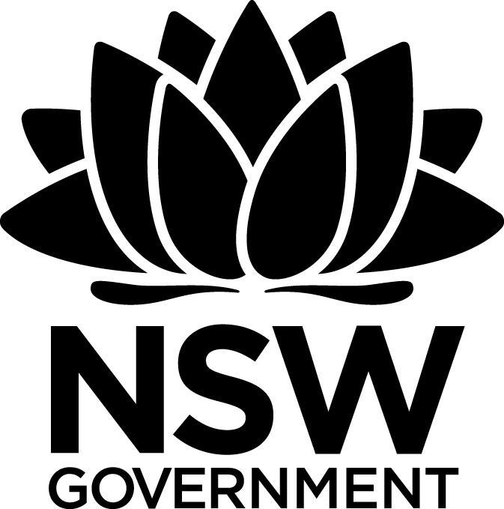
2017 Premier’s HTA History Scholarship

Approaches to teaching Indigenous Histories
Kathleen McDonogh
Kincumber High School

Introduction
Professor Richard White of Stanford University described a typical activity conducted by teachers in Californian classrooms, where students build Spanish monasteries using pasta sheets.
He believed that, for many students, this was as deep as early colonisation history of the West Coast got. They might learn a bit more about the East Coast, a lesson or two on the significant early encounters between Native Americans and Europeans, but the consideration of Indigenous histories is inconsistent and largely sparse beyond that. Professor White’s assessment of the situation in the United States certainly encouraged me to reflect on our approaches to teaching Indigenous histories in NSW.

Focus of Study
The focus of my study tour was an examination of the ways that the history of Indigenous peoples, particularly during the contact and colonisation period, is taught in schools in Canada and the USA. Many teachers around Australia are doing fantastic things with their students and in many respects my study tour confirmed this. I hope that some of the activities to be explored will add to the pool of teaching and learning strategies that already support students to develop an understanding of Indigenous histories.

Significant Learning
From the first stop on the study tour to the last stop, the importance of tapping into local histories was raised. Teachers and students who were most engaged in the exploration of Indigenous histories were exploring the topic through local case studies. This was very clear in the state of Arizona, where local sights abound. As in Australia, National Parks services provide excellent resources and opportunities for students to engage with local history. The Museum of Northern Arizona in Flagstaff, the Tusayan Museum and archaeological site in the Grand Canyon, Walnut Canyon National Park Archaeology Site and the Navajo National Monument were all incredible sites equipped for small school group tours. Unfortunately, the teachers and professors I met with in Arizona were, like Professor White, concerned about the state of history education in the USA.
The next stop after Arizona was Colorado. My visit with Denise Wasik, a primary school teacher at Eagleview Elementary School in Denver, provided a valuable opportunity to see a Grade 4 class explore the Sand Creek Massacre. Conversations with the students about the Sand Creek massacre have reminded me that the sad event presents an interesting case study to explore when examining the Myall Creek Massacre.

Whilst in Colorado, I had the privilege of discussing an engaging learning activity with Professor Patricia Nelson Limerick, Faculty Director at the Centre of the American West. The activity Limerick outlined involved using primary sources to challenge preconceived ideas about interactions between Indigenous and non-Indigenous peoples. This exercise reveals a diversity of experiences during the contact and colonisation period to students.
As the tour of the United States progressed, it became apparent that local museums and cultural centres within schools play a vital role in engaging students with Indigenous histories. During my time in Lander, Wyoming, I visited many schools on the Wind River Reservation. The practices within each school specifically related to educating a mostly Indigenous student population. Both Fort Washakie Elementary School and Wyoming Indian Elementary School integrate Indigenous histories and cultural traditions in many different ways. At both schools, for example, feathers are awarded to students to acknowledge achievement. Various verbal instructions, signs and posters displayed around the schools contain both English and Indigenous languages and symbols to help continue the use of Indigenous languages amongst the younger generations.
The school curriculums also contain unique cultural experiences for students. At Fort Washakie I visited with a Shoshone teacher, George Abeyta, who was looking at Aztec history with his students. When asked how he teaches Native American history, George walked me down to the school’s Culture Centre where he introduced me to Zedora, who is his mother and centre director. He explained that it is common practice in their community to consult elders for information on history and culture. This experience reminded me of the importance of consulting Aboriginal education specialists and groups within the school and wider community.
At Fort Washakie, students are often brought down to the cultural centre for talks with elders and lessons in culture. The centre primarily contains material relating to the Eastern Shoshone and the Northern Arapaho Tribes, as well as material relating to other groups from the area. Abeyta prefers to consult the available cultural items to help explore the history, as opposed to textbook work. Recent legislative changes in Wyoming should see teachers like him take the lead in resource development for schools. Teachers at Wyoming Indian Elementary also consult elders for culture classes. The school has three circular rooms dedicated for culture lesson use. The circular rooms foster a more inviting and sharing environment, akin to a talking circle. Three culture teachers, two from the Arapaho Tribe and one from the Shoshone tribe, hold regular lessons with the students.

My visits to St Louis and Cleveland provided an interesting cross-cultural comparison to the Wyoming experience. JD Huitt, history teacher at Bourbon High School, and Ken Clarke, history teacher at Hawken High School, approach Indigenous histories in similar ways. Both teachers ask their students to think about what they already know about the socio-cultural and geographical situation of Native American groups today. Huitt specifically asked students to consider local groups, whereas Clarke encourages the students to think more broadly, as most of the local Indigenous groups were removed from Ohio. They both noted that the students raise issues such as poverty, shorter life expectancy, health and education issues, crime on reservations and more. The students then move on to learn about and discuss conflict, relocation, re-education and tribal network breakdown during the 1880s. Students then reflect upon what they have just explored to see how that information connects to the socio-economic situation of many Native American Indian groups today. This backwards mapping styled exercise allows students to reflect on generational poverty on a wider social scale. The task encourages students to draw real connections between the past and present, and fosters empathy by drawing upon experiences of poverty in 20th and 21st century America.
The importance of cross-curriculum collaboration in exploring Indigenous histories and perspectives was raised in Cleveland, where teachers at Hawken High School make a concerted effort to develop cross-curricula connections. Ken Clarke draws upon content raised in books written by Sherman Alexie and N. Scott Momaday. Alexie's An Absolutely True Diary of a Part Time Indian is ideal reading for 8th and 9th graders, as it taps into adolescent experiences in a humorous way, yet also delves into some challenging issues associated with the long-term effects of colonisation. History teachers discuss this content with English teachers and approach the development of their lesson activities in such a way that English and History lessons are complementary. The students found this approach meaningful and interesting. The humanities approach, where History, English and Geography are taught as part of a single course, would provide opportunities to explore Indigenous histories in a more meaningful way in Australia.
My time in Canada was invaluable, as the various education departments are currently undergoing reform in connection to Canada’s Reconciliation process. The Canada 150 celebrations, which revolve around colonisation and confederation, have coincided with the unfolding of the Truth and Reconciliation Commission’s Final Report. The report has, like the Bringing Them Home Report in Australia, revealed many sad truths that have left many questioning the 150 celebrations. Many educators, according to teachers I spoke to, are coming to terms with Canada’s real history and how to teach it. The historic Residential Schools Program (recently historic, as the last residential school closed in 1996) and current issues, such as the National Inquiry into Murdered and Missing Indigenous Women, are on the national agenda and this clearly flows over into the classroom.
Educational leaders are contributing to the Reconciliation process in interesting ways. At the Durham District School Board, Ontario, Canada I met Nancy Hamer Strahl, the Aboriginal Education Officer. Here, as in Australia, the reconciliation process is complex and educators across all states want to get it right. For Hamer Strahl, this means acting as a facilitator for Indigenous peoples to have their voices heard in the state education setting. She organises in-service where she and Indigenous people visit schools to discuss Indigenous histories and learning styles. She also organises public lecture series free for all to attend. Like the United States, there seems to be a very concerted effort to build connections between the past and the present through the incorporation and use of Indigenous languages in the educational setting. Cultural evenings organised by Hamer Strahl at the Board office provide language lessons and other culture classes, which help parents and grandparents to expose their children to Indigenous cultures in a fun and supportive environment. There are also Aboriginal Education Teams in schools here, just as there are in Australia. All of this helps to set the foundation for First Nations histories to be explored in a meaningful way in Canadian classrooms.
Crossing the state border into Manitoba, there was an obvious shift in attitude toward the Canada 150 Celebrations. Most of the people I spoke to in Winnipeg felt that 150 years of Canada should not be celebrated, rather, the occasion should serve as a commemoration for the lives and freedoms lost during the colonisation experience. This certainly resonated with me and revealed the common struggles surrounding commemorations and “celebrations” in nations born out of Empire. The irony surrounding celebrating Canada’s 150 years of national existence was quite poignantly highlighted in a classroom activity developed by Shane Larratt, History and culture studies teacher at Vincent Massey High School in Winnipeg.
This activity reminded me of the backwards mapping-styled task shared by JD Huitt and Ken Clarke in Cleveland. Students are encouraged to think about assumptions surrounding Indigenous peoples in Canada. They discuss what they know about Indigenous social welfare issues, such as poverty and the murdered and missing Indigenous women crisis. Some of his students raise the idea that many people living on the streets in Winnipeg have chosen to do so because it can be easier than getting work or maintaining responsibilities. Winnipeg, in comparison to other cities in Canada, has high inadequate housing and homelessness rates. He then shows the students an image of the newly constructed Human Rights Museum and outlines the construction costs for the museum (an incredible $351 million!). Shane asks his students to consider “choices” – what does a comparison of the situation of Indigenous peoples and the nature of government spending reveal about choices that can be made regarding human rights? This task really addresses some of the historical and contemporary social issues that need to be explored as part of the reconciliation process.
In Winnipeg, I was fortunate to meet with Kevin Lamoureux, Associate Vice-President of Indigenous Affairs at the University of Winnipeg, to discuss the valuable resources that he shares with teachers in training. Lamoureux expressed his concerns surrounding the current state of the Reconciliation process succinctly and eloquently. He believes that the key underlying social issue is that people in Canada, and other former British colonies, have inherited broken relationships. These broken relationships have formed the foundations that have resulted in a divide between the privileged and those in less privileged situations. He feels that it is important not to blame anyone today for this – rather, those in privileged situations need to be made aware of this privilege and they need to be empowered to act on behalf of those who are less privileged.
Professor Lamoureux was extremely generous and keen to share resources that he has drawn from popular culture. Gord Downie, lead singer of the rock band Tragically Hip, recently released the solo album Secret Path. The album and the accompanying graphic novel (a work completed in collaboration with Jeff Lemire) follow the journey of Chanie Wenjack, a victim of the residential school system. The album and book were designed to shed light on this part of Canada’s history and educate people in a moving and engaging format. Another graphic novel series called 7 Generations – a Plains Cree Saga, by David Alexander Robertson and Scott B. Henderson, is used in many schools. There seems to be a concerted effort in the wider society to help explore Indigenous histories in more accurate, meaningful and engaging ways. Similar graphic novels have been produced in Australia, such as Stolen Girl by Trina Saffioti and Norma MacDonald, these could be used to engage students beyond the textbook.
Many teachers are looking to move beyond more traditional classroom activities to help engage their students. Archaeology has been embraced by many teachers in Canada, as it has been in Australia, as a tangible and valuable way to engage with Indigenous histories.
For a summary of some of the activities used by Canadian teachers, please see this link to a Google Drive folder created to share activity ideas (https://drive.google.com/open?id=1DJjA_TxfNPMSYXvDRxKWneC-qZCzQBDX). CHECK address
Perhaps the most interesting and exciting activity I observed and discussed on my study tour was the Blanket Exercise. Everyone within the education systems in Ontario and Manitoba – from board members to students – has participated in the activity or is aware of it. The Blanket Exercise was developed by the Kairos Organisation, that ran training courses for teachers to help them develop their own regionally appropriate versions of the exercise. Angela Fey, the ‎Indigenous Student Success Teacher and Consultant at Pembina Trails School Division, Winnipeg, was most helpful in sharing resources and explaining how the Kairos Blanket Exercise works in practice. She talked me through her program and it was incredibly moving. The exercise is scripted, and a narrator guides the process with an accompanying presentation. The presentation includes a timeline and a power point containing information, images, video and audio clips. Students and parents are notified about the exercise by letter home in advance.

Conclusion
The Kairos Organisation, that developed the exercise, has been contacted and they are supportive of plans to develop versions of the exercise for schools in New South Wales and elsewhere in Australia. I have since developed my own local version of this exercise to be used in Stage 5 History classrooms. To develop this presentation, I consulted local history books, archival material and local knowledge from Indigenous and non-Indigenous peoples who have lived in the Central Coast region for many decades. I hope to also work with my Indigenous students over the coming year to include their research and stories in the closing section of the presentation.

Images
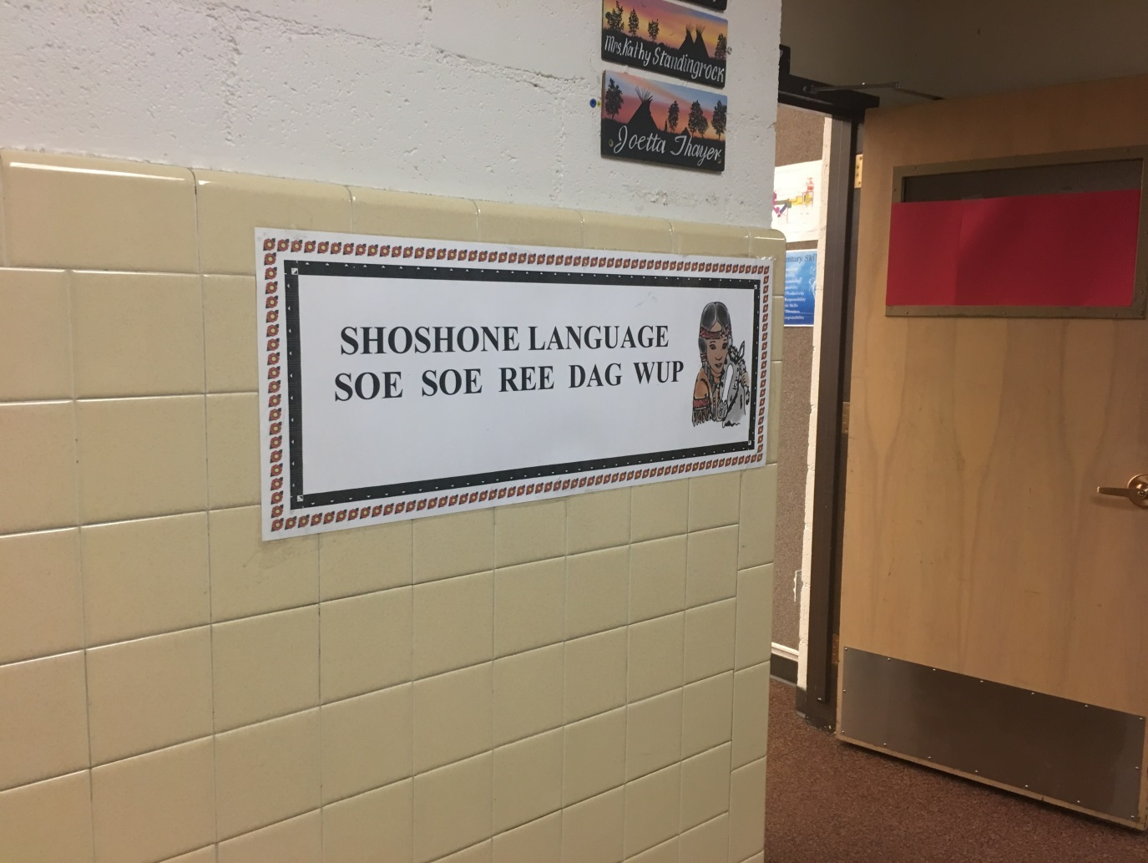
Figure 1: Native Shoshone language in use at Fort Washakie Elementary, Wyoming.
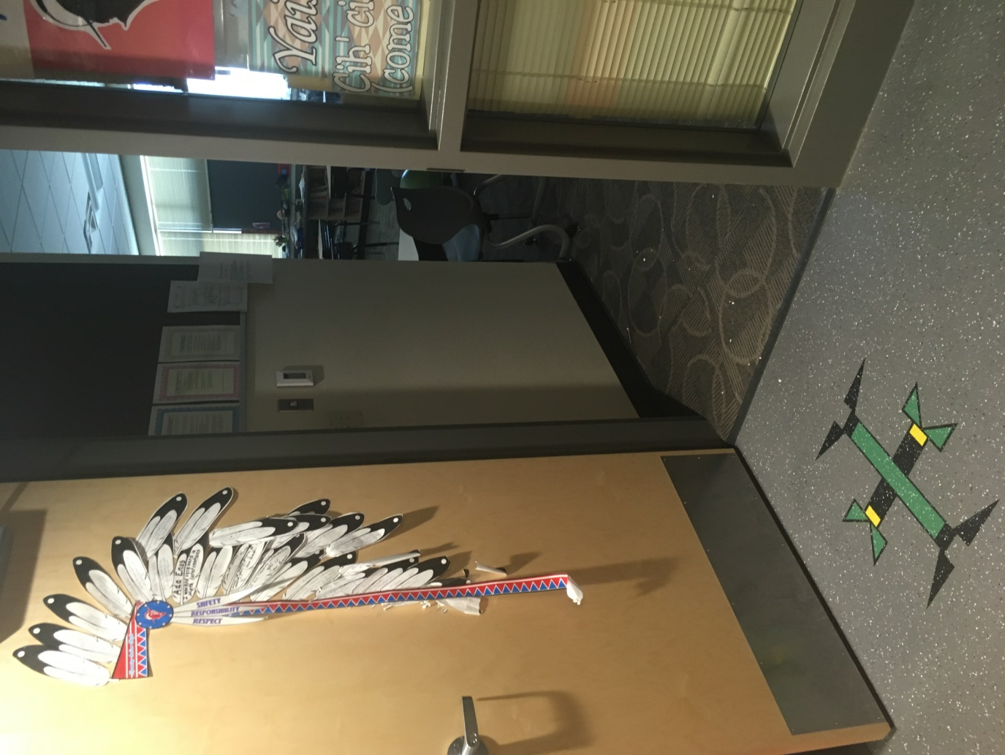
Figure 2: Arapaho and Shoshone traditional symbols in use at Wyoming Indian Elementary School.
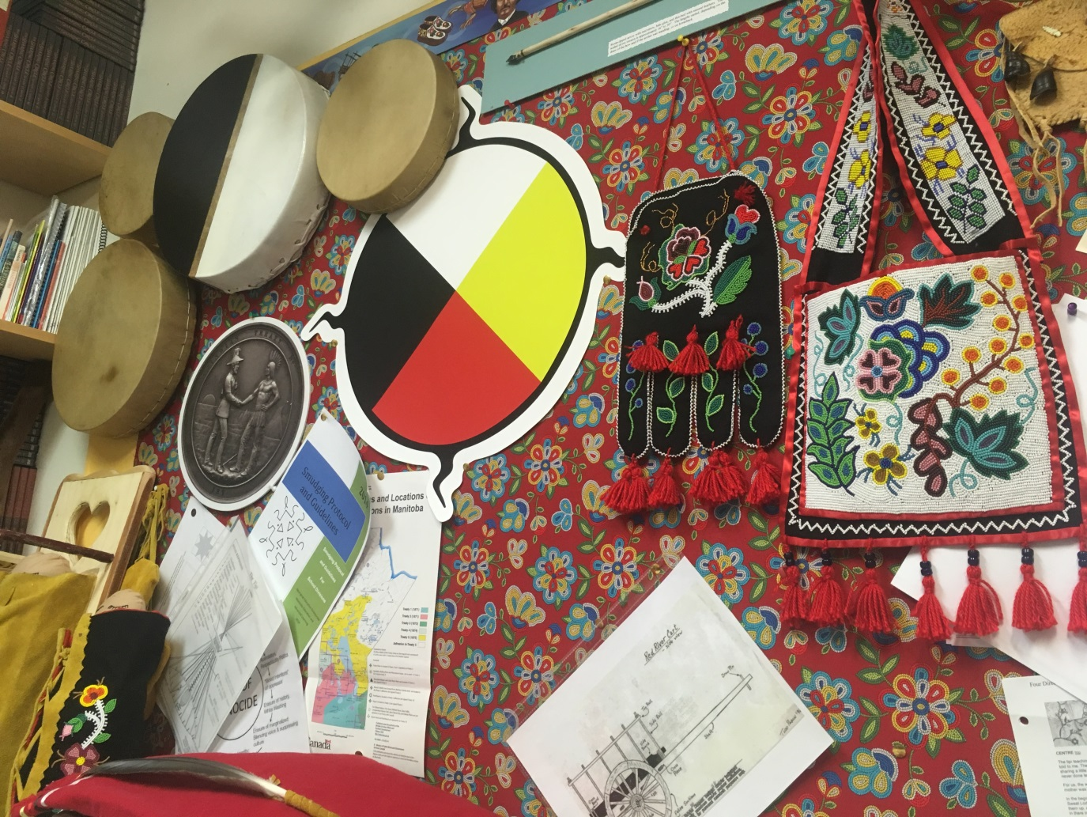
Figure 3: Replica materials produced by Angela Fey to be used in the Blanket Exercise.

Professor Patricia Nelson Limerick has been instrumental in reshaping understandings of the American West – its past and present. Limerick’s seminal 1987 work, The Legacy of Conquest, explored the then novel idea that the history of the conquest of the West was more complex than the traditional and romantic picture of the conquered West. Limerick argued that there was greater diversity of experiences, including both changes and continuities, for all who lived or travelled through the West (for more information, please see http://centerwest.org for Centre of the American West).
Please see images 1 and 2.
Legislation has recently passed in Wyoming to make “Indian Education for All” (https://edu.wyoming.gov/in-the-classroom/native-american/); as part of this, local Native American leaders will be leading curriculum and resource development. It would be interesting to revisit in a few years to see how this plays out in classrooms.
For information relating to the Secret Path album and book please see: http://secretpath.ca. Last accessed 14/8/2017.
For more detailed information relating to the Kairos Organisation and their Blanket Exercise please see: https://www.kairosblanketexercise.org/. Last accessed 14/8/2017. Please also see image 3.

