Premier’s History Scholarship

History and memory in the former USSR
  - The centenary of the Russian Revolution and beyond
Jonathon Dallimore
Smith’s Hill High School, Wollongong
Sponsored by
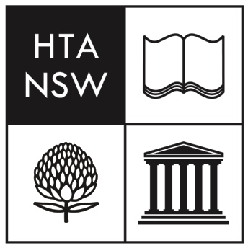

Introduction
Russian history appears set to become a far more widely studied part of Modern History in NSW with the new syllabuses published in 2017. This includes familiar topics such as the collapse of the Romanov dynasty, the Bolshevik Revolution, pre-war Stalinism and the Cold War. The new syllabus also includes an opportunity to examine aspects of more recent post-Soviet history in the entirely new topic ‘The Changing World Order, 1945 – 2011’. This comes at a time when, partly as a result of Russia’s resurgence as global power, Russian history seems to be undergoing a renaissance. As one leading historian recently claimed: ‘The Russia thing is good business. The world gets worse and worse and I get more invitations to speak at brunches.’ (Kotkin, 2018)
One of the central themes of this renewed interest is how the Russian story can be told from a 21st century viewpoint (Sherlock, 2011). Within Russia itself history has become an overtly political tool for many and it continues to generate heated debate among non-Russian scholars (Sheiko and Brown, 2014). Public discussions of the rule of Vladimir Putin are often rooted in historical imagery such as the cover of Time magazine in early 2018 which read: ‘Rising Tsar: How Vladimir Putting plans to stay on top’ (Time, 2 April 2018)
A greater understanding of how Putin’s government may be using history for political purposes will be useful for teachers pursuing the new Changing World Order, 1945 – 2011 already mentioned. A greater appreciation of the issues of history and memory in contemporary Russia and former Soviet states such as Lithuania, Latvia and Poland, however, also provide great opportunities for teachers exploring history and memory as a topic in Year 11 Modern History, those studying the Russia and the Soviet Union, 1917 – 1941 National Study in Year 12 and for classes exploring contemporary problems of national history in History Extension.

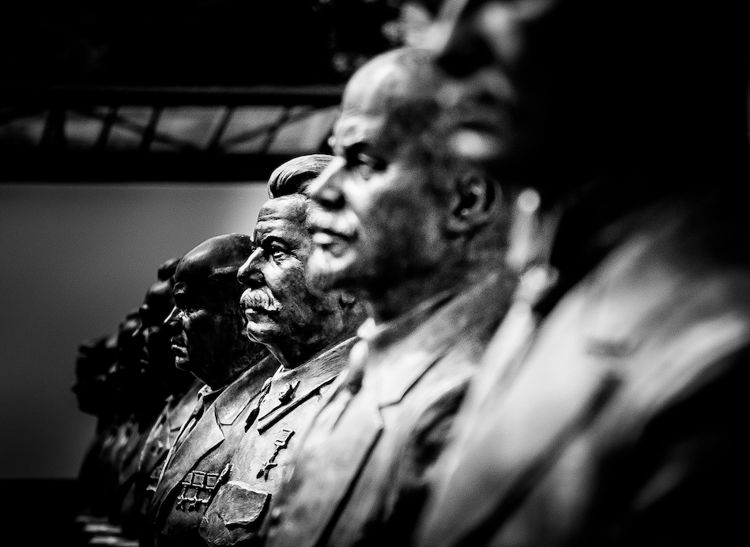
Figure 1: Recently unveiled busts of Soviet leaders including Vladimir Lenin and Joseph Stalin in the 'Alley of Rulers' in Moscow (photo by Jonathon Dallimore)

Focus of Study
The focus of this study tour was to explore and develop an appreciation of the complexities of history and memory in the Russian Federation and the former Soviet Union. The central aim of the study tour was to investigate how key events in Soviet history fit into the larger national story of Russia and former Soviet states (Lithuania, Latvia and Poland) promoted in contemporary historical memory and to explore how these issues might contribute to the teaching of Russian and Soviet history in NSW. Key to this was an exploration of important sites of memory including museums and monuments in the Russian Federation and the former USSR states of Latvia, Lithuania and Poland.
The events/themes I was most interested in exploring included:
- the Russian empire (relevant to Year 11 Modern History)
- the 1917 Revolutions (relevant mostly to Year 12 Modern History)
- pre-war Stalinism (relevant to Year 12 Modern History)
- post-Soviet developments especially related to the rule of Vladimir Putin (relevant to Year 11 and 12 Modern History and to History Extension)
- public history in Russia and how (some of these other events/themes) are taught in Russian schools.

In addition to visiting key sites, I also aimed to interview a range of individuals with different connections to and insight on issues of historical memory in Russia. These included journalists, historians and teachers in Russia who have been exploring these issues for a much longer period of time.

Significant Learning
The majority of this study tour was spent in the Russian Federation (primarily Saint Petersburg and Moscow), followed by a smaller time allocated to the Baltic states of Latvia and Lithuania and finishing up with a brief trip into Poland. Collectively, these areas provided an excellent opportunity to compare-and-contrast the way key events such as the 1917 revolution, Stalinism and the late Soviet period feature in the national stories of several very different nations. In addition, they provide interesting points of reflection about how we often discuss and teach Russian and Soviet history from what are often detached positions in NSW.
Overall, the study tour provided deep and often very personal insights into the highly contested nature of Russian and Soviet history. These included a greater appreciation for the difficulties of the Russian Federation in compiling an acceptable national story in the post-Soviet period and the ways nationalism continues to influence the preferred histories of Russia, the Baltics and Poland.

The Russian Federation
The main part of this study tour began in St. Petersburg. As the former capital of the Russian empire following its construction during the rule of Peter I (Peter the Great), this city offered a rich insight into specific aspects of Russian history. There are many museums, monuments and sites within and around the city that bring to life important aspects of Russia’s imperial past and the early Soviet period.
In St. Petersburg I took several walking tours with local guides who have been trained by government institutions to tell the story of the Russian Revolution to tourists. Interestingly, I found that the story recounted by these particular tour guides fitted quite comfortably with that provided by popular and influential accounts of the revolution by international historians. In addition, these walking tours provided good insight into many specific aspects of the 1917 revolutions including the sites of specific demonstrations and, of course, the supposed climax of the October coup at the Winter Palace in 1917.
From St. Petersburg I also booked a one-day trip with a local historian who has been working on a variety of conservation and preservation projects around the Gulf of Finland and, in particular, the Kronstadt naval installations. This day provided an excellent opportunity to discuss Russian history with a very well-informed local and to see first-hand a range of historical and archaeological projects taking place around Kronstadt. Given that the weather was clear, I was also able to accompany him on a boat trip out among the key forts of Kronstadt. We landed on several small islands and inspected the work being done by private contractors to restore some of the forts and convert others into modern museums (and even one into a hotel). Finally, we visited the Kronstadt Naval Cathedral which has an important monument to the individuals who supported the Bolsheviks in 1917 with an ‘eternal flame’. I was almost completely unaware of these efforts to preserve and restore these important historic sites before this one-day trip.
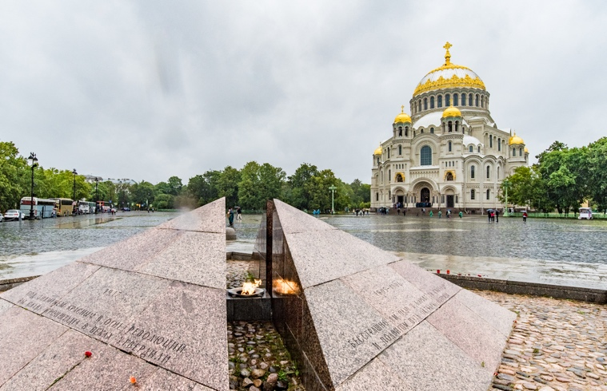  Figure 2: The Kronstadt Naval Cathedral (photo by Jonathon Dallimore) | 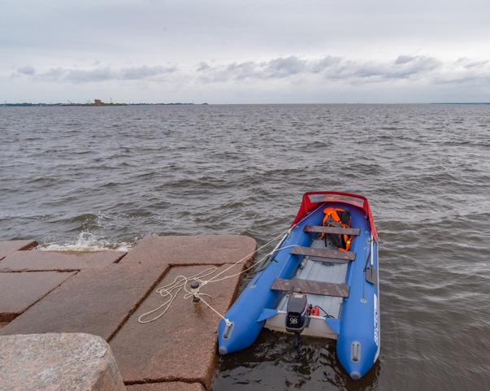  Figure 3: Looking out from one of the Kronstadt naval bases (photo by Jonathon Dallimore)
St. Petersburg also provided an opportunity to visit other key historic sites. These included:
- the Peter and Paul fortress which was an important part of Bolshevik propaganda (supposedly epitomising the cruel and arbitrary state violence of the Romanov regime)
- the Hermitage Museum / Winter Palace
- Yusupov Palace – the site of Rasputin’s murder in 1916
- Veliky Novgorod – cultural centre after the decline of Muscovy and before the Mongol invasion.

After St. Petersburg I travelled to Moscow which became the Russian and Soviet capital during the Civil War (1918 – 1921). As the current capital city and a much larger metropolis than St. Petersburg, Moscow provided some excellent opportunities to explore more important sites and museums. The stand-out site was Park Pobedy (Victory Park) built to commemorate the USSR’s monumental efforts in the Second World War. The site includes a long promenade, an enormous monument and a large museum. It is, in many ways, the most important historic site commemorating what has become the central event in the Russian Federation’s national story: the victory over German Nazism (or the Great Patriotic War as Russians call it). Although I had read much about the place of the Second World War in contemporary Russian historical memory, visiting this site provided an overwhelming experience of what modern commemorative culture in Russia can look like.
Moscow also provided further opportunities to meet and discuss these issues with experts from a range of fields. I was able to interview several journalists from a variety of national backgrounds who have been working in Russia for many years. These were contacted based upon their interest in contemporary issues of history and memory and some have had extensive contact with important individuals connected to commemorative culture such as sculptors who have produced some of the Putin regime’s most important monuments. In addition, I spent one day with a prominent historian from one of Moscow’s major universities who took me to a range of new monuments to various historical events and individuals constructed during Putin’s rule. These included the Pyotr Stolypin statue and the Alley of Rulers. I had read about these sites before travelling to Russia but the perspective offered by the journalists and historians provided much greater insight into why these monuments were chosen/created and what they are designed to achieve. I came to see these monuments as part of what Thomas Sherlock has described as an attempt by Putin (and his closest allies in the Russian political system) to: ‘… craft an uplifting historical narrative that would bind the nation with a sense of common purpose and legitimate their increasingly authoritarian rule… (Sherlock, 2011, p. 94) At the same time, in Moscow I also saw that there has been some attempt since about 2009 to deal more openly with darker aspects of Russia’s past – most notably the Stalinist terror of the 1930s and beyond. The government funding provided to dramatically expand the fairly explicit Gulag Museum and the construction of the Wall of Grief (both in Moscow) attest to this greater openness.
The degree to which these efforts are reflective of a deeper commitment to true openness about Russia’s past is, however, questionable. Most of the journalists and historians I interviewed had their own examples of censorship enforced on a range of commentators working in this area. This has allegedly even effected international historians trying to work in the Russian Federation (The Moscow Times, 27 November, 2017). Many reports of this kind of alleged censorship on Russian commentators have been made public (Parkhomenko, 2018).
My travelling in Moscow and the interviews I conducted provided strong support for one journalist’s claim that: ‘Nothing in Russia works in a straight-line’. By this he meant that it is rare for issues surrounding historical memory and the politics of the past to be black-and-white cases; they are always very complicated. While the government and its representatives supported the construction of the Wall of Grief, for example, there is also some clear censorship of particular individuals and groups.
The time in Moscow also provided great insight into the difficult task the current government has in speaking about Russia’s past. It is difficult for the government to throw its open support behind any single expression symbol of Russian nationhood (empire, monarchy, Soviet) because there are so many impassioned interest groups in the nation. Instead, it seems that the government has opted for a much more heterogenous approach through themes of continuity, greatness and pride (in a word, nationalism) rather than support for any one particular ruler/leader/system. No monument did more to represent this than the rather odd Alley of Rulers in Moscow. This is a small (by Russian standards) monument outside the headquarters of the Russian Military Historic Society founded by Putin in 2012 modelled on the Imperial Russian Military Historical Society established in 1907 (Kremlin news, 14 March, 2013). It includes busts of all Russia’s leaders from the first Viking, Rurik, down to Boris Yeltsin. There is no distinction between any of the rulers (successful or otherwise) and although the government has denied close affiliation with the installation, most people I interviewed believed that it was a clear reflection of the general message promoted in recent years by the Putin government: that Russia stands for greatness and needs to remain united in the way it thinks about its past and imagines its future.
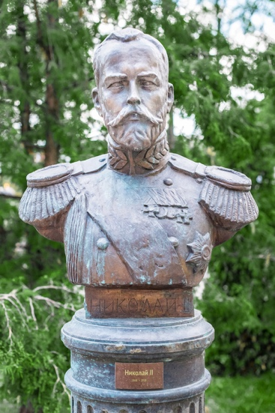  Figure 4: \ Nicholas II (Romanov) in the Alley of Rulers in Moscow (photo by Jonathon Dallimore) | 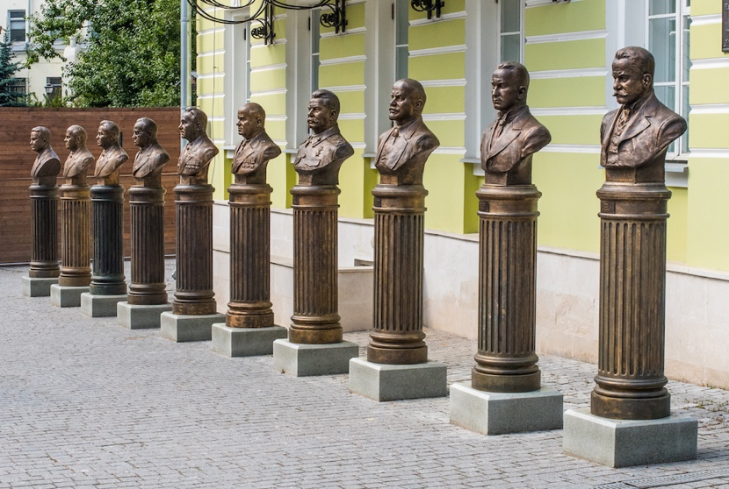  Figure 5: The latest additions to the Alley of Rulers in Moscow - the 20th century (photo by Jonathon Dallimore)
In Moscow I also visited a variety of other sites including:
- Gorky Park
- Muzeon Park (with former Soviet monuments)
- the Moscow Metro system (which include a wide variety of monuments and murals to various aspects of Russian and Soviet history)
- Lenin’s Mausoleum
- the Museum of the Patriotic War of 1812
- monument to Mikhail Kalashnikov.

All of these sites provided significant insight into the landscape of history and memory in contemporary Russia. They reveal the extremely broad series of events that compete for attention in Russia including the war of 1812, the construction of iconic infrastructure such as the Moscow Metro and the role of towering individuals such as Vladimir Lenin. They also highlighted some of the more divisive aspects of Russia’s historical memory beyond the Soviet story (such as the monument to Mikhail Kalashnikov).

Former Soviet states
After leaving Russia I travelled to the Baltic states of Latvia and Lithuania and then finally into Poland. The main reason for visiting these countries was to compare-and-contrast the way they represented the Soviet story from a different (and notoriously critical) perspective. This paid off more than expected as all three nations have museums dedicated to telling a very different version of important events in Russian history, especially the Soviet period.
Although not entirely surprising, I discovered that Latvia and Lithuania have very politically-charged museums openly critical of Russian/Soviet intervention in their nations. In the Lithuanian capital of Vilnius, for example, the Museum of Genocide Victims (KGB) provides a clear example of an institution that presents a powerfully antagonistic memory of the USSR and its role in Lithuanian history (Stefan Berger, et. al. 2017). Visiting this site made me consider finding ways to bring this story alive for NSW history students in History Extension who have rich opportunities to explore issues of national history/memory and their contested nature. The fact that the museum was originally set up by the KGB to celebrate its work and then completely reformed in the early 1990s to tell a radically different story raises great opportunities to discuss the politics of memory and other issues.
In Lithuania I also found a bizarre expression of public memory regarding the Soviet period: Grutas Park. This was set up by a wealthy Lithuanian who had lived through the Soviet occupation. When the nation was granted independence, he collected a range of prominent Soviet statues from around Lithuania and built a park to display them. The park includes mock Soviet guard towers, several buildings that act as mini-museums and, oddly, a small zoo housing rare animals and rides for children. It is colloquially known to locals as Stalin Land and still causes controversy among Lithuanians who believe the monuments should be destroyed. The park’s creator believes, however, that the compound has a role to play in helping Lithuanians deal with the grief of the occupation (Time, 30 August, 2017).
In Poland, I discovered greater tension in the national memory between two major episodes: the Second World War (and the Holocaust more particularly) and the nation’s Soviet past. The various museums and sites of memory across Poland dedicated to the Second World War (and the Holocaust) were very popular. However, there also appeared to be real anti-Russian sentiment expressed through some museums and the national media. This provided further evidence of the specific ways that the region’s history is also being filtered through contemporary political issues (Kamil Zwolski, 2016).

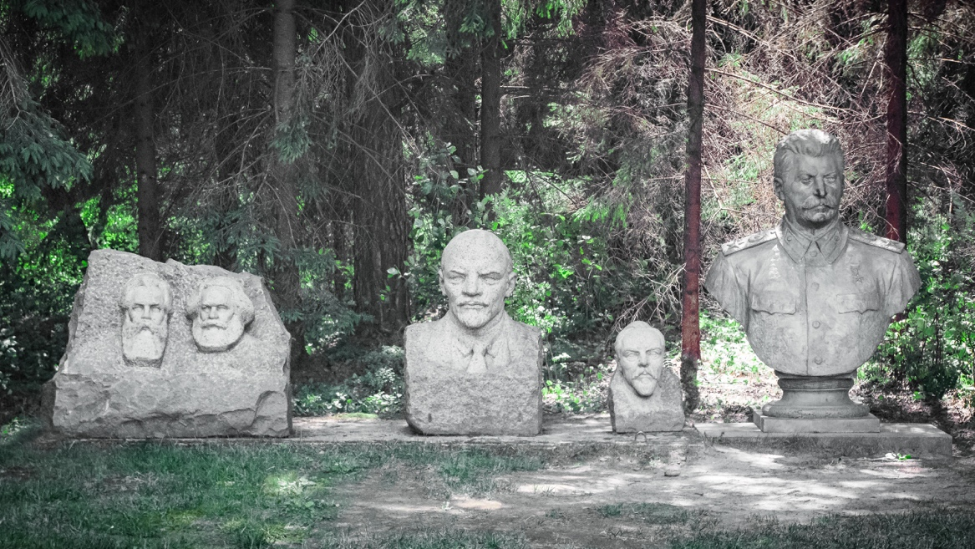
Figure 6: Busts of influential communists in Grutas Park, Lithuania (photo by Jonathon Dallimore)

Conclusion
This study tour provided great insight into contemporary issues of history and memory in Russia and other former Soviet states. It was a rich introduction to some of the points of historical tension in and between these nations and helped me make more sense of some of the issues that appear frequently in our own news media and in scholarly journals. In short, the tour deepened my understanding of the region’s past (including key events such as the 1917 Revolution) and how that past is being dealt with in the present. Given that it is such complex history and current politics are equally complicated, the trip raised as many questions as it answered which I have already begun to pursue with academics and colleagues back in Australia.
On a more specific level, the study tour revealed to me that the Russian Revolution (1917) has not been a major aspect of the history/memory landscape in Russia in the way that we might expect of other major events. It remains overshadowed by the Great Patriotic War and other issues that compete for national attention in Russia. Certainly, the current government has tried to avoid too much public commentary on 1917, so commemoration has been largely left to other groups.
The tour was also insightful regarding the great work being done by various historians in Russia on many levels. These include the conservation and preservation work around Kronstadt and the research conducted by a range of different scholars into different episodes of Russian and Soviet history. Learning about the specific challenges of working as a historian in Russia was particularly informative.
I plan to disseminate the ideas and resources gathered on this study tour in a variety of ways.
- Some information I gathered has already been included in an upcoming publication on the Russian Revolution and pre-war Stalinism due out in late 2018.
- I have also shared some resources gathered on this study tour with teachers planning to teach the Changing World Order topic in Year 12 in 2019.
- Other aspects of this study tour will feature in lectures for secondary teachers and students that I am booked to deliver in the latter half of 2018 and in 2019 which focus on Russian and Soviet history.
- I will also be sharing some of the insights of this study tour at professional development workshops around NSW during late 2018 and 2019.

I would like to sincerely thank the History Teachers’ Association of NSW for generously making these funds available through the Premier’s Teachers Scholarship initiative. I have observed other PTS scholars for many years with great admiration for the study tours they design and the resources they develop. It was a great privilege to participate as a recipient and I very much look forward to continuing the discussion of what I have learned with students and colleagues.

References

- Author unknown, ‘How Lithuania dealt with its Soviet statues’, Time, 30 August, 2017: https://www.economist.com/prospero/2017/08/30/how-lithuania-dealt-with-its-soviet-statues
- Author unknown ‘Russia Deports Polish Historian After Stalinist Purge Lecture’, The Moscow Times, 27 November, 2017: https://themoscowtimes.com/news/russia-deports-polish-historian-after-stalinist-purge-lecture-59699
- Stefan Berger, Anna Cento Bull and Hans Lauge Hansen, ‘Agonistic Memory’, Traces, 28 January, 2017: http://www.traces.polimi.it/2017/01/28/agonistic-memory-interview-with-stefan-berger-anna-cento-bull-hans-lauge-hansen/
- Stephen Kotkin, ‘What Everyone Needs to Know about Russia under Putin’, Foreign Policy Research Institute address, 22 April, 2018: https://www.youtube.com/watch?v=RnWp_kr4tfc&t=2097s
- Kremlin news, 14 March, 2013: http://en.kremlin.ru/events/president/news/17677
- Sergey Parkhomenko, ‘Russia has yet to recover from the trauma of the Stalinist era’, The Guardian, 7 March, 2018
- Konstantin Sheiko and Stephen Brown, History as Therapy: Alternative History and Nationalist Imaginings in Russia, Ibidem-Verlag, Stuttgart, 2014
- Thomas Sherlock, ‘Confronting the Stalinist Past: The Politics of Memory in Russia’, The Washington Quarterly, Spring, 2011, pp. 93 – 109
- Time, Vol. 191, No. 12, 2 April, 2018
- Kamil Zwolski, ‘Why everyone is giving Poland a hard time’, The Conversation, 13 January, 2016: https://theconversation.com/explainer-why-everyone-is-giving-poland-a-hard-time-53074

