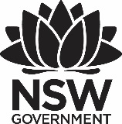
2017 Premier’s First State Super Financial Literacy Scholarship

Starting Young!
  - An international study of successful primary school financial literacy programs
Nikki Goldspink Chaffey
Narranga Public School, Coffs Harbour
Sponsored by

Introduction
“Young people, to be successful, to secure retirement, to take care of their families, and to not be in poverty, have to have a level of financial literacy that 30, 40, 50 years ago maybe wasn’t required. Today it’s an absolute necessity.” – Arne Duncan US Secretary for Education.
Consumer and financially literate people are: “Individuals who have the ability to apply knowledge, understanding, skills and values in consumer and financial contexts to make informed and effective decisions that have a positive impact on themselves, their families, the broader community and the environment” National Consumer and Financial Literacy Framework, Ministerial Council for Education, Early Childhood Development and Youth Affairs (MCEECDYA), 2011.
Financial Literacy is increasingly being called essential learning in NSW primary schools. The Australian and Securities and Investments Commission (ASIC) has stated that it is “critical to start financial education at a young age and school is the most effective place for this learning to occur”. http://www.financialliteracy.gov.au/strategy-and-action-plan/financial-literacy-strategy
The PISA 2012 study found that just 15.9% of Australian 15 year olds reached Level 5 proficiency (they can apply a wide range of financial terms and concepts to contexts and accurately describe the potential outcomes of financial decisions). This is compared to 42.6% Level 5 proficiency students in Shanghai-China. China currently represents 23.9% of our international trade and this has grown substantially in the last five years (dfat.gov.au). Clearly, it is imperative that Financial Literacy takes on a higher priority in Australian schools.
Further researchers at Cambridge University have found that children’s habits around money are formed by the age of seven (SMH 27/3/13), Financial Literacy education must start in NSW Primary Schools.
According to the ASIC MoneySmart website 80% of students thought that it was important to learn about money management at school. With ASIC and other online resources available, why is it that Financial Literacy is still perceived to be “woefully absent across our education system”? Herald Sun 18/3/16.

Focus of Study
The focus questions of my study have been:
- What common criteria do successful early financial literacy programs exhibit and how can we ensure that these are emulated in all NSW primary schools?
- Secondly, what does the current research on learning have to offer to help with teaching financial literacy to young students?

Significant Learning
In 2016, I trained to become a NSW Department of Education MoneySmart Facilitator. ASIC's MoneySmart Teaching (https://www.moneysmart.gov.au/teaching) is a broad strategy to build consumer and financial literacy capabilities in young Australians.
The MoneySmart website contains:
- information on how teachers can use MoneySmart - what MoneySmart can offer teachers in and out of the classroom
- professional development - Workshops, online learning and resources to build teacher capability
- teaching resources - Units of work and digital activities aligned to the Australian curriculum; and
- MoneySmart Schools - A program to recognise and support schools.
At Narranga Public School the whole school completed the initial MoneySmart training and many of the MoneySmart units have been taught with great success.
Given widespread access to this resource and the universal acknowledgement of the importance of financial education, it is important to look at why it is not being taught more widely across NSW schools.

Survey Results
As part of my study I conducted a survey on teaching financial literacy. In total I had 60 teachers complete the survey, 90% of respondents from Australia and 10% from other countries. While most teachers surveyed were Primary level (5-12 years), a cross-section of all teachers were surveyed.

Age of Students Taught (60 responses)
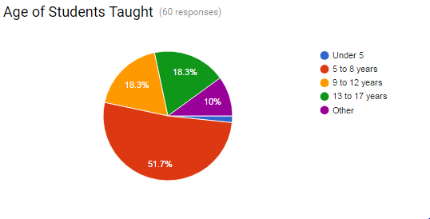
Under 5 | 1.7%
5 to 8 years | 51.7%
9 to 12 years | 18.3%
13 to 17 years | 18.3%
Other | 10%

80% of teachers surveyed had received some training in teaching financial literacy.

Own initial training in Finance or Financial Literacy (60 responses)
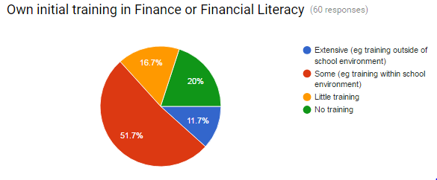
Extensive (e.g. training outside of school environment) | 11.7%
Some (e.g. training within school environment) | 51.7%
Little training | 16.7%
No formal training | 20%

Forty three per cent of respondents felt their ongoing training and support was low, with only 8% feeling this support was very high. Despite my expectations, while there was some correlation between ongoing support and confidence to teach, this did not appear to be the main driver.
There was a direct correlation between confidence to teach and the teachers’ initial training in finance or financial literacy. Those teachers with extensive external training all had high (29%) or extremely high (71%) confidence. Additionally, 100% of those with extensive training currently teach financial literacy to their students, while only 45% of those teachers with no training teach any financial literacy.
Teaching of financial literacy was felt to be effective by 94.8% of teachers. When asked how they knew this, some replies included:
- Because the students are engaged in the lessons and want to discuss it with their families at home.
- You see it in everyday situations such as the school canteen and dramatic role play. It has made the students more aware about looking after their money too.
- I believe it was the combination of learning financial literacy through the project-based learning that gave such positive results for the students. The finance was real and their responsibility.
From the survey results, it appears that teacher confidence is boosted most when they receive strong initial training in financial literacy and to a lesser extent by ongoing support.

Partnerships
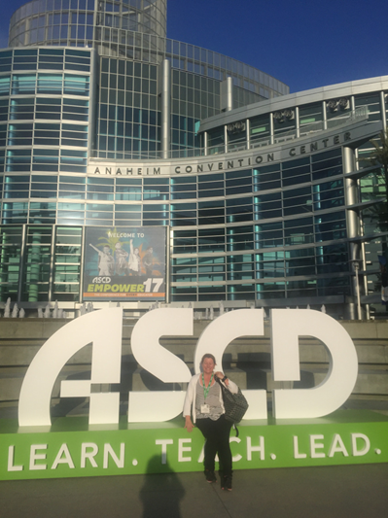
Figure 1: Attending the ASCD Conference at Anaheim in April 2017
A model to deal with the lack of teacher confidence with financial literacy is to operate a partnership between business and schools. JA Worldwide is one such organisation that is dedicated to addressing fundamental social and economic challenges of young people by educating and empowering them to transform their future and own their economic success.
Through the delivery of cutting-edge, experiential learning in financial literacy, work readiness, and entrepreneurship, JA effectively broaden the possibilities for young people by engaging in their own economic development and contribute to the strength of their families, communities, and economies. Each year, their network of over 470,000 volunteers serves more than 10 million students in over 100 countries. (https://www.jaworldwide.org/reports) Interestingly, as at 2016 JA had not reached any students in Australia.
I met with Christine Wong from JA Hong Kong and Amanda Lan from JA China, both of whom were passionate about financial education. Amanda saw her role as “building a bridge” between businesses and schools.
Another organisation, with extensive partnerships and resources is Jump$tart (http://www.jumpstart.org). Their head office is based in Washington DC, but they have affiliate organisations throughout the USA. The Jump$tart Coalition for Personal Financial Literacy is a 501(c)(3) tax-exempt non-profit. As a coalition, they “unite organizations committed to advancing financial literacy among pre-school through college-age youth”. Ted Beck, President of the National Endowment for Financial Education (NEFE), summed up the role of Jump$tart at the 2107 Annual Awards evening when he described it as “a community working towards doing the right thing.”
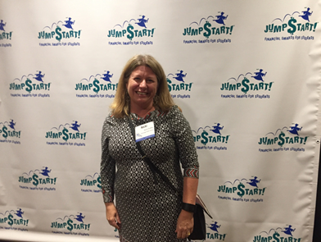
Figure 2: Attending the JumpStart 2017 Annual Awards Dinner in Washington DC
In the United States, NEFE is the leading private non-profit national foundation dedicated to inspiring empowered financial decision making for individuals and families through every stage of life (http://nefe.org ) PwC has been described as “a financial literacy champion”. In 2012, the business services giant launched what would become a five-year $190 million commitment to address youth education focusing on financial concepts.
In Australia, partnerships appear to have less of a role, but are evident. Clearly, ASIC’s Moneysmart resources provide an outstanding source of financial literacy education. Additionally, the following is a list of business and industry organisations who are actively supporting the National Financial Literacy Strategy through financial literacy initiatives (http://www.financialliteracy.gov.au/supporters/business-and-industry.) At Narranga Public School in 2017 we have worked with the Commonwealth Bank to deliver free financial literacy lessons to all students. Importantly, without the partnership of First State Super this study would not have been possible.

High Performing Schools
Three schools that have been recognised in the United States for their excellence in financial literacy are the Walter Bracken STEAM Academy Elementary School (Las Vegas), Skyline High School (Salt Lake City) and Two Rivers Elementary (Washington DC).
At the innovative Walter Bracken students are involved in “PiggyBank Friday: Life Skills through Financial Literacy”. They converted a janitor's closet into a financial centre for student banking. They set up a real bank account, make weekly deposits with bankers at their school, track their balances, and receive monthly financial literacy lessons. While Piggy-Bank Friday is heavily partner-involved, the success of the program depends on teachers. The teachers' role is to encourage, support, and get their students excited about saving money.
Walter Bracken STEAM Academy partnered with United Way's Young Philanthropists Society (YPS), who developed the Piggy-Bank program at Bracken and have since expanded it to two other elementary schools in Nevada’s Clark County School District and are also working with a school in Florida.
United Way connected Walter Bracken administrators and teachers to:
- a local bank, Silver State Schools Credit Union
- Andson Inc., a non-profit that developed the financial literacy curriculum
- volunteers who donated their time and the materials to build an on-campus bank at the school site.
Sid Lott’s classes at Skyline High school in Salt Lake City have won many prizes in financial literacy. Lott attributes this success to his programs being adapted to meet the specific needs of his students. He has many former students studying finance or working on Wall Street. Speaking with him and a couple of his students it is obvious that his passion and depth of knowledge are key contributors to his students' success.
Utah was the only state to get an A+ on a report released by Chaplain College, which examined each state's efforts to teach financial literacy in their schools. Utah earned the grade for implementing policy that goes well beyond what other states require their students and teachers to do when it comes to financial learning.
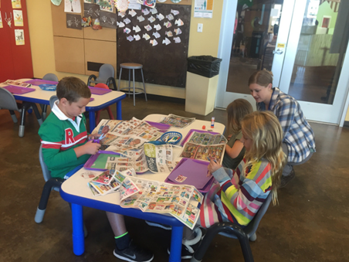
Figure 3: Children completing Financial Literacy activities at the Utah Children’s Museum in Salt Lake City,
April 2017
So what sets Utah apart?
Financial literacy has been taught as a high school course in Utah for more than a decade. During that time, education leaders have developed “specific standards for the course, with curriculum that covers goal setting, income and careers, savings, investing, retirement planning and other subjects”.
The State Legislature passed a bill that called for updating the standards, requiring students to pass an online 72-question finance test to graduate, and requiring instructors to obtain up to 16 credit hours of training in order to teach the class.
At Two Rivers Public Charter School in Washington DC the focus is on learning social skills as well as cognitive skills. Two Rivers is dedicated to ensuring its students have rich and varied options for their future. A Two Rivers education goes beyond the basic subjects to ensure every student is well positioned to be successful members in our society. Students are taught ‘21st Century’ skills or ‘Deeper Learning’ skills such as:
- critical thinking and problem-solving skills
- character (responsibility, perseverance, growth mindset)
Growth mindset is evident in everything that the school does. They began by recognising a culture of mathematics fear among the staff and worked hard to change teachers’ relationships to maths as part of their broader strategy to improve maths achievement. This professional development in turn helped teachers feel capable of teaching in problem-based ways that stretch student thinking. The Two Rivers Charter School example is a good reminder how so often the culture of particular schools and the attitudes of the adults affect efforts to improve academic outcomes.

Learning and the Brain Research

Growth Mindset
Stanford psychologist, Carol Dweck has found that the way students think about and approach challenge has a big impact on their learning. Students who believe that they were born with a certain amount of intelligence that cannot be changed – a condition Dweck calls a fixed mindset – are often afraid to seek out challenging tasks and are resigned to one’s perceived set of abilities. Students who see intelligence as something that can grow and change with effort - known as a growth mindset – tend to persist at difficult tasks, trying new strategies and ultimately performing better in school.

Growth Mindset in Mathematics
Stanford Mathematics Education Professor Jo Boaler is proposing a dramatic shift in how teachers approach mathematics instruction. Rather than focusing on the algorithms and procedures that make mathematics feel like a fixed process - with one right way of solving problems - Boaler encourages teachers to embrace the visual aspects of mathematics. She encourages teachers to ask students to deal with open-ended problems, to share ideas and to see mathematics as a creative endeavour. She says that when students are in a mathematics environment that does not focus on performance, speed, procedures, and right and wrong answers they thrive. They begin to change their perceptions about learning mathematics.
I propose that financial literacy falls within this area. Repeatedly during my scholarship trip and beyond, teachers often tell me that they are “bad” at money. Extending the growth mindset to teachers and students about financial literacy will result in increased confidence and therefore increased ability to learn.

Academic Self-Efficacy
Psychologist Albert Bandura has defined self-efficacy as one's belief in one's ability to succeed in specific situations or accomplish a task. One's sense of self-efficacy can play a major role in how one approaches goals, tasks, and challenges. Ellen L Usher, PhD has studied self-efficacy and found that mastery experience is typically the most influential source of self-efficacy, and that teacher feedback has a major influence on student self-efficacy. At the Learning & the Brain Conference 2017 she noted that teacher self-efficacy matters. John Hattie has updated his list of 195 effects in The Applicability of Visible Learning to Higher Education (2015), and Collective Teacher Efficacy is shown to have an effect size of 1.57. That is, if teachers start to believe that they can teach students about financial literacy, then they can.

Positive Emotion and Positive Education
The Positive Psychology movement and Martin Seligman PhD state that for learning to be optimised there should be PERMA in the classroom. That is, Positive and pleasant emotions, Engagement, Relationships, Meaning (purpose) and Achievement and accomplishment. Research shows a classroom encouraging positive emotions and optimistic viewpoints produces broadened thoughts and actions and improves resourcefulness and exploration, which can result in improved academic achievement and fulfilment.
Students who succeed academically often rely on being able to think effectively and independently to take charge of their learning. These students have mastered fundamental skills such as being organised, completing tasks on schedule, making a plan, monitoring their learning path, and recognising when it might be useful to change course. These are skills that we now know can be taught through metacognition (the ability to think about your thoughts with the aim of improving learning). - https://www.edutopia.org/blog/metacognition-gift-that-keeps-giving-donna-wilson-marcus-conyers

Teaching Resilience (or Grit)
Caroline Adams Miller presented a session at the 2017 Learning & the Brain Conference on “Getting Grit: How to Embed Passion, Persistence and Awe” with some key points for teaching financial literacy. Grit is increasingly considered one of the key ingredients of success. It is defined as “passion and perseverance in pursuit of long-term goals.” She proposed that society has changed so that children no longer encouraged to take risks and wondered have we prepared them for what life will throw at them? Adams Miller further stated that American entrepreneurship has gone down by 9%. She proposes that grit can and must be cultivated as early as seven years old.

The building blocks of financial literacy
The US Consumer Financial Protection Bureau conducted research in 2016 called “Building Blocks to Help Youth Achieve Financial Capability”. The report concludes that there are three components learned from ages 3 to 21 that lead to good money management as adults:
- Executive function.
This is self-control and problem solving, and it starts to develop as early as ages three to five. “Everyone, including parents and educators, can help create environments that nurture the development of a child’s executive function,” the report states. Rewarding delayed gratification is one strategy. Specific interventions have shown to support the development of executive function in young children.
- Financial habits and norms.
This is learning rules of thumb that lead to better money decisions. These norms are picked up from ages six to twelve, typically by observing parents. “Children begin to gain a sense of what is normal or appropriate regarding spending, saving, and other financial matters,” the report states. At primary school, these habits and norms can be examined, remodelled and support provided for effective and efficient practices.
- Financial knowledge and decision-making.
This is factual financial knowledge acquired through education or experience, and it typically develops as children age.
http://time.com/money/4502227/financial-literacy-building-blocks-smart-money-decisions/

Conclusion
It is universally acknowledged that the world has changed and that it is imprudent to continue to teach financial literacy as if preparing our students for the 20th century. Additionally, we now know more about how students learn and it is imperative that we consider this in all our teaching.
According to a survey from the NEFE in partnership with Right About Money, 74% of Americans believe financial instruction in K-12 schools gets the best results in building financial well-being. In addition, surveys show nearly 90% of parents and teachers believe that financial education should be taught in school (Time, 2016).
Despite the best efforts of the education community, the reality is only a fortunate few young people receive financial education in school. In the United States, less than half of the states (22) have a requirement in place where a high school course in financial education must be offered, and just seven states have adopted standardised testing specifications, according to the Jump$tart Coalition for Personal Financial Literacy and the Council for Economic Education.
“There are random acts of success where states have implemented effective programs, but we really need more schools to step up and require personal finance instruction as part of their curricula,” says Billy Hensley, Ph.D., senior director of education with NEFE. “And this isn’t just a one-time offering. Parents, schools, employers and community organisations all need to provide better access to educational resources throughout a person’s economic lifetime.” (http://nefe.org/Press-Room/News/Where-Financial-Education-Has-the-Greatest-Impact)
It appears the situation is the same in Australia, with financial literacy programs limited to the skills of individual schools and teachers. My survey found that 45% of those teachers with no training, taught no financial literacy to students at all. My study has led me to believe, that an optimal primary level financial literacy program needs:
- a rigorous research-based curriculum
- teacher confidence and self-efficacy through strong initial training and support that could be enhanced through partnerships with business and external organisations
- both the teacher and students to be actively demonstrating a growth mindset
- to incorporate experiences that allow mastery, but also allows mistakes that build resilience.
In summary, financial literacy education is not just about numbers, but about critical thinking skills, especially among the young. “We have seen that financial capability goes well beyond just learning facts and is shaped by this broader set of attributes,” Richard Cordray, Director of the Consumer Financial Protection Bureau.
In Australia, we are extremely fortunate to have the well-researched and highly effective MoneySmart teaching resources. We now need to increase teacher confidence to implement this, through strong initial training, on-going support and partnerships. As the importance of growth mindset and self-efficacy pervade education, it is imperative that these are extended to the teaching of financial literacy in primary school.
As stated at the Annual Conference on Financial Education in Chicago, April 2017, “Winter is Coming” and it is up to us, as educations, to provide students with the skills to weather it.

Websites
https://filmpond.com/#/ponds/narrangaps/films/qxsd5sph6epe. - A video showing further details of our learning
https://www.edutopia.org/practice/piggy-bank-friday-life-skills-through-financial-literacy
http://www.deseretnews.com/article/865639513/Report-Utah-only-A-state-in-financial-literacy-for-students.html
https://ww2.kqed.org/mindshift/2016/11/02/how-one-school-changed-its-math-culture-starting-with-teachers/
https://www.tworiverspcs.org/learning-approach/curriculum/deeper-learning
http://www.p21.org/exemplar-program-case-studies/1632-case-study-two-rivers-public-charter-school
https://www.youcubed.org/
https://ww2.kqed.org/mindshift/2017/04/05/five-ways-to-shift-teaching-practice-so-students-feel-less-math-anxious/
http://hechingerreport.org/opinion-time-stop-clock-math-anxiety-heres-latest-research/
http://www.carolinemiller.com/grit/
https://kathleenkryza.com/
http://nefe.org/Press-Room/News/Where-Financial-Education-Has-the-Greatest-Impact
http://www.rightaboutmoney.com/
https://www.edutopia.org/blog/metacognition-gift-that-keeps-giving-donna-wilson-marcus-conyers
https://www.edutopia.org/article/helping-struggling-students-build-growth-mindset-donna-wilson-marcus-conyers#comment-282861
https://visible-learning.org/hattie-ranking-influences-effect-sizes-learning-achievement/
http://time.com/money/4502227/financial-literacy-building-blocks-smart-money-decisions/
https://www.moneyadviceservice.org.uk/en/corporate/habit-formation-and-learning-in-young-children
My blog at finlitnicki2017.wordpress.com has further details on my study. I reached nearly 500 readers in the following countries over my tour:
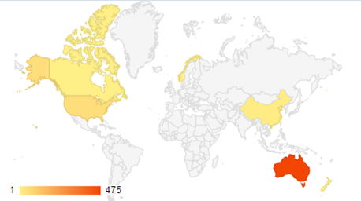
Figure 4: The world countries incorporated in this study

