Communication systems
The Communication System Framework is a simplified model that represents the path of a message or data from a source (sender) to a destination (receiver). It does not detail components or processes within communication systems or computer networks.
A benefit of this simplified approach is that it is applicable to a broad range of scenarios. There is a risk that students may not appreciate or recognise the extra complexity this framework can contain.
Students interact with this framework and add meaning to the model by making conceptual links between the syllabus’ Communication Framework and those used in industry, like the TCP and OSI models. By mapping technical industry terminology to the Communication System Framework along with explanations from the video resources students will develop deeper understanding of the processes and technology used in communication systems.
The video resources have been curated to address the elements of the Communication System Framework. Students are advised to view the videos and then annotate the diagram of the framework.
This diagram from the syllabus along with some additional scaffolding is provided on the accompanying A3 poster. Parts of the poster are reproduced as tables to be completed with other questions in the student workbook document.
The framework should be used with scenario-based questions from past HSC examination papers to map components of the question and provide opportunities to develop deeper understanding. Where applicable some past HSC examination questions have been referenced against relevant syllabus content.

The communication system framework diagram as presented in the Information Processes and Technology syllabus.

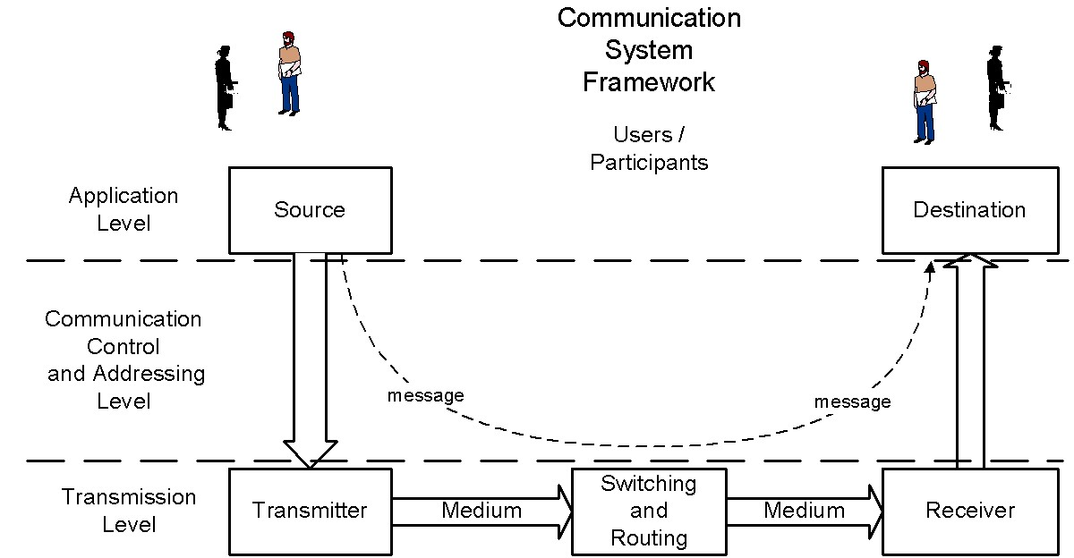
Diagram and syllabus content listed in the tables below are from the Information Processes and Technology Stage 6 syllabus, © NSW Education Standards Authority (NESA) for and on behalf of the Crown in right of the State of New South Wales 2009.
This modified diagram shows the alignment of the three models and where some models combine layers.
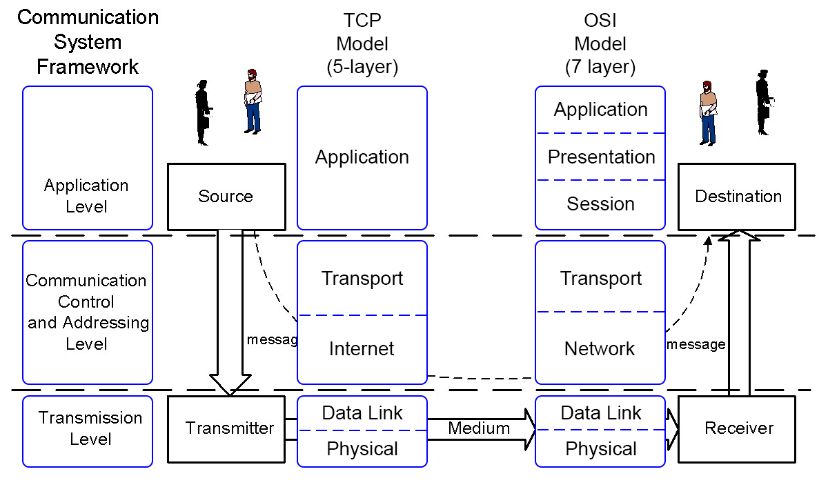
Diagram adapted from the Information Processes and Technology Stage 6 syllabus, © NSW Education Standards Authority (NESA) for and on behalf of the Crown in right of the State of New South Wales 2009.
Important: Access LinkedIn Learning from within the Staff portal before clicking the video links listed in this document.
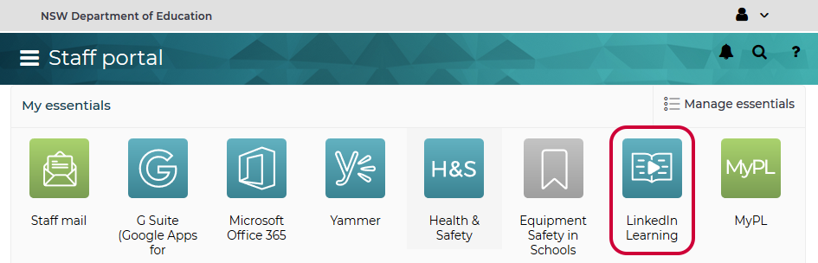
Before clicking the video links listed below, access LinkedIn Learning from within the Staff portal. If this tile is not listed it can be added using Manage essentials. After the initial use please ensure you are logged into the Staff Portal before clicking on the LinkedIn Learning video links.

Note: The accompanying A3 poster is intended to be printed and for students to annotate.

Syllabus content | LinkedIn Learning / YouTube / website | Notes / questions
characteristics of communication systems
communication systems as being those systems which enable users to send and receive data and information
the framework in which communication systems function, demonstrated by the following model | Communications System Framework (6:37)  TCP/IP Five-Layer Software Model Overview | Eddie Woo explains the framework using analogies and examples.  Question: Compare the syllabus framework to the OSI model and the TCP model.  Answer: Looking at the framework diagram from the syllabus (page 36) there are clear parallels between the three models having similar structure and purpose, with the TCP and OSI models representing greater detail.  Using this approach enables a common language with a wider range of learning resources which use current industry terminology.  Previous HSC questions:  2019, Q9  2017: Q19  2016: Q18  2014: Q16
the functions performed within the communication systems in passing messages between source and destination, including:  - message creation  - organisation of packets at the interface between source and transmitter  - signal generation by the transmitter  - transmission  - synchronising the exchange  - addressing and routing  - error detection and correction  - security and management | - Binary and bits (2:35) [Preamble]  - Communicating with bits (4:28)  - Digital communication (6:27)  Sending and receiving information (2:28)  The Internet Protocol and IP address (2:46)  Scaling up the Internet from IPv4 to IPv6 (3:33)  Routers and directing requests (2:26)  Packets and fault tolerance (3:10)  Reliability and TCP (2:16)  Extension:  A Layered Security Model: OSI and Information Security (pdf) | - Introduces the idea of encoding and decoding messages with bits as the fundamental unit.  - Encoding and decoding messages requires a shared understanding which is conceptually analogous to establishing protocols.  - Introduces foundational principles of communication mediums of radio, electrical and optical. Principles of speed, bitrate, standards and compatibility.  Concisely introduces communication concepts in networks.  Further explains concepts of addressing  More detailed explanation of IP addressing  Explanation of packets and movement of packets through networks, and introduces the concept of fault tolerance.  Previous HSC questions:  2019, Q16  2015: Q15  2014: Q8, Q23(c)
the roles of protocols in communication  - handshaking and its importance in a communications link  - functions performed by protocols at different levels | The role of protocols in networking (1:57)  What Is a Three-Way Handshake in TCP? (4:57)  The sound of the dialup, pictured  Internet protocols (2:33)  TCP/IP Ports Defined  Example: Simplified Local Network TCP/IP Communication  Detailed TCP/IP Communication Example | How does the 3-way handshake in TCP ensure reliability?  Historical reflection on handshaking between dial-up modems.  Introduces the concepts of different layers of protocols (and ports) for carrying out different functions. Ports are not specifically mentioned in the syllabus, but this webpage addresses both protocols and ports with common examples of applications concisely.  Use this model to describe how either of the other examples in the syllabus, mail server and print server, would operate.  Previous HSC questions:  2019: Q7, Q9, Q14  2018: Q9  2017: Q19, Q24(a)  2016: Q18  2015: Q17  2014: Q16
the client–server model  - the role of the client and the server  - thin clients and fat clients  - examples of clients such as web browsers and mail clients  - examples of servers such as print servers, mail servers and web servers | Investigating client-server and peer-to-peer connections (4:49)  Explore the components of the cloud (1:55)  Understanding how the web works (2:37)  Working with clients and servers (web) (2:38)  Understanding email servers and clients (2:23)  (Optional)  Server roles (6:46) | What are the advantages and disadvantages of client-server architectures compared with the peer-to-peer model?  How has the cloud changed the concept of client-server architecture and thick/thin clients  Important for students to distinguish between the web and the internet. Introduces the concepts of clients and servers  Basic description of client-server model in email  Also consider VPN mentioned in later section.  Previous HSC questions:  2019: Q11  2018: Q6  2016: Q24(a)

Syllabus content | LinkedIn Learning / YouTube / website | Notes
Examples of communication systems  Teleconferencing systems | Audio and video conferencing (2:44) | For given examples, explain how data is transmitted and received.
Messaging systems  (See Course Specifications Document) | Presence, instant messaging, and email (5:08)  Telephony and VoIP integration (3:13) | For given examples, explain how data is transmitted and received.  Previous HSC questions:  2018: Q3, Q21(b),  2016: Q21(c)  2014: Q24(b)  2013: Q6, Q10, Q11
other systems dependent on communication technology such as:  - e-commerce  - EFTPOS  - electronic banking | What is eftpos in Australia? How does it work?  Can I use my EFTPOS or Credit Card terminal on the nbn™?  What Australia can learn from Sweden's move to a cashless society  How e-commerce is changing retail trends during the pandemic: Shopify COO (6:46) | Shopify COO interview: What is the difference between a strategy and a tactic?  Previous HSC questions:  2019: Q24(b)  2018: Q22(c), Q23(c)  2017: Q12  2013: Q22(c)
 | Unified communication (1:05)  Web conferencing (3:02)  Cloud-based collaboration (2:08)  Social media collaboration (1:55) | What are some modern examples of technology used for communication systems?  Previous HSC questions:  2013: Q21(c)
 | The big picture of technology trends (5:54)  Internet of Things (6:26) | How can these systems and technology be described by the communications framework?

Syllabus content | LinkedIn Learning / YouTube / website | Notes
Transmitting and receiving in communication systems  transmission media, including:  - wired transmission (See Course Specifications Document)  - wireless transmission (See Course Specifications Document) | Comparing cabling standards (2:08)  Identifying copper connectors (1:49)  Comparing fiber connectors and cables (3:56)  Exploring wireless LAN types (2:23)  Connect to wired networks (3:06)  Connect to Wi-Fi (wireless) networks (3:58) | Only worry about plugs  List in order of increasing bandwidth  List the recent wireless (802.11) standards and their specifications.  Elementary mechanics of connecting to wired network. Explanation of general settings. Foundation knowledge expected  Explain how to connect to a wireless network in win10.  Previous HSC questions:  2019: Q3, Q24(b)  2018: Q8, Q24(c)  2017: Q24(b)  2016: Q9, Q24(b)  2015: Q12  2014: Q3, 24(c)  2013: Q24(a)
characteristics of media in terms of speed, capacity, cost and security | Network cabling (6:30)  Physical interface and cable types (3:38)  Distinguishing legacy, current, and future Wi-Fi standards (2:39)  Comparing the 2.4 and 5 GHz frequencies (4:44)  Understanding security limitations of copper cabling (2:20) [Extension]  Analyzing the shortcomings of wireless security (2:57) [Extension] | References to 568A and 568B is beyond the scope of IPT.  The AC standard is referred to as future but is current now. End at (1:35) as modulation is beyond scope of this course.  Previous HSC questions:  2019: Q3, Q22(c), Q24(c)  2018, Q8, Q24(c)  2017: Q24(b)  2016: Q9, Q24(b)  2015: Q12  2014: Q3, 24(c)  2013: Q24(a)
communication protocols, including:  - application level protocols  - http  - smtp  - SSL  - communication control and addressing level protocols  - TCP  - IP  - transmission level protocols  - Ethernet  - Token ring | Common Ports and Protocols (4:57)  HTTP (2:51)  HTTPS (1:48)  Mail services: POP, IMAP, and SMTP (3:52)  Introducing Secure Sockets Layer (SSL) (4:39)  SSL vs. TLS (9:50) [Extension]  Exploring HTTP (4:13) [Additional]  Packets and frames (3:06) | Reference should made to the framework.  In conjunction with a data unit diagram, compare the Communication System (IPT) framework, TCP model and OSI model.  Token ring is listed in syllabus but rarely used today.  Previous HSC questions:  2019: Q9, Q14, (Q16)  2018: Q6, Q22(c)  2017: Q19  2016: Q18  2015: Q15, Q17  2014: Q16
strategies for error detection and error correction | Connection vs. connectionless (2:26)  TCP reliability (2:16) RPT  TCP vs. UDP  Parity Check (10:58)  Parity Check Problem (3:17)  Checksum (6:27)  Cyclic Redundancy Check (2:33)  Extension:  Error detection: Parity checking (21:41)  Checksums and Hamming distance (28:20)  How do CRCs work? (47:29) | How does TCP ensure reliability?  Contrast this with UDP where the risk of dropped packets is a trade-off for increased speed.  Describe the three traditional methods of error detection – parity, checksum and cyclic redundancy checks.  The videos in the extension section go beyond the scope of what is generally examined. The presenter clearly articulates and demonstrates how bits can be transmitted from one system (microprocessor) to another. Having some background with the Arduino platform is beneficial.  Previous HSC questions:  2019: Q12, Q21(d), (Q16)  2018: Q2  2017: Q16  2016: Q11  2015: Q20, Q24(a)  2014: Q7, Q19, Q23(c)
network topologies, including:  - star  - bus  - ring  - hybrid  - wireless networks | Network Topologies  Understanding logical and physical network topologies (1:02)  Understanding mesh, bus, and ring topologies (8:38)  Exploring star and hybrid star topologies (4:48)  Understanding point-to-point and point-to-multipoint networks (1:53)  Exploring network collisions, CSMA/CD, and CSMA/CA (6:14)  If no CSMA/CD on switches what are they using (Read second reply to original post) | The distinction between logical and physical topologies is less observable nowadays. It was more common when examining hubs in star networks, or token ring networks that had a physical layout of a star topology.  Some previous HSC questions have examined the ability to recognise topologies with distractors using incorrect/misleading shapes. See 2012 IPT HSC question 9.  The example scenarios in this video use wired network topologies (usually bus topology) to describe the CSMA/CD and CSMA/CA processes.  Is CSMA/CD relevant for switch technology and/or star topologies?  Which process is used for wireless topologies?  Previous HSC questions:  2018: Q10  2016: Q14  2015: Q21(b)  2014: Q13  2013: Q5
the functions performed by the following hardware components used in communication systems  (See Course Specifications Document) | Commonly Used Network Devices  - Introducing network interface controllers (NICs) (2:49)  - Exploring hubs (4:15)  - Understanding bridges (1:39)  - Exploring switches (4:21)  - Understanding routers (3:39)  - Introducing wired and wireless access points (2:12)  - Dial-up (4:34)  - DSL and ADSL (3:25)  Extension (additional content):  - Hubs, bridges, and switches (2:49)  - Network components (4:39) | Use these videos to complete activities 1 and 18.  Obviously, not all are common nowadays.  The presenter refers to Wi-Fi cards as NICs.  Previous HSC questions:  2018: Q11  2017: Q5  2016: Q1, Q10, Q13, Q17  2015: Q7, Q11  2014: Q11  2013: Q24(a)
characteristics of network operating software | Historical perspective  Network Operating Systems (NOS)  NOS Server Software  NOS Client Software  Network Operating Systems & Policies (8:39)  Modern perspective  Operating system types (3:51)  Linux network operating systems (NOS) (4:49) | Important to note the distinction between server OS and network OS. Modern sources now refer to NOS being used on network devices like routers.  Server and client NOS are historical terms as this functionality is built into modern operating systems.  Students read and watch the resources and then participate in some class discussion to evaluate the relevance of these terms today.  Provides a range of modern operating system types and uses.  Start at (0:25). Unfortunately this video simply lists examples and uses of some linux network operating systems.
similarities and differences between the Internet, intranets and extranets | Understanding the difference between the Internet, intranets, and extranets (2:14) | Recall the definitions. Understanding of what constitutes an extranet is  How are Microsoft Azure and Amazon Web Services considered to be extranets?  Previous HSC questions:  2019: Q8  2017: Q18  2015: Q21(c), Q24(c)  2014: Q9

Syllabus content | LinkedIn Learning / YouTube / website | Notes
Other information processes in communication systems
Collecting, (such as)  - the phone as the collection device with voice mail  - EFTPOS terminal as a collection device for electronic banking | Modern perspective: the phone as a collection device …  Digital assistants: Voice plus video (2:19)  Specialised Computer Systems (1:58)
Processing, (including: )  - encoding and decoding analog and digital signals  - formation of data packets  - routing  - encryption and decryption  - error checking  - parity bit check  - check sum  - cyclic redundancy check (CRC) | Parity Check (10:58)  Parity Check Problem (3:17)  Checksum (6:27)  Cyclic Redundancy Check (2:33) | Describe the three methods of error checking.  Explain the limitations of each.  (They are listed in the order they were developed and level of complexity.)  Previous HSC questions:  2019: Q4, Q16  2017: Q16  2016: Q11, Q24(c)  2015: Q20, Q24(a)  2014: Q7, Q19  2013: Q9
Displaying, (such as)  - the phone as the display device with voice mail  - EFTPOS terminal as a display device for electronic banking | Modern perspective: the phone as a display device …  The ups and downs of vertical video (2:23)  Marketing in the micro-moment, part 2 (2:38)  Digital assistants: Voice plus video (2:19)  Specialised Computer Systems (1:58) | With the advances in phone technology newer uses have been provided to illustrate the displaying process.

Syllabus content | LinkedIn Learning / YouTube / website | Notes
Managing communication systems  Network administration tasks, such as:  - adding/removing users  - assigning users to printers  - giving users file access rights  - installation of software and sharing with users  - client installation and protocol assignment  - logon and logoff procedures  - network-based applications | Account Management (10:21)  Assigning Rights: Peripherals (6:07)  Assigning Rights: File Privileges (10:12)  Creating user accounts (5:50)  Access control (6:17)  Modern perspective:  What is software as a service (SaaS)? (4:53)  What is infrastructure as a service (IaaS)? (4:32)  What is platform as a service (PaaS)? (5:17) | Previous HSC questions:  2017: Q5  2015: Q3  2014: Q2, Q8  2013: 21(a)  These tasks were essential to the role of network administration in traditional on-premise networks. With widespread adoption of cloud services it is important to acknowledge the significant changes to roles like network administration and user activities.  How has “the cloud” changed the construct of a network?  What are the advantages and disadvantages of cloud-based architectures and services compared with on-premise networks?

Syllabus content | LinkedIn Learning / YouTube video | Notes
Issues related to communication systems  - security  - globalisation  - changing nature of work  - interpersonal relationships  - e-crime  - legal  - virtual communities  - current and emerging trends in communications  (See Course Specifications Document) | Common ethical issues (3:19)  Cybersecurity  ACSC - What is phishing (1:49)  It’s a scam: how the scammers trick us (3:29)  Digital transformation  Making data and systems accessible via the cloud (3:15)  Digital footprints  Digital reputation | What comes up when you Google yourself? (1:41)  Remote Workers  Communication tools (3:26)  Collaboration tools (3:52)  When to use specific tools (3:32)  Emerging trends  Linking elements together via the Internet of Things (3:08)  What is 5G and how does it work? (2:07)  Everything You Need to Know About 5G (6:14)  How technology and globalization impact performance management (2:42) | Explain the ethical issues listed using relevant examples of communication systems.  Cybersecurity is a whole topic in itself, but here are two videos on phishing and scamming. What is the difference between the two?  What are the ethical issues associated with digital transformation and the changes in practices mentioned in this video?  Discuss the implications of these social and ethical issues.  Previous HSC questions:  2019: Q22(c), Q23(a)  2018: Q22(c)  2017: Q2, Q12, Q22(c), Q24(c)  2016: Q21(d)  2015: Q2, Q6  2013: Q12, Q24(c)

