Information Processes and Technology - Communication systems

Overview
The Communication System Framework is a simplified model that represents the path of a message or data from a source (sender) to a destination (receiver). It does not detail components or processes within communication systems or computer networks.
A benefit of this simplified approach is that it is applicable to a broad range of scenarios.
There is a risk that students may not appreciate or recognise the extra complexity this framework can contain.
The activities are designed to get students to interact with this framework and add meaning to the model by making conceptual links between the syllabus’ Communication Framework and other industry-based models, like the TCP (Transmission Control Protocol) model and the OSI (Open Systems Interconnection) model. By mapping technical industry terminology to the Communication System Framework along with explanations from the video resources students will develop deeper understanding of the processes and technology used in communication systems.
The video resources have been curated to address the elements of the Communication System Framework. Students are advised to view the videos and then annotate the diagram of the framework.
This diagram from the syllabus along with some additional scaffolding is provided on the accompanying A3 poster. Parts of the poster are reproduced as tables to be completed with other questions in this document.
The framework should be used with scenario-based questions from past HSC examination papers to map components of the question and provide opportunities to develop deeper understanding. Where applicable some past HSC examination questions have been referenced against relevant syllabus content.

Understanding models
The following diagram is the communication system framework presented in the Information Processes and Technology Stage 6 syllabus.
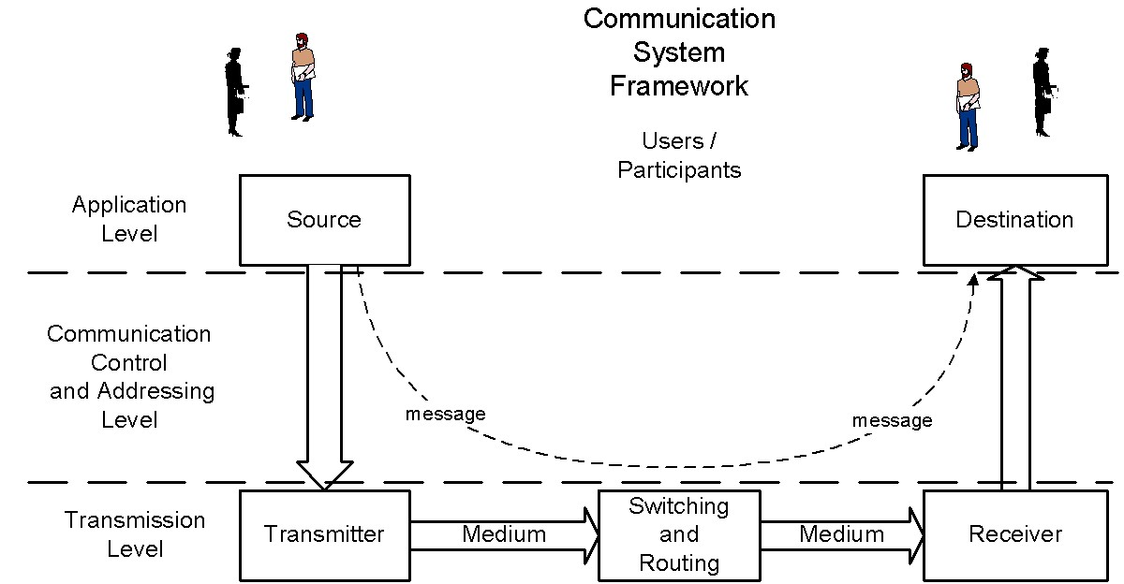
To enable stronger connections between common technical industry terminology and their place within in the framework, the following diagram is presented to map levels (or layers) between the framework and the main models recognised in industry today. It shows the alignment of the three models and where some models combine layers.
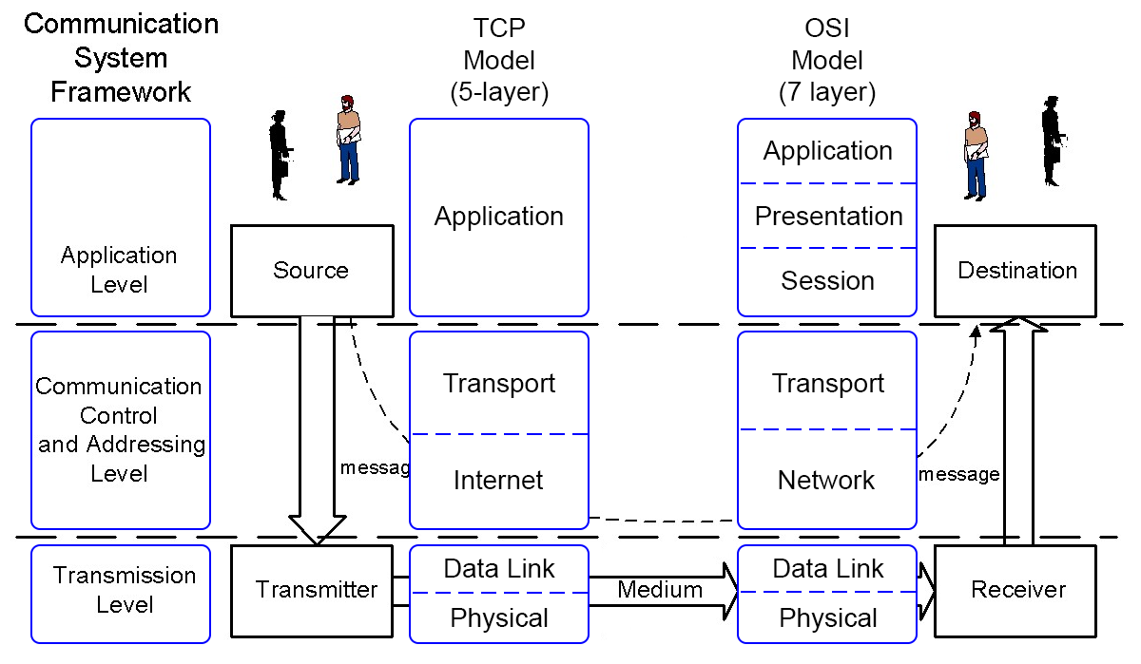
Diagrams reproduced and adapted from the Information Processes and Technology Stage 6 syllabus, © NSW Education Standards Authority (NESA) for and on behalf of the Crown in right of the State of New South Wales 2009.
Important: Access LinkedIn Learning from within the Student portal before clicking the video links listed in this document.
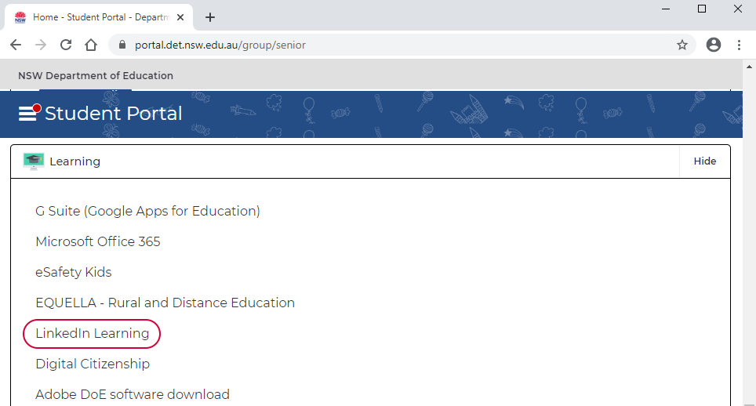
After the initial use please ensure you are logged into the Student portal before clicking on the LinkedIn Learning video links.

The Framework
Option: The accompanying A3 poster is designed to complement this workbook. Students may either annotate the A3 poster and/or complete the tables and questions in this workbook. The first three tables below represent the boxes on the left hand side of the diagram on the poster.
Note: Where a particular framework/model layer overlaps a number of layers within another model, for example application level, its label has been repeated on multiple rows of the following tables for accessibility purposes.
Watch the following videos and read the webpages:
- Introducing network interface controllers (NICs) (2:49)
- Exploring hubs (4:15)
- Understanding bridges (1:39)
- Exploring switches (4:21)
- Understanding routers (3:39)
- Introducing wired and wireless access points (2:12)
- Dial-up (4:34)
- DSL and ADSL (3:25)
- Example: Switch Operation on a Local Network
- Example: Simplified Local Network TCP/IP Communication

- Complete the table below by identifying a hardware device that operates in the respective layer (not all the levels have a corresponding hardware device).
IPT Framework | Hardware device | OSI model
Application level |  | Application (layer 7)
Application level |  | Presentation (layer 6)
Application level |  | Session (layer 5)
Communication Control level |  | Transport (layer 4)
Addressing level |  | Network (layer 3)
Transmission level |  | Data Link (layer 2)
Transmission level |  | Physical (layer 1)

Watch the following videos and read the webpages:
- Internet protocols (2:33)
- TCP/IP Five-Layer Software Model Overview

- Complete the table below by identifying a protocol that operates in the respective layer.
IPT Framework | Protocol | OSI model
Application level |  | Application (layer 7)
Application level |  | Presentation (layer 6)
Application level |  | Session (layer 5)
Communication Control level |  | Transport (layer 4)
Addressing level |  | Network (layer 3)
Transmission level |  | Data Link (layer 2)
Transmission level |  | Physical (layer 1)

Extension:
In conjunction with a data unit diagram, compare the Communication System (IPT) framework, TCP model and OSI model. The TCP/IP Five-Layer Software Model Overview also has a diagram which visually describes the structure of data at different layers (see bottom of page).
- Complete the table below by identifying the data unit that operates in the respective layer. The bottom layer has been filled in.
IPT Framework | Data unit | OSI model
Application level |  | Application (layer 7)
Application level |  | Presentation (layer 6)
Application level |  | Session (layer 5)
Communication Control level |  | Transport (layer 4)
Addressing level |  | Network (layer 3)
Transmission level |  | Data Link (layer 2)
Transmission level | bits | Physical (layer 1)

Functions within communication systems
The two groups of videos on this page provide a good foundation to .The first set introduces the principles of communicating a message and concludes with a digital perspective. The second set provides an overall big picture view of the functions occurring within a familiar communication system – the internet.
Watch the following resources and then participate in some class discussion:
- Binary and bits (2:35) [Preamble]
- Communicating with bits (4:28)
- Digital communication (6:27)

- On the framework diagram, there are two arrows between the transmitter and receiver labelled medium. What are the three main categories of medium that communication networks can be composed of?
- What is one limitation of each of these categories?

Watch the following resources and then participate in some class discussion:
- Sending and receiving information (2:28)
- The Internet Protocol and IP address (2:46)
- Scaling up the Internet from IPv4 to IPv6 (3:33) [Optional]
- The Domain Name Server and DNS (3:42) [Optional]
- Routers and directing requests (2:26)
- Packets and fault tolerance (3:10)
- Reliability and TCP (2:16)

The role of protocols
Communication protocols have already been mentioned in relation to where they fit in a particular model. To develop this understanding further let us examine what a protocol is, their general purpose and the various functions they perform within networks.
The role of protocols in networking (1:57)
- Explain using an example, what is the role of protocols in networking? Do they exist outside of networking?
What Is a Three-Way Handshake in TCP? (4:57)
- How does the 3-way handshake in TCP ensure reliability?
Watch the following videos and read the webpages:
- Internet protocols (2:33)
- TCP/IP Ports Defined
Identify some common internet protocols and their ports.
Protocol | Port

The following visual models use different numbers of layers for various devices and specific types of layers have a particular colour. Examine the examples and note how the different layers perform their specific role and interact with each other. This visual model uses different
- Example: Simplified Local Network TCP/IP Communication
- Detailed TCP/IP Communication Example
- Use this model to describe how either of the other examples in the syllabus, mail server and print server, would operate.

Client-server model
Traditionally there were two network management models, the client-server model and the peer-to-peer model. Investigating client-server and peer-to-peer connections (4:49)
- Describe each model and explain the differences.
- What are the advantages and disadvantages of client-server architectures compared with the peer-to-peer model?
Advantages | Disadvantages
Client-server | Client-server
Peer-to-peer | Peer-to-peer

Thin clients and fat clients represent the two traditional types of user devices on LANS. Fat clients are also known as thick clients. Zero client mentioned in the third video, is a newer term that is contrasted against thin clients and is not part of this course.
- Networking - Thin vs thick client computing (4:54)
- Thin vs Thick Client Computing (3:46)
- Thin Client Computing and the Market (6:00)
- In terms of processing, what is the difference between thin clients and fat clients?
- What are the advantages and disadvantages of thin clients compared to thick clients?
Advantages | Disadvantages
Thin-client | Thin-client
Thick-client | Thick-client
- What are some examples of thin clients today?
Explore the components of the cloud (1:55)
- How has cloud computing changed the concept of thin clients?
- How could the operation of a thin client be described by either the communications system framework or one of the other models?
- Understanding how the web works (2:37)
- Working with clients and servers (web) (2:38)
- Understanding email servers and clients (2:23)
- How could the operation of a web client and a web server be described by either the communications system framework or one of the other models?
- How could the operation of an email client and an email server be described by either the communications system framework or one of the other models?

Examples of communication systems
- Audio and video conferencing (2:44)
- Presence, instant messaging, and email (5:08)
- Telephony and VoIP integration (3:13)
- e-commerce
- EFTPOS – what is eftpos in Australia? How does it work?
- electronic banking
- From the given examples, select two and identify some advantages and disadvantages of the system.
Example | Advantage | Disadvantage
1
2
- From the given examples, select one and explain how data is transmitted and received.
- Represent this communication system in a diagram.
How e-commerce is changing retail trends during the pandemic: Shopify COO (6:46)
- Analyse how e-commerce is changing retail trends? (pre-covid and post-covid)
Can I use my EFTPOS or Credit Card terminal on the nbn™?
- What technology is required by a merchant for EFTPOS to work?
- How has/will the NBN change this? (Optional)
- What are some modern examples of technology used for communication systems? (Your teacher may provide some additional links)

- The big picture of technology trends (5:54)
- Internet of Things (6:26)
- How can these systems and technology be described by the Communications Systems Framework?

Transmitting and receiving in communication systems
The course specifications document lists two groups of example types of transmission media. They are wired and wireless transmission.
- Comparing cabling standards (2:08)
- Identifying copper connectors (1:49)
- Comparing fiber connectors and cables (3:56)
- List in order of increasing bandwidth.
Wired media | Bandwidth / capacity | Maximum distance

- Exploring wireless LAN types (2:23)
- Distinguishing legacy, current, and future Wi-Fi standards (2:39)
- List the recent wireless (802.11) standards and their specifications.
802.11 standard | Specifications
- Identify some other forms of wireless transmission.
- Explain how to connect to a wireless network in common operating system, for example Windows 10.

Communication protocols
Communication protocols have already been mentioned in relation to their general purpose. To develop this understanding further let us explore some specific protocols and the various functions they perform within networks.
- Common Ports and Protocols (4:57)
- HTTP (2:51)
- HTTPS (1:48)
- Mail services: POP, IMAP, and SMTP (3:52)
- Introducing Secure Sockets Layer (SSL) (4:39)
- SSL vs. TLS (9:50) [Extension]
- Packets and frames (3:06)
- What is the function of these protocols
Protocol | Function
HTTP
HTTPS
POP
IMAP
SMTP
SSL
TCP
IP
Ethernet

- What are some other examples of protocols?

Error detection and error correction
How does TCP ensure reliability?
Describe the three traditional methods of error detection – parity, checksum and cyclic redundancy checks.
Error correction is listed with error detection in the syllabus and most of the attention is given to error detection, but what is the most effective error correction strategy?

Network Topologies
With some hardware and network technologies phased out of use the distinction between logical and physical topologies is less observable nowadays. It was more common when examining hubs in star networks, or token ring networks that had a physical layout of a star topology. Watch these videos to learn the difference between topologies and which topologies are now commonly used.
- Understanding logical and physical network topologies (1:02)
- Understanding mesh, bus, and ring topologies (8:38)
- Exploring star and hybrid star topologies (4:48)
- Understanding point-to-point and point-to-multipoint networks (1:53)
Exam questions have generally tested the ability to recognise correct visual representations of network topologies.
- Draw representations of the following network topologies.
Topology | Visual representation
Bus
Star
Ring
Hybrid
Mesh
Exploring network collisions, CSMA/CD, and CSMA/CA (6:14)
The example scenarios in this video use wired network topologies (usually bus topology) to describe the CSMA/CD and CSMA/CA processes.
- Is CSMA/CD relevant for switch technology and/or star topologies?
- What topologies are recognised//available for wireless networks?
- Which process (CSMA/CD or CSMA/CA) is used for wireless topologies?

Hardware components
Previously we explored where hardware devices fitted in the framework and TCP/OSI models. This time we focus on the function of these devices.
- Introducing network interface controllers (NICs) (2:49)
- Understanding bridges (1:39)
- Exploring switches (4:21)
- Understanding routers (3:39)
- Introducing wired and wireless access points (2:12)
- Dial-up (4:34)
- DSL and ADSL (3:25)
- Switches in Local Networks

- Complete the table below by providing a function of the following hardware components.
Hardware component | Function
Network cables
Network interface card
Bridge
Switch
Router
Wireless access point
Dial-up modem
ADSL modem

Network operating systems
Network operating systems (NOS), NOS server software and NOS client software are terms which have either changed their meaning or have become redundant in a highly connected world where all nodes, end-user devices or clients have networking functionality built-in by default.
Read and watch the following resources and then participate in some class discussion to evaluate the relevance of these terms today.
- Network Operating Systems (NOS)
- NOS Server Software
- NOS Client Software
- Network Operating Systems & Policies (8:39)
Additionally, here are two videos that provide a modern perspective on the use of these terms:
- Operating system types (3:51)
- Linux network operating systems (NOS) (4:49)

Internet, intranets and extranets
Extranets are probably the area where the meaning has evolved from its original usage. So what constitutes as an extranet today?
Understanding the difference between the Internet, intranets, and extranets (2:14)
- Compare and contrast the Internet, intranets and extranets.
Internet | intranets | extranets
How are platforms like Microsoft Azure and Amazon Web Services considered to be extranets? (What part of their functionality or business processes characterises them as extranets)

Managing communication systems

- Account Management (10:21)
- Assigning Rights: Peripherals (6:07)
- Assigning Rights: File Privileges (10:12)
- Creating user accounts (5:50)
- Access control (6:17)
These tasks were essential to the role of network administration in traditional on-premise networks. With widespread adoption of cloud services it is important to acknowledge the significant changes to roles like network administration and user activities.
A modern perspective:
- What is software as a service (SaaS)? (4:53)
- What is infrastructure as a service (IaaS)? (4:32)
- What is platform as a service (PaaS)? (5:17)

- Explain how “the cloud” has changed the construct of a network?
- Explain how cloud computing has changed traditional network administration tasks?
- How has cloud computing changed traditional ideas on installing software for network users AND the concept of network-based applications?
- How has cloud computing changed the traditional concept of network-based applications?
What are the advantages and disadvantages of cloud-based architectures and services compared with on-premise networks?
Advantages | Disadvantages
On-premise | On-premise
Cloud-based | Cloud-based

Issues related to communication systems
Common ethical issues (3:19)
Explain the ethical issues mentioned using relevant examples of communication systems.
Cybersecurity is a whole topic in itself with many aspects available to discuss, but two relatively common practices that affect users are phishing and scamming. Here are two videos on phishing and scamming. What is the difference between the two?
Digital transformation – making data and systems accessible via the cloud (3:15)
What are the ethical issues associated with digital transformation and the changes in practices mentioned in this video?
Select three examples from the list provided here (also found in the syllabus on page 36).
- security
- globalisation
- changing nature of work
- interpersonal relationships
- e-crime
- legal
- virtual communities
- current and emerging trends in communications
If you chose “current and emerging trends in communications”, specify the issue below. (It is important to note that the content dash points listed on the bottom of page 8 of the course specifications document are examples of technologies and not issues themselves).
- How can each of these issues be explained in the context of the communications systems framework?
Issue 1:

Issue 2:

Issue 3:

For each of these examples:
Define the issue. Is it social or ethical?
Example | Issue
Digital footprint
Remote Workers
Emerging Trends (IoT)

Additional links your teacher may use in class discussions
Teachers may add additional links to resources here.

Additional resources
Network Direction - YouTube
Each video is between 12 – 25 minutes long with each video containing two or more sections separated by some questions aimed to challenge and develop deeper understanding. Most of the content is relevant information for this unit but sometimes goes beyond the scope of Stage 6 IPT.
- Network Fundamentals Part 1 – Introduction to Networking (11:53)
- Network Fundamentals Part 2 – Cabling Devices (25:24)
- Network Fundamentals Part 3 – How the OSI Model Works (16:50)
- Network Fundamentals Part 4 – How IP Addresses Work (15:30)
- Network Fundamentals Part 5 – IP Addressing in Depth (20:33)
- Network Fundamentals Part 6 – TCP/IP Model (Internet Protocol Suite) (10:44)
The author suggests the following questions be used while watching the first episode. More questions are presented in the other episodes.
Network Fundamentals Part 1 – Introduction to Networking
- What are the two ways computers can connect to the network?
- What devices do they usually connect to?
- How many protocols are used when one computer accesses another computer?
- Your company has three divisions. Each group has a network, and all the networks are joined together. Is this still a LAN? Or is it something else?
- The company adds a retail division. There is a head office and six branch offices. What type of network is this?

