Year 12 EAL/D – Focus on Writing

Part one
HSC Hub student support session – writing with audience, context and purpose in mind

Resource booklet

Table of contents
Resource booklet 1
Table of contents 2
Required materials 3
Advice to the teacher supporting students 3
Advice to the independent student 3
Learning intentions and success criteria 4
Section one – revisiting the module description 5
Resource one – key sentences from the module description 5
Activity one – examples of activities 5
Activity two – questions on the module description 6
Resource two – useful links for EAL/D 6
Activity three – definitions (in your own words) 7
Activity four – reflect on learning 7
Resource three – the module description in full. 8
Section two – writing in the examination 9
Activity five – types of text 9
Activity seven – examining the stimulus 10
Resource four – stimulus from the 2019 exam 12
Activity eight: applying our learning 13
Activity nine – reflect on learning from section two of part one. 13

Required materials
Students, please ensure that you have –
- one or two pieces of your own writing, either classwork or completed assessment tasks. These could be any type of text, including persuasive or imaginative.
- this resource in a soft or hard copy and access to the PowerPoint presentation
- pens and highlighters.

Advice to the teacher supporting students
If using in a classroom context the teacher may like to –
- use this resource in a workshop setting with a group or an individual student to work through on their own
- pause the recording and ask students to read, reflect and write
- refer to school-based assessments or classwork as examples for discussion.

Advice to the independent student
If using this resource at home independently students will need –
- the required materials listed above
- time and space to work on this resource thoroughly. We recommend stopping the recording when prompted and taking the time to complete all activities in this resource booklet.
You may wish to use this resource over two separate learning periods. There are two parts to the resource, each taking approximately 15 minutes of viewing time on the video. Properly completing the activities, however, will take you another 15 to 30 minutes in each part so we recommend having a break between parts.

Learning intentions
For students to –
- understand the most appropriate language for the purpose, audience and context of a writing task
- clarify the types of texts required for writing in this module
- analyse some student sample writing and identify what the marker feedback reveals.

Success Criteria
For students to be able to –
- identify the requirements of Focus on Writing exam questions
- understand how language can be used to address purpose, audience and context, as well as the type of text required
- write a stronger response to a Focus on Writing question.

Section one – revisiting the module description
Complete the following activities in consultation with the instructional video.

Resource 1 – key sentences from the module description
Complete the following activities by writing in the spaces given to you.

Activity 1 – examples of activities
Slide 8 in PowerPoint presentation
Do you remember completing these types of activities through your course? Write a specific example of something you wrote or worked on over the last two years into the space provided for each sentence.
- Students … design and present a range of texts, appropriate to the module being studied, to communicate information, ideas, attitudes and values for different purposes, audiences and contexts.
For example, that website we created on animal rights in term 2 of Year 11… and...
- Students … experiment with techniques, styles and forms in … creative, imaginative, critical, discursive, persuasive and informative texts.
For example...
- Students … plan, draft and refine (texts) … for their audience, context and purpose.
For example...
Statements from the module description for the Focus on Writing module in the English EAL/D Stage 6 Syllabus © NSW Education Standards Authority (NESA) for and on behalf of the Crown in right of the State of New South Wales, 2017.

Activity 2 – questions on the module description
Slide 9 in the PowerPoint presentation
Answer each question in the space provided.
1. Which key words are repeated in sentences one and three?
2. Which words identify the kinds of work you are expected to do in this module?
3. Which types of text can you be asked to write in the examination?

Resource 2 – useful links for EAL/D
Slide 13 in the PowerPoint presentation
- NESA glossary for EAL/D
- NESA syllabus for English EAL/D
- NESA sample examination papers (further down the syllabus page)
- NESA English EAL/D 2019 HSC exam pack

Activity 3 – definitions (in your own words)
Use the glossary to help you develop a definition for each of these terms:
- Audience:
- Context:
- Purpose:
- Register:

Activity 4 – reflect on learning
Slide 17 in the PowerPoint presentation
Table 1 – I used to think…but now I think…
I used to think… | But now I think…

Resource 3 – the module description in full

Focus on Writing module
In this concurrent module, students develop and refine their knowledge and skills in writing, speaking and representing. They design and present a range of texts, appropriate to the module being studied, to communicate information, ideas, attitudes and values for different purposes, audiences and contexts.
Students analyse, evaluate and reflect on the expressive, aesthetic and imaginative qualities of the written, spoken and multimodal texts studied in their other HSC modules. Using these texts as models and inspiration, they experiment with techniques, styles and forms in a range of modes and media to produce their own crafted works, for example creative, imaginative, critical, discursive, persuasive and informative texts. Through the process of writing they generate ideas, experiment with techniques, styles and forms, and reflect on the strengths and weaknesses in their compositions and their emerging proficiency as English language users.
Students develop and apply effective editing processes, including the use of assistive technologies, to plan, draft, revise, refine, proofread and publish texts. Explicit, targeted English language study includes research and referencing skills, and implementing and maintaining ethical practices and standards when responding to and composing texts. Students plan, draft and refine their own written and spoken texts, applying the conventions of syntax, spelling and grammar appropriately and with increased confidence and accuracy for their audience, context and purpose.
Content in this section is from the English EAL/D Stage 6 Syllabus (2017) © NSW Education Standards Authority (NESA) for and on behalf of the Crown in right of the State of New South Wales, 2017.

Section 2 – writing in the examination
This section supports your development of the types of texts you could be asked to write in within the examination.

Activities
Continue the following activities in the spaces provided.

Activity 5 – types of text
Slide 20 in the PowerPoint presentation
How confident are you in writing the three types of text? Tick the most appropriate column in this table for how you feel right now. You will fill in the fourth row after the video.
Table 2 – levels of confidence about the three types of text
Type of text | Very confident | A little confident | So-so | A little worried | Very worried
Imaginative
Informative
Persuasive
D

Note-taking space.
Write in at least two key features for each type of text that you hear in the video.
Slide 21 in the PowerPoint presentation
Table 3 – Notes on the types of texts
Type of text | Feature one | Feature two
Persuasive
Imaginative
Informative
D

Activity 6 – discursive texts
Slide 22 in the PowerPoint presentation
Table 4 – similarities and differences between discursive and other types of text
Similar to the other types of text | Different from the other types
Structure
Purpose
Language

Activity 7 – examining the stimulus
Slide 25 in the PowerPoint presentation
How likely are each of these options? Tick the box that is closest to your feeling. If doing this as a class or with a peer, discuss your answers first and explain your reasons.
Table 5 – stimulus possibilities
Stimulus | Highly unlikely | Unlikely | Unsure | Likely | Highly likely
A line from a poem
An image
An extract from a story or article
A web page
Multimodal
A very specific topic known to some students
A general topic known to all students
Open to interpretation
A single perspective
A quote
A long text
An extract from a prescribed text

Resource 4 – stimulus from the 2019 exam
Image 1 – Teen Reading Habits stimulus
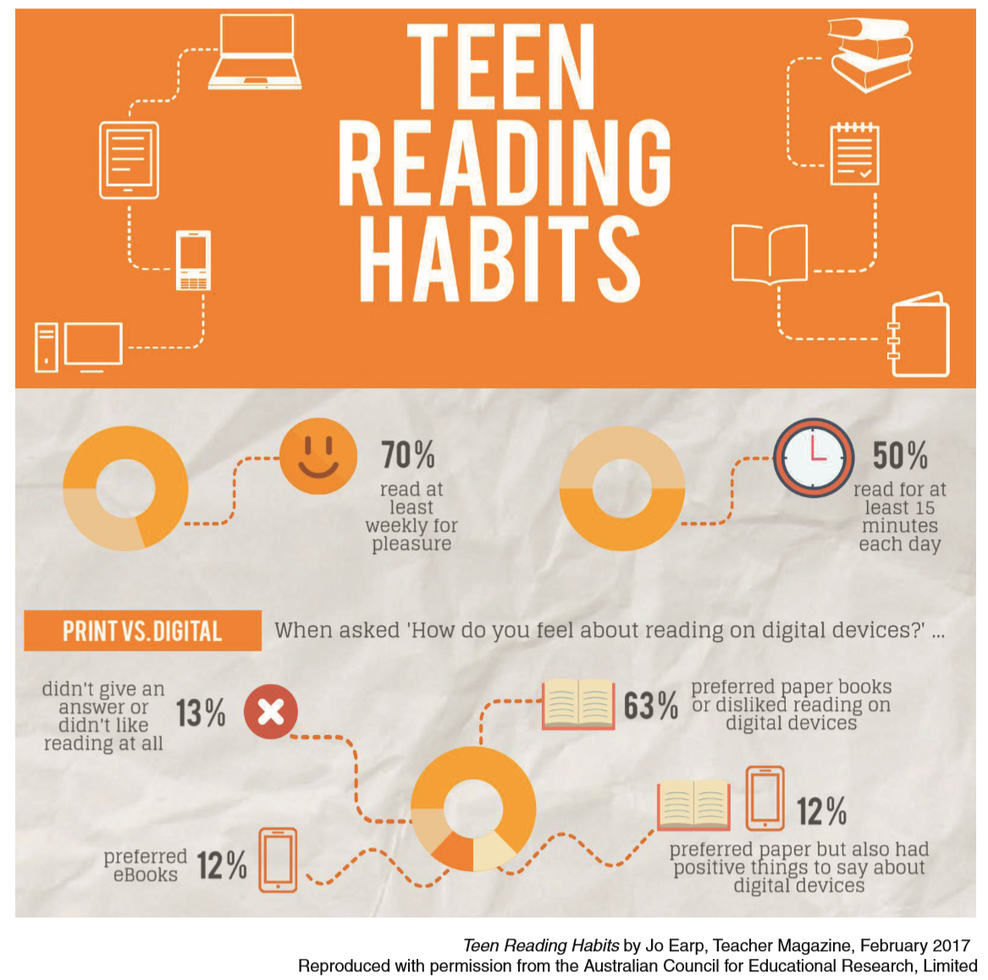
Material from the 2019 Higher School Certificate Examination English as an Additional Language or Dialect (EAL/D) © 2019 NSW Education Standards Authority. (See the English EAL/D 2019 HSC exam pack).
The question:
You have been asked to speak to your school community. The topic is ‘technology has changed teen reading habits.’ Write a persuasive speech expressing your view on this topic. Use the stimulus provided… and your own ideas to write the text of your speech.

Activity 8 – applying our learning
Slide 28 in the PowerPoint presentation
As you plan your writing, think about context, audience and purpose. The table below will help you organise your thoughts. Refer to the guiding question for each concept and use the space provided to fill in your ideas.
Table 6 – thinking about context, audience and purpose
Concept | Guiding question | Your response – and what are the implications of this?
Context one | What is your role? | A student  Implications: you have a relationship with people in the audience and…
Context two | What is the situation?
Audience | Who are you writing for?
Purpose | What are you trying to achieve?

Activity 9 – reflect on learning from section two of part one.
Slide 31 in the PowerPoint presentation
Complete the KWL table below to check in on the key points from this section of the resource.
Table 7 – reflect on learning
K – what I already knew about this topic | W – what I still want to learn about this topic | L – what I learnt about this topic during this section
That is the end of part one of this HSC hub student session on EAL/D Focus on Writing.

